**Rest_API_Flow_Diagram**

**Flow Diagram: 01**

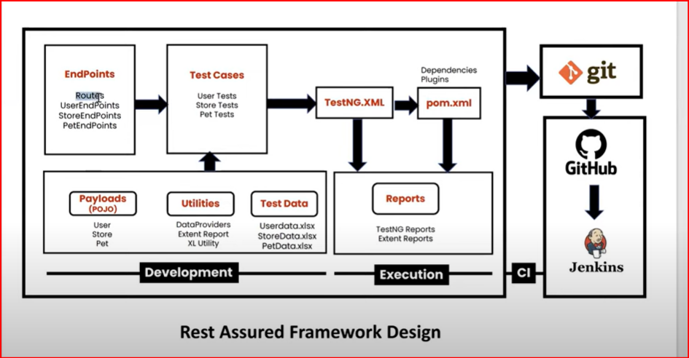

**Flow Diagram: 02 with Properties File**

