Data mining is about explaining the past and predicting the future by analyzing the data. It is a multi-disciplinary field which combines statistics, artificial intelligence, machine learning and database technology. Data mining predicts the future by the means of modelling. Predictive modelling is a process where in which an outcome is predicted by creating a model. If the outcome is categorical, it is called classification and if the outcome is numerical, it is called regression. Classification is a data mining task of predicting the values of a categorical variable by building a model based on one or more categorical variables. Association rules find interesting associations among observations.

The following are the groups of classification algorithms.

Frequency table, covariance matrix, similarity functions and others.

K Nearest Neighbors algorithm falls under the similarity functions category.

Association rules find all sets of items that have a support greater than the minimum support and using large sets to get desired rules that have confidence greater than the minimum confidence.

The following are the algorithms I am using in the project.

Bootstrap algorithm

K Nearest Neighbors algorithm

AIS algorithm for association rules

Weakly supervised method or Comparator Mining:

A sequential pattern is defined as a sequence S (S1S2S3…. Si…. Sn), where Si can be a word, symbol or a POS tag denoting a comparator (C$) or the beginning (#start) or the end of a question (#end). A sequential pattern is called an Indicative Extraction Pattern (IEP) if it can be used to identify comparative questions and extract comparators.

Mining Indicative Extraction Patterns

Weakly supervised method or comparator mining is based on the following assumptions

1. If a sequential pattern can be used to extract comparator pairs, then it is very likely to be an IEP.
2. The pair is capable to compare if a comparator pair can be extracted by an IEP

Based on the above assumption, boot strapping algorithm is designed. The two main keys steps involved are

1. Pattern generation
2. Pattern evaluation

Pattern generation:

The three kinds sequential patterns generated from sequences of questions are

**Lexical patterns:** These patterns indicate sequential patterns consisting of only words and symbols ($C, #start, and #end).

Example: Which is better, Omaha or Lincoln?

**Generalized patterns:** A lexical pattern is too specific for matching. Lexical patterns are generalized by replacing one or more words with their POS tags.

Example: Which city is better, Omaha or Lincoln?

**Specialized patterns:** Pattern specialization by adding POS tags to all comparator slots.

For example, from the lexical pattern “<$C or $C>” and the question “Omaha or Lincoln?”, “<$C=NN or $C=NN?>” will be produced as a specialized pattern.

Example: Omaha or Lincoln?

Pattern Evaluation

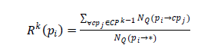

Reliability score for a candidate pattern Pi at iteration k is calculated as stated above.

All the candidate patterns are evaluated and the pattern whose reliability score is greater than a threshold value is stored as IEP in the database.

Comparator Extraction:

Using IEP’s, comparator questions are easily identified and comparators are extracted from comparative questions. The following is the process for comparator extraction

1. Generate sequence for the comparator question
2. If the IEP is a pattern without generalization, then we need to tokenize the question.
3. If the IEP is a specialized pattern, then POS tags should follow the conditions specified by the pattern.

Algorithm

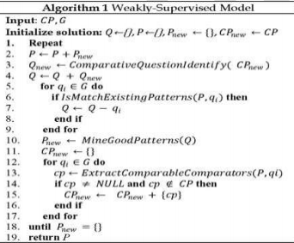

1. Bootstrapping starts with a single IEP
2. Extract initial seed comparator pairs from that single IEP
3. For each comparator pair all questions that contain the pair are considered as the comparative questions
4. From comparative questions, all the possible comparators are extracted.
5. Reliable patterns are added to the IEP repository.

K Nearest Neighbors algorithm

It is one of the top 10 data mining algorithms

Nearest Neighbor algorithm is a useful data mining technique to use the past data instances, with known output values, to predict an unknown output value. It is a simple algorithm where in which the training data set is stored, so that a classification for a new unclassified record may be found simply by comparing it to most similar records in the training set. Commonly used distance metric is Euclidean distance.