HARAMAYA UNIVERSITY
COLLEGE OF COMPUTING AND INFORMATICS
DEPARTMENT OF INFORMATION SYSTEMS
PRACTICAL ATTACHMENT ON THE SAVINGS ACCOUNT OPENING PROCESS AT COMMERCIAL BANK OF ETHIOPIA AND THE DEVELOPMENT OF A DEMONSTRATION ACCOUNT-OPENING WEBSITE
Prepared By:
Jalata Tolasa, ID: 1665
The Practical Attachment document submitted to the Information Systems Department
Advisor: [Advisor name]
[Date of submission]
Haramaya
ETHIOPIA
Declaration (Advisor's Approval)
This Internship work document is my original work and has not been submitted as a partial requirement for a degree in any university, except where otherwise stated. Other sources are acknowledged by citations giving explicit references. A list of references is appended.
…… [Student Signature] …….
Jalata Tolasa
[Date of submission]
The Internship work document has been submitted for examination with my approval as an advisor.
…… [Advisor Signature] …….
[Advisor name]
[Date of submission]

Acknowledgement
First, I thank the Almighty God for the health, patience and strength He gave me to complete this practical attachment.
I am sincerely grateful to my advisor, [Advisor name], of the Department of Information Systems, Haramaya University, for his/her guidance, constructive comments and continuous follow-up throughout the preparation of this document.
I also thank Commercial Bank of Ethiopia, [Branch name] Branch, for hosting me, and my company supervisor, [Supervisor name], and the staff who shared their time and knowledge about the savings account opening process.
My appreciation goes to the Department of Information Systems and the College of Computing and Informatics for the knowledge and skills that made this work possible, and to my family and friends for their encouragement. [Add any grant, fund or special support you received, as the guideline asks.]
Table of Contents
Acknowledgement 3
Abstract (Executive Summary) 8
CHAPTER ONE: INTRODUCTION 9
1.1 Background of the Hosting Organization 9
1.2 Mission, Vision and Core Values of the Hosting Organization 9
1.3 Organizational Chart 9
1.4 Statement of the Problem 9
1.5 Task Assigned 10
1.5.1 Task Completed 10
1.5.2 Task is not Completed 11
1.6 Objective / Aim of the Task 11
1.6.1 General Objective 11
1.6.2 Specific Objectives 11
CHAPTER TWO: METHODOLOGY FOR BUSINESS PROCESS ANALYSIS AND CASE STUDY 12
2.1 Method of Data Collection 12
2.2 Method of Problem Analysis 12
2.3 Difficulty in Internship 13
2.4 Strength and Weakness of the Hosting Organization 13
CHAPTER THREE: RESULT AND DISCUSSION 15
3.1 Result 15
3.1.1 Findings of the Study 15
3.1.2 Functional Requirements 16
3.1.3 Use Cases 17
3.1.4 System Design 18
3.1.5 The Website 19
3.1.6 Testing Results 25
3.2 Discussion 26
3.3 Recommendation 27
3.3.1 For the Hosting Organization 27
3.3.2 For Haramaya University, College of Computing and Informatics, School of Information Systems 27
CONCLUSION 29
REFERENCES 30
APPENDIX A: USE CASE DESCRIPTIONS AND FAILURE CASES 31
List of Tables
Table 1: Tasks completed during the attachment 10
Table 2: Tasks not completed 11
Table 3: Data sources used 12
Table 4: Tools used to build the website 13
Table 5: Strengths and weaknesses of the hosting organization 13
Table 6: Published annual interest rates 15
Table 7: Published charges 15
Table 8: Functional requirements and where they are implemented 16
Table 9: Use cases 17
Table 10: Pages of the website 19
Table 11: Automated test results 25
Table 12: Assumptions made in the website 27
Table 13: Use case descriptions and failure cases 31
List of Figures
Figure 1: Organizational chart of Commercial Bank of Ethiopia [add source] 9
Figure 2: Use case diagram of the savings account website 17
Figure 3: Account opening process flow with failure branches 18
Figure 4: System architecture of the website 19
Figure 5: Entity-relationship diagram of the database 19
Figure 6: Home page 20
Figure 7: Applicant guide with checklist 21
Figure 8: Interest calculator 21
Figure 9: Rates and fees page with the fee discrepancy warning 22
Figure 10: Staff login page 22
Figure 11: New application form (officer) 23
Figure 12: Failure case: an incomplete application is rejected with clear messages 23
Figure 13: Supervisor approval screen 24
Figure 14: Account statement with deposit, withdrawal and the ETB 12 fee 24
Figure 15: Zero-balance account awaiting funding 25
Figure 16: Month-end page: demo date, interest and deadline check 25
List of Abbreviations/Acronyms
Abbreviation | Meaning
ATM | Automated Teller Machine
CBE | Commercial Bank of Ethiopia
CBS | Core Banking System
CIF | Customer Information File
CSRF | Cross-Site Request Forgery
CSS | Cascading Style Sheets
ERD | Entity-Relationship Diagram
ETB | Ethiopian Birr
FR | Functional Requirement
HTML | HyperText Markup Language
HTTP | HyperText Transfer Protocol
ID | Identification
IEEE | Institute of Electrical and Electronics Engineers
KFS | Key Facts Statement
KYC | Know Your Customer
NBE | National Bank of Ethiopia
PDO | PHP Data Objects
PHP | PHP: Hypertext Preprocessor
PK / FK | Primary Key / Foreign Key
SQL | Structured Query Language
UC | Use Case
VAT | Value Added Tax

Abstract (Executive Summary)
This document reports the practical attachment carried out at Commercial Bank of Ethiopia (CBE), [Branch name] Branch, from [start date] to [end date]. The work focused on how a personal savings account is opened at CBE and on turning that process into a demonstration website.
A desk-based study of CBE's savings Key Facts Statement, its published tariffs, its account-opening information and the National Bank of Ethiopia's consumer-protection resources was used as the source of requirements. The study found that CBE opens an ordinary savings account free of charge, allows opening with a zero balance if the balance reaches ETB 100 within 15 days, pays 7% a year on ordinary savings, and requires identity verification. It also found that some published fees differ between documents, and that some information, such as accepted identity documents, is not published.
From these findings, 20 functional requirements, 11 use cases and 8 stated assumptions were derived. A website was then designed and built with PHP and SQLite. It gives applicants a guide, a rates and fees page and an interest calculator, and gives bank staff a role-based system for application, identity verification, supervisor approval, deposits, withdrawals, passbook replacement, monthly interest, funding-deadline monitoring, account closing and an audit trail. Forty-six automated tests of the business rules and a live walk-through of the main flows all passed.
The work shows how published banking terms can be turned into a working information system and where the published terms are unclear. The report recommends that applicants obtain the current Key Facts Statement and tariff before signing, that CBE keep its documents consistent and dated, and that the university add more practical training on banking systems.

CHAPTER ONE: INTRODUCTION

1.1 Background of the Hosting Organization
Commercial Bank of Ethiopia (CBE) is the largest commercial bank in Ethiopia, with its head office in Addis Ababa. It was established as a separate commercial bank in 1963 after the reorganisation of the State Bank of Ethiopia [1]. Over the years it has grown a nationwide network of branches and offers electronic services such as ATM, mobile and internet banking. [Verify and complete: number of branches, number of customers and a short history, from CBE's website or latest annual report.]
CBE serves individuals and businesses with deposit, loan, payment and trade-finance services. For individuals, its savings products include ordinary savings and specialised accounts such as youth, educational, women's, wedding and holiday savings [2]. This report concerns the individual personal savings account.
The practical attachment took place at [Branch name] Branch, located in [town/city]. The branch [describe the branch: year opened, number of staff, services, and the section where you worked, for example Customer Service].

1.2 Mission, Vision and Core Values of the Hosting Organization
Mission: [Copy CBE's current mission statement exactly from its official website or annual report.]
Vision: [Copy CBE's current vision statement exactly from its official source.]
Core values: [Copy CBE's core values exactly from its official source.]

1.3 Organizational Chart
Figure 1 shows the organizational structure of CBE. The section in which this attachment was carried out is [name of department or section].
[Insert the CBE organizational chart image here, from the annual report or from your supervisor.]
Figure 1: Organizational chart of Commercial Bank of Ethiopia [add source]

1.4 Statement of the Problem
A savings account lets a person deposit money, receive funds and earn interest. Before opening one, an applicant needs to know which documents to bring, how much to deposit, which fees apply and what they agree to when signing. The desk study found that these answers are spread over several documents and that the figures in them are not always the same. For example, the savings Key Facts Statement lists the first debit card at ETB 50, while the tariff page lists domestic debit card issuance at ETB 115 including VAT [2]. The published documents also show no effective date and give no universal list of accepted identity documents.
For bank staff and trainees, the opening process involves several linked rules: identity verification, the zero-balance condition with its 15-day deadline, the ETB 100 minimum balance, fees that depend on the amount, monthly interest on the lowest balance, and approval by a second person. These rules are hard to learn from documents alone, and there was no practical demonstration that puts them together and shows what happens when a rule is broken.
This work therefore addressed two questions: what exactly the published requirements and procedures are, and how they can be turned into a working system that applicants can use to prepare and staff can use to practise the process.

1.5 Task Assigned
During the attachment I was assigned to study the savings account opening process at CBE and to develop a demonstration website of that process, under the supervision of [Supervisor name]. The scope is individual personal savings accounts opened in person. Business accounts, foreign-currency accounts and other banks are outside the scope.

1.5.1 Task Completed
Table 1 lists the tasks that were completed.
Table 1: Tasks completed during the attachment
No. | Task | Description | Output
1 | Study of published terms | Reviewed CBE's savings Key Facts Statement, tariffs, account-opening information and NBE consumer-protection resources, and compared figures across them. | Desk study
2 | Requirements analysis | Derived functional requirements, use cases (with failure cases) and assumptions from the study. | 20 FRs, 11 UCs, 8 assumptions
3 | System design | Designed the opening process flow, system architecture and database. | Figures 2 to 5
4 | Implementation | Built the website with PHP and SQLite: public applicant pages and a role-based staff system. | Working website
5 | Testing | Wrote automated tests of the business rules and walked through the live site as officer and supervisor. | 46 tests passed
6 | Documentation | Wrote the README, the requirements page inside the website, and this report. | This document
7 | [Add branch activities] | [Add what you actually did at the branch, for example orientation, observing account opening, customer service support.] | [ ]

1.5.2 Task is not Completed
Table 2 lists the tasks that were not completed and the reasons.
Table 2: Tasks not completed
No. | Task | Reason
1 | Checking the published figures against real branch practice | The study used published documents only. No branch application was made and no officers or customers were interviewed.
2 | Connecting the website to CBE's core banking system | The bank's system is confidential and access is restricted. The demo uses its own database and does not process real money.
3 | Testing remote account opening, e-signature and online identity verification | CBE Docs advertises these services, but they were not tested.
4 | Usability testing with bank staff and customers | Not arranged within the attachment period.
5 | Amharic interface and public hosting | Outside the time available. Listed as future work.

1.6 Objective / Aim of the Task

1.6.1 General Objective
To assess the requirements and procedures for opening a personal savings account at Commercial Bank of Ethiopia, and to turn them into a working demonstration website that applicants and staff can use to understand the process.

1.6.2 Specific Objectives
- To identify the documents, eligibility rules, opening deposit, minimum balance, interest rates and charges that CBE publishes for personal savings accounts.
- To flag the points that applicants should verify with the bank before signing.
- To derive functional requirements and use cases, including failure cases, from the published terms.
- To design and build a website that implements those requirements, with role-based access, approval control and an audit trail.
- To test the website's business rules and report the results.
- To make recommendations for CBE and for the Department of Information Systems.

CHAPTER TWO: METHODOLOGY FOR BUSINESS PROCESS ANALYSIS AND CASE STUDY
This chapter explains how the data were collected, how the account opening process and the requirements were analysed, the difficulties met, and the strengths and weaknesses of the hosting organization.

2.1 Method of Data Collection
The study is descriptive and desk-based and uses secondary data. The sources are listed in Table 3. Figures on balances, identification, interest and fees were extracted, grouped by objective, and compared across documents to find inconsistencies.
Table 3: Data sources used
No. | Source | Used for
1 | CBE, Key Facts Statement for Saving Accounts [2] | Opening balance, minimum balance, interest rates, charges
2 | CBE, Terms and Tariffs [3] | Fees such as passbook replacement and withdrawals
3 | CBE, CBE Docs: Account Opening and Digital Banking Documents [4] | Account-opening information and the digital alternative
4 | National Bank of Ethiopia, Financial Consumer Protection [5] | Consumer rights to information, choice, fair treatment, privacy, education and redress
5 | [Branch observation and staff discussions, if you did them] | [Add only what you really did. Remove this row otherwise.]

Limitation: no officers or customers were interviewed and no branch application was made for the study, so it reports published terms, not verified branch practice.

2.2 Method of Problem Analysis
The analysis followed the steps of a small software development cycle:
- Requirements elicitation. Each finding in the study was rewritten as a testable functional requirement. Where the study did not settle a point, a stated assumption was recorded instead of inventing a rule [6].
- Use case analysis. For each requirement group a use case was written with its actor, normal steps and failure cases (Figure 2 and Appendix A).
- Design. The opening process was drawn as a flow (Figure 3), the structure of the system as an architecture (Figure 4), and the data as an entity-relationship diagram (Figure 5).
- Implementation. The website was built with the tools in Table 4. Business rules were kept in one file, separate from the pages, so they can be tested without a browser.
- Testing. Automated tests exercised each rule, including failure cases. The live site was then walked through as officer and as supervisor.
Table 4: Tools used to build the website
Component | Tool | Purpose
Server-side language | PHP 8 | Pages, validation, business rules, sessions
Database | SQLite through PDO | Customers, accounts, transactions, users, settings, audit log
Front end | HTML5, CSS3 and a little JavaScript | Responsive pages, checklist and interest calculator
Local server | PHP built-in server or XAMPP | Running the demo on a computer
Tests | PHP command-line script | 46 automated checks of the business rules

2.3 Difficulty in Internship
- Figures differ between CBE documents, for example the first debit card fee, so some rules could not be fixed from one source.
- Some information is not published: the list of accepted identity documents, the charge for withdrawals above ETB 75,000, the charge for closing an account after six months, and the effective date of the tariff.
- CBE's core banking system is confidential, so the website could not be compared with the real system or connected to it.
- No branch application or interviews were possible within the study, so published terms could not be checked against daily practice.
- [Add your own difficulties, for example transport, working hours, limited access to staff or unfamiliar banking terms.]

2.4 Strength and Weakness of the Hosting Organization
Table 5 summarises the strengths and weaknesses seen in the published information and in the attachment.
Table 5: Strengths and weaknesses of the hosting organization
Strengths | Weaknesses
Publishes a Key Facts Statement and a tariff for savings accounts. | Fee figures differ between documents (debit card ETB 50 vs ETB 115 incl. VAT).
Clear core terms: free opening, zero-balance opening under a 15-day condition, 7% on ordinary savings. | No effective date is shown on the documents reviewed.
Several savings products with published rates (youth, educational, women's, wedding, holiday). | No universal list of accepted identity documents in the Key Facts Statement.
Identity verification is mandatory, which protects customers and the bank. | Some charges are not published (withdrawals above ETB 75,000, closing after six months).
Advertises digital services (remote account opening, e-signature) through CBE Docs. | Digital services were not tested, so their reliability is unknown.
[Add your own observed strengths, for example experienced and cooperative staff.] | [Add your own observed weaknesses.]

CHAPTER THREE: RESULT AND DISCUSSION

3.1 Result
This section presents what the study found, the requirements and use cases derived from it, the design of the website, the website itself and the test results.

3.1.1 Findings of the Study
Eligibility and identification. Applicants must pass identity verification. The Key Facts Statement gives no universal list of accepted documents and sends applicants to the branch.
Opening deposit and balance. An account may be opened with a zero balance if the applicant has a reasonable source of funds that brings it to at least ETB 100 within 15 days. The minimum balance to keep the account is also ETB 100.
Interest. Interest is calculated on the minimum balance kept during the month and credited on the last business day of the month. Table 6 shows the published rates. For example, ETB 1,000 kept for a full year at 7% earns ETB 70. This is an illustration, not a guarantee.
Table 6: Published annual interest rates
Account type | Annual rate
Ordinary savings | 7%
Youth savings | 7.125%
Educational savings | 7.125%
Women's savings | 7.125%
Wedding savings | 7.5%
Holiday savings | 7.5%

Fees. Table 7 shows the published charges. The savings Key Facts Statement lists the first debit card at ETB 50, while the tariff page lists domestic debit card issuance at ETB 115 including VAT, so applicants must ask which applies.
Table 7: Published charges
Service | Published charge
Opening an account | Free
First passbook at opening | Free
Replacing a lost passbook | ETB 115.00 incl. VAT
Replacing a damaged passbook | ETB 57.50 incl. VAT
Branch cash withdrawal up to ETB 500 | Free
Branch cash withdrawal of ETB 501 to 75,000 | ETB 12.00 incl. VAT
Closing a savings account before six months | Free
First debit card | ETB 50 or ETB 115 incl. VAT (sources differ)

3.1.2 Functional Requirements
Table 8 lists the 20 functional requirements derived from the findings and the page of the website that implements each one.
Table 8: Functional requirements and where they are implemented
ID | Requirement | Implemented in
FR-01 | Register an applicant with personal details. | new.php
FR-02 | Make identity verification mandatory before submission and approval. | new.php, approvals.php
FR-03 | Record ID type and number, prevent duplicate customers, reject the same ID under a different name. | new.php
FR-04 | Choose among six account types and show each annual rate. | new.php, tariff.php
FR-05 | Opening is free and the first passbook is free. | approvals.php
FR-06 | Allow zero-balance opening with a source of funds and a 15-day deadline to reach ETB 100. | new.php, approvals.php
FR-07 | Enforce the ETB 100 minimum balance on withdrawals and fees. | account.php
FR-08 | Monitor the 15-day deadline and flag overdue accounts for closure review. | account.php, admin.php
FR-09 | Record that the KFS and tariff were given, conditions explained, and the agreement signed with a copy given. | new.php, approvals.php
FR-10 | Require supervisor approval; the approver cannot be the submitter; approval issues the account number. | approvals.php
FR-11 | Accept deposits into active accounts. | account.php
FR-12 | Branch cash withdrawals: free up to ETB 500, ETB 12 from 501 to 75,000, refused above 75,000. | account.php
FR-13 | Credit monthly interest on the lowest balance of the month on the last business day, once per month. | admin.php
FR-14 | Replace a passbook: ETB 115 if lost, ETB 57.50 if damaged, including VAT. | account.php
FR-15 | Close an account: free before six months, pay out the balance, block further transactions. | account.php
FR-16 | Support an optional debit card and show that the sources disagree on its fee. | new.php, tariff.php
FR-17 | Public applicant guide with checklist, rates and fees, interest calculator and consumer rights. | guide.php, tariff.php
FR-18 | Show each account with a printable statement. | account.php
FR-19 | Role-based access, secure login and an audit trail. | login.php, audit.php
FR-20 | Warn that fees differ between documents and that no effective date is shown. | tariff.php, new.php

3.1.3 Use Cases
Eleven use cases were identified. Figure 2 shows the three actors and the use cases they take part in, and Table 9 lists them. The normal steps and the failure cases of every use case are given in Appendix A.
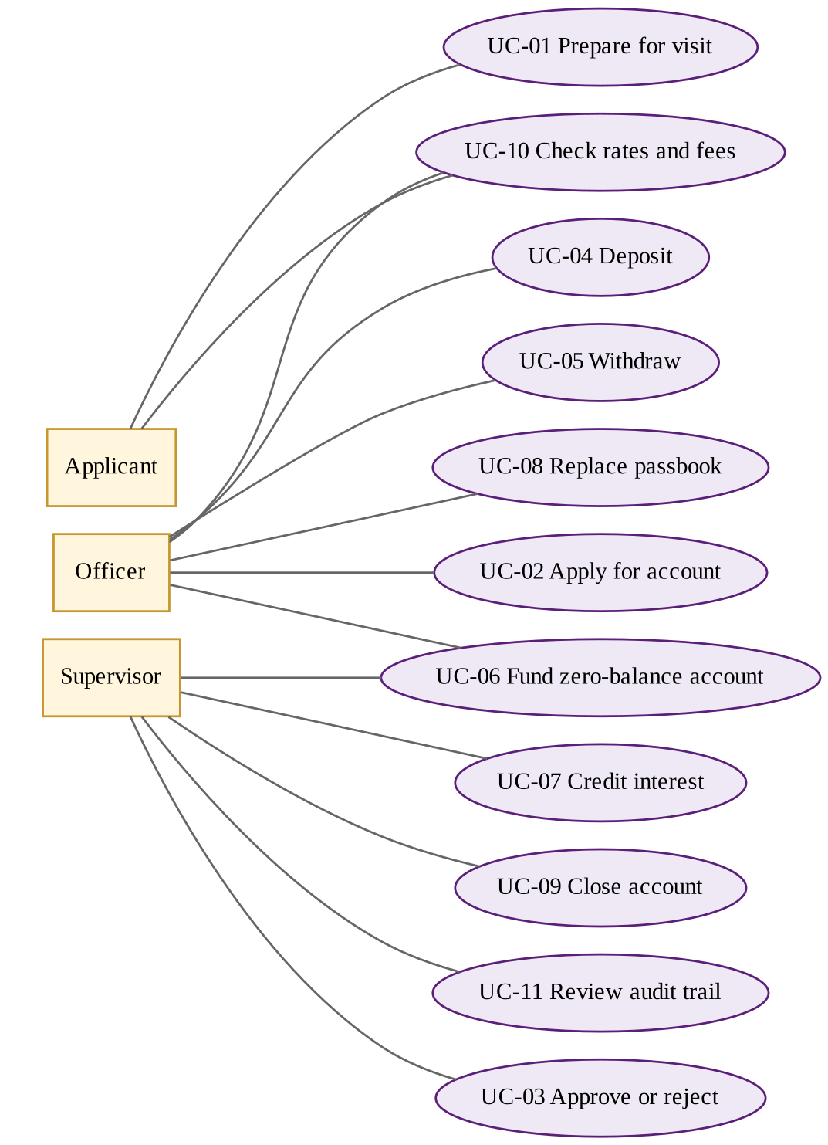
Figure 2: Use case diagram of the savings account website
Table 9: Use cases
ID | Use case | Actor
UC-01 | Prepare for a branch visit | Applicant
UC-02 | Apply for a savings account | Officer
UC-03 | Approve or reject an application | Supervisor
UC-04 | Deposit money | Officer
UC-05 | Withdraw cash | Officer
UC-06 | Fund a zero-balance account | Officer, Supervisor
UC-07 | Credit monthly interest | Supervisor
UC-08 | Replace a passbook | Officer
UC-09 | Close an account | Supervisor
UC-10 | Check the fees and rates | Applicant, Staff
UC-11 | Review the audit trail | Supervisor

3.1.4 System Design
Figure 3 shows the account opening process as the website implements it, including the places where a request is stopped. Figure 4 shows the structure of the system: pages call shared setup code and one file of business rules, which talks to the database through prepared statements. Figure 5 shows the database.
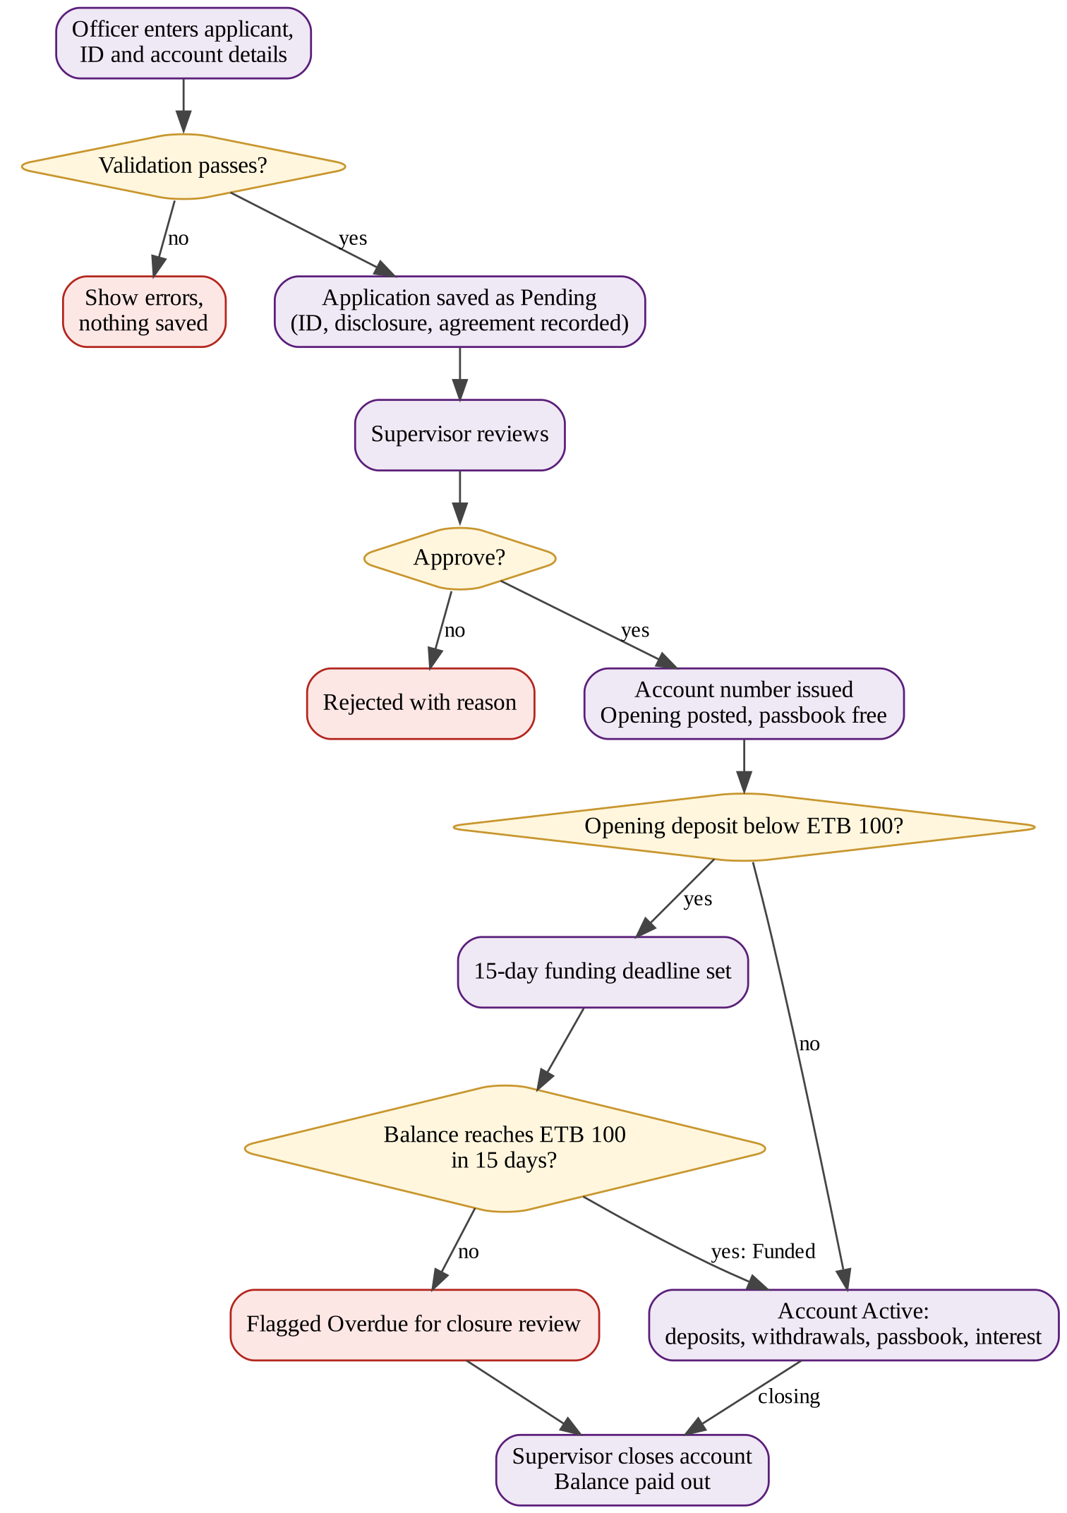
Figure 3: Account opening process flow with failure branches
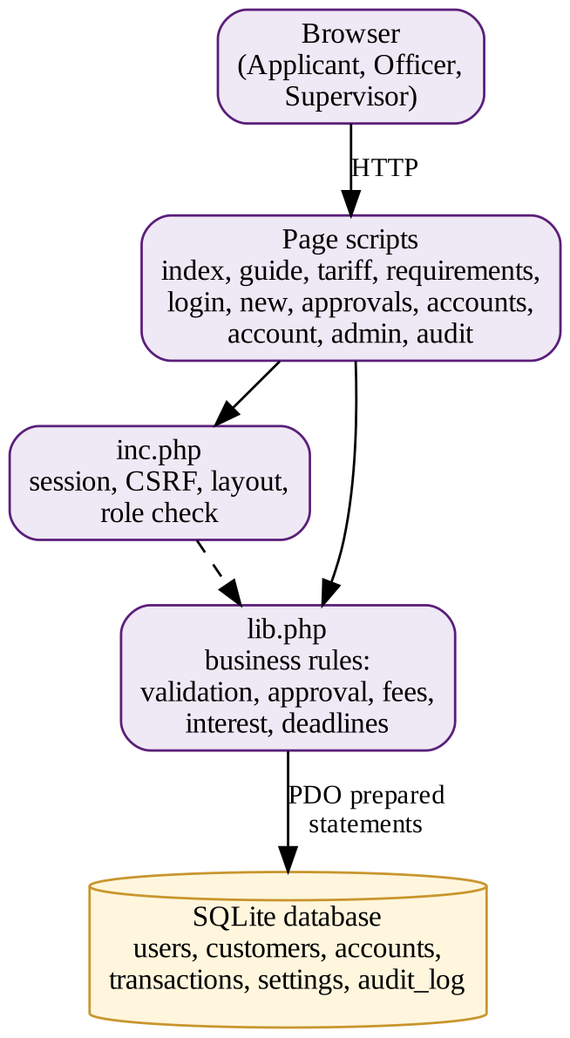
Figure 4: System architecture of the website
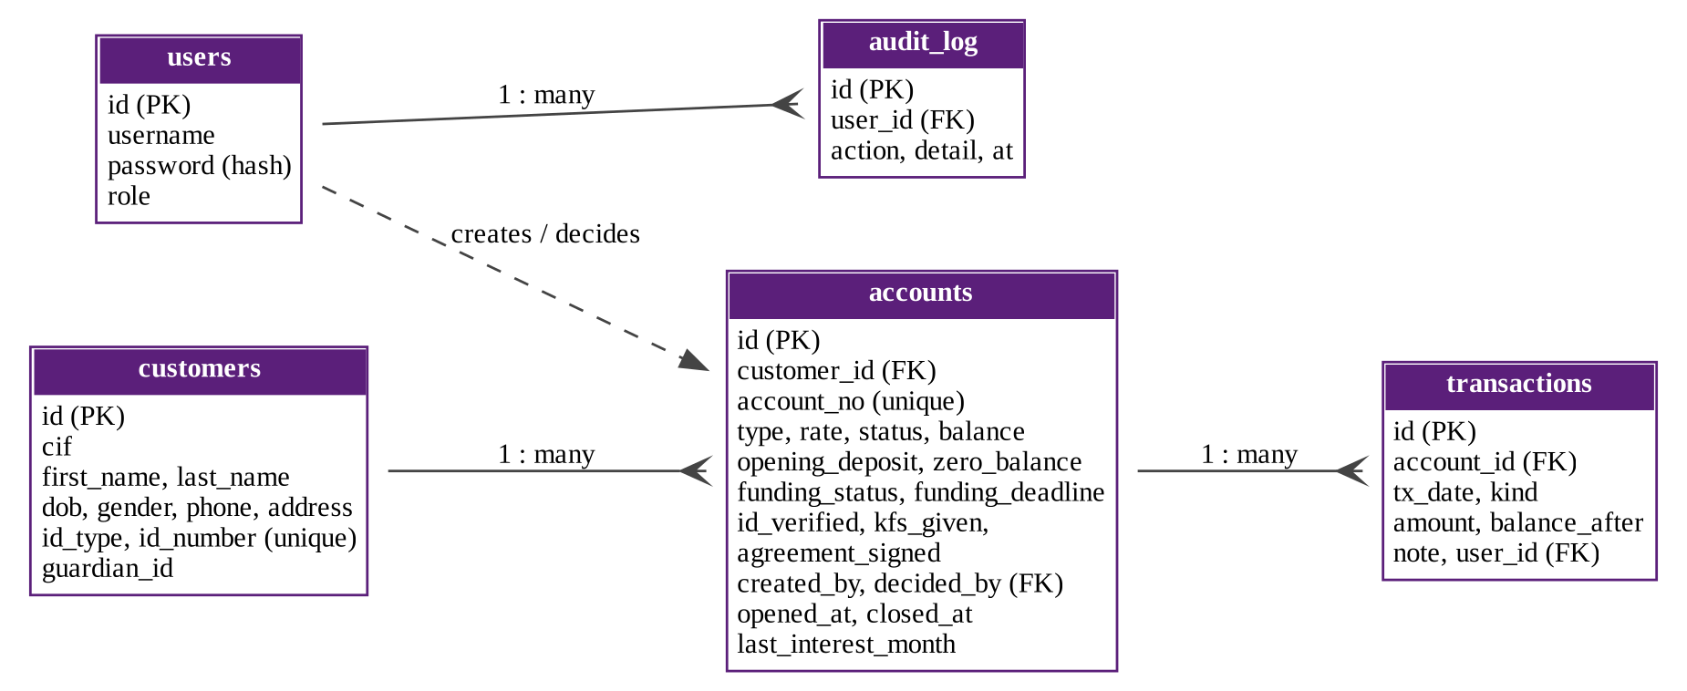
Figure 5: Entity-relationship diagram of the database

3.1.5 The Website
The website has a public part for applicants and a login-protected part for staff. Table 10 lists the pages and who can use them. Figures 6 to 16 show the main screens.
Table 10: Pages of the website
Page | Who | Purpose
index.php | Everyone | Home page with the key facts
guide.php | Everyone | Checklist for before, during and after the visit; interest calculator; consumer rights
tariff.php | Everyone | Rates and fees, with the fee discrepancy warning
requirements.php | Everyone | Functional requirements, use cases and assumptions
login.php | Staff | Secure login for officer and supervisor
new.php | Officer | New application with identity and agreement confirmations
approvals.php | Supervisor | Review, approve or reject applications
accounts.php, account.php | Officer, Supervisor | Search accounts; statement; deposit, withdrawal, passbook replacement, closing
admin.php | Supervisor | Demo date, monthly interest, funding-deadline check, reset
audit.php | Supervisor | Audit trail of every action

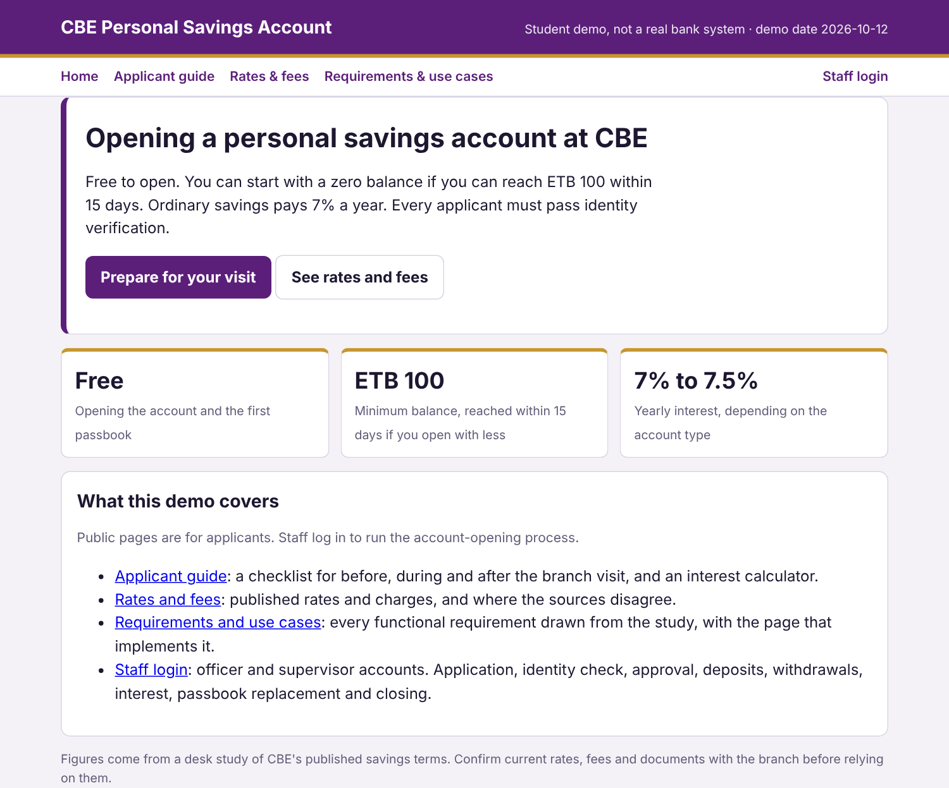
Figure 6: Home page
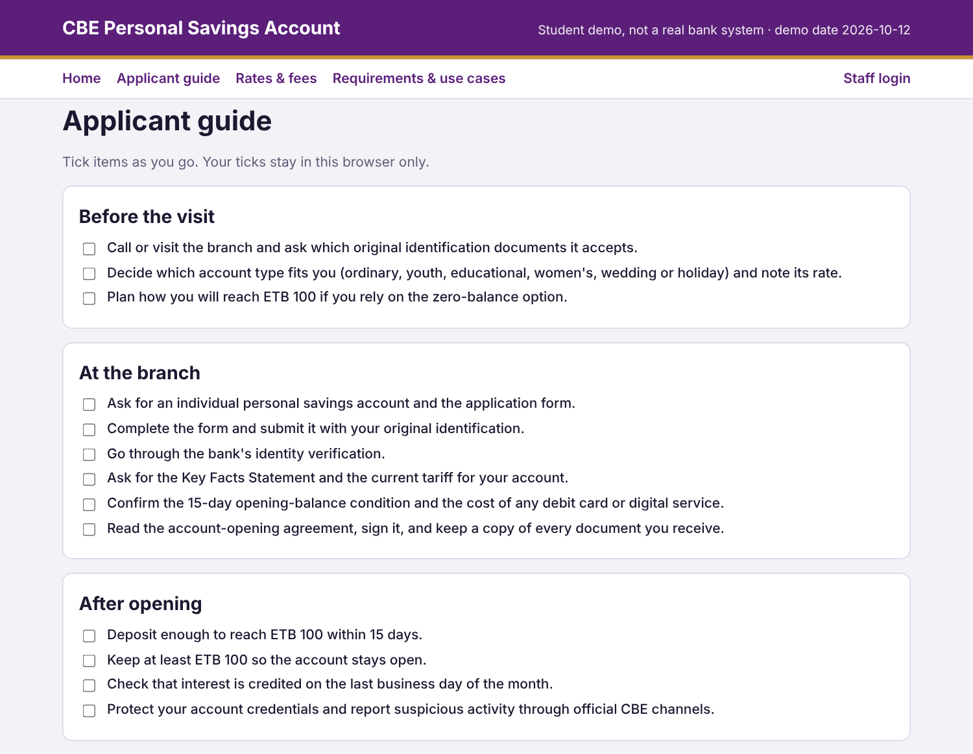
Figure 7: Applicant guide with checklist
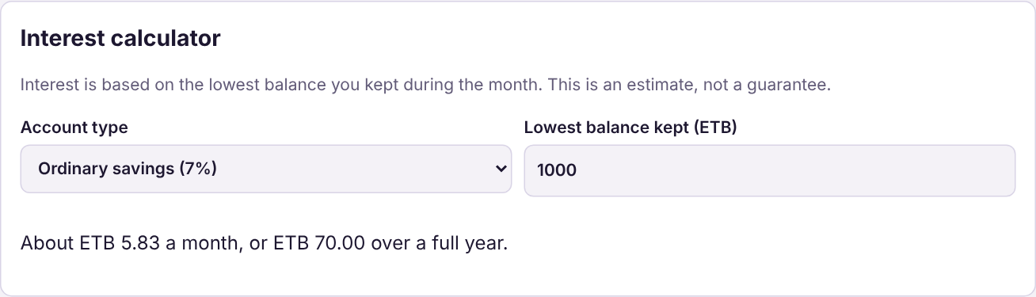
Figure 8: Interest calculator
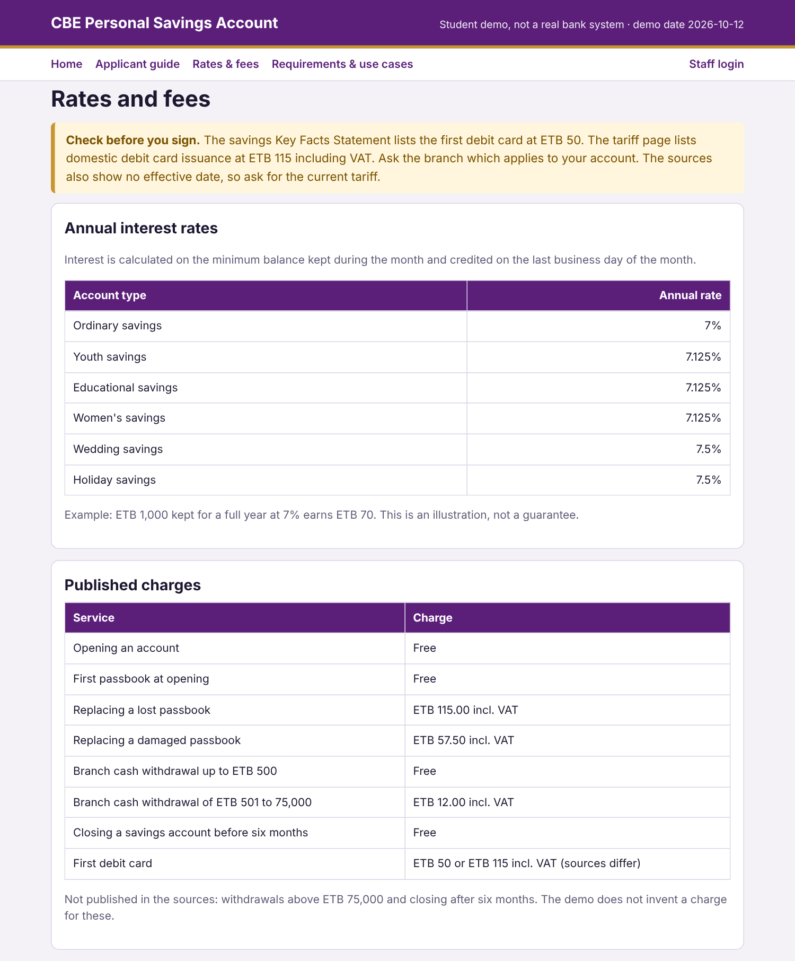
Figure 9: Rates and fees page with the fee discrepancy warning
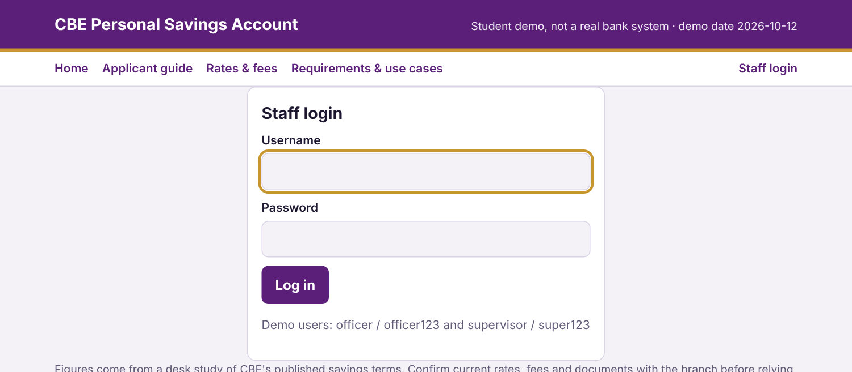
Figure 10: Staff login page
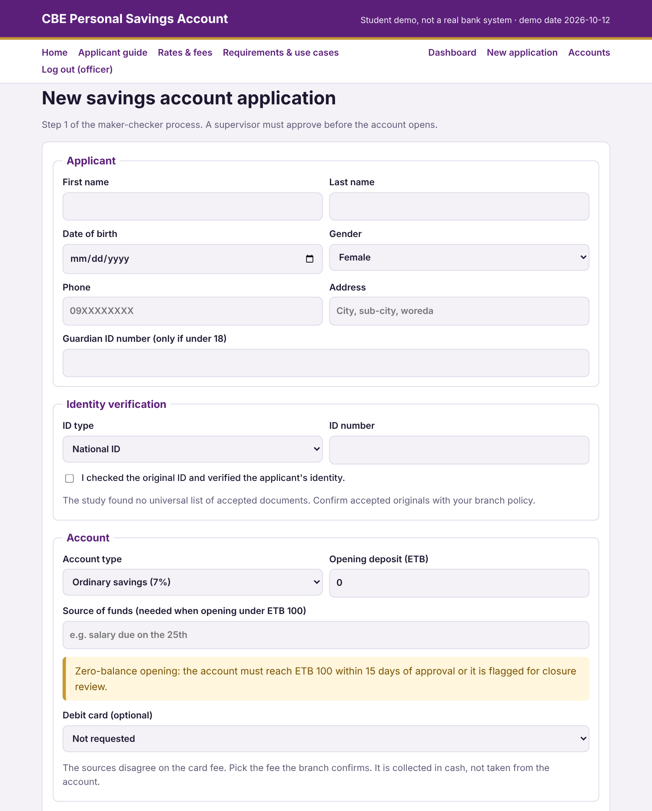
Figure 11: New application form (officer)
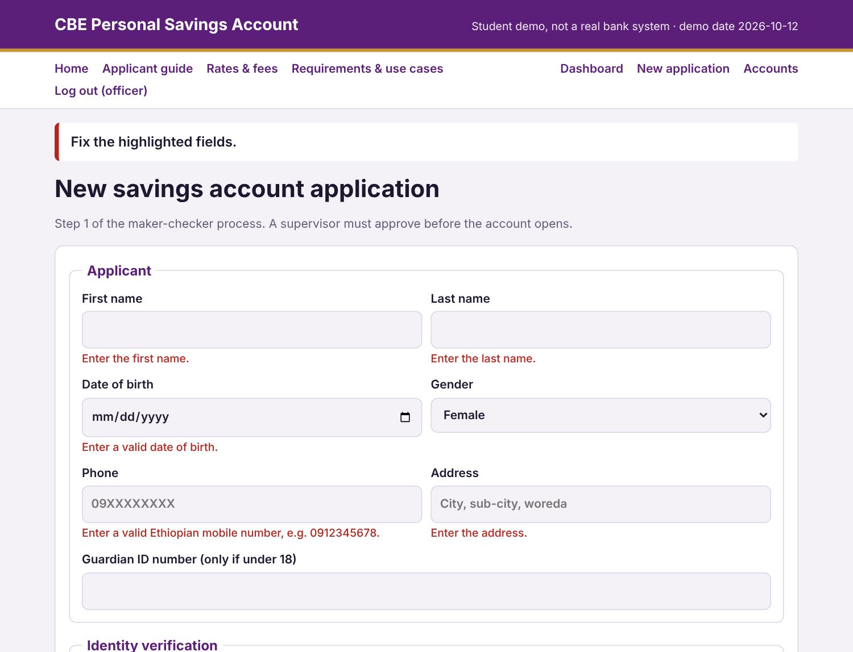
Figure 12: Failure case: an incomplete application is rejected with clear messages
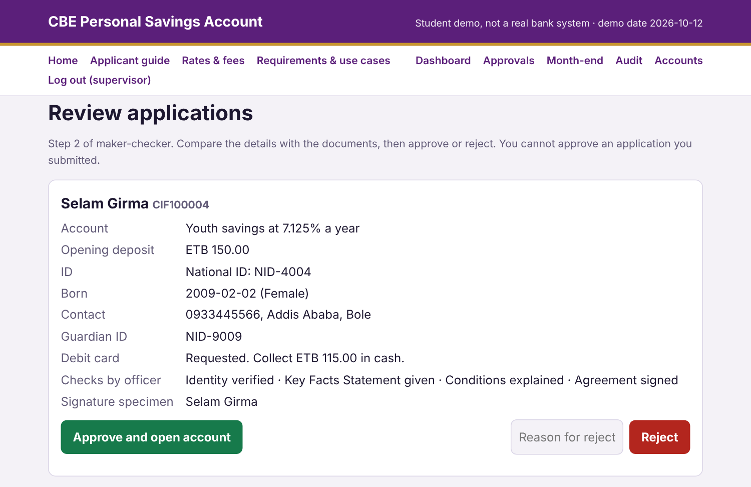
Figure 13: Supervisor approval screen
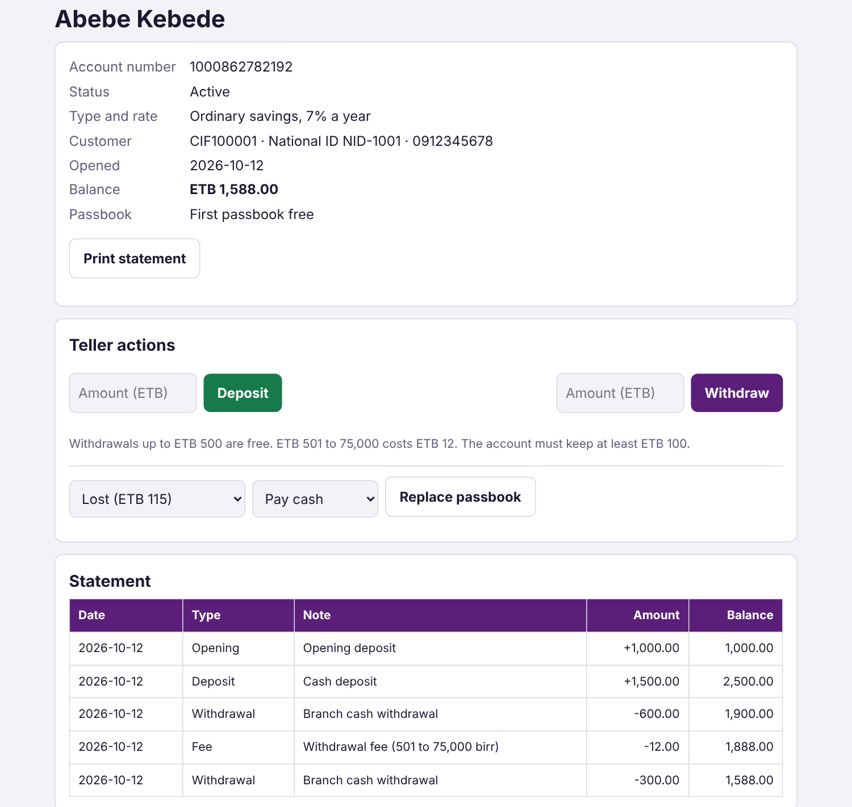
Figure 14: Account statement with deposit, withdrawal and the ETB 12 fee
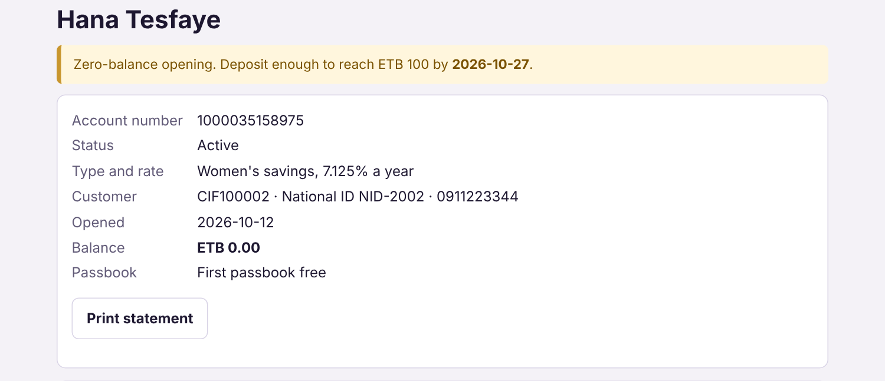
Figure 15: Zero-balance account awaiting funding
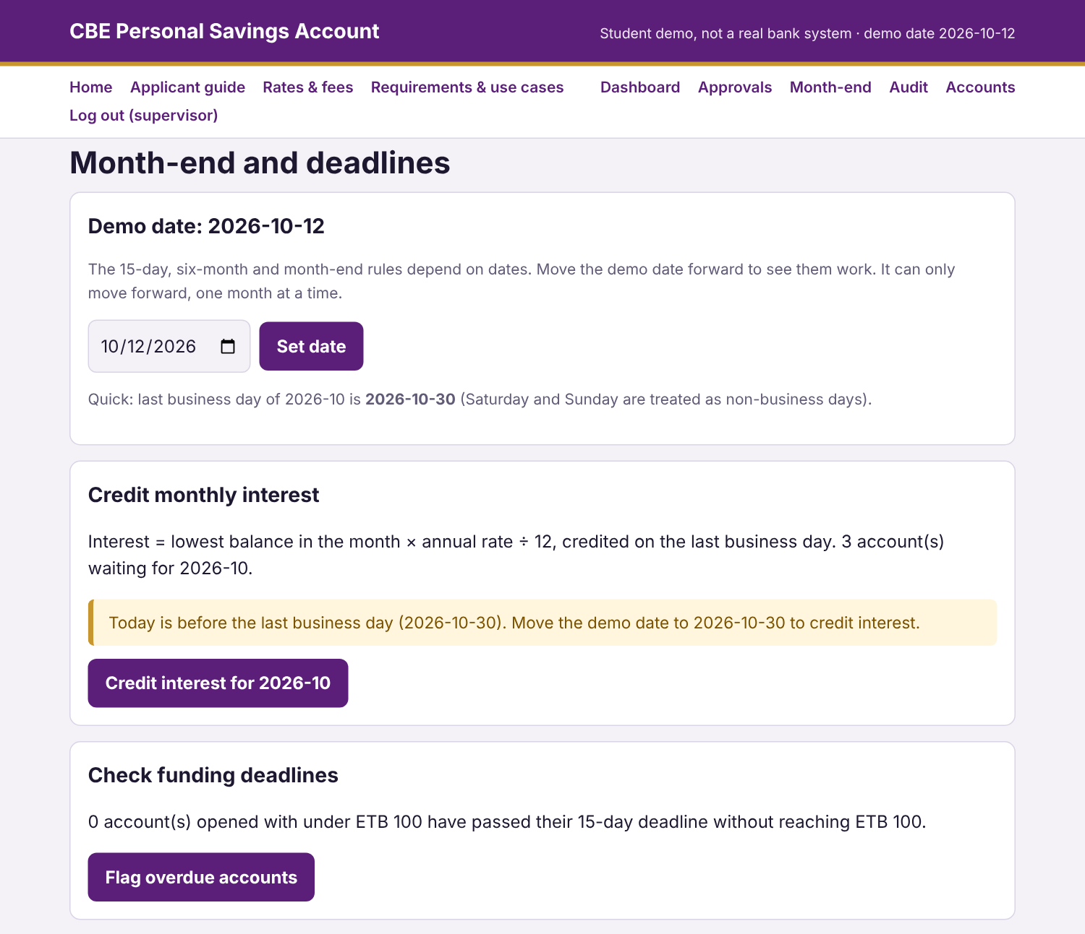
Figure 16: Month-end page: demo date, interest and deadline check

3.1.6 Testing Results
Forty-six automated tests were written for the business rules. They run against a throwaway database with a fixed starting date, so they do not touch real data. Table 11 groups the results. All tests passed.
Table 11: Automated test results
Area | Checks | Examples of what is verified
Application validation | 11 passed | Missing identity check or agreement, bad phone, name mismatch, under-18 without guardian, women's savings rule, negative deposit
Approval and maker-checker | 6 passed | Submitter cannot approve; reject needs a reason; account number and balance on approval; no double approval
Deposits and withdrawals | 7 passed | Fee tiers (free to 500, ETB 12 to 75,000, refused above); ETB 100 minimum; zero amounts refused
Passbook replacement | 2 passed | ETB 115 charged from the account; fee refused if it would break the minimum
Zero-balance and deadline | 4 passed | Deadline is approval date plus 15 days; deposit to ETB 100 marks Funded; no flag before the deadline
Dates and interest | 12 passed | Last business day; interest refused early; interest equals lowest balance × 7% ÷ 12; second run credits nothing; no skipping a month
Closing | 4 passed | Reason required; early closure free with payout; closed account refuses transactions; six-month rule
Total | 46 passed, 0 failed

A live walk-through was also done with the running site. All public pages loaded; a visitor who was not logged in was redirected to the login page; the officer could log in and submit an application; an incomplete form showed 12 error messages; the officer was refused access to the approval page (HTTP 403); a form sent without its security token was refused (HTTP 400); and the supervisor could see the pending application and approve it, which issued an account number and set the 15-day deadline.

3.2 Discussion
Answer to the research questions. The study answered what documents and conditions apply, what deposit and balance rules exist, which rates and charges are published, and what steps an applicant should follow. It also showed what cannot be answered from published sources: the accepted identity documents, the charge for large withdrawals and for late closing, and the effective date of the tariff. The website shows these gaps openly instead of filling them with guesses.
From findings to a working system. Every finding became a requirement and every requirement is implemented and tested. The two rules that most affect an applicant, the zero-balance condition and the ETB 100 minimum, are enforced in several places: the application form asks for a source of funds, approval sets a 15-day deadline, deposits clear it, a supervisor check flags missed deadlines, and withdrawals cannot take the balance below ETB 100.
Control and security. The maker-checker rule means no account opens without a second person's review, which is the control described for banking transaction processing in Information Systems courses. Passwords are hashed, forms carry anti-forgery tokens, database queries are prepared, output is escaped, roles limit what each user can do, and every action is written to the audit trail [7]. The demo date lets a reader see the 15-day, six-month and month-end rules work without waiting.
Assumptions. Where the study left a point open, the website makes a stated choice. Table 12 lists them. They should be confirmed with the branch before the website is relied on for anything other than teaching.
Table 12: Assumptions made in the website
No. | Assumption | Reason
A1 | The accepted ID list is not published, so four common types are offered. | Confirm with the branch.
A2 | Monthly interest = lowest balance in the month × annual rate ÷ 12. | The study gives the basis, not the monthly formula.
A3 | Saturday and Sunday are non-business days; public holidays are not modelled. | Simplification.
A4 | Applicants under 18 need a guardian ID. | The study states no age rules.
A5 | Women's savings is limited to female customers. | Implied by the product name.
A6 | The debit card fee is collected in cash and not deducted from the account. | The study does not settle which fee applies.
A7 | A zero-balance account that misses the deadline is flagged for closure review, not closed automatically. | The study does not state the consequence.
A8 | A movable "demo date" lets the 15-day, six-month and month-end rules be shown. | Teaching tool only.

Limitations. The website does not process real money, does not connect to CBE's core banking system, and does not model public holidays. The figures come from published documents that may change. The work reports published terms and a prototype, not how often customers meet problems in practice.

3.3 Recommendation

3.3.1 For the Hosting Organization
- Make identification requirements easy to find online and in branches.
- Keep the savings PDF and the tariff page consistent, for example on the debit card fee.
- Show the effective date on every tariff and Key Facts Statement.
- Publish the charge for withdrawals above ETB 75,000 and for closing an account after six months.
- Explain minimum-balance conditions and charges in plain language, and consider a public guide and calculator like the one built here.
- Test the digital account-opening services (CBE Docs) with real users and publish how they work.

3.3.2 For Haramaya University, College of Computing and Informatics, School of Information Systems
- Add practical training on banking and enterprise information systems, including core banking concepts and approval controls.
- Arrange orientation and agreements with host organizations before the attachment so that students receive meaningful, well-defined tasks.
- Encourage students to combine a case study with a working prototype, as this work did, and give a template for the report formatting rules.
- Strengthen supervision and follow-up of students during the attachment period.
For applicants, the study recommends: confirm accepted identification before the visit; request the current Key Facts Statement and tariff; ask whether the zero-balance condition applies to you; confirm the cost of any debit card or optional service; read the agreement and keep a copy of every document. For researchers, interview bank officers and customers to study real account-opening experience, waiting times and satisfaction.

CONCLUSION
This attachment studied how a personal savings account is opened at Commercial Bank of Ethiopia and turned the published terms into a working demonstration website. CBE publishes the main terms clearly: free opening, zero-balance opening under a 15-day condition, 7% on ordinary savings and mandatory identity verification. Fee figures differ between documents and some information is not published, so applicants must confirm them with the branch.
From the findings, 20 functional requirements and 11 use cases were derived and implemented in a PHP and SQLite website with role-based access, supervisor approval, transaction rules, monthly interest, deadline monitoring and an audit trail. All 46 automated tests and the live walk-through passed. The objectives of the attachment were therefore achieved, within the limits that the study used published documents only and that the website is a teaching prototype and not a bank system.
The experience strengthened my skills in requirements analysis, database and web development, testing and technical writing, and showed how information systems enforce rules and controls in banking. Future work includes checking the figures at the branch, usability tests with staff and customers, an Amharic interface, public hosting and a study of the digital account-opening services.

REFERENCES
[1] Commercial Bank of Ethiopia, "About us." [Online]. Available: [URL]. [Accessed: [date]].
[2] Commercial Bank of Ethiopia, "Key Facts Statement for Saving Accounts," n.d. [Online]. Available: [URL]. [Accessed: [date]].
[3] Commercial Bank of Ethiopia, "Terms and Tariffs," n.d. [Online]. Available: [URL]. [Accessed: [date]].
[4] Commercial Bank of Ethiopia, "CBE Docs: Account Opening and Digital Banking Documents," n.d. [Online]. Available: [URL]. [Accessed: [date]].
[5] National Bank of Ethiopia, "Financial Consumer Protection," n.d. [Online]. Available: [URL]. [Accessed: [date]].
[6] I. Sommerville, Software Engineering, 10th ed. Harlow, U.K.: Pearson, 2016.
[7] OWASP Foundation, "OWASP Top Ten." [Online]. Available: https://owasp.org/www-project-top-ten/. [Accessed: [date]].
[8] The PHP Group, "PHP Manual." [Online]. Available: https://www.php.net/manual/. [Accessed: [date]].
Verify every URL, access date and the effective date of each CBE document before submitting.

APPENDIX A: USE CASE DESCRIPTIONS AND FAILURE CASES
Table 13 gives the normal steps and the failure cases that the website handles for each use case.
Table 13: Use case descriptions and failure cases
Use case | Normal steps | Failure and alternative cases
UC-01 Prepare for a branch visit (Applicant) | Open the guide. Tick the before, at-branch and after items. Use the calculator. | Browser storage unavailable: the checklist still works but is not remembered. Balance below 0 in the calculator shows an error.
UC-02 Apply for a savings account (Officer) | Enter applicant, ID, account type and deposit. Confirm ID check, KFS, conditions and agreement. Submit. Status becomes Pending. | Invalid or missing field: highlighted, nothing saved. Same ID under another name: rejected. Same customer already has that account type pending or active: rejected. Women's savings for a male customer: rejected. Under 18 without guardian ID: rejected. Deposit under ETB 100 without a source of funds: rejected. Any confirmation unticked: rejected.
UC-03 Approve or reject (Supervisor) | Open Approvals. Compare details with the officer's checks. Approve: account number issued, opening posted, free passbook. Or reject with a reason. | Supervisor is the submitter: blocked. Already decided: blocked. Reject without a reason: blocked. Zero-balance opening: a 15-day deadline is set.
UC-04 Deposit (Officer) | Open the account, enter the amount, deposit. Balance and statement update. | Amount zero or negative: rejected. Account pending, closed or rejected: rejected. Deposit that lifts the balance to ETB 100: marked Funded.
UC-05 Withdraw (Officer) | Open the account, enter the amount. The fee is applied by amount and the withdrawal posts. | Balance after amount and fee below ETB 100: refused. Above ETB 75,000: refused. Zero or negative: refused.
UC-06 Fund a zero-balance account | Account opens under ETB 100. Officer deposits until the balance reaches ETB 100. Status becomes Funded. | Deadline passes first: the supervisor runs the deadline check and the account is flagged Overdue for closure review.
UC-07 Credit monthly interest (Supervisor) | Move the demo date to the last business day. Run the credit. Each active account gets interest on its lowest balance of the month. | Run before the last business day: refused. Run twice: second run credits nothing. Moving to the next month before running interest: blocked. Lowest balance zero: no interest.
UC-08 Replace a passbook (Officer) | Open the account, choose lost or damaged and how the fee is paid. Passbook issued. | Paying from the account would go below ETB 100: refused, collect cash instead.
UC-09 Close an account (Supervisor) | Enter a reason and confirm. Balance is paid out and the account becomes Closed. | No reason: refused. Not active: refused. Older than six months: no charge is published, none is applied and the screen says so.
UC-10 Check fees and rates | Open Rates and fees. Read the discrepancy notice on the debit card fee. | Not published in the study: withdrawals above ETB 75,000 and closing after six months. The site says so instead of inventing a number.
UC-11 Review the audit trail (Supervisor) | Open Audit. See who did what and when. | Staff without the supervisor role are denied.

