Western Pacific University
CMN224/CMP224 Software Engineering
Task 4 Assembly Checklis
Name: Justin Albert
ID: 00110
Task 4 Assembly: Kina Ridge Primary School Fee-Tracking System
1. System Components Portfolio
Diagram 1: Package Diagram (Lab 4, Week 5)

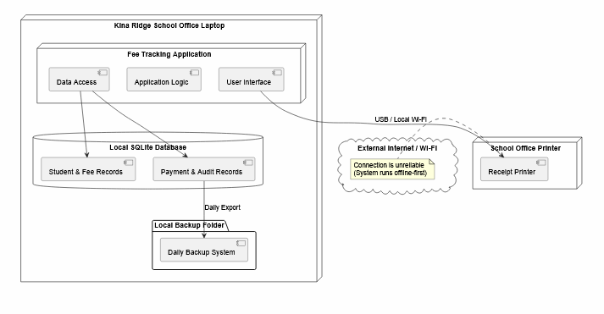

What it shows: This diagram models the logical layer structure of the application running locally inside the school's laptop. It clearly isolates the User Interface, Application Logic, and Data Access subsystems, demonstrating their strict downward dependency paths toward the Local SQLite Database and its automated Daily Backup System.

Design decision recorded: It formalizes a strict Layered Architecture. By decoupling the financial Application Logic from the User Interface, the core balance calculation engines remain completely independent and easy to test without relying on screen layout changes.

Diagram 2: Deployment Diagram (Lab 4, Week 5)
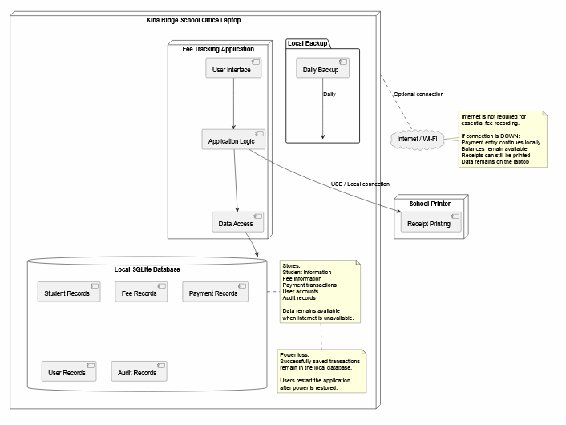
What it shows: This diagram displays the physical hardware architecture topology of the school environment, detailing the Kina Ridge School Office Laptop, a hardwired School Office Printer connected via USB, and an optional, unstable network boundary node pointing to the Internet / Wi-Fi cloud.

Design decision recorded: It enforces an Offline-First Architectural Pattern. The system stores all active records inside a local instance of SQLite inside the physical laptop boundary so operations never lock up when network connectivity drops.

Diagram 3: Use Case Diagram (Lab 6, Week 9)
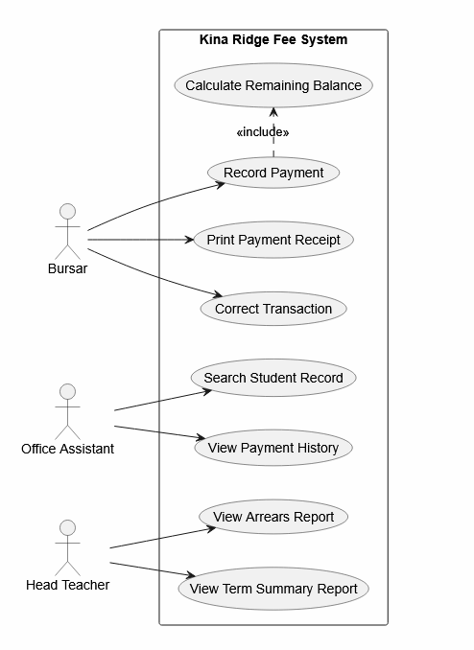

What it shows: This behavioral diagram maps system scope boundaries against roles including the Bursar, Office Assistant, and Head Teacher. It highlights core behavioral requirements such as recording payments, tracking balances, searching student files, and pulling compliance or arrears updates.

Design decision recorded: The diagram explicitly links the core function Record Payment to an automatic inclusion step: «include» Calculate Remaining Balance. This ensures no user can ever log a transaction without the system immediately updating the student's true ledger state.

Diagram 4: Class Diagram (Lab 6, Week 9)

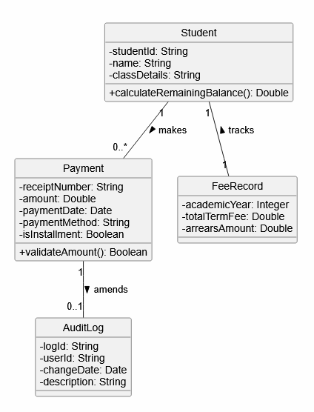

What it shows: This structural diagram shows the static data relationships between Student, Payment, FeeRecord, and AuditLog domain elements. It details exact attribute properties like studentId, receiptNumber, and isInstallment alongside their explicit association multi-directional multiplicities.

Design decision recorded: It captures a structural ledger rule where a single Payment record can selectively update (0..1) an AuditLog mapping block via the amends structural path, protecting system integrity if historical bookkeeping corrections occur.

Diagram 5: State Diagram (Lab 6, Week 9)
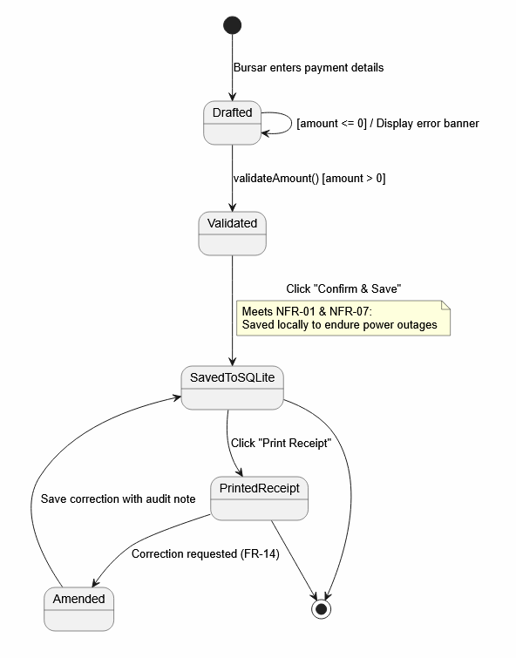

What it shows: This lifecycle diagram traces a payment transaction through its sequential valid operational conditions: from an initial Drafted status, moving to Validated via validateAmount(), transitioning into SavedToSQLite via a Confirm & Save click, and moving to PrintedReceipt or an Amended correction log.
Design decision recorded: It implements strict transaction protection. It blocks zero or negative entries right at the start using an [amount <= 0] loop guard on the Drafted state, while using a note anchor to explicitly mark where data is safe locally from power outages.

Diagram 6: Activity Diagram (Lab 6, Week 9)
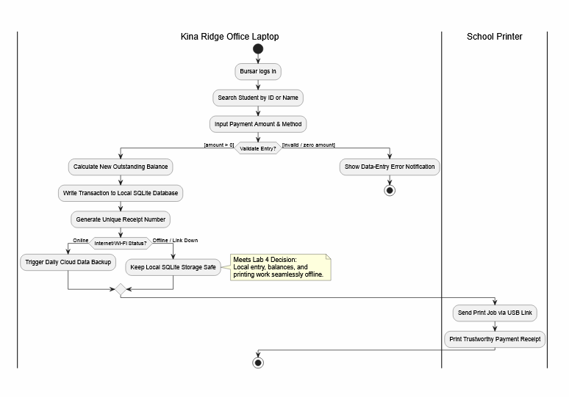

What it shows: This workflow diagram maps the step-by-step processing of a fee transaction across two physical swimlanes: the Kina Ridge Office Laptop and the School Printer. It details searching, logging, local database writing, and physical receipt printing.

Design decision recorded: It establishes infrastructure resilience through an explicit Internet/Wi-Fi Status? decision diamond. If the status is Offline / Link Down, it routes seamlessly to Keep Local SQLite Storage Safe, bypassing cloud dependencies entirely.

2. Design Pattern Application Analysis

Pattern Chosen: Hybrid Architectural Blend — Offline-First Framework combined with a Three-Tiered Layered Architecture.

Pattern Location: Implemented directly across the software boundary layers inside the Kina Ridge School Office Laptop. The separation cuts vertically from the User Interface down to the Data Access component, using a local SQLite Database engine wrapper.

Justification (What it buys you): Kina Ridge Primary School deals with recurring weekly power blackouts and highly spotty Wi-Fi networks. This hybrid pattern provides immense resilience:

1. Separation of Concerns: Developers can modify user interface screens without risking breaks in core accounting logic.

2. Zero Downtime Operational Continuity: Because the data access layer points locally to an internal database engine rather than a remote cloud host, the Bursar can continually log student payments and print physical receipts via USB even if the school has no internet access. Data remains safe, stored locally, and ready for backup.

2. Consitency checks

No | Check | Fixed?
1 | Every use case traces to a user requirement in my SRS | Yes
2 | Every class attribute appears somewhere in my requirements | Yes
3 | At least one multiplicity encodes a real business rule | Yes
4 | At least one state transition carries a guard from a business rule | Yes
5 | My activity diagram has a branch for the offline / no-power case | Yes
6 | The swimlanes match the devices in my deployment diagram | Yes
7 | Every class is placed on some machine in the deployment view | Yes
8 | No package has an upward dependency arrow | Yes
9 | One scenario traces cleanly through all five views | Yes
10 | The design pattern is named, located and justified | Yes

3. AI-Use Declaration
- Tool Used: AI Assistant.
- How I used it: I used AI to help me review my old diagrams from Lab 4 and Lab 6. The AI helped me check that all my diagrams match each other and helped me write out the neat descriptions and tables for this report. All the diagrams and project ideas are my own original work from my labs.

