WESTERN PACIFIC UNIVERSITY
CMN224 / CMP224 Software Engineering — Week 5

Lab 4: Architecture & UML for Your Client
Formative (ungraded) · Moodle-enabled · output is the first half of Task 4 (15%, due Week 11)
Item | Details
Linked to | Week 5 lecture — Designing Software Architecture with UML (ULO2, ULO4)
Work mode | Individually, on the SAME client you chose for Task 2
Time | About 90 minutes
Tools | diagrams.net desktop OR PlantUML — both free, both work offline, both cached on Moodle
Submission | Diagrams + this worksheet to Moodle AND committed to week05/ in your Git portfolio
Do this properly and Task 4 gets much easier. Task 4 (Design & Modelling Deliverable, due Week 11) asks for an outline architecture plus UML models. The two diagrams you produce today are exactly that architecture section. Weeks 9–10 add the behavioural diagrams.

Part A — Answer the six design questions (25 min)
Answer for YOUR client (Kina Ridge Primary School or Waghi Valley Produce Cooperative). One or two sentences each — but each answer must be a decision, not a description.
# | Question | Your decision, and the requirement that forced it
1 | What are the major parts of the system? | The system will consist of five main components: User Interface, Application Logic, Data Access, Local Database, and Backup/Audit features. This framework is necessary since the system needs to manage payment documentation, balance computation, user permissions, audit logs, and dependable local storage.
2 | How do the parts communicate? | The User Interface will interact with the Application Logic, which will verify transactions and utilize the Data Access layer to access and update the local database. This division minimizes mistakes and maintains financial processing distinct from the displays.
3 | Where does the data live? | The primary student, fee, and payment information will be kept in a local SQLite database on the office laptop of the school, along with routine backups to distinct storage. Local storage is necessary as Wi-Fi is not reliable, and critical payment processing must persist during brief internet disruptions.
4 | Where does each part physically run? | The User Interface, Application Logic, Data Access, and SQLite database will first operate on the current office laptop of the school, and the printer will be utilized to generate physical receipts. This eliminates the need for the school to buy a dedicated server.
5 | How is access controlled, and where is that enforced? | Users are required to log in to access financial records, and the Application Logic will impose role-based permissions for activities including recording, correcting, and viewing financial transactions. This is necessary as financial data should only be available to authorized personnel.
6 | What happens when it fails — power loss, no signal, duplicate sync? | Transactions that are saved successfully will persist in the local database following a power outage, and the system will keep recording essential entries without needing internet connectivity. The initial version utilizes a local database instead of automatic cloud syncing, thus preventing duplicate-sync issues; daily backups ensure recovery in case the laptop malfunctions.

Part B — Choose an architectural pattern (10 min)
Pattern chosen (or blend): Offline-first + Layered Architecture
In 100–150 words: why this pattern for THIS client? Name one pattern you rejected and the specific requirement that ruled it out.
The Fee-Tracking System for Kina Ridge Primary School will implement an offline-first approach along with a layered architectural design. This is appropriate since the school faces weekly power interruptions and reliable Wi-Fi access is not assured. The system will consequently save key student, fee, and payment details in a local database on the current office laptop. Employees will have the capability to log payments and verify balances without relying on constant internet connectivity. The tiered architecture will distinguish the user interface, application logic, and data access, facilitating easier system maintenance and testing. Regular backups will minimize the risk of data loss if the laptop malfunctions. A conventional client-server model featuring a single central online database was dismissed due to the lack of dependable continuous network access at the school. The offline-first strategy aligns more effectively with the school's real operating conditions.

Warning: if you chose client–server with one central database, check it against your Part A question 6 answer. At a site with no reliable connectivity that choice fails on day one.

Part C — Draw the package diagram (25 min)
Show your system as 3–5 logical packages with dependency arrows. Rules: arrows point downward only; every package has one clear responsibility; no package is called “Miscellaneous”.

PlantUML version
@startuml
node "Kina Ridge School Office Laptop" {
node "Fee Tracking Application" {
[User Interface]
[Application Logic]
[Data Access]
}

database "Local SQLite Database" {
[Student & Fee Records]
[Payment & Audit Records]
}

folder "Local Backup Folder" {
[Daily Backup System]
}
}

node "School Office Printer" {
[Receipt Printer]
}

cloud "External Internet / Wi-Fi" as internet {
note right: Connection is unreliable\n(System runs offline-first)
}

' Visual Layout & Physical Connections
[Data Access] --> [Student & Fee Records]
[Data Access] --> [Payment & Audit Records]
[Payment & Audit Records] --> [Daily Backup System] : Daily Export

[User Interface] --> [Receipt Printer] : USB / Local Wi-Fi
"Fee Tracking Application" -[hidden]- internet : Intermittent Sync Only
@enduml

PlantUML version Diagram 1
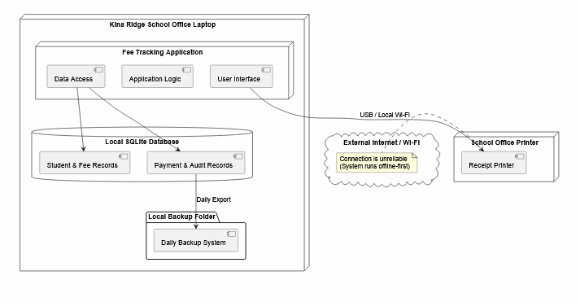

Part D — Draw the deployment diagram (25 min)
Show every device your system runs on, what is installed on each, and the link between them. This is the diagram that exposes PNG delivery risk, so be honest about the network.
Must appear on your diagram | Check
Every physical device (laptop, phone, office PC, printer) | Yes. Included as node "Kina Ridge School Office Laptop", node "School Printer", and cloud "Internet / Wi-Fi".
What software component sits on each device | Yes. Nested the node "Fee Tracking Application" components (UI, Logic, Data Access) inside the main laptop node.
Where the data is stored on each device | Yes. Included database "Local SQLite Database" and folder "Local Backup" inside the physical laptop boundary.
The link between devices, labelled with how and how  often it is available | Yes. Printer link is explicitly labeled USB / Local connection. Internet link is a dotted line labeled Optional connection.
A note on what still works while that link is DOWN | Yes. Added a note right of Internet block confirming that local entry, balances, and receipt printing all work seamlessly offline.

PlantUML deployment starter

@startuml

node "Kina Ridge School Office Laptop" {

node "Fee Tracking Application" {
[User Interface]
[Application Logic]
[Data Access]
}

database "Local SQLite Database" as DB {
[Student Records]
[Fee Records]
[Payment Records]
[User Records]
[Audit Records]
}

folder "Local Backup" as Backup {
[Daily Backup]
}

[User Interface] --> [Application Logic]
[Application Logic] --> [Data Access]
[Data Access] --> DB

[Daily Backup] --> Backup : Daily

note right of DB
Stores:
Student information
Fee information
Payment transactions
User accounts
Audit records

Data remains available
when Internet is unavailable.
end note

note bottom
Power loss:
Successfully saved transactions
remain in the local database.

Users restart the application
after power is restored.
end note
}

node "School Printer" {
[Receipt Printing]
}

cloud "Internet / Wi-Fi" as Internet

[Application Logic] --> [Receipt Printing] : USB / Local connection

"Kina Ridge School Office Laptop" .. Internet : Optional connection

note right of Internet
Internet is not required for
essential fee recording.

If connection is DOWN:
Payment entry continues locally
Balances remain available
Receipts can still be printed
Data remains on the laptop
end note
@enduml

PlantUML version Diagram 2

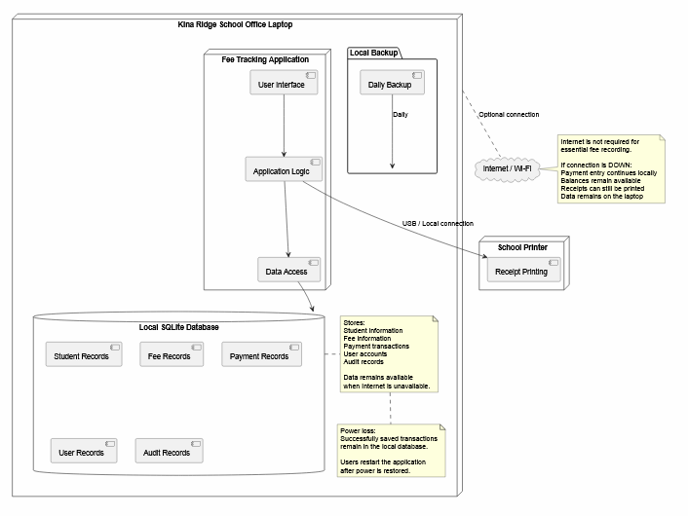

Part E — Commit (5 min)
- Put both diagram files and this worksheet into week05/ in your portfolio.
- Commit with a message that says what you decided, not just what you added:
git add week05/ git commit -m "Add offline-first architecture: package and deployment diagrams"
AI use: you may use AI to draft PlantUML text. You must then check it against your own Part A answers — generated architectures default to cloud client–server and routinely ignore power loss and duplicate sync. Declare AI use in your README.

