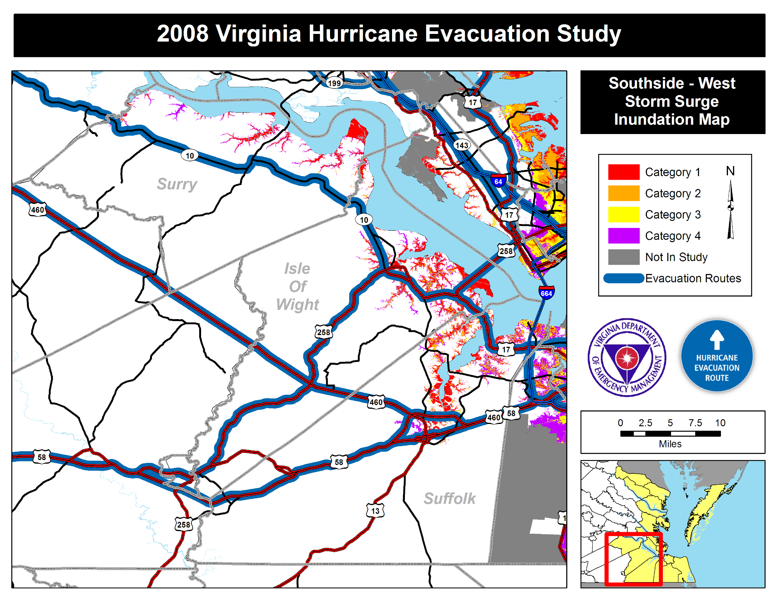
008 Vir inia Hurricane Evacuation tud
_ Category 1 N _ Category 2 _ Category 3 _ Category 4 _ Not In Study
_Evacuation Routes

