SPRING GROVE |  |  |  |  |  |  |  |  |  | GRAFTON
SAVEDGE |  |  | SURRY ALLIANCE |  |  |  | FORT EUSTIS |  | ORIANA |  | TABB | POQUOSON |  | MESSICK
SAVEDGE |  |  |  |  | BACONS CASTLE |  |  |  | DENBIGH |  | TABB |  |  | MESSICK
GWALTNEY CORNER |  |  |  |  |  |  |  |  | OYSTER POINT |  |  |  | LANGLEY AFB
CARSLEY |  |  | BEACHLAND |  | POOLESVILLE |  |  |  | MENCHVILLE
 | ELBERON |  | BEACHLAND |  |  | RUSHMERE |  |  | NEWPORT NEWS |  |  |  | LANGLEY VIEW
 |  |  |  |  |  |  |  |  | BEACONSDALE
 |  |  | DELK CROSSROADS |  |  |  | MOGARTS BEACH |  |  |  | NORTHAMPTON
 | DENDRON RUNNYMEDE |  |  |  | MOONLIGHT |  |  |  |  | HILTON VILLAGE
 | ELLIS FORK |  | PONS |  |  |  | LAWSON | RESCUE |  |  | 60 |  | RALEIGH TERRACE
 | ELLIS FORK |  |  |  | COMET |  | SMITHFIELD
BOOTH FORK |  |  |  |  | COMET |  | SMITHFIELD
WAKEFIELD |  |  | _{RAYNOR} BETHEL CHURCH |  |  |  | CARROLLTON
 |  |  |  |  |  |  | BENNS CHURCH |  |  |  |  |  | 664
 | IVOR |  |  |  | CENTRAL HILL |  |  |  | CRITTENDEN |  |  |  | 664
MANRY | IVOR |  |  | WHITLEY |  |  | LONGVIEW |  | HOBSON |  | HUNTERSVILLE
MANRY |  |  | ZUNI |  |  |  | WILLS CORNER
DORY BERLIN |  |  | ZUNI |  |  |  | CHUCKATUCK |  |  | DEANES |  |  | CHURCHLAND
VICKSVILLE |  |  |  |  | WINDSOR ^{INDIKA} |  |  |  | DRIVER |  | WESTERN BRANCH
VICKSVILLE |  |  |  |  |  |  |  |  | WILROY |  | BOWERS HILL |  |  | 264
SEDLEY | BURDETTE | WALTERS |  |  |  |  | KINGS FORK |  | WILROY |  |  |  |  | 64
 |  |  | COLLOSSE |  | BOAZ |  |  |  | MAGNOLIA |  |  |  | DEEP CREEK
 |  |  | CARRSVILLE |  |  |  | KILBY DOWNTOWN SUFFOLK
STORY HUNTERDALE |  |  | CARRSVILLE |  |  | LUMMIS |  |  |  |  |  |  |  | 17
 |  |  | _{ELWOOD} HOLLAND |  |  | LUMMIS | SUFFOLK AIRPORT |  |  |  |  |  |  | 17
 | FRANKLIN |  |  |  |  |  |  |  |  |  |  |  |  | 17
 |  |  |  |  |  |  | 13
HANDSOM |  |  |  |  |  |  | NURNEY SAUNDERS
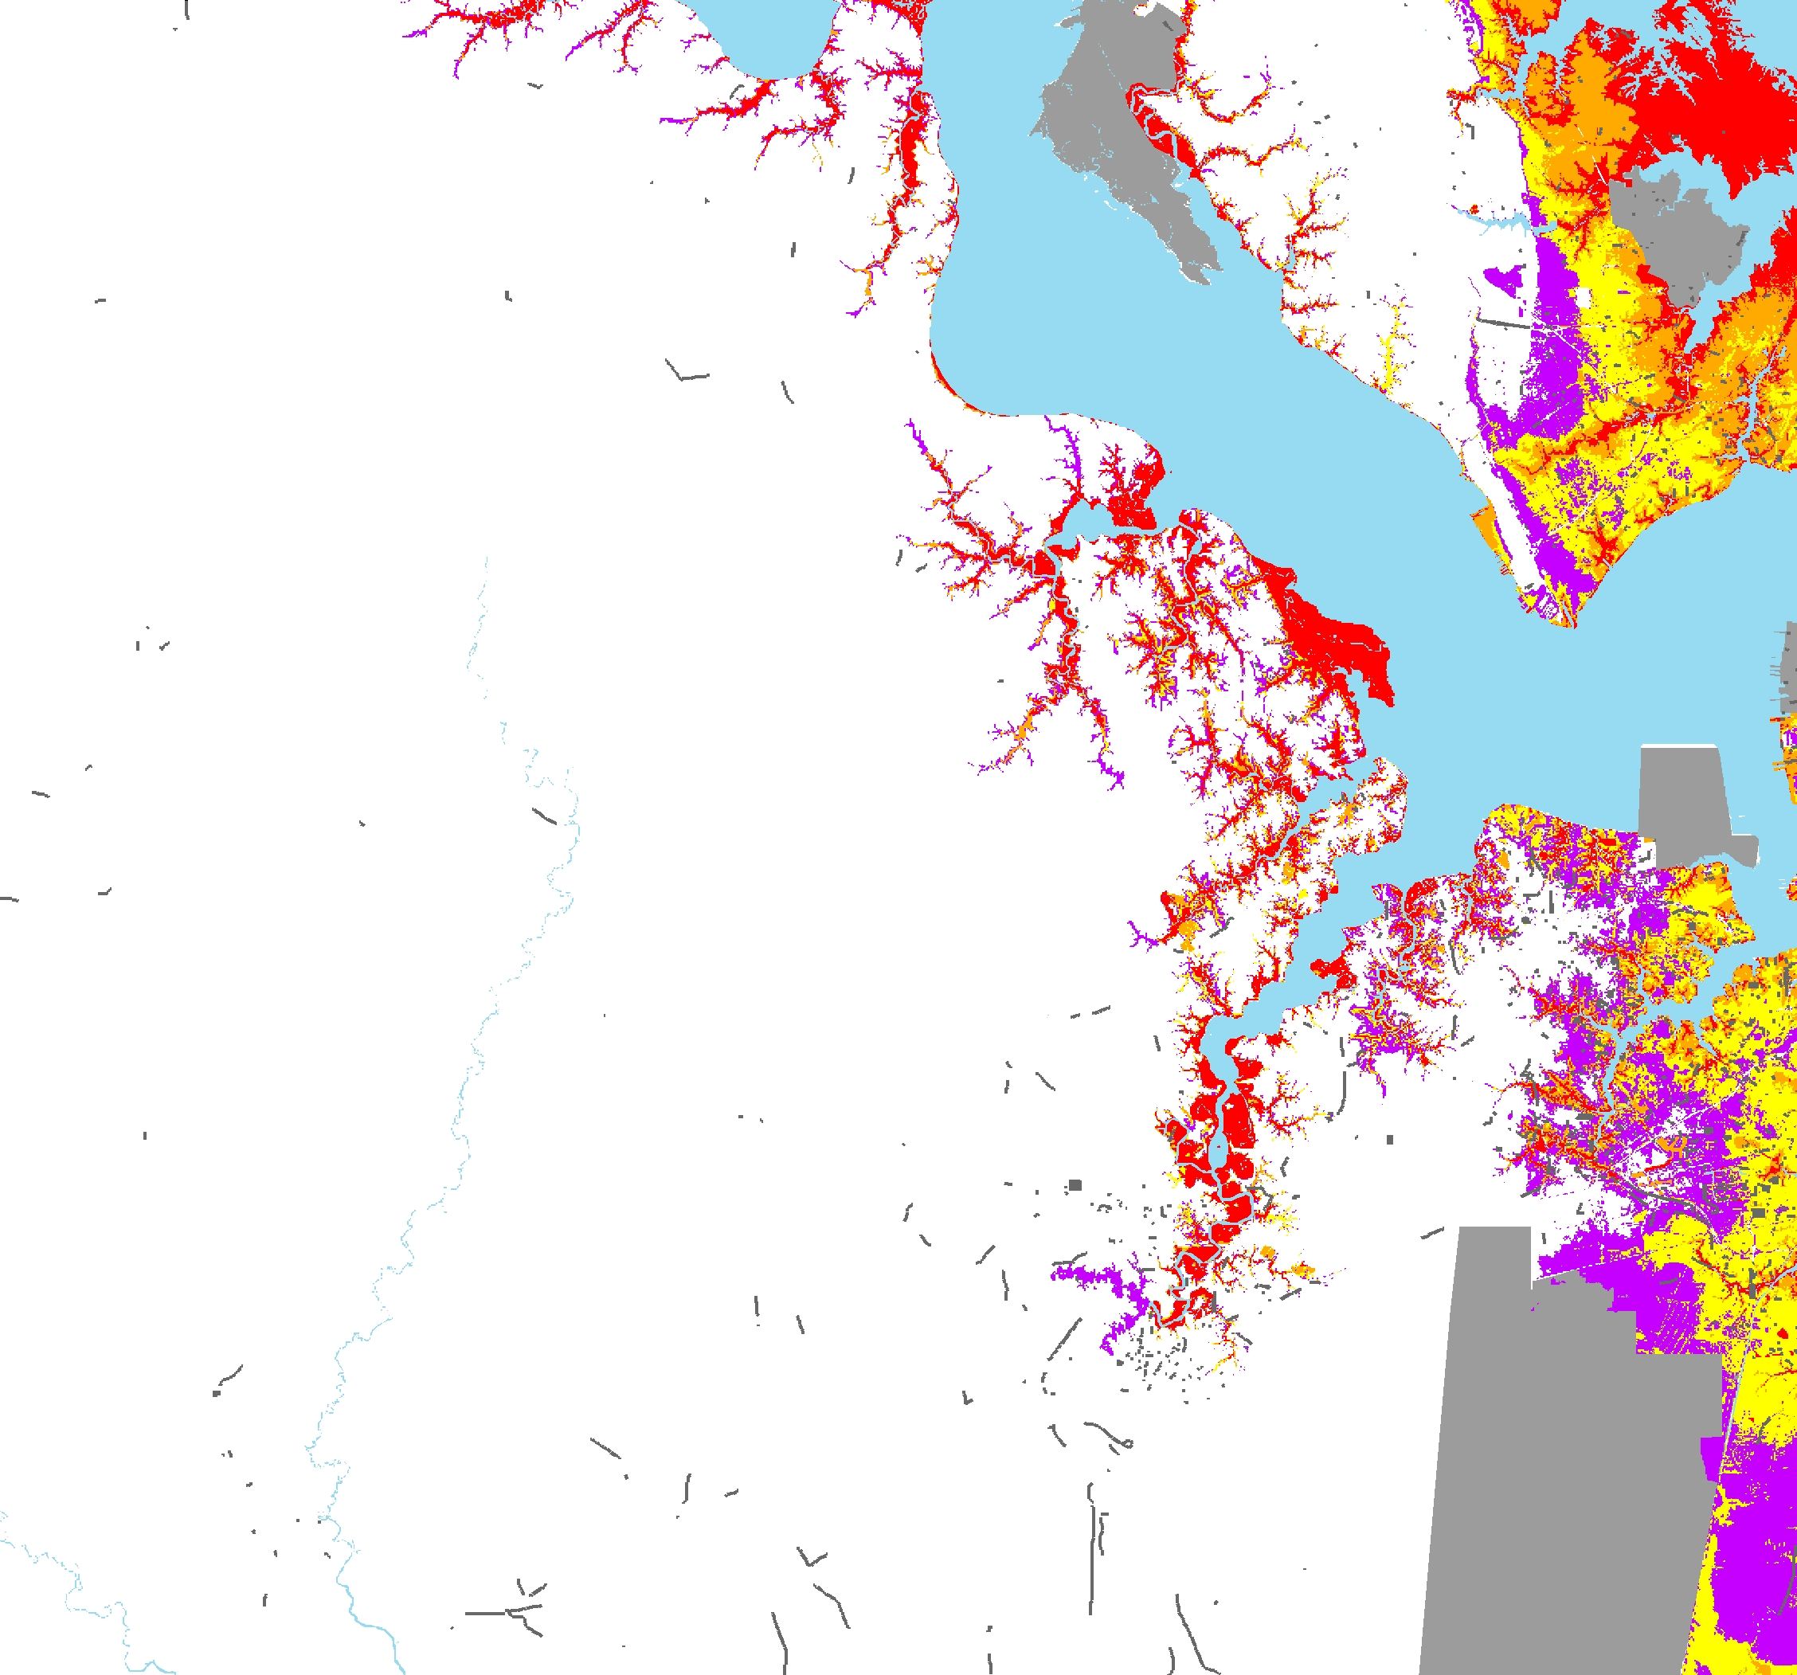

Storm Surge Inundation

Area Not Included

Category 1

Category 2

Category 3

Category 4

Interstates

Primary Routes

Addressed Roads

Jurisdiction Boundaries


0 | 1 | 2 | 3 | 4 | 5 | 6 | 7 | 8 | 9 10 11
 |  |  |  |  | Miles

