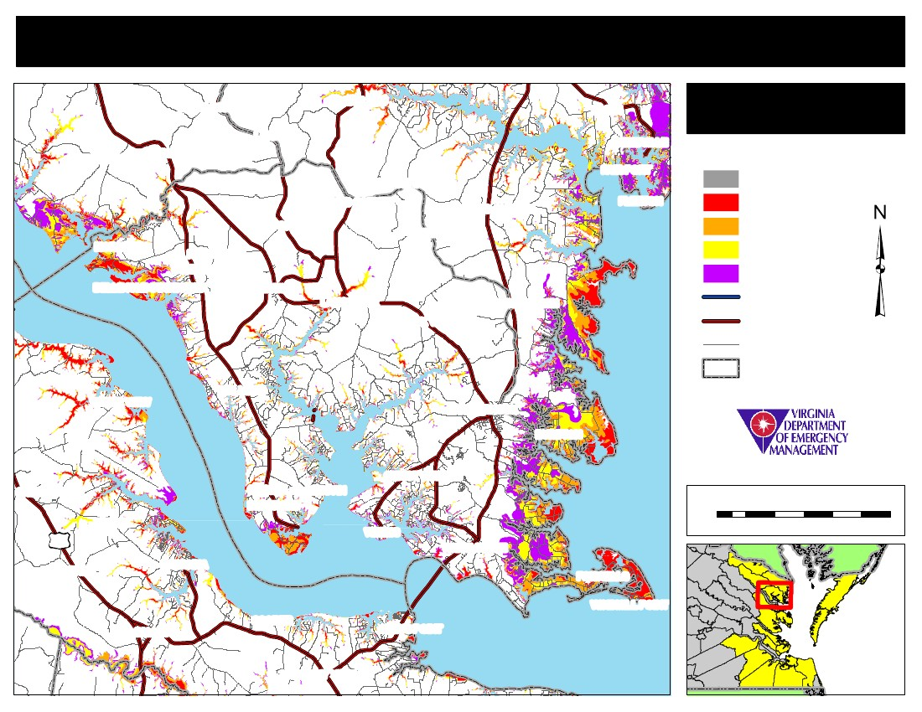
Commonwealth of Virginia Storm Surge Inundation Maps
MOON CORNER
LARA
HOWLAND
LILIAN
REEDVILLE
BROWNS STORE
BEANES CORNER
ALFONSO
MORATTICO
NUTTSVILLE
LIVELY
WICOMICO CHURCH
REGINA
FAIR PORT
FLEETON
Lancaster
Storm Surge Inundation
Area Not Included
Category 1
Category 2
Category 3
Category 4
DOWNING
ROBLEY
SOMERS
BELLE ISLE STATE PARK
LANCASTER
BROOK VALE
REHOBOTH CHURCH
Interstates
Primary Routes
Addressed Roads
NESTING
WATER VIEW
MOLLUSK
KILMARNOCK
BYRDTON
CHRIST CHURCH
Jurisdiction Boundaries
SAMOS
CHURCH VIEW
REMLIK
17
WARNER
URBANNA
SENORA SLABTOWN
BERTRAND
0
WEEMS
WHITE STONE
FOXWELLS
WINDMILL POINT
GREYS POINT
1
2
3
Miles
4
5
6
SALUDA
COOPER
HEALYS
HARMONY VILLAGE

