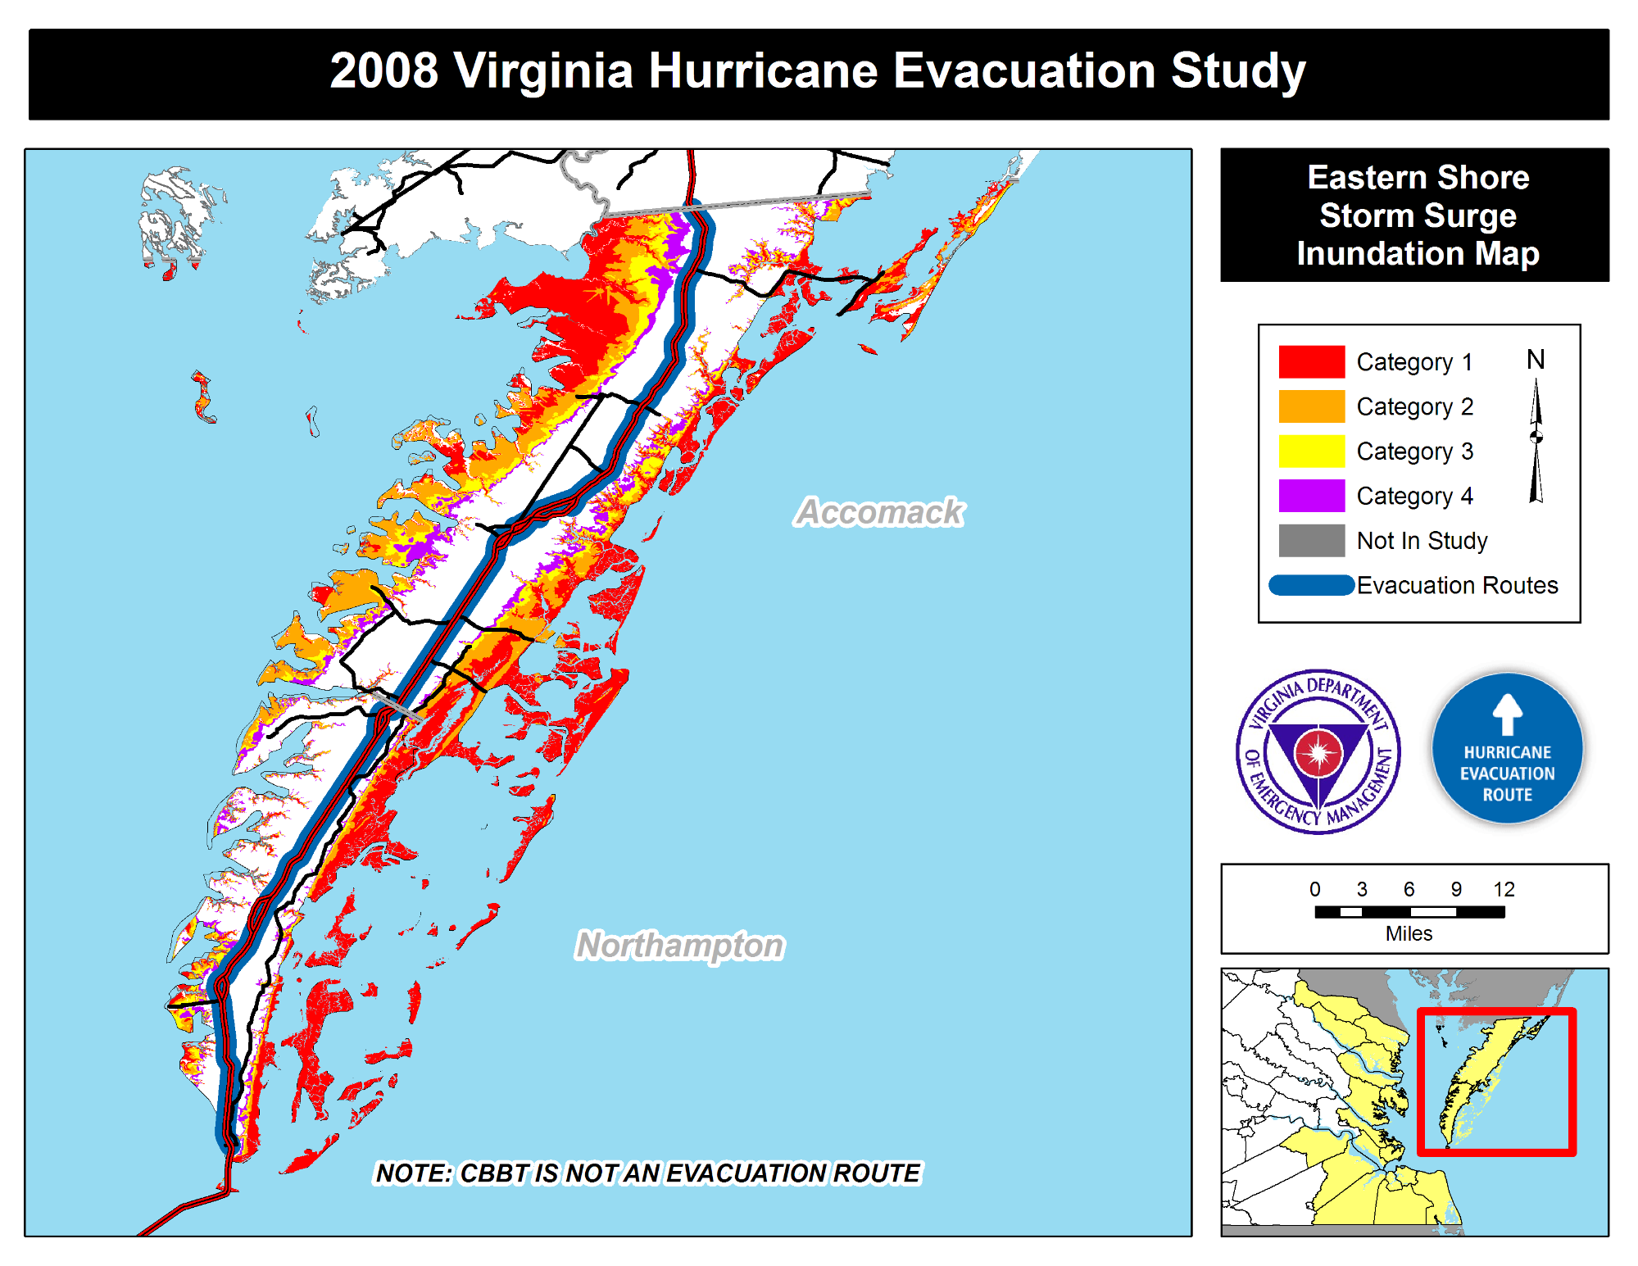
_Evacuation Routes
_ Category 1 _ Category 2 _ Category 3 _ Category 4 _ Not In Study
nunatlon 'a
HUIIIIIVI
EDI
. Hurricane Evacuation tud j

