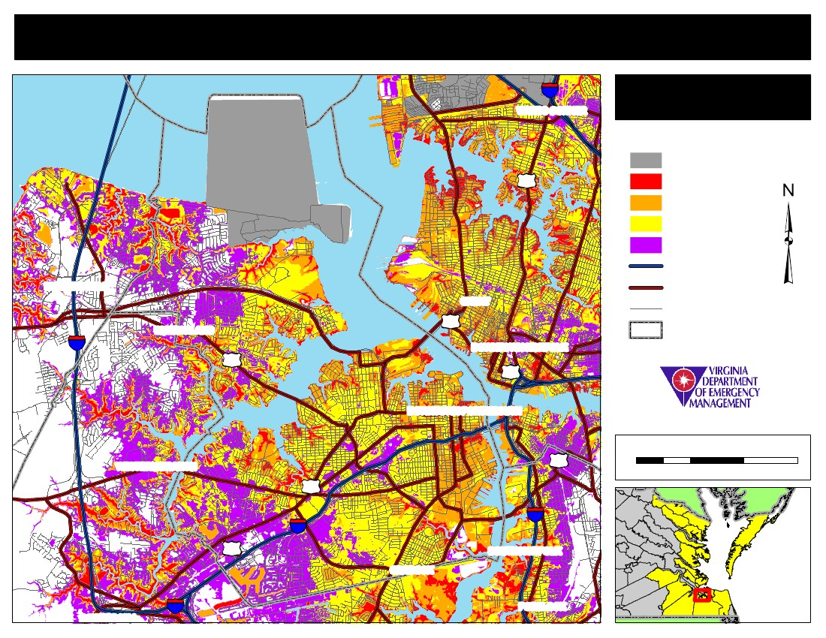
Commonwealth of Virginia Storm Surge Inundation Maps
64
WARDS CORNER
Portsmouth
Storm Surge Inundation
Area Not Included
Category 1
Category 2
Category 3
Category 4
Interstates
460
HUNTERSVILLE
58
GHENT
CHURCHLAND
17
Primary Routes
Addressed Roads
664
DOWNTOWN NORFOLK
460
Jurisdiction Boundaries
DOWNTOWN PORTSMOUTH
WESTERN BRANCH
58
464
460
0
1
Miles
2
3
264
460
CRADOCK
SOUTH NORFOLK
BOWERS HILL
64
PORTLOCK

