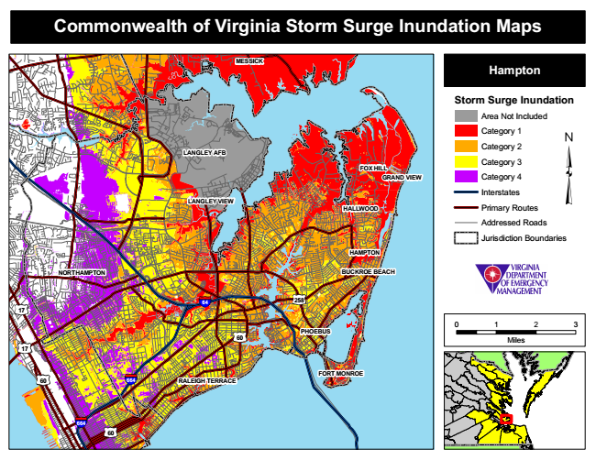
Commonwealth of Virginia Storm Surge Inundation Maps
MESSICK
Hampton
Storm Surge Inundation
Area Not Included
Category 1
LANGLEY AFB
Category 2
FOX HILL
Category 3
GRAND VIEW
Category 4
Interstates LANGLEY VIEW
Primary Routes
Addressed Roads
Jurisdiction Boundaries
HAMPTON
NORTHAMPTON
BUCKROE BEACH
0 1 2 3
Miles
FORT MONROE RALEIGH TERRACE
HALLWOOD
258 17
60
64
664
664
60
PHOEBUS
17
60

