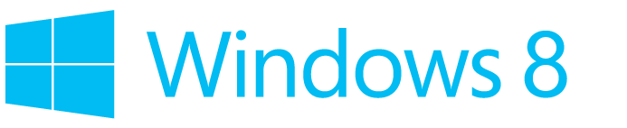

Accessibility in Windows 8
Overview of accessibility in Windows 8, tutorials, and keyboard shortcuts

Published by Microsoft Corporation, Trustworthy Computing
One Microsoft Way
Redmond, Washington 98052
Copyright © 2012 Microsoft Corporation. All rights reserved. No part of the contents of this document may be reproduced or transmitted in any form or by any means without the written permission of the publisher. For permissions, visit www.microsoft.com.
Microsoft and Windows are trademarks of Microsoft Corporation in the United States and/or other countries. Find further information on Microsoft Trademarks (http://www.microsoft.com/about/legal/en/us/IntellectualProperty/Trademarks/EN-US.aspx).
Table of Contents
Overview of Accessibility in Windows 8 7
What’s new in Windows 8 accessibility 7
Narrator and touch-enabled devices 7
Magnifier and touch-enabled devices 9
Ease of Access 12
Make your PC easier to use 12
Customizing the Ease of Access page 12
Choosing more tools and settings in the Ease of Access Center 14
Get recommendations for Ease of Access settings 16
Make the text on your screen larger or smaller 16
Hear text read aloud with Narrator 17
Starting Narrator 17
New touch gestures 18
New keyboard shortcuts 18
Narrator settings 18
Using Speech Recognition 22
Set up Speech Recognition 23
Using Speech Recognition 24
Controlling your PC with Speech Recognition 25
Dictation 26
Keyboard keys 27
Punctuation marks and special characters 27
Controls 29
Windows 30
Tap or click anywhere on the screen 30
Use Magnifier to see items on the screen 31
Using Magnifier 31
Changing Magnifier views 31
Customizing Magnifier 32
Use the On-Screen Keyboard (OSK) to type 32
To open On-Screen Keyboard 33
Use text or visual alternatives to sounds 34
To change your settings 34
Personalization 35
Personalize your PC 35
Change your background, colors, and account picture 35
Themes and desktop backgrounds 36
Customize the Start screen 36
Create tiles for your favorite people and places 36
Pin or unpin apps 36
Rearrange and resize tiles 37
Rearranging tiles on Start 37
Get started with themes 38
What's a theme? 38
Creating themes 39
Where is Control Panel? 42
How to use the taskbar 44
Rearrange taskbar buttons 44
Move the taskbar 44
Change how taskbar buttons appear 45
Pin an app to the taskbar 46
Customize the notification area 46
Take a look at the desktop 47
Change taskbar settings for multiple displays 48
Adding apps, websites, and more to Start 49
Connect multiple monitors to your PC 50
Connect another screen to your PC 51
Set up your screens 51
Sync your settings 51
Mouse and Keyboard 52
Mouse and keyboard: What's new in Windows 52
How to use the touch keyboard 55
Touch: swipe, tap, and beyond 56
Touch and pen settings: Frequently asked questions 60
How do I check if my PC has a touchscreen? 60
How do I calibrate my pen and touch settings? 61
How do I get my touchscreen to go to the correct screen? 61
How do I change my pen and touch actions? 62
Change keyboard settings 63
Change the keyboard layout 64
To change the keyboard layout for a language 64
Change mouse settings 65
To change the mouse settings 65
Use the numeric keypad to move the mouse pointer 65
To turn on Mouse Keys 65
Moving the pointer using Mouse Keys 66
Selecting a mouse button 66
Clicking items using Mouse Keys 66
Dragging items using Mouse Keys 67
Keyboard Shortcuts 68
New keyboard shortcuts for Windows 8 and Windows RT 68
Useful keyboard shortcuts for Windows 68
Complete list of keyboard shortcuts 69
General keyboard shortcuts 69
Dialog box keyboard shortcuts 71
File Explorer keyboard shortcuts 71
Taskbar keyboard shortcuts 72
Windows logo key keyboard shortcuts 73
Calculator keyboard shortcuts 76
Calendar keyboard shortcuts 78
Ease Of Access keyboard shortcuts 79
Internet Explorer keyboard shortcuts 79
Magnifier keyboard shortcuts 79
Mail keyboard shortcuts 80
Messaging keyboard shortcuts 81
Narrator keyboard shortcuts 82
Narrator touch keyboard shortcuts 83
Paint keyboard shortcuts 83
People App keyboard shortcuts 84
Reader keyboard shortcuts 84
Remote Desktop Connection on the desktop keyboard shortcuts 85
Remote Desktop Connection keyboard shortcuts 86
Skydrive keyboard shortcuts 86
Windows Help viewer keyboard shortcuts 86
Windows Journal keyboard shortcuts 87
Wordpad keyboard shortcuts 88

Overview of Accessibility in Windows 8
The built-in assistive technologies in Windows 8 work with both Windows 8 applications and with desktop software to provide seamless access to the entire Windows experience.
Devices running Windows 8 Professional will also allow you to use assistive technology (AT) software from specialty Assistive Technology vendors (http://www.microsoft.com/enable/at/).
What’s new in Windows 8 accessibility
One of the most exciting aspects of Windows 8 is the introduction of touch-only devices. With touch devices, you can directly interact with everything on your screen by touch, without using a keyboard or mouse, including managing accessibility options in the Ease of Access Center.
With Windows 8 you can easily access the most commonly used accessibility options right from the sign-in screen. Select the Ease of Access button in the lower-left corner of your screen, or press the Windows logo key+U, to choose the settings for your PC that you want to have available each time it starts. Learn more in the Ease of Access section below.
Narrator and touch-enabled devices
Narrator, a basic screen reader that reads aloud the text that appears on screen, and describes events such as error messages, has been redesigned in Windows 8 to be substantially faster, and to support many new features.
Whether you’re an individual who is blind, has low vision, or who is fully sighted, you will be able to use Windows 8 from the first time you start your device.
By default on touch-only devices, Narrator can be launched by simply holding down the Windows logo button and pressing the Volume Up button. Once Narrator is running, you can use Narrator’s built-in touch commands to explore the screen and control your device.
There are also some new configuration options for Narrator in Windows 8. You can select one of several voices, change the speed at which Narrator speaks, create customizable keyboard commands, and specify many other settings to suit your preferences.
Depending upon what device you use, and how you configure accessibility utilities on that device, there are different ways to start Narrator. These are the three shortcuts many people prefer:
- On the sign-in screen, press the Windows logo key +U or click the Ease of access button in the
lower-left corner, and then choose Narrator.
- On a keyboard, press the Windows logo key +Enter.
- On a touch-only device, hold down the Windows logo button and press the Volume Up button.
Learn more about using Narrator in Windows 8, in the Ease of Access section below.

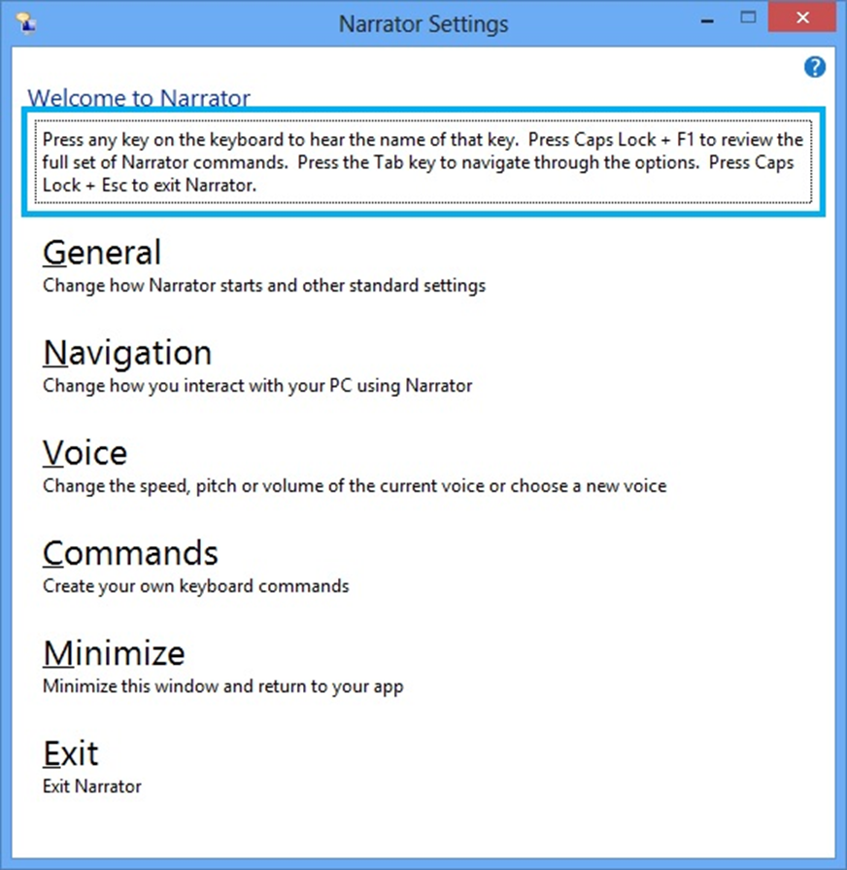
Narrator Settings screen used to configure how Narrator starts, navigation, voice, and other command settings.

Magnifier and touch-enabled devices
Magnifier is a tool that enlarges your screen, or portions of your screen, making words and images easier to see. For users with low vision who have trouble seeing their devices, Magnifier makes it easier to see the screen and touch it too.
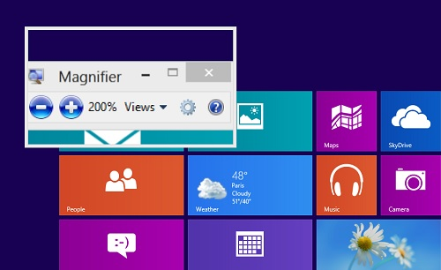
Magnifier lens view in Windows 8.
If you use a touch-enabled device you can control Magnifier from the edges of your screen. To start Magnifier on a touch-enabled device you first will need to designate Magnifier as the start option when pressing the Windows logo button+Volume up in the Ease of Access settings.
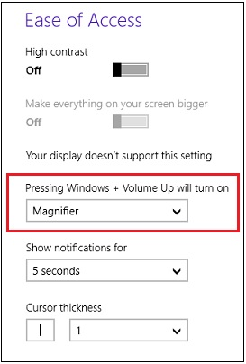
Ease of Access settings screen where you can select which accessibility tool to open with the keyboard shortcut Windows logo+Volume Up.
Once magnifier has been started on your touch-enabled device, a border will appear around the edges of the magnified screen. You can use these borders to move around the entire screen and it will work with all of your Windows 8 and desktop applications. Simply drag your finger along a border to move Magnifier in that direction. When the border disappears, you are at the edge of the screen.
By pressing the plus (+) and minus (-) buttons in the corners of the screen, you can zoom in or out to a size that best suits your preference. You can also quickly change the zoom level by moving two fingers closer together or farther apart on one of the borders.
To help keep track of your location on the screen, Magnifier has a preview feature that shows you exactly where you are in the context of the entire screen. To see the preview, tap with a thumb or finger on opposite borders at the same time. The currently magnified window will zoom out and highlight the part of the screen you are viewing. After a few seconds it will zoom back to the currently highlighted location. When viewing the preview, you can also drag the highlighted region to quickly move Magnifier around the screen.
Learn more about using Magnifier in Windows 8 in the Ease of Access section below.
Ease of Access and Personalization options on your computer
The following sections of this document provide information on how to make your device easier to see, hear, and use with settings and options in Ease of Access and Personalization in Windows 8 Professional. It also provides direction on accessing options using your mouse; or touch, for touch-only devices; and, provides a complete list of keyboard shortcuts for those who access their computers through the keyboard. Find more information about Windows 8 Accessibility on the Microsoft Accessibility website (www.microsoft.com/enable/), and on the Microsoft Windows website (http://windows.microsoft.com/).

Important
Windows RT only supports the installation of apps through the Windows Store. Windows 8, or Windows 8 Professional, is required for individuals using assistive technology software or devices. Be sure to check with your assistive technology manufacturer (www.microsoft.com/enable/at/matvplist.aspx) regarding compatibility before purchasing a new Windows 8 device.

Ease of Access
Windows offers several programs and settings that can make the computer easier and more comfortable to use. This section tells you how to find and set up accessibility options whether you use a mouse and keyboard, or a touch-enabled computer.
Make your PC easier to use
There’s no single best way to set up your PC. Everyone works differently so Windows 8 provides a variety of ways to change your settings so you can use your PC the way you want.
Note:
• The most commonly used accessibility options are available from the sign-in screen. Click the Ease of Access button in the lower-left corner to choose those settings for your PC that you want to have available each time it starts.
• For more information about these and other assistive technologies, go to the Microsoft Accessibility website (http://www.microsoft.com/enable/).
Customizing the Ease of Access page
You can find a few more settings on the Ease of Access page—a convenient summary page where you can change common settings.
- Swipe in from the right edge of the screen, and then tap Search.
(If you're using a mouse, point to the upper-right corner of the screen, move the mouse pointer down, and then click Search.)
- Enter Ease of Access in the search box, tap or click Settings, and then tap or click Ease of Access in
the results.
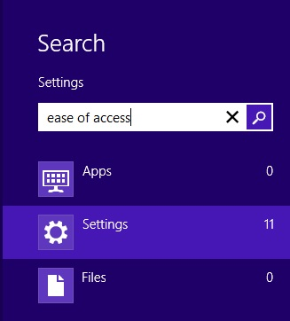
Search box with ease of access typed and Settings selected.
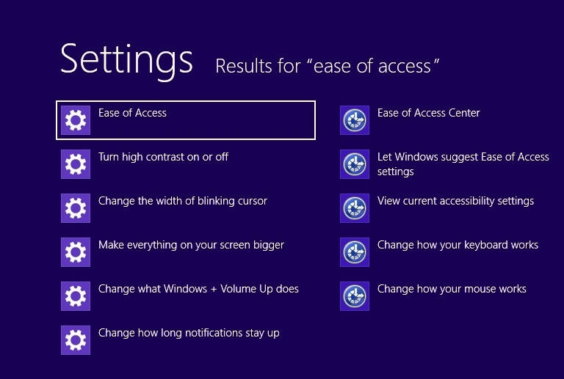
Results of a search on “ease of access” with the Ease of Access control highlighted.
Here are the settings you'll find on the Ease of Access page:
- High contrast. If it’s hard to read text on your screen, you can change the theme of your PC to a color combination that’s easier to read.
- Make everything on your screen bigger. If things on your screen are too small to read, you can use this setting to magnify everything on the screen.
- Pressing Windows+Volume Up. This works on newer laptops and tablets. First, choose a setting (Narrator, Magnifier, or On-Screen Keyboard), and then turn it on with a quick press of the Windows logo button and Volume Up button together.
- Show notifications for. If you find that notifications appear and disappear too quickly, you can change how long they’re visible—so you have time to read and react to them.
- Cursor thickness. If the cursor is too small for you and hard to spot on the screen, use this setting to change its thickness.
Choosing more tools and settings in the Ease of Access Center
The Ease of Access Center in Windows 8 Professional gives you the most control for customizing your accessibility settings.
- Swipe in from the right edge of the screen, and then tap Search.
(If you're using a mouse, point to the upper-right corner of the screen, move the mouse pointer down, and then click Search. Or, from the Start screen, press the Windows logo key + C.)
- Enter current accessibility settings in the search box, tap or click Settings, and then tap or click View current accessibility settings.
The first section in the Ease of Access Center includes quick access to four common tools:
- Magnifier. This enlarges part—or all—of the screen, so it’s easier to read. For more info, see Use Magnifier to see items on screen.
- Narrator. This is a screen reader that reads the text on your screen aloud. For more info, see Hear text read aloud with Narrator.
- On-Screen Keyboard. This lets you use your mouse or other pointing device to interact with a keyboard on the screen.
- High Contrast. This heightens the color contrast of some text and images on your screen, which helps make those items easier to identify.
The second section of the Ease of Access Center lists all of the other settings you can use.
- Use the computer without a display. Here, you can turn on Narrator, turn on audio descriptions for videos, set up Text to Speech, and change how long dialog boxes stay open.
- Make the computer easier to see. If you occasionally have trouble-seeing items on your screen, adjust these settings to make the screen easier to see. You can change to a high contrast theme, turn on Magnifier, adjust colors, and remove unnecessary animations and background images.
- Use the computer without a mouse or keyboard. Windows includes an on-screen keyboard that lets you enter text by selecting characters on the screen. You can also use Speech Recognition to control your PC with voice commands, and dictate text into programs. For more info, see Using Speech Recognition.
- Make the mouse easier to use. This setting lets you change the size and color of the mouse pointer, and use the numeric keypad to control the mouse.
- Make the keyboard easier to use. You can adjust the way Windows responds to mouse or keyboard input so that key combinations are easier to press, typing is easier, and accidental keystrokes are ignored.
- Use text or visual alternatives for sounds. Windows can replace system sounds with visual cues and display text captions for spoken dialog in multimedia programs.
- Make it easier to focus on tasks. These settings include a number of ways to help you focus on reading and typing. Use them to turn on Narrator, adjust how the keyboard responds to certain keystrokes, and change the way certain visual elements are displayed.
- Make touch and tablets easier to use. When you choose this option, Narrator starts automatically when you press the Windows logo button and Volume Up button together. You can change this so Magnifier or On-Screen Keyboard starts instead.
Get recommendations for Ease of Access settings
If you're not sure which settings to use, fill out the Ease of Access questionnaire to get recommendations.
- Swipe in from the right edge of the screen, and then tap Search.
(If you're using a mouse, point to the upper-right corner of the screen, move the mouse pointer down, and then click Search.)
- Enter current accessibility settings in the search box, tap or click Settings, and then tap or click View current accessibility settings.
- Tap or click Get recommendations to make your computer easier to use.
Make the text on your screen larger or smaller
You can make the text (and other things like icons) larger without changing the screen resolution of your monitor or laptop screen. That way, you can make text easier to see and still keep your monitor or laptop set to the best possible resolution.
- Open Screen Resolution by swiping in from the right edge of the screen, tapping Search (or if you're using a mouse, pointing to the upper-right corner of the screen, moving the mouse pointer down, and then clicking Search), entering Display in the search box, tapping or clicking Settings, and then tapping or
clicking Display.
- Choose one of the following:
  - Smaller - 100% (default). This keeps text and other items at normal size.
  - Medium - 125%. This sets text and other items to 125% of normal size.
  - Larger - 150%. This sets text and other items to 150% of normal size. This option appears only if your monitor supports a resolution of at least 1200 x 900 pixels.
- Tap or click Apply.
To see the new text size, close all of your apps, and then sign out of Windows. The change will take effect the next time you sign in.
Also, you can change the text size for specific items in Windows, like window title bars or tooltips, without changing the size of anything else on the screen.
- Open Screen Resolution by swiping in from the right edge of the screen, tapping Search (or if you're using a mouse, pointing to the upper-right corner of the screen, moving the mouse pointer down, and then clicking Search), entering Display in the search box, tapping or clicking Settings, and then tapping or
clicking Display.
- Under Change only the text size, choose the item you'd like to change and pick a text size. If you want the text to be bold, select the Bold check box.
- Tap or click Apply.
You'll see the change the next time you sign in to Windows.
You can also make text appear larger or smaller by changing your screen resolution, but if you're using an LCD monitor or laptop, it's a good idea to set your screen to its native resolution to avoid blurry text. This is the resolution that a monitor or laptop screen was designed to display based on its size. For more info, see Get the best display on your monitor.
Note:
You can't change the default font or font color used for items in Windows (like window title bars, menus, or tooltips). But you can change the color of your window borders and taskbar, or use a High Contrast Theme to make the items on your screen easier to see. For more info, see Get started with themes.
Hear text read aloud with Narrator
Narrator is a screen reader that reads text on the screen aloud and describes events like error messages so you can use your computer without a display.
Starting Narrator
There are different ways to start Narrator. These are the three shortcuts many people prefer:
- On a keyboard, press the Windows logo key +Enter.
- On a tablet, press the Windows logo button and Volume Up button together.
- On the sign-in screen, press the Windows logo key +U or click the Ease of access button in the
lower-left corner and choose Narrator.
Note:
If you want to quickly exit Narrator, press Caps Lock+Esc.
Another way to get to Narrator is to use search:
- Swipe in from the right edge of the screen, and then tap Search.
(If you're using a mouse, point to the upper-right corner of the screen, move the mouse pointer down, and then click Search.)
- Enter Narrator in the search box, tap or click Apps, and then tap or click Narrator.
Note:
• If you want to get started right away, after you open Narrator, press the Caps Lock key+F1. This keyboard combination will show you all of the Narrator commands.
• If you want to use Caps Lock to capitalize letters while you're using Narrator, press the Caps Lock key twice in quick succession.
New touch gestures
Windows 8 and Windows RT have new actions and new locations for common commands. Here are a few important gestures to get you started.
Use this touch gesture |  | To do this
Swipe in from the right edge with one finger |  | Open the charms (Search, Share, Start, Devices, Settings)
Swipe in from the left edge with one finger |  | Switch apps, snap them to the side, and close them
Swipe in from the top or bottom edge with  one finger |  | Show app commands like Save, Edit, and Delete
Note:
The press and hold gesture isn't supported in Narrator.
New keyboard shortcuts
Windows 8 and Windows RT have new keyboard shortcuts too. Here are a few helpful ones. To find the rest, go to Keyboard shortcuts.
Use this keyboard shortcut |  | To do this
Windows logo key‌ +C |  | Open the charms (Search, Share, Start, Devices, Settings)
Windows logo key‌ +Z |  | Show app commands like Save, Edit, and Delete
Windows logo key‌ +period |  | Snap apps to the side
Windows logo key‌ +Tab or Alt+Tab |  | Switch apps
Narrator settings
Here are some of the main settings you might want to use:
General
- Lock the Narrator key so you don’t have to press it for each command (Caps Lock). When you choose this option, you won’t have to use the Caps Lock key with the Narrator keys. For example, instead of pressing Caps Lock key+F1, you can simply press F1.
Note:
On a 106 keyboard, Ctrl+Alt+Z won't lock the Narrator key.
- Start Narrator minimized. This option keeps the Narrator window out of your way.
- Echo keyboard keystrokes while typing. You can choose whether or not Narrator reads each key you type.
- Read out voiced Narrator errors. Choose this option if you want Narrator to read the actual error in addition to playing an error tone.
- Enable visual highlighting of Narrator cursor. This option lets you show or hide the box that highlights where Narrator is on your screen.
- Play audio cues. This option lets you turn on or off the extra sounds that Narrator plays when you do
certain actions.
- Read hints for common items. This option controls whether Narrator will read hints about how to interact with common items such as buttons, links, list items, and sliders.
- Lower the volume of other apps when Narrator is running. This option makes other apps quieter so it's easier to hear Narrator.
- Retain notifications to be read for. This drop-down menu lets you control how long notifications will be retained for being read by Narrator.
- Control whether Narrator starts automatically. This link takes you to the Ease of Access Center where you can choose to have Narrator on automatically.
Navigation
- Read and interact with the screen using the mouse. This option controls whether Narrator mouse mode is on. When mouse mode is on, Narrator will read what’s currently under your mouse cursor.
- Activate keys on the touch keyboard when you lift your finger. If touch mode is on, you can turn on this setting so you can type faster using the touch keyboard. With this setting, you can drag to find the item you're looking for and lift your finger to press the key.
- Enable the Narrator cursor to follow the keyboard focus. This adds a blue box to your screen that moves with the keyboard focus, so that if you tab through items the Narrator cursor will follow.
Voice
- Select the speed, volume, or pitch of the voice. You can customize the voice with these three sliders.
- Select a different voice for Narrator. With this drop-down menu you can select different types of voices in Narrator, if they are available in your language.
Commands
- Click this option to see a list of existing shortcut keys for Narrator. You can always change these shortcuts if you like. The most important keyboard shortcut to know is Caps Lock+F1. Pressing this keyboard combination will show all Narrator commands. For reference, the following table lists the commands too.
Use this keyboard shortcut | To do this
Ctrl | Stop reading
Caps Lock+Esc | Exit Narrator
Caps Lock+Space | Do primary action
Caps Lock+Right arrow | Move to next time
Caps Lock+Left Arrow | Move to previous item
Caps Lock+Up arrow | Change view
Caps Lock+Down arrow | Change view
Caps Lock+F1 | Show commands list
Caps Lock+F2 | Show commands for current item
Caps Lock+F3 | Jump to next cell in row
Caps Lock+Shift+F3 | Jump to previous cell in row
Caps Lock+F4 | Jump to next cell in column
Caps Lock+Shift+F4 | Jump to previous cell in column
Caps Lock+F5 | Read which row and column Narrator is in
Caps Lock+F6 | Jump to table cell
Caps Lock+F7 | Read current column
Caps Lock+F8 | Read current row
Caps Lock+F9 | Read current column header
Caps Lock+F10 | Read current row header
Caps Lock+F11 | Toggle touch mode on/off
Caps Lock+F12 | Toggle keystroke announcements
Caps Lock+Z | Lock Narrator Key
Caps Lock+X | Pass keys to app
Caps Lock+V | Repeat last phrase
Caps Lock+Page Up | Increase voice volume
Caps Lock+Page Down | Decrease voice volume
Caps Lock+Plus | Increase voice speed
Caps Lock+Minus | Decrease voice speed
Caps Lock+D | Read item
Caps Lock+F | Read item advanced
Caps Lock+S | Read item spelled out
Caps Lock+W | Read Window
Caps Lock+R | Read all items in containing area
Caps Lock+Q | Move to last item in containing area
Caps Lock+G | Move Narrator cursor to system cursor
Caps Lock+T | Move Narrator cursor to pointer
Caps Lock+Tilde | Set focus to item
Caps Lock+Backspace | Go back one item
Caps Lock+Insert | Jump to linked item
Caps Lock+M | Start reading
Caps Lock+Close bracket | Read text from start to cursor
Caps Lock+O | Read text attributes
Caps Lock+H | Read document
Caps Lock+U | Read next page
Caps Lock+Ctrl+U | Read current page
Caps Lock+Shift+U | Read previous page
Caps Lock+I | Read next paragraph
Caps Lock+Ctrl+I | Read current paragraph
Caps Lock+Shift+I | Read previous paragraph
Caps Lock+O | Read next line
Caps Lock+Ctrl+O | Read current line
Caps Lock+Shift+O | Read previous line
Caps Lock+P | Read next word
Caps Lock+Ctrl+P | Read current word
Caps Lock+Shift+P | Read previous word
Caps Lock+Open bracket | Read next character
Caps Lock+Ctrl+Open bracket | Read current character
Caps Lock+Shift+Open bracket | Read previous character
Caps Lock+J | Jump to next heading
Caps Lock+Shift+J | Jump to previous heading
Caps Lock+K | Jump to next table
Caps Lock+Shift+K | Jump to previous table
Caps Lock+L | Jump to next link
Caps Lock+Shift+L | Jump to previous link
Caps Lock+Y | Move to beginning of text
Caps Lock+B | Move to end of text
Caps Lock+N | Rewind while reading a document
Caps Lock+Comma | Fast-forward while reading a document
Caps Lock+C | Read current date/time

If you have a new PC that supports four or more contact points, you can use touch commands to control your PC.
Use this touch command |  | To do this
Tap once with two fingers |  | Stop Narrator from reading
Tap three times with four fingers |  | Show all Narrator commands (including ones not in this list)
Double-tap or hold with one finger and tap anywhere with a second |  | Activate primary action
Triple-tap or hold with one finger and double-tap  with a second |  | Activate secondary action
Hold with one finger and tap with two others |  | Start dragging or extra key options
Tap with three fingers |  | Show/hide Narrator settings window
Tap with four fingers |  | Show commands for current item
Tap or drag a single finger |  | Read what's under your finger
Double-tap with four fingers |  | Toggle search mode
Triple-tap with four fingers |  | Show Narrator commands list
Flick left/right with one finger |  | Move to next or previous item
Flick up/down with one finger |  | Change move increment
Swipe left/right/up/down with two fingers |  | Scroll
Swipe left/right with three fingers |  | Tab forward and backward
Swipe down with three fingers |  | Start reading explorable text
Swipe up with three fingers |  | Read current window
Note:
• Narrator provides basic screen-reading capabilities so you can use Windows when you don't have a more comprehensive screen reader. Narrator isn't designed to read content in all apps. For more info about screen readers and other assistive technologies, go to the
Microsoft Accessibility (www.microsoft.com/enable/) website.
• TTS support in Narrator is available in Cantonese, English (United States and United Kingdom), French, German, Japanese, Korean, Mandarin, and Spanish.
Using Speech Recognition
Windows Speech Recognition makes using a keyboard and mouse optional. You can control your PC with your voice and dictate text instead.
Note:
Speech Recognition isn't available in all languages.
Set up Speech Recognition
There are a few steps you need to take before you can start using Speech Recognition. First, you’ll need to set up a microphone. Next, it’s a good idea to take the tutorial to learn how to use Speech Recognition effectively. Finally, you can train your PC to recognize your voice.
To set up a microphone
Before you set up Speech Recognition, make sure you've plugged the microphone into your PC so the following steps work.
- Swipe in from the right edge of the screen, and then tap Search.
(If you're using a mouse, point to the upper-right corner of the screen, move the mouse pointer down, and then click Search.)
- Enter set up a microphone in the search box, tap or click Settings, and then tap or click Set up a microphone.
- Follow the instructions on the screen.
Note:
If possible, use a headset microphone; it's less likely to pick up background noise.
To take the tutorial
The tutorial that comes with Speech Recognition takes about 30 minutes to complete, and it’s a good use of time. It teaches you the voice commands used in Speech Recognition.
- Swipe in from the right edge of the screen, and then tap Search.
(If you're using a mouse, point to the upper-right corner of the screen, move the mouse pointer down, and then click Search.)
- Enter speech recognition in the search box, tap or click Settings, and then tap or click Speech Recognition.
- Tap or click Take Speech Tutorial.
- Follow the instructions in the Speech Recognition Tutorial.
To train your pc to recognize your speech
Speech Recognition uses a special voice profile to recognize your voice and spoken commands. The more you use Speech Recognition, the more detailed your voice profile becomes—and that should improve your PC's ability to understand you.
- Swipe in from the right edge of the screen, and then tap Search.
(If you're using a mouse, point to the upper-right corner of the screen, move the mouse pointer down, and then click Search.)
- Enter speech recognition in the search box, tap or click Settings, and then tap or click Speech Recognition.
- Tap or click Train your computer to better understand you.
- Follow the instructions in the Speech Recognition Voice Training.
Using Speech Recognition
You can use your voice for many things, such as filling out online forms or typing letters. When you speak into the microphone, Speech Recognition changes your spoken words into text on the screen.
To dictate text using speech recognition
- Swipe in from the right edge of the screen, and then tap Search.
(If you're using a mouse, point to the upper-right corner of the screen, move the mouse pointer down, and then click Search.)
- Enter speech recognition in the search box, tap or click Apps, and then tap or click Windows Speech Recognition.
- Say "start listening," or tap or click the Microphone button to start the listening mode.
- Open the app you want to use, or select the text box you want to dictate text into.
- Say the text you want to dictate.
To correct mistakes
You can correct mistakes in three different ways.
- To correct the last thing you said, say "correct that."
- To correct a single word, say "correct" followed by the word that you want to correct. If the word appears more than once, all instances will be highlighted, and you can choose the one you want to correct.
- In the Alternates panel dialog box, say the number next to the item you want, and then say "OK."
To add or change words in the speech dictionary
Using the Speech Dictionary, you can add your own words, stop a specific word from being dictated or corrected or delete a word in the dictionary.
- Swipe in from the right edge of the screen, and then tap Search.
(If you're using a mouse, point to the upper-right corner of the screen, move the mouse pointer down, and then click Search.)
- Enter speech recognition in the search box, tap or click Apps, and then tap or click Windows Speech Recognition.
- Say "start listening," or tap or click the Microphone button to start the listening mode.
- Say "open Speech Dictionary" and do any of the following:
  - To add a word to the dictionary, say "Add a new word," and then follow the instructions.
  - To prevent a specific word from being dictated, say "Prevent a word from being dictated," and then follow the instructions.
  - To correct or delete a word that is already in the dictionary, say "Change existing words," and then follow the instructions.
Controlling your PC with Speech Recognition
You can use simple, short commands to control your PC. The following table shows some of the most commonly used Speech Recognition commands. Words in italics mean you can replace the example word or phrase with similar words and get useful results.
Note:
Any time you need to find out what commands to use, say "what can I say?"
To do this |  | Say this
Select any item by its name |  | Click File; Start; View
Select any item or icon |  | Click Recycle Bin; Click Computer; Click file name
Double tap or double-click any item |  | Double-click Recycle Bin; Double-click Computer; Double-click file name
Switch to an open app |  | Switch to Paint; Switch to WordPad; Switch to program name; Switch application
Scroll in one direction |  | Scroll up; Scroll down; Scroll left; Scroll right
Insert a new paragraph or new line in a document |  | New paragraph; New line
Select a word in a document |  | Select word
Select a word and start to correct it |  | Correct word
Select and delete specific words |  | Delete word
Show a list of applicable commands |  | What can I say?
Update the list of speech commands that are  currently available |  | Refresh speech commands
Turn on listening mode |  | Start listening
Turn off listening mode |  | Stop listening
Move the Speech Recognition microphone bar |  | Move speech recognition
Minimize the microphone bar |  | Minimize speech recognition
View Windows Help and Support content about specific tasks |  | How do I do something?  For example, say “How do I install a printer?” and a list of Help topics is returned.  Note that this command is available only if you're using the U.S. English Speech Recognizer.

Dictation
To do this |  | Say this
Insert a new line in the document |  | New line
Insert a new paragraph in the document |  | New paragraph
Insert a tab |  | Tab
Insert the literal word for the next command (for example, you can insert the word "comma" instead of the punctuation mark) |  | Literal word
Insert the numeral form of a number |  | Numeral number
Put the cursor before a specific word |  | Go to word
Put the cursor after a specific word |  | Go after word
Don't insert a space before the next word |  | No space
Go to the start of the sentence that the cursor is in |  | Go to start of sentence
Go to the start of the paragraph that the cursor is in |  | Go to start of paragraph
Go to the start of the document |  | Go to start of document
Go to the end of the sentence that the cursor is in |  | Go to end of sentence
Go to the end of the paragraph that the cursor is in |  | Go to end of paragraph
Go to the end of the current document |  | Go to end of document
Select the word in the current document |  | Select word
Select the word range in the current document |  | Select word range; Select word through word
Select all text in the current document |  | Select all
Select a number of words before the location of the cursor |  | Select previous 20 words; Select previous 10 words
Select a number of words after the location of the cursor |  | Select next 20 words; Select next 10 words
Select the last text you dictated |  | Select that
Clear the selection on the screen |  | Clear selection
Capitalize the first letter of the word |  | Caps word
Capitalize all the letters of the word |  | All caps word
Make all the letters in the word lowercase |  | No caps word
Change the next number of words to uppercase |  | Change next 10 words to uppercase
Change the next number of words to lowercase |  | Change next 10 words to lowercase
Delete the previous sentence |  | Delete previous sentence
Delete the next sentence |  | Delete next sentence
Delete the previous paragraph |  | Delete previous paragraph
Delete the next paragraph |  | Delete next paragraph
Delete the selected or last dictated text |  | Delete that
Keyboard keys
To do this |  | Say this
Press any key on the keyboard |  | Press keyboard key; Press a; Press capital b; Press Shift plus a;  Press Ctrl plus a
Press certain keyboard keys without saying "press" first |  | Delete; Backspace; Enter; Page Up; Page Down; Home; End; Tab
Note:
• You can also use the ICAO\NATO phonetic alphabet to say the keyboard keys to press. For example, you can say "press alpha" to press "a" or "press bravo" to press "b."
• Using Speech Recognition to press keyboard keys works only with languages that use
Latin alphabets.
Punctuation marks and special characters
To insert this |  | Say this
, |  | Comma
; |  | Semicolon
. |  | Period; Dot; Decimal point
: |  | Colon
“ |  | Open double quote; Open quote
” |  | Close double quote; Close quote; Close inverted commas
' |  | Apostrophe
‘ |  | Open single quote
’ |  | Close single quote
> |  | Greater than sign
< |  | Less than sign
/ |  | Forward slash
\ |  | Backslash
~ |  | Tilde
@ |  | At sign
! |  | Exclamation mark; Exclamation point
? |  | Question mark
# |  | Number sign; Pound sign
$ |  | Dollar sign
% |  | Percent sign
^ |  | Caret
( |  | Open parenthesis; Open paren
) |  | Close parenthesis; Close paren
_ |  | Underscore
- |  | Hyphen; Minus sign; Dash
– |  | En dash
— |  | Em dash
= |  | Equal sign
+ |  | Plus sign
{ |  | Open brace; Open curly bracket
} |  | Close brace; Close curly bracket
[ |  | Open bracket; Open square bracket
] |  | Close bracket; Close square bracket
| |  | Vertical bar
:-) |  | Smiley face
:-( |  | Frowny face
;-) |  | Winky face
™ |  | Trademark sign
¾ |  | Three quarter sign
¼ |  | One quarter sign
½ |  | One half sign
£ |  | Pound sterling sign
& |  | Ampersand; And sign
* |  | Asterisk
// |  | Double slash
` |  | Back quote
< |  | Open angle bracket
> |  | Close angle bracket
± |  | Plus or minus sign
« |  | Open angle quote
» |  | Close angle quote
× |  | Multiplication sign
÷ |  | Division sign
¢ |  | Cent sign
¥ |  | Yen sign
§ |  | Section sign
© |  | Copyright sign
® |  | Registered sign, Registered trademark sign
° |  | Degree sign
¶ |  | Paragraph sign
… |  | Ellipsis; Dot dot dot
ƒ |  | Function sign
Controls
To do this |  | Say this
Select any item by saying  its name |  | File; Edit; View; Save
Select any item |  | Click File; Click Bold; Click Save; Click Close
Double-tap or double-click  any item |  | Double-click Computer; Double-click Recycle Bin; Double-click folder name
Press and hold or right-click  any item |  | Right-click Computer; Right-click Recycle Bin; Right-click folder name
Minimize all windows to show your desktop |  | Show desktop
Select something if you don't know what it's called |  | Show numbers (Numbers will appear on the screen for every item in the active window. Say an item's corresponding number to select it.)
Select a numbered item |  | 19 OK; 5 OK
Double-tap or double-click  a numbered item |  | Double-click 19; Double-click 5
Press and hold or right-click  a numbered item |  | Right-click 19; Right-click 5
Windows
To do this |  | Say this
Open an app |  | Open Paint; Open WordPad; Open app name
Switch to an open app |  | Switch to Paint; Switch to WordPad; Switch to app name; Switch application
Close an app |  | Close that; Close Paint; Close Documents
Minimize |  | Minimize that; Minimize Paint; Minimize Documents
Maximize |  | Maximize that; Maximize Paint; Maximize Documents
Restore |  | Restore that; Restore Paint; Restore Documents
Cut |  | Cut that; Cut
Copy |  | Copy that; Copy
Paste |  | Paste
Delete |  | Delete that; Delete
Undo |  | Undo that; Scratch that; Undo
Scroll in one direction |  | Scroll up; Scroll down; Scroll right; Scroll left
Scroll an exact distance in pages |  | Scroll down 2 pages; Scroll up 10 pages
Scroll an exact distance in  other units |  | Scroll up 5; Scroll down 7
Go to a field in a form or an app |  | Go to field name; Go to Subject; Go to Address; Go to cc
Tap or click anywhere on the screen
To do this |  | Say this
Show the mousegrid |  | Mousegrid
Move the mouse pointer to the center of any mousegrid square |  | Number of the square; 1, 7, 9
Tap or click any mousegrid square |  | Click number of the square
Select an item to drag with the mousegrid |  | Number of the square where the item appears; 3, 7, 9 (followed by) mark
Select an area in the mousegrid where you want to drag the item |  | Number of the square where you want to drag; 4, 5, 6 (followed by) click
Use Magnifier to see items on the screen
Magnifier is a useful tool that enlarges part—or all—of your screen so you can see the words and images better. It comes with a few different settings, so you can use it the way that suits you best.
Using Magnifier
You can open and close Magnifier quickly so it's handy when you need it and it's out of your way when you don't.
To open Magnifier
- Swipe in from the right edge of the screen, and then tap Search.
(If you're using a mouse, point to the upper-right corner of the screen, move the mouse pointer down, and then click Search.)
- Enter Magnifier in the search box, tap or click Apps, and then tap or click Magnifier.
Magnifier will open in Full-screen view unless you change the settings.
To close Magnifier
- To exit Magnifier quickly, press the Windows logo key + Esc. You can also tap or click the magnifying glass icon , and then tap or click the Close button on the Magnifier toolbar.
Note:
• If you want to have Magnifier always at your fingertips, you can pin it to the Start screen or taskbar. For more info, see How to use the taskbar.
• Some people want to change the clarity or size of the words and images on the screen. If this is what you want to do, you can use the app to zoom in on a page or change your screen resolution. For more info about changing your screen resolution, see
Get the best display on your monitor.
Changing Magnifier views
You can use Magnifier in a few ways, depending on how you like to work: Full-screen, lens, and docked. Try them all to find out which one you prefer.
- Full-screen. In this view, your entire screen is magnified. You probably won’t be able to see the whole screen at the same time when it’s magnified, but as you move around the screen, you can see everything. If you have a touchscreen, Magnifier will display white borders around the edge of your screen. Drag your finger or mouse along the borders to move around the screen.
- Lens. In this view, when you move around the screen, it’s like moving a magnifying glass around.
- Docked. Docked view works on the Windows desktop. In this view, a magnifier is docked to portion of your screen. As you move around the screen, parts of the screen appear magnified in the docking area, even though the main part of the screen is unchanged.
Customizing Magnifier
You can change the way Magnifier works. For example, you can use the zoom buttons ( and ) to change how much Magnifier enlarges your screen. Pressing Windows + Plus and Windows + Minus on your keyboard is another quick way to zoom in and out. You can also open the Magnifier options button to
change Magnifier.
Note:
You can set Magnifier to follow your mouse, the insertion point, or the keyboard. Follow the instructions below to customize Magnifier.
- Swipe in from the right edge of the screen, and then tap Search.
(If you're using a mouse, point to the upper-right corner of the screen, move the mouse pointer down, and then click Search.)
- Enter Magnifier in the search box, tap or click Apps, and then tap or click Magnifier.
- Go to the Windows Desktop and click the Magnifying glass .
- Click the Options button .
- Do one or more of the following:
  - Use the slider to choose a zoom increment. The percentage you choose here will be the increment by which Magnifier enlarges the screen when you press the zoom in button .
  - Select the Turn on color inversion check box to reverse colors on the screen. Sometimes reversing colors makes text easier to read.
  - Select a check box to choose how Magnifier focuses. Depending on your settings, Magnifier can follow your mouse, the insertion point, or the keyboard.
Note:
When you open Magnifier, the Magnifier toolbar appears briefly. It quickly gets out of your way, but you can display it again by clicking the magnifying glass icon on your screen or the Magnifier icon on the taskbar.
Use the On-Screen Keyboard (OSK) to type
There are a few different kinds of keyboards. The most common is a physical, external keyboard that you plug into your PC. A PC with a touchscreen also has a touch keyboard. When you’re using a Windows 8 or Windows RT PC with a touchscreen, tap in a text field or other area where you can type and the touch keyboard appears. For more info about the touch keyboard, see How to use the touch keyboard.
Windows also has On-Screen Keyboard (OSK), an Ease of Access tool. You can use OSK instead of relying on the physical keyboard to type and enter data. You don’t need a touchscreen to use On-Screen Keyboard. OSK displays a visual keyboard with all the standard keys. You can select keys using the mouse or another pointing device, or you can use a physical single key or group of keys to cycle through the keys on the screen.
To open On-Screen Keyboard
- Swipe in from the right edge of the screen, and then tap Search.
(If you're using a mouse, point to the upper-right corner of the screen, move the mouse pointer down, and then click Search.)
- In the search box, enter On-Screen Keyboard, tap or click Apps, and then tap or click On-Screen Keyboard.
Note:
You can also open OSK from the sign-in screen. Click the Ease of Access button in the lower-left corner to choose to have OSK open automatically every time you turn on your PC.
To change how information is entered into On-Screen Keyboard
- With OSK open, tap or click the OSK Options key, and then select the options you want:
  - Use click sound. Use this option if you want to hear a sound when you press a key.
  - Show keys to make it easier to move around the screen. Use this option if you want the keys to light up as you type.
Turn on numeric keypad. Use this option to expand OSK to show a numeric keypad.
Click on keys. Use this mode if you prefer to click or tap the on-screen keys to enter text.
Hover over keys. Use this mode if you use a mouse or joystick to point to a key. The characters you point to are entered automatically when you point to them for a specified time. You can set the time in the Options
dialog box.
Scan through keys. Use this mode if you want OSK to continually scan the keyboard. Scan mode highlights areas where you can type keyboard characters by pressing a keyboard shortcut, using a switch input device, or using a device that simulates a mouse click.
Use Text Prediction. Use this option if you want OSK to suggest words for you as you type so you don't need to type each complete word.
Note:
• Text prediction is available in English, French, Italian, German, and Spanish. To use text prediction in a specific language, first install additional language files for that language.
• If you're using either hovering mode or scanning mode and accidently minimize On-Screen Keyboard, you can restore it by pointing to it in the taskbar (for hovering mode) or by pressing the scan key (for scanning mode).
• If you minimize OSK and switch to the Start screen or a full-screen app, you won't be able to get to OSK. Open OSK first, and then go to the Start screen or app.
Use text or visual alternatives to sounds
You can use visual cues rather than sounds in many apps by changing your PC settings.
To change your settings
- Swipe in from the right edge of the screen, and then tap Search.
(If you're using a mouse, point to the upper-right corner of the screen, move the mouse pointer down, and then click Search.)
- In the search box, enter Replace sounds with visual cues, tap or click Settings, and then tap or click Replace sounds with visual cues.
- Select the options that you want to use:
  - Turn on visual notifications for sounds. This option replaces system sounds with visual cues, such as a flash on the screen, so you can see notifications even when they're not heard. You can also choose how you want sound notifications to warn you.
  - Turn on text captions for spoken dialog. With this option, Windows will display text captions in place of sounds to indicate that activity is happening on your PC (for example, when a document starts or finishes printing).

Personalization
Personalize your PC
If you spend a lot of time using your PC, you can make it reflect who you are and what you care about. Make yourself at home on the Start screen and arrange it to your liking. Create tiles for your favorite people or websites and drag them anywhere you want—or put similar tiles in their own group. Pin your favorite apps to the Start screen and remove the ones you don't use. You can even change the background and color on your Start screen to match your mood.
With Windows, you can make your PC your own.
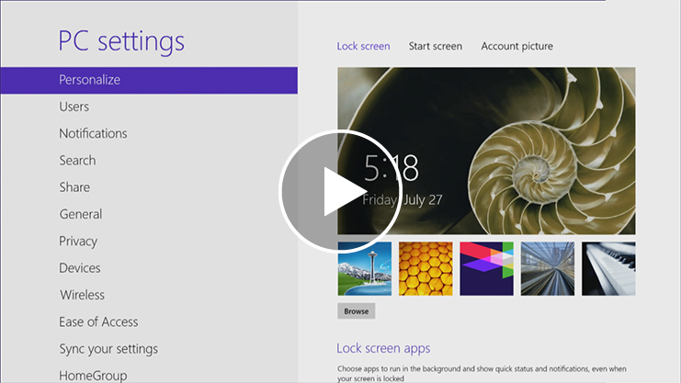
Change your background, colors, and account picture
In Windows 8 and Windows RT, there are a few new places to show your favorite pictures and colors. On the Start screen, you can change the background and color. The background shows up only on Start, but the color you pick shows up in a few other places too, like the charms and the sign-in screen. You can also make sure there's a favorite photo waiting to greet you on your lock screen, and choose a few apps to show you info and updates you might have missed while your PC was locked. And you can add some excitement to your account picture — if you have a webcam, you can create a video clip to use instead of a photo. Or if you have photo editing apps, you can use them to add some finishing touches to a photo.
Here's how to try out these new picture and color options:
- Open the Settings charm, and then tap or click Change PC settings.
- Tap or click Personalize, and then change the options you want.
Themes and desktop backgrounds
All of the personalization settings you know and love are still here too, and you can still use them to personalize your desktop.
Here's how to check out the brand new themes and desktop backgrounds:
- Open the Search charm, enter personalization, and then tap or click Settings.
- Tap or click Personalization.
- If you don't see something you like, you can download more themes, or even create your own, from this
same place.
Customize the Start screen
Just like you had a Start menu in Windows 7, you have a Start screen in Windows 8 and Windows RT. It has all of the info you care about in one place. You can just glance at the tiles to get the latest headlines, real-time updates, and info, or you can open apps, websites, contacts, and folders.
Here are the quickest ways to get to Start:
- With touch, swipe in from the right edge of your screen, and then tap Start.
- With a mouse, move your pointer to the upper-right or lower-right corner, and then move it up or down and click Start. (Or, point to the lower-left corner, and click Start when it appears.)
- With a keyboard, press the Windows logo key .
So arrange Start any way you want it, and put your favorite apps, people, and websites front and center. Here are a few options you can try.
Create tiles for your favorite people and places
A tile is an app or content (like a website, contact, or folder) that you can open from the Start screen. So if you have a website that you visit every day or people that you chat with all the time, you might want to create tiles for them on Start so you can get to them quickly.
When you come across a website, contact, or folder that you want to add to Start, here's how:
- To pin a website or contact from an app, open the app commands and tap or click Pin to Start.
- To pin a folder, open it in File Explorer, press and hold or right-click it, and then tap or click Pin to Start.
Pin or unpin apps
Some apps that are installed on your PC might not be pinned to Start. But you can always pin them if you want them there. On the Start screen, open the Search charm, select the app you want to pin to open its commands, and then tap or click Pin to Start.
And if there are apps you don't use, you can unpin them from Start. On the Start screen, select an app to open its commands, and then tap or click Unpin from Start. If you unpin an app, it's still installed on your PC, so you can always find it again with the Search charm.
Rearrange and resize tiles
To move a tile, drag it up or down, and then drag it anywhere you want it. (You don't need to press and hold.) You can arrange the tiles any way you want. Put similar tiles together, group all your favorites, or create a "Work" group for the apps for your job.
Here's how to name a group of tiles:
- Touch the Start screen with two or more fingers, and then pinch them toward each other to zoom out. (If you're using a mouse, click the Zoom button .)
- Select the group of tiles you want to name, and then tap or click Name Group.
- If a tile isn't fitting in the spot you want, you can make it larger or smaller. Just select the tile on the Start screen to open the app commands and then tap or click Larger or Smaller. (Some tiles can't be resized.)
Rearranging tiles on Start
In Windows 8 and Windows RT, you have lots of options to help you set up Start in a way that's right for you. You can create groups, show updates on tiles, and move tiles around for better access to your favorite people, websites, and more. Or, you can create a simple Start with just a few choices. Take a few minutes to move and resize tiles to see what works best for you.
What you can do |  | How to do it
Rearrange tiles |  | - Slide the tile you want to change either up or down, and then drag it to a new position.  - (If you're using a mouse, click and drag the tile in any direction to a  new position.)  - If you want to quickly move it from one end of Start to the other, drag the tile down to the bottom of the screen. This shows all the tiles at once and makes it easy to move tiles longer distances.
Group tiles together |  | - To start a new group, drag a tile to an open space. When a gray bar appears, release the tile.  - Slide and drag or click and drag more tiles next to the first tile.
Name groups |  | - Pinch your fingers together on the Start screen or click the icon in the lower-right corner to zoom out and see all the tiles.  - To rearrange the groups, press and hold or click and drag the group, and then move it to a new position.  - Tap or right-click the group you want to name, and then tap or click  Name group.  - Enter a name, and then tap or click Name.
Resize tiles (only available on some tiles) |  | - Swipe down on or right-click the tile you want to change.  - Tap or click Smaller or Larger to change its size. (A tile's color and font can't be changed.)
Turn tile updates on or off (only available on  some tiles) |  | - Swipe down on or right-click the tile you want to change.  - Tap or click Turn live tile on or Turn live tile off to change its setting.
Get started with themes
In Windows, you can use themes to help make your desktop feel a little more like your own. Themes change the desktop background, window border color, sounds, and screen saver on your PC all at once, and you can switch between themes as often as you like. You can also create your own themes, and share them with friends
and family.
What's a theme?
A theme is a combination of pictures, colors, and sounds. Themes include:
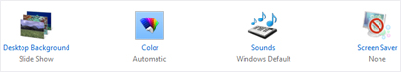
Parts of a theme
- A desktop background. A picture, color, or design that acts as a backdrop to the open windows on your desktop. The desktop background can be a single picture or a slide show. You can choose from the desktop background pictures that come with Windows, or you can use your own pictures.
- A window border color. The color of your window borders and taskbar. A theme can include one specific window border color, or a color can be chosen automatically based on the colors in the desktop
background picture.
- Sounds. A collection of related sounds that you hear when events happen on your PC. An event can be an action that you do, like signing in to your PC, or something that your PC does, like letting you know when you get a new email.
- A screen saver. A moving picture or pattern that appears on your PC screen when you haven’t used the mouse or keyboard for a certain period of time. The screen saver is turned off in the themes that come with Windows, but you can turn it on and add one to a theme. For more info about screen savers, see How to use screen savers.
You can find all of your themes in Personalization in Control Panel. Tap or click any theme to apply it to
your desktop.
Open Personalization by swiping in from the right edge of the screen, tapping Search (or if you're using a mouse, pointing to the upper-right corner of the screen, moving the mouse pointer down, and then clicking Search), entering Personalization in the search box, tapping or clicking Settings, and then tapping or clicking Personalization.
In Personalization in Control Panel, there are four types of themes.
- My Themes. Themes that you've created, made changes to, saved, or downloaded. Any time you change a theme, the new settings appear here as an unsaved theme.
- Windows Default Themes. Windows themes you can use to personalize your PC. Most of them include a desktop background slide show.
- Installed Themes. Themes that were created by your PC manufacturer or other non-Microsoft providers.
- High Contrast Themes. Themes that make items on your screen easier to see. The High Contrast themes don't include automatic window border colors or desktop background slide shows.
Creating themes
You’re not limited to the themes that come with Windows—you can create customized themes using your own pictures and screen savers, and choose the colors and sounds that go along with them. To get started, tap or click any theme to apply it to your desktop. Then change each part of the theme until the desktop background, window border color, sounds, and screen saver are just how you want them to be. All of your changes will be saved under My Themes as an unsaved theme.
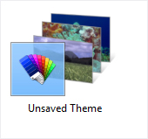
An unsaved theme
To create a theme
- Open Personalization by swiping in from the right edge of the screen, tapping Search (or if you're using a mouse, pointing to the upper-right corner of the screen, moving the mouse pointer down, and then clicking Search), entering Personalization in the search box, tapping or clicking Settings, and then tapping or clicking Personalization.
- To change the desktop background, tap or click Desktop Background, browse to the pictures you want to use, select the check boxes for the pictures that you want to include in your slide show, and then tap or click Save changes.
- To change the color of your window borders and taskbar, tap or click Window Color, and then do one of
the following:
Tap or click Automatic to let Windows choose a color automatically based on the colors in your desktop background picture, and then tap or click Save changes
– or –
Tap or click the color that you want to use, and then tap or click Save changes.
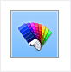
The automatic window color option
- To change the sounds you hear when something happens on your computer, tap or click Sounds, tap or click an item in the Sound Scheme list, and then tap or click OK.
- To add or change a screen saver, tap or click Screen Saver, tap or click an item in the Screen saver list, change any settings to suit your preference, and then tap or click OK.
Once you're happy with the way your new theme looks and sounds, save it so you can use it any time.
To save a theme
- Open Personalization by swiping in from the right edge of the screen, tapping Search (or if you're using a mouse, pointing to the upper-right corner of the screen, moving the mouse pointer down, and then clicking Search), entering Personalization in the search box, tapping or clicking Settings, and then tapping or clicking Personalization.
- Under My Themes, tap or click your unsaved theme to apply it to the desktop.
- Tap or click Save theme.
- Enter a name for your theme, and then tap or click Save.
The new theme name will appear under My Themes.
Sharing themes
Once you've saved a theme, you can share it with your friends and family. To send your theme to other people, first you'll need to save it in a file format that can be shared, called a .themepack file.
- Open Personalization by swiping in from the right edge of the screen, tapping Search (or if you're using a mouse, pointing to the upper-right corner of the screen, moving the mouse pointer down, and then clicking Search), entering Personalization in the search box, tapping or clicking Settings, and then tapping or clicking Personalization.
- Tap or click your customized theme to apply it to the desktop.
- Press and hold or right-click the theme, and then tap or click Save theme for sharing.
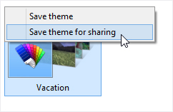
Saving a theme
- In the File name box, enter a name for your theme, and then tap or click Save.
You can share your theme using email, a network, or an external drive.
Deleting themes
If you're no longer using a theme you've created or downloaded, you can delete it from your PC to save on disk space. (The themes that come with Windows can't be deleted.)
- Tap or click a different theme to apply it to the desktop. You can't delete a theme while it's being used.
- Press and hold or right-click the theme that you want to delete, and then tap or click Delete theme.
Get more themes
You can find more themes to add to your collection in the Personalization Gallery on the Windows website.
Get more Info about the pictures
If you're curious about the pictures that are included in a particular theme, you can see more info about them, including titles and the locations where the photos were taken. (This info might not be available for
some pictures.)
- Open Personalization by swiping in from the right edge of the screen, tapping Search (or if you're using a mouse, pointing to the upper-right corner of the screen, moving the mouse pointer down, and then clicking Search), entering Personalization in the search box, tapping or clicking Settings, and then tapping or clicking Personalization.
- Tap or click a theme to apply it to the desktop, and then tap or click Desktop Background.
- Press and hold or point to a picture to see more info about it.
Note:
You can't change the default font or font color used for items in Windows (like window title bars, menus, or tooltips). But you can make all of the text (and other things like icons) on your screen larger, or you can change the text size for specific items without changing the size of anything else on the screen. To learn more, see Make the text on your screen larger or smaller.
Where is Control Panel?
In Windows 8 and Windows RT, there are a few different ways to find and change your settings: Control Panel, the Settings charm, PC settings, and Search. Most of the settings that you'll want to change can be found in
PC settings.
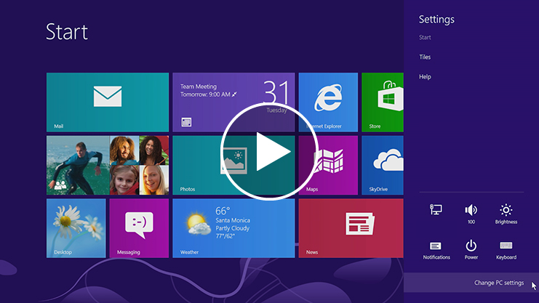
Play video on Where is Control Panel? page
Watch a video about finding and changing settings (http://windows.microsoft.com/en-US/windows-8/where-is-control-panel.)
To open PC settings
- Swipe in from the right edge of the screen, tap Settings, and then tap Change PC settings.
(If you're using a mouse, point to the upper-right corner of the screen, move the mouse pointer down, click Settings, and then click Change PC settings.)
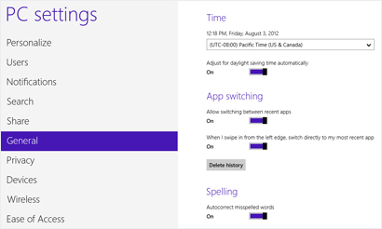
PC settings screen with General settings highlighted
In PC settings, you can personalize the Start and lock screens, customize the Search and Share charms, add user accounts, and change various other settings.
To open Control Panel
- Open Control Panel by swiping in from the right edge of the screen, tapping Search (or if you're using a mouse, pointing to the upper-right corner of the screen, moving the mouse pointer down, and then clicking Search), entering Control Panel in the search box, tapping or clicking Apps, and then tapping or clicking Control Panel.
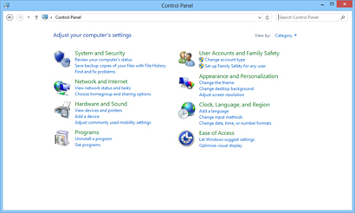
Control Panel
Control Panel has familiar settings like themes and desktop backgrounds, Family Safety, screen resolution,
and more.
To open the Settings charm
- Swipe in from the right edge of the screen, and then tap Settings.
(If you're using a mouse, point to the upper-right corner of the screen, move the mouse pointer down, and then click Settings.)
In the Settings charm, you'll find settings, help, and info for the app you're in, plus a few common PC settings—network connection, volume, brightness, notifications, power, and keyboard. These PC settings are the same no matter where you are in Windows, but the app settings are different in every app.
To search for settings
If you're not sure where to find the settings you're looking for, you can search your PC.
- Swipe in from the right edge of the screen, and then tap Search.
(If you're using a mouse, point to the upper-right corner of the screen, move the mouse pointer down, and then click Search.)
- Enter a word or phrase in the Search box, tap or click Settings, and then select from the list of results.
How to use the taskbar
You can customize the taskbar, including the way taskbar buttons look, how they group together when you have more than one window open, change where the taskbar is on your desktop, and decide what icons and apps are on it.
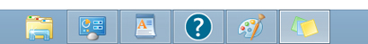
The taskbar
Rearrange taskbar buttons
- To rearrange the order of app buttons on the taskbar, drag a button from its current position to a different position on the taskbar. You can rearrange apps as often as you like.
Note:
All open files from the same app are always grouped together, even if you didn’t open them one after the other. This is so you can see all of the previews for that app at the same time.
Move the taskbar
Usually, you can find the taskbar at the bottom of the desktop, but you can move it to the sides or top of the desktop. Before you can move the taskbar, you need to unlock it.
To unlock the taskbar
- Press and hold or right-click an empty space on the taskbar. If Lock the taskbar has a check mark next to it, the taskbar is locked. You can unlock it by tapping or clicking Lock the taskbar, which removes the
check mark.
To move the taskbar
- Do one of the following:
  - Tap an empty space on the taskbar, and then drag it to one of the four edges of the desktop. When the taskbar is where you want it, let go.
  - (If you're using a mouse, click an empty space on the taskbar, and then hold down the mouse button as you drag the taskbar to one of the four edges of the desktop. When the taskbar is where you want it, release the mouse button.)
Note:
To lock the taskbar into place, press and hold or right-click an empty space on the taskbar, and then tap or click Lock the taskbar so that the check mark appears. This helps make sure that the taskbar doesn't accidentally get moved or resized.
Change how taskbar buttons appear
You can choose how buttons are grouped together when there's more than one window open, and change the size of taskbar button icons.
- Open Taskbar Properties by swiping in from the right edge of the screen, tapping Search (or if you're using a mouse, pointing to the upper-right corner of the screen, moving the mouse pointer down, and then clicking Search), entering Taskbar in the search box, tapping or clicking Settings, and then tapping or
clicking Taskbar.
- On the Taskbar tab, select one of the options from the Taskbar buttons list:
  - Always combine, hide labels
This is the default setting. Each app appears as a single, unlabeled button, even when multiple windows for that app are open.
  - Combine when taskbar is full
This setting shows each window as an individual, labeled button. When the taskbar becomes crowded, apps with multiple open windows collapse into a single app button. Tap or clicking the button displays a list of the windows that are open.
  - Never combine
This setting shows each window as an individual, labeled button, and never combines them, no matter how many windows are open. As more apps and windows open, buttons get smaller, and eventually the buttons will scroll.
- To use small taskbar button icons, select the Use small taskbar buttons check box. To use large icons, clear the check box.
- Tap or click OK.
Pin an app to the taskbar
You can pin an app directly to the taskbar for quick and easy access.
- Swipe in from the right edge of the screen, and then tap Search.
(If you're using a mouse, point to the upper-right corner of the screen, move the mouse pointer down, and then click Search.) In the search box, enter the name of the app you want to pin. Then, on the search results page, tap or click the app to open it on the desktop.
- On the desktop, press and hold or right-click the app's button on the taskbar to open the app’s Jump List (a list of shortcuts to recently opened files, folders, and websites), and then tap or click Pin this program
to taskbar.
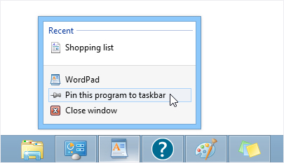
Pin an app to the taskbar for easy access.
Note:
• To remove a pinned app from the taskbar, open the app's Jump List, and then tap or click Unpin this program from taskbar.
• Folders and shortcuts to folders appear in the File Explorer Jump List.
Customize the notification area
The notification area is located at the far right side of the taskbar, and it contains app icons that provide status and notifications about things like incoming email, updates, and network connectivity. You can change which icons and notifications appear there.
To hide an Icon in the notification area
- In the notification area at the far right of the taskbar, tap or click the icon you want to hide, and then drag it toward the desktop.
Tip:
• If you want to re-add a hidden icon, tap or click the Show hidden icons arrow next to the notification area , and then drag the icon you want to move back to the notification area. You can drag as many hidden icons as you want.
• You can rearrange icons that appear in the notification area—just drag an icon to a
different spot.
To view hidden icons
- Tap or click the Show hidden icons arrow next to the notification area.
To change how icons and notifications appear in the notification area
- Press and hold or right-click an empty area on the taskbar, and then tap or click Properties.
- Next to Notification area, tap or click Customize.
- For each icon, select one of these options, and then tap or click OK:
  - Show icon and notifications. The icon is always in the notification area of the taskbar and
notifications appear.
  - Hide icon and notifications. The icon is hidden and you won't see notifications for that app.
  - Only show notifications. The icon is hidden, but notifications will appear.
Take a look at the desktop
You can use the Show desktop button at the right end of the taskbar to minimize your open windows and get to the desktop quickly. And if you're using a mouse, you can also use it to preview the desktop without closing or minimizing your open windows.
To minimize all of the open windows on the desktop
- Tap or click the Show desktop button at the right end of the taskbar. All of the open windows minimize, revealing the desktop.
- To get the windows back, tap or click the Show desktop button again.
To turn on desktop preview
Note:
• You can only change this setting if you're using a mouse.
• Right-click the Show desktop button at the right end of the taskbar and click Peek at desktop.
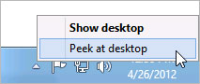
Use the Show desktop button to show the desktop or peek at it.
To preview the desktop
Note:
Desktop preview only works if you're using a mouse.
- Point to the Show desktop button at the right end of the taskbar. The open windows fade from view, revealing the desktop.
- To make the windows reappear, move the mouse away from the Show desktop button.
Change taskbar settings for multiple displays
If you're using more than one display (for example, if you have more than one monitor), you can decide whether you want to have a taskbar on all of your displays, and how you want buttons to be arranged on the taskbars.
To show a taskbar on all of your displays
- Open Taskbar Properties by swiping in from the right edge of the screen, tapping Search (or if you're using a mouse, pointing to the upper-right corner of the screen, moving the mouse pointer down, and then clicking Search), entering Taskbar in the search box, tapping or clicking Settings, and then tapping or
clicking Taskbar.
- Under Multiple displays, make sure the Show taskbar on all displays check box is selected, and then tap or click OK.
To choose how taskbar buttons are shown on multiple displays
- Open Taskbar Properties by swiping in from the right edge of the screen, tapping Search (or if you're using a mouse, pointing to the upper-right corner of the screen, moving the mouse pointer down, and then clicking Search), entering Taskbar in the search box, tapping or clicking Settings, and then tapping or
clicking Taskbar.
- Under Multiple displays, select one of the options from the Show taskbar buttons on: list, and then tap or click OK.
  - All taskbars
The taskbar buttons for all of your open windows will be duplicated on the taskbars on each display.
  - Main taskbar and taskbar where window is open
This setting shows a taskbar button on your main monitor and duplicates it on the taskbar on the display where the window is open.
  - Taskbar where window is open
This setting shows a taskbar button only on the display where the window is open. None of the buttons are duplicated on other taskbars.
Adding apps, websites, and more to Start
You can easily access what you use most by pinning your favorite apps, websites, and more to the Start screen. There are several ways to do this.
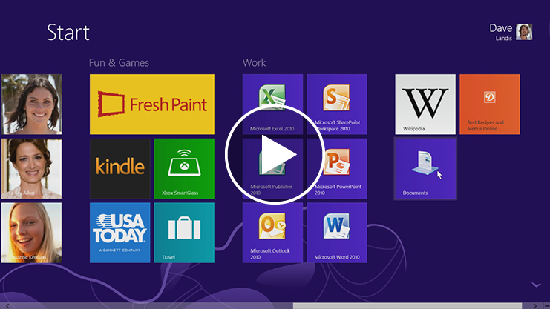Play video on Adding apps, websites, and more to Start page.
Watch a video about adding apps, websites, and more to Start (http://windows.microsoft.com/en-US/windows-8/adding-apps-websites-to-start).

To pin this to Start |  | Do this
Apps from the Windows Store |  | They are automatically pinned to Start when you install them.
All other apps |  | - Swipe in from the right edge of the screen, and then tap Search.  (If you're using a mouse, point to the upper-right corner of the screen, move the mouse pointer down, and then click Search.)  - Enter the app name, or scroll until you find it.  - Swipe down on or right-click the app to select it.  - Tap or click Pin to Start.
Things you use frequently, like websites and contacts |  | - Open the app you want to use, such as Microsoft Internet Explorer or the  People app.  - Select the item you want to pin to Start.  - Tap or click Pin to Start.  - Enter a name or short description, and then tap or click Pin to Start. The tile is added at the far side of Start.  Note:  Some apps might have different steps or might not support pinning items to Start. For more info, check Help for the app.
Folders you use frequently, like Documents or Pictures |  | - Open File Explorer by swiping in from the right edge of the screen, tapping Search (or if you're using a mouse, pointing to the upper-right corner of the screen, moving the mouse pointer down, and then clicking Search), entering File Explorer in the search box, tapping or clicking Apps, and then tapping or clicking  File Explorer.  - Browse to the folder you want to pin, press and hold or right–click it, then tap or click Pin to Start.
To unpin something from Start, swipe down on it or right-click it, and then tap or click Unpin from Start.
To learn more about how to rearrange tiles, see Rearranging tiles on Start.
Connect multiple monitors to your PC
Connecting another monitor to your laptop or desktop is a great way to get the best out of your PC. You can use one monitor for work (programming, files, work email) and the other for play (chatting with friends, social updates, or movies).
Connect another screen to your PC
- To connect a monitor to your desktop PC, use a video card that has two DVI (or VGA) ports—most PCs today do, and most flat panel monitors have a matching port. If you have a video card with two ports, you can usually just plug two monitors into the matching ports. Look on the back of your desktop PC for the video ports, and match the cable from each monitor to the corresponding port. These ports connect directly to your video card.
- If you have a laptop or tablet, plug a monitor into the PC’s DVI, VGA, or HDMI port, and Windows 8 will automatically detect the monitor.
In both cases, you might need an adapter to plug a DVI cable into a VGA port or vice versa.
Note:
If you have a video card with only one port, some PC makers include custom monitor cables that split the signal from one port to two monitors.
Set up your screens
Once you plug in your screen, you can choose your display options. To do that:
- Swipe in from the right edge of the screen, and then tap Devices.
(If you're using a mouse, point to the upper-right corner of the screen, move the mouse pointer down, and then click Devices.)
- Tap or click Second screen and then choose one of these options:
  - Duplicate. You’ll see the same things on both screens.
  - Extend. Your screen is now spread over two monitors, and you can drag and move items between
the two.
  - Second screen only. You’ll see everything on the connected screen, and the other one will remain blank.
Sync your settings
A Microsoft account—an email address and password—is a new way to sign in to any PC running Windows 8 or Windows RT. When you sign in with a Microsoft account, your PC is connected to the cloud, and many of the settings, preferences, and apps associated with your account can "follow" you between different PCs.
You can sync your Personalization and Ease of Access settings so that all your accessibility selections are reflected in your computer settings.
Your personal settings are automatically synced online and between the Windows 8 and Windows RT PCs you use. This includes items like your themes, language preferences, browser favorites and history, and content for Microsoft apps and services Find out more (http://windows.microsoft.com/en-US/windows-8/microsoft-account#1TC=t1).

Mouse and Keyboard
Mouse and keyboard: What's new in Windows
Most of what you know about using a mouse and keyboard with Windows has stayed the same, especially in the desktop. Here are a few ways to use the new Windows 8 and Windows RT features with a mouse and with keyboard shortcuts—and how to find some familiar things in new places.
To do this |  | With a mouse |  | With a keyboard
Open the charms (Search, Share, Start, Devices, and Settings). |  | Point to the upper-right or lower-right corner to see the charms. (Try moving so  far into the corner that the mouse pointer disappears.) When the charms appear, move up or down the edge to click the one  you want.  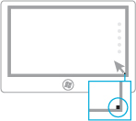 |  | All charms: Windows logo key +C  Search charm: Windows logo key +Q  Share charm: Windows logo key +H  Start charm: Windows logo key  Devices charm: Windows logo key +K  Settings charm: Windows logo key +I
Search your PC (apps, settings, and files), the web, or within  an app. |  | Point to the upper-right or lower-right corner to see the charms. (Try moving so far into the corner that the mouse pointer disappears.) When the charms appear, move up or down the edge, click Search, and then enter your search term. If you want to search settings, files, or another app, click  that option. |  | If you’re on Start, just start typing your search term.  If you want to see a list of all apps on your PC, right-click the Start screen, and then click  All apps.  Search within apps or find an app: Windows logo key +Q  Search settings: Windows logo key +W  Search files: Windows logo key +F
Go to Start. |  | Point to the lower-left corner. When Start appears, click the corner.  Point to the upper-right or lower-right corner to see the charms. (Try moving so far into the corner that the mouse pointer disappears.) When the charms appear, move up or down the edge, and then click Start. |  | Press the Windows logo key on your keyboard.
Get to commands and  context menus. |  | Right-click to see commands and context menus. Right-clicking on items often brings up options specific to that item.  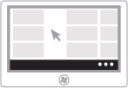 |  | Windows logo key +Z  Use Tab or arrows keys to highlight things, and then press the space bar or Enter.
Switch between recently  used apps. |  | To switch to your most recently used app, point to the upper-left corner. (Try moving it so far into the corner that the mouse pointer disappears.) When the previous app appears, click the corner.  To switch to a different app, point to the upper-left corner and then move down slightly. When the other apps appear, click the one you want.  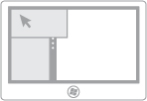 |  | Windows logo key +Tab
Snap an app to use two apps  side by side.  Note:  Your screen resolution must be at least 1366 x 768 to snap apps. To check this setting:  Open Screen Resolution by swiping in from the right edge of the screen, tapping Search (or if you're using a mouse, pointing to the upper-right corner of the screen, moving the mouse pointer down, and then clicking Search), entering Display in the search box, tapping or clicking Settings, and then tapping or clicking Display.  The desktop is treated as a single app. |  | Move your pointer into the upper-left corner until the second app appears, and then drag that app to the left or right side of the screen until an opening appears  behind it.  You can also point to the upper-left corner and then move the pointer down to see the apps you've used recently. Click and drag the app you want to snap.  Keep the app that size, or resize it to fill  two-thirds or the full screen. |  | Windows logo key +Period
Open the desktop. |  | Go to Start, and then click the Desktop tile. |  | Windows logo key +D
Zoom in or out |  | On Start, use the zoom icon in the  lower-right corner or Ctrl+Scrollwheel. |  | Ctrl+Plus sign to zoom in  Ctrl+Minus sign to  zoom out
Close an app |  | Point to the top edge of the screen, and then click and drag the app to the bottom of the screen.  You can also close apps you've used recently by pointing to the upper-left corner and then pulling down. Right-click the one you want. and then select Close. |  | Alt+F4
Shut down |  | Point to the upper-right or lower-right corner to see the charms. (Try moving so far into the corner that the mouse pointer disappears.) When the charms appear, move up or down the edge, and then click Settings. Click Power, and then select a shutdown option. |  | Press Ctrl+Alt+Del.  Use the Tab key to move to the Power icon. A list of shutdown options appears.  Use the up or down arrow keys to get to the option you want.  Press Enter.
How to use the touch keyboard
You can use different keyboards with Windows to fit your needs. The most common is a physical, external keyboard that you plug into your PC. Windows 8 and Windows RT also include a touch keyboard for PCs
with touch.
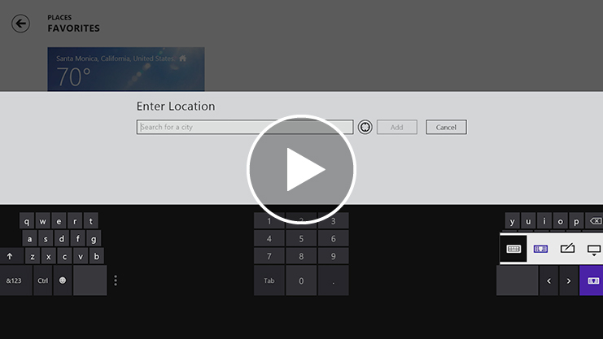
Play video on the How to use the touch keyboard webpage.
Watch a video about using the touch keyboard (http://windows.microsoft.com/en-US/windows-8/using-touch-keyboard/).
To use the touch keyboard, tap in a text field or other area where you can type. The keyboard appears automatically.
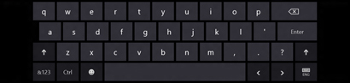
The touch keyboard
In some places that you type, the touch keyboard suggests words so you can correct misspellings with a tap. And, the keyboard layout automatically adjusts to the language you choose for Windows.
If you're using a tablet, you might want to switch to the thumb keyboard, which splits the keys on either side of the screen, making it easier and more comfortable to use.

Note:
The thumb keyboard might not be available in all languages.
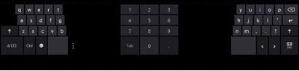
The thumb keyboard
Tip:
Here are a few tips when you're using the touch keyboard:
• Switch between the touch keyboard and thumb keyboard by tapping the keyboard icon in the lower-right corner of the keyboard.
• Close the keyboard by tapping outside the text box or by using the keyboard icon.
• Use keyboard shortcuts by tapping the Ctrl key and then tapping another key.
• Turn Caps Lock on and off by double-tapping the Up Arrow key.
• Automatically insert a period by double-tapping the Spacebar.
• If you're looking for some fun characters, tap the Emoticon key.
If you want to open the touch keyboard manually (without tapping in a text field or other area where you can type), here's how:
- Swipe in from the right edge of the screen, and then tap Settings.
(If you're using a mouse, point to the upper-right corner of the screen, move the mouse pointer down, and then click Settings.)
- Tap the Keyboard icon.
- Tap Touch keyboard and handwriting panel.
- Tap where you want to type.
Touch: swipe, tap, and beyond
If you want to know what we mean when we mention swipe, tap, or other ways to interact with Windows 8 or Windows RT when you’re using a touchscreen, take a look at this table.

What we say |  | How to do it |  | What it does
Tap  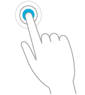 |  | Tap once on the item. |  | Opens whatever you tap. Similar to clicking with a mouse.
Press and hold  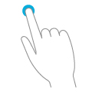 |  | Press your finger down and leave it there for a few seconds. |  | Shows info to help you learn more about an item.  Opens a menu specific to what you're doing. Similar to right-clicking with  a mouse.
Pinch or stretch to zoom  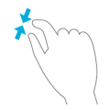 |  | Touch the screen or an item with two or more fingers, and then move the fingers toward each other (pinch) or away from each other (stretch). |  | Shows different levels of info. A good place to explore this is the Start screen.  Visually zooms in or out, like with pictures or maps.
Rotate  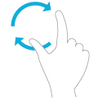 |  | Put two or more fingers on an item and then turn your hand. |  | Rotates things in the direction you turn your hand. Only some items can  be rotated.
Slide to scroll  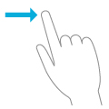 |  | Drag your finger on the screen. |  | Moves through what’s on the screen. Similar to scrolling with a mouse.
Slide to rearrange  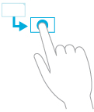 |  | Press and drag an item in the opposite direction you would scroll. (For example, if you would scroll left or right, drag the item up or down.) When you've moved the item to the new location, release it. |  | Moves an item. Similar to dragging with a mouse. A good place to explore this is the Start screen.
Swipe to select  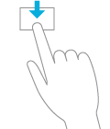 |  | Slide an item a short distance in the opposite direction compared to how the page scrolls. (For example, if you would scroll left or right, slide the item up or down.) A quick, short movement works best. |  | Selects an item, like a photo or tile on Start. This often brings up app commands.
Swipe from edge  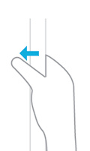 |  | Starting on the edge, swipe in. |  | - Right edge: Opens the charms (Search, Share, Start, Devices, Settings).  - Left edge:  - Brings in open apps.  - Snaps apps. Swipe in from the left edge and drag the app until a divider appears, and then move the app where you want it. Slide the divider to adjust app size.  - Shows your recently opened apps. Swipe in from the left edge without lifting your finger, and then push the app back toward the left edge.  - Closes apps. Swipe an app from the list without lifting your finger, and then drag it to the bottom of the screen.  - Top or bottom edge:  - Shows commands, like New  and Refresh.  - Closes apps. Swipe down from the top without lifting your finger, and then drag the app to the bottom of the screen.

Note:
• Your screen must be a touchscreen to use these interactions. To check your pen and
touch settings:
Open System by swiping in from the right edge of the screen, tapping Search (or if you're using a mouse, pointing to the upper-right corner of the screen, moving the mouse pointer down, and then clicking Search), entering System in the search box, tapping or clicking Settings, and then tapping or clicking System.
• Your screen resolution must be at least 1366 x 768 to snap apps. To check this setting:
Open Screen Resolution by swiping in from the right edge of the screen, tapping Search (or if you're using a mouse, pointing to the upper-right corner of the screen, moving the mouse pointer down, and then clicking Search), entering Display in the search box, tapping or clicking Settings, and then tapping or clicking Display.
To learn about how to do similar tasks using a mouse and keyboard, see Mouse and keyboard: What's new in Windows. For more on using the new features, see Get to know Windows.
Touch and pen settings: Frequently asked questions
Here are answers to some common questions about touch and pen settings.
How do I check if my PC has a touchscreen?
Try using your finger to tap a tile on Start. If it’s a touchscreen, the app will open. You can also check your current system settings with your mouse:
From Start, click the Desktop tile.
- Point to the upper-right corner of the screen, move the mouse pointer down, and then click Settings.
- Click PC info.
- Under System, check the Pen and Touch setting. If your PC’s screen is a touchscreen, it will describe what input it supports.
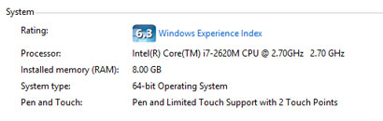
Pen and Touch info under System
Touch input is on by default and can’t be turned off. If you expect your laptop or monitor to respond to touch and it doesn’t, check the manufacture’s website to make sure it supports touch and that you have the correct
drivers installed.
How do I calibrate my pen and touch settings?
To adjust how accurately your screen senses when you use a pen or finger:
- Swipe in from the right edge of the screen, and then tap Search.
(If you're using a mouse, point to the upper-right corner of the screen, move the mouse pointer down, and then click Search.)
- Enter calibrate in the search box, tap or click Settings, and then tap or click Calibrate the screen for pen or touch input to open Tablet PC Settings.
- Check that the monitor shown in the Display field matches the screen you want to calibrate.
- Tap or click Calibrate, and then follow the on-screen instructions.
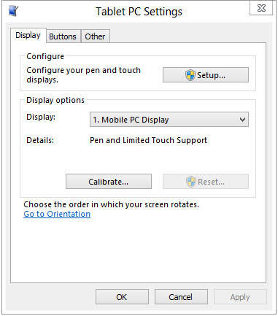
Tablet PC Settings
How do I get my touchscreen to go to the correct screen?
- Swipe in from the right edge of the screen, and then tap Search.
(If you're using a mouse, point to the upper-right corner of the screen, move the mouse pointer down, and then click Search.)
- Enter calibrate in the search box, tap or click Settings, and then tap or click Calibrate the screen for pen or touch input to open Tablet PC Settings.
- Tap or click Setup, and then follow the on-screen instructions.
Tablet PC Settings
How do I change my pen and touch actions?
To change how fast, far, or long an action takes:
- Swipe in from the right edge of the screen, and then tap Search.
(If you're using a mouse, point to the upper-right corner of the screen, move the mouse pointer down, and then click Search.)
- Enter pen and touch in the search box, tap or click Settings, and then tap or click Pen and Touch.
- Tap or click the action you want to configure, and then click Settings. Follow the on-screen instructions.
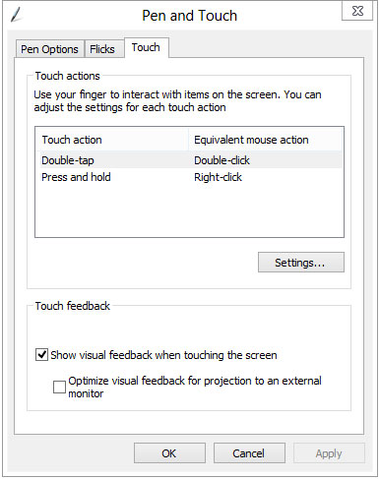
Pen and Touch Settings
Change keyboard settings
If you want to make the keyboard easier to use, you can change the settings to suit your needs.
- Swipe in from the right edge of the screen, and then tap Search.
(If you're using a mouse, point to the upper-right corner of the screen, move the mouse pointer down, and then click Search.)
- In the search box, enter Change how your keyboard works, tap or click Settings, and then tap or click Change how your keyboard works.
- Select the options that you want to use:
  - Turn on Mouse Keys. If using a mouse is awkward or hard to use, you can turn on Mouse Keys so you don’t need to use the mouse. Instead, you can use the arrow keys on your keyboard or use the numeric keypad to move the pointer. For more info, type Move the pointer with the keypad using Mouse Keys, in the search box, then tap or click Settings.
  - Turn on Sticky Keys. With Sticky Keys turned on, you won’t have to press complicated key combos. For example, instead of pressing the Ctrl+Alt+Del keys at the same time, you can press keys one at a time.
  - Turn on Toggle Keys. Toggle Keys play an alert each time you press the Caps Lock, Num Lock, or Scroll Lock keys. These notifications can help prevent the frustration of inadvertently pressing a key and not realizing it.
  - Turn on Filter Keys. When you turn on Filter Keys, Windows will ignore keystrokes that occur in rapid succession, or keystrokes that are held down for several seconds unintentionally.
  - Underline keyboard shortcuts and access keys. This option makes keyboard access in dialog boxes easier by highlighting the access keys of the controls. For more info about keyboard shortcuts, see Keyboard shortcuts.
  - Prevent windows from being automatically arranged when moved to the edge of the screen. With this option, you can prevent windows from automatically resizing and docking along the sides of your screen when you move them.
Note:
• If you prefer to use your PC without using a keyboard, try using On-Screen Keyboard, a tool that lets you enter text by selecting characters on the screen. For more info, see
Use On-Screen Keyboard to type.
• If you're looking for new ways to use a mouse and keyboard, see
Mouse and keyboard: What’s new in Windows.
Change the keyboard layout
You can add a keyboard layout to a language and switch to using that if you want to use the same layout to type in different languages or don't want to use the default one that Windows provides.
To change the keyboard layout for a language
- Swipe in from the right edge of the screen, and then tap Search.
(If you're using a mouse, point to the upper-right corner of the screen, move the mouse pointer down, and then click Search.)
- Enter language, choose Settings, and then tap or click Add a language.
- Select the language that you want to add a keyboard layout to.
- Tap or click Options next to the language name, and then under Input method, tap or click Add an
input method.
- Browse the input method list or use the search box to find the keyboard layout you want to use.
- Double-tap or double-click the keyboard layout, and then tap or click Save.
Change mouse settings
If you want to make the mouse easier to use, you can change the settings to suit your needs.
To change the mouse settings
- Swipe in from the right edge of the screen, and then tap Search.
(If you're using a mouse, point to the upper-right corner of the screen, move the mouse pointer down, and then click Search.)
- In the search box, enter Change how your mouse works, tap or click Settings, and then tap or click Change how your mouse works.
- Select the options that you want to use:
  - Change the color and size of mouse pointers. You can use these options to make the mouse pointer larger, or change the color to make it easier to see.
  - Turn on Mouse Keys. You can use this option to control the movement of the mouse pointer by using the numeric keypad. For more info, type Move the pointer with the keypad using Mouse Keys, in the search box, then tap or click Settings.
  - Activate a window by hovering over it with the mouse. This option makes it easier to select and activate a window by pointing at it with the mouse rather than by clicking it.
  - Prevent windows from being automatically arranged when moved to the edge of the screen. This option prevents windows from automatically resizing and docking along the sides of your screen when you move them there.
Note:
• If you prefer to use your PC without using a mouse, try using Windows Speech Recognition, a tool that lets you use voice commands to work with Windows. For more info, see Using
Speech Recognition.
• If you're looking for new ways to use a mouse and keyboard, see Mouse and keyboard: What’s new in Windows.
Use the numeric keypad to move the mouse pointer
When you turn on Mouse Keys, you can move the mouse pointer using the numeric keypad on your keyboard instead of using a mouse.
To turn on Mouse Keys
- Swipe in from the right edge of the screen, and then tap Search.
(If you're using a mouse, point to the upper-right corner of the screen, move the mouse pointer down, and then click Search.)
- Tap or click Settings.
- In the search box, enter Change how your mouse works, and then tap or click Change how your
mouse works.
- Under Control the mouse with the keyboard, select the Turn on Mouse Keys check box, and then or
click OK.
Moving the pointer using Mouse Keys
After you turn on Mouse Keys, you can use the numeric keypad to move the mouse.
To move the mouse pointer | Press
Up | 8
Down | 2
Right | 6
Left | 4
Up and to the left | 7
Up and to the right | 9
Down and to the left | 1
Down and to the right | 3
Selecting a mouse button
Before you use Mouse Keys to click items on your screen, you’ll first need to select which mouse button you want to be the active button: the left button, the right one, or both.
To | Press
Select the left mouse button | The forward slash (/)
Select both buttons | The asterisk (*)
Select the right mouse button | The minus sign (-)
Note:
If you choose to make the left mouse button the active button, it will remain the active button until you choose another button. After you select a mouse button, you don't need to select a mouse button again until you want to change buttons.
Clicking items using Mouse Keys
After you choose a button, you can click items on your screen.
To | Do this
Click an item | With the left button selected as your active button, point to the item, and then press 5
Right-click an item | With the right button selected as your active button, point to the item, and then press 5
Double-click an item | With the left button selected as your active button, point to the item, and then press the plus sign (+)
Dragging items using Mouse Keys
You can use the numeric keypad to press and hold the active mouse button and to release it. This is helpful if you want to drag an item.
To | Do this
Drag an item | Point to the item, and then press zero (0)
Drop the item | Point to the location where you want to move the item, and then press the decimal point (.)
Note:
• You can also turn on Mouse Keys by pressing Left Alt+Left Shift+Num Lock.
• To change how quickly the mouse pointer moves, whether your computer makes a sound when you turn on Mouse Keys, and other options, in the Ease of Access Center, under Control the mouse with the keyboard, click Set up Mouse Keys.

Keyboard Shortcuts
Keyboard shortcuts are combinations of two or more keys that you can use to perform a task that would typically require a mouse or other pointing device. Keyboard shortcuts can make it easier to work with your PC, saving you time and effort as you work with Windows and other apps.
Most apps also provide accelerator keys that can make it easier to work with menus and other commands. Check the menus of apps for accelerator keys. If a letter of a word is underlined in a menu, it usually means you can press the Alt key and the underlined key together instead of clicking that menu item. When you're using a touch keyboard, you can also see some shortcuts when you press the Ctrl key.
Pressing the Alt key in some apps, such as Paint and WordPad, shows commands that are labeled with additional keys that you can press to use them.
Note:
If you're looking for new ways to use a mouse and keyboard, see Mouse and keyboard:
What's new in Windows.
New keyboard shortcuts for Windows 8 and Windows RT
With Windows 8 and Windows RT, you can use the keyboard shortcuts you're already using, and you'll find new ones too. For example, the easiest way to search on the Start screen is to simply start typing. Not on the Start screen? Press the Windows logo key‌ and you can quickly switch between Start and the app you're in.
If you’re not familiar with keyboard shortcuts—or you’d like to see a list of shortcuts in one place—see the bigger list of keyboard shortcuts.
Useful keyboard shortcuts for Windows
Press this |  | To do this
Windows logo key‌ +  start typing |  | Search your PC
Ctrl+plus (+) or Ctrl+minus (-) |  | Zoom in or out of a large number of items, like apps pinned to the  Start screen
Ctrl+scroll wheel |  | Zoom in or out of a large number of items, like apps pinned to the  Start screen
Windows logo key‌ +C |  | Open the charms
Windows logo key‌ +F |  | Open the Search charm to search files
Windows logo key‌ +H |  | Open the Share charm
Windows logo key‌ +I |  | Open the Settings charm
Windows logo key‌ +J |  | Switch the main app and snapped app
Windows logo key‌ +K |  | Open the Devices charm
Windows logo key‌ +O |  | Lock the screen orientation (portrait or landscape)
Windows logo key‌ +Q |  | Open the Search charm to search apps
Windows logo key‌ +W |  | Open the Search charm to search settings
Windows logo key‌ +Z |  | Show the commands available in the app
Windows logo key‌ + spacebar |  | Switch input language and keyboard layout
Windows logo key‌ + Ctrl+spacebar |  | Change to a previously selected input
Windows logo key‌ +Tab |  | Cycle through open apps (except desktop apps)
Windows logo key‌ + Ctrl+Tab |  | Cycle through open apps (except desktop apps) and snap them as they  are cycled
Windows logo key‌ + Shift+Tab |  | Cycle through open apps (except desktop apps) in reverse order
Windows logo key‌ +  PgUp |  | Move the Start screen and apps to the monitor on the left (Apps in the desktop won’t change monitors)
Windows logo key‌ + PgDown |  | Move the Start screen and apps to the monitor on the right (apps in the desktop won’t change monitors)
Windows logo key‌ + Shift+period (.) |  | Snaps an app to the left
Windows logo key‌ +  period (.) |  | Snaps an app to the right
Complete list of keyboard shortcuts
General keyboard shortcuts
The following table contains general keyboard shortcuts that you can use to navigate around Windows.
Press this key |  | To do this
F1 |  | Display Help
F2 |  | Rename the selected item
F3 |  | Search for a file or folder
F4 |  | Display the address bar list in File Explorer
F5 |  | Refresh the active window
F6 |  | Cycle through screen elements in a window or on the desktop
F10 |  | Activate the menu bar in the active app
Alt+F4 |  | Close the active item, or exit the active app
Alt+Esc |  | Cycle through items in the order in which they were opened
Alt+underlined letter |  | Perform the command for that letter
Alt+Enter |  | Display properties for the selected item
Alt+Spacebar |  | Open the shortcut menu for the active window
Alt+Left arrow |  | Back
Alt+Right arrow |  | Forward
Alt+Page Up |  | Move up one screen
Alt+Page Down |  | Move down one screen
Alt+Tab |  | Switch between open apps (except desktop apps)
Ctrl+F4 |  | Close the active document (in apps that allow you to have multiple documents open simultaneously)
Ctrl+A |  | Select all items in a document or window
Ctrl+C (or Ctrl+Insert) |  | Copy the selected item
Ctrl+D (or Delete) |  | Delete the selected item and move it to the Recycle Bin
Ctrl+R (or F5) |  | Refresh the active window
Ctrl+V (or Shift+Insert) |  | Paste the selected item
Ctrl+X |  | Cut the selected item
Ctrl+Y |  | Redo an action
Ctrl+Z |  | Undo an action
Ctrl+plus (+) or Ctrl+minus (-) |  | Zoom in or out of a large number of items, like apps pinned to the  Start screen
Ctrl+ mouse scroll wheel |  | Change the size of desktop icons or zoom in or out of a large number of items, like apps pinned to the Start screen
Ctrl+Right arrow |  | Move the cursor to the beginning of the next word
Ctrl+Left arrow |  | Move the cursor to the beginning of the previous word
Ctrl+Down arrow |  | Move the cursor to the beginning of the next paragraph
Ctrl+Up arrow |  | Move the cursor to the beginning of the previous paragraph
Ctrl+Alt+Tab |  | Use the arrow keys to switch between all open apps
Ctrl+arrow key (to move to an item)+Spacebar |  | Select multiple individual items in a window or on the desktop
Ctrl+Shift with an arrow key |  | Select a block of text
Ctrl+Esc |  | Open the Start screen
Ctrl+Shift+Esc |  | Open Task Manager
Ctrl+Shift |  | Switch the keyboard layout when multiple keyboard layouts are available
Ctrl+Spacebar |  | Turn the Chinese input method editor (IME) on or off
Shift+F10 |  | Display the shortcut menu for the selected item
Shift with any arrow key |  | Select more than one item in a window or on the desktop, or select text within a document
Shift+Delete |  | Delete the selected item without moving it to the Recycle Bin first
Right arrow |  | Open the next menu to the right, or open a submenu
Left arrow |  | Open the next menu to the left, or close a submenu
Esc |  | Stop or leave the current task
Dialog box keyboard shortcuts
The following table contains keyboard shortcuts that you can use to navigate dialog boxes.
Press this key |  | To do this
F1 |  | Display Help
F4 |  | Display the items in the active list
Ctrl+Tab |  | Move forward through tabs
Ctrl+Shift+Tab |  | Move back through tabs
Ctrl+number (number 1-9) |  | Move to nth tab
Tab |  | Move forward through options
Shift+Tab |  | Move back through options
Alt+underlined letter |  | Perform the command (or select the option) that goes with that letter
Spacebar |  | Select or clear the check box if the active option is a check box
Backspace |  | Open a folder one level up if a folder is selected in the Save As or Open dialog box
Arrow keys |  | Select a button if the active option is a group of option buttons
File Explorer keyboard shortcuts
The following table contains keyboard shortcuts for working with File Explorer windows or folders.
Press this key |  | To do this
Alt+D |  | Select the address bar
Ctrl+E |  | Select the search box
Ctrl+F |  | Select the search box
Ctrl+N |  | Open a new window
Ctrl+W |  | Close the current window
Ctrl+mouse scroll wheel |  | Change the size and appearance of file and folder icons
Ctrl+Shift+E |  | Display all folders above the selected folder
Ctrl+Shift+N |  | Create a new folder
Num Lock+asterisk (*) |  | Display all subfolders under the selected folder
Num Lock+plus (+) |  | Display the contents of the selected folder
Num Lock+minus (-) |  | Collapse the selected folder
Alt+P |  | Display the preview pane
Alt+Enter |  | Open the Properties dialog box for the selected item
Alt+Right arrow |  | View the next folder
Alt+Up arrow |  | View the folder that the folder was in
Alt+Left arrow |  | View the previous folder
Backspace |  | View the previous folder
Right arrow |  | Display the current selection (if it's collapsed), or select the first subfolder
Left arrow |  | Collapse the current selection (if it's expanded), or select the folder that the folder was in
End |  | Display the bottom of the active window
Home |  | Display the top of the active window
F11 |  | Maximize or minimize the active window
Taskbar keyboard shortcuts
The following table contains keyboard shortcuts for working with items on the desktop taskbar.
Press this key |  | To do this
Shift+click a taskbar button |  | Open an app or quickly open another instance of an app
Ctrl+Shift+click a  taskbar button |  | Open an app as an administrator
Shift+right-click a  taskbar button |  | Show the window menu for the app
Shift+right-click a  grouped taskbar button |  | Show the window menu for the group
Ctrl+click a grouped  taskbar button |  | Cycle through the windows of the group
Windows logo key keyboard shortcuts
The following table contains keyboard shortcuts that use the Windows logo key .
Press this key |  | To do this
Windows logo key +F1 |  | Open Windows Help and Support
Windows logo key |  | Display or hide the Start screen
Windows logo key +B |  | Set focus in the notification area
Windows logo key +C |  | Open the Charms
Windows logo key +D |  | Display and hide the desktop
Windows logo key +E |  | Open Computer
Windows logo key +F |  | Open the Search charm and search for files
Windows logo key +G |  | Cycle through Gadgets on the desktop
Windows logo key +H |  | Open the Share charm
Windows logo key +I |  | Open the Settings charm
Windows logo key +J |  | Switch the main app and snapped app
Windows logo key +K |  | Open the Devices charm
Windows logo key +L |  | Lock your PC or switch users
Windows logo key +M |  | Minimize all windows
Windows logo key +O |  | Lock device orientation
Windows logo key +P |  | Choose a presentation display mode
Windows logo key +Q |  | Open the Search charm and search for apps
Windows logo key +R |  | Open the Run dialog box
Windows logo key +T |  | Cycle through apps on the taskbar
Windows logo key +U |  | Open Ease of Access Center
Windows logo key +V |  | Cycle through notifications
Windows logo key +Shift+V |  | Cycle through notifications in reverse order
Windows logo key +W |  | Open the Search charm and search for settings
Windows logo key +X |  | Open the Quick Link menu
Windows logo key +Z |  | Show the commands available in the app
Windows logo key +, |  | Temporarily peek at the desktop
Windows logo key +Pause |  | Display the System Properties dialog box
Windows logo key +Ctrl+F |  | Search for PCs (if you're on a network)
Windows logo key +Shift+M |  | Restore minimized windows on the desktop
Windows logo key +number |  | Start the desktop app pinned to the taskbar in the position indicated by the number. If the app is already running, switch to that app.
Windows logo key + Shift+number |  | Start a new instance of the desktop app pinned to the taskbar in the position indicated by the number
Windows logo key + Ctrl+number |  | Switch to the last active window of the desktop app pinned to the taskbar in the position indicated by the number
Windows logo key + Alt+number |  | Open the Jump List for the desktop app pinned to the taskbar in the position indicated by the number
Windows logo key + Ctrl+Shift+number |  | Open a new instance of the desktop app located at the given position on the taskbar as an administrator
Windows logo key +Tab |  | Cycle through open apps (except desktop apps)
Windows logo key + Ctrl+Tab |  | Cycle through open apps (except desktop apps) and snap them as they are cycled
Windows logo key + Shift+Tab |  | Cycle through open apps (except desktop apps) in reverse order
Windows logo key +Ctrl+B |  | Switch to the app that displayed a message in the notification area
Windows logo key +  Up arrow |  | Maximize the desktop window
Windows logo key +  Down arrow |  | Minimize the desktop window
Windows logo key +  Left arrow |  | Maximize the desktop window to the left side of the screen
Windows logo key +  Right arrow |  | Maximize the desktop window to the right side of the screen
Windows logo key +  Home |  | Minimize all but the active desktop window (restores all windows on second stroke)
Windows logo key + Shift+Up arrow |  | Stretch the desktop window to the top and bottom of the screen
Windows logo key + Shift+Down arrow |  | Restore/minimize active desktop windows vertically, maintaining width
Windows logo key + Shift+Left arrow or Right arrow |  | Move a window in the desktop from one monitor to another
Windows logo key + Spacebar |  | Switch input language and keyboard layout
Windows logo key + Ctrl+Spacebar |  | Change to a previously selected input
Windows logo key +Enter |  | Open Narrator
Windows logo key +  Page Up |  | Move the Start screen and apps to the monitor on the left (apps in the desktop won’t change monitors)
Windows logo key +  Page Down |  | Move the Start screen and apps to the monitor on the right (apps in the desktop won’t change monitors)
Windows logo key + Shift+period (.) |  | Snap an app to the left
Windows logo key +  period (.) |  | Snap an app to the right
Windows logo key +/ |  | Initiate IME reconversion
Windows logo key + Alt+Enter |  | Open Windows Media Center
Windows logo key +  plus (+) or minus (-) |  | Zoom in or out using Magnifier
Windows logo key +Esc |  | Exit Magnifier

Calculator keyboard shortcuts
The following table contains keyboard shortcuts for working with Calculator.
Press this key |  | To do this
F1 |  | Open Calculator Help
F2 |  | Edit the calculation history
Alt+1 |  | Switch to Standard mode
Alt+2 |  | Switch to Scientific mode
Alt+3 |  | Switch to Programmer mode
Alt+4 |  | Switch to Statistics mode
Alt+C |  | Calculate or solve date calculations and worksheets
Ctrl+E |  | Open date calculations
Ctrl+H |  | Turn calculation history on or off
Ctrl+L |  | Press the MC button
Ctrl+M |  | Press the MS button
Ctrl+P |  | Press the M+ button
Ctrl+Q |  | Press the M- button
Ctrl+R |  | Press the MR button
Ctrl+U |  | Open unit conversion
Ctrl+Shift+D |  | Clear the calculation history
F9 |  | Press the +/– button
R |  | Press the 1/× button
@ |  | Press the square root button
Del |  | Press the CE button
Up arrow |  | Navigate up in the calculation history
Down arrow |  | Navigate down in the calculation history
Esc |  | Press the C button or stop editing the calculation history
Enter |  | Recalculate the calculation history after editing
F3 |  | Select Degrees in Scientific mode
F4 |  | Select Radians in Scientific mode
F5 |  | Select Grads in Scientific mode
Ctrl+B |  | Press the 3√x button in Scientific mode
Ctrl+G |  | Press the 10x button in Scientific mode
Ctrl+O |  | Press the cosh button in Scientific mode
Ctrl+S |  | Press the sinh button in Scientific mode
Ctrl+T |  | Press the tanh button in Scientific mode
Ctrl+Y |  | Press the y√x button in Scientific mode
D |  | Press the Mod button in Scientific mode
I |  | Press the Inv button in Scientific mode
L |  | Press the log button in Scientific mode
M |  | Press the dms button in Scientific mode
N |  | Press the ln button in Scientific mode
O |  | Press the cos button in Scientific mode
P |  | Press the pi button in Scientific mode
Q |  | Press the x^2 button in Scientific mode
S |  | Press the sin button in Scientific mode
T |  | Press the tan button in Scientific mode
V |  | Press the F-E button in Scientific mode
X |  | Press the Exp button in Scientific mode
Y |  | Press the x^y button in Scientific mode
# |  | Press the x^3 button in Scientific mode
; |  | Press the Int button in Scientific mode
! |  | Press the n! button in Scientific mode
F2 |  | Select Dword in Programmer mode
F3 |  | Select Word in Programmer mode
F4 |  | Select Byte in Programmer mode
F5 |  | Select Hex in Programmer mode
F6 |  | Select Dec in Programmer mode
F7 |  | Select Oct in Programmer mode
F8 |  | Select Bin in Programmer mode
F12 |  | Select Qword in Programmer mode
A-F |  | Press the A-F buttons in Programmer mode
J |  | Press the RoL button in Programmer mode
K |  | Press the RoR button in Programmer mode
< |  | Press the Lsh button in Programmer mode
> |  | Press the Rsh button in Programmer mode
% |  | Press the Mod button in Programmer mode
| |  | Press the Or button in Programmer mode
^ |  | Press the Xor button in Programmer mode
~ |  | Press the Not button in Programmer mode
& |  | Press the And button in Programmer mode
Spacebar |  | Toggles the bit value in Programmer mode
A |  | Press the Average button in Statistics mode
Ctrl+A |  | Press the Average Sq button in Statistics mode
S |  | Press the Sum button in Statistics mode
Ctrl+S |  | Press the Sum Sq button in Statistics mode
T |  | Press the S.D. button in Statistics mode
Ctrl+T |  | Press the Inv S.D. button in Statistics mode
D |  | Press the CAD button in Statistics mode
Calendar keyboard shortcuts
The following table contains keyboard shortcuts for working with the Calendar appapp.
Press this key |  | To do this
Ctrl+1 |  | Show the day view
Ctrl+2 |  | Show the week view
Ctrl+3 |  | Show the month view
Ctrl+T |  | Go to today
Ctrl+N |  | Create a new event
Page up |  | In month view, go to the previous month  In week view, go to the previous week  In day view, go to the previous two days
Ctrl+H |  | In month view, go to the previous month  In week view, go to the previous week  In day view, go to the previous two days
Page down |  | In month view, go to the next month  In week view, go to the next week  In day view, go to the next two days
Ctrl+J |  | In month view, go to the next month  In week view, go to the next week  In day view, go to the next two days
Right arrow |  | In a view, go to the next day
Left arrow |  | In a view, go to the previous day
Down arrow |  | In a view, go to the next hour
Up arrow |  | In a view, go to the previous hour
Esc |  | Go back
Ctrl+S |  | Save or send the event
Ctrl+P, use up and down arrows to select |  | Respond to an event
Ctrl+D |  | Delete an event
Ease Of Access keyboard shortcuts
The following table contains keyboard shortcuts that can help make your PC easier to use.
Press this key |  | To do this
Right Shift for eight seconds |  | Turn Filter Keys on and off
Left Alt+left Shift+Print Screen |  | Turn High Contrast on or off
Left Alt+left Shift+Num Lock |  | Turn Mouse Keys on or off
Shift five times |  | Turn Sticky Keys on or off
Num Lock for five seconds |  | Turn Toggle Keys on or off
Windows logo key +U |  | Open the Ease of Access Center
Internet Explorer keyboard shortcuts
You can find shortcuts for Internet Explorer at Internet Explorer shortcuts.
Magnifier keyboard shortcuts
The following table contains keyboard shortcuts for working with Magnifier.
Press this key |  | To do this
Windows logo key +plus (+) or minus (-) |  | Zoom in or out
Ctrl+Alt+Spacebar |  | Preview the desktop in full-screen mode
Ctrl+Alt+D |  | Switch to docked mode
Ctrl+Alt+F |  | Switch to full-screen mode
Ctrl+Alt+I |  | Invert colors
Ctrl+Alt+L |  | Switch to lens mode
Ctrl+Alt+R |  | Resize the lens
Ctrl+Alt+arrow keys |  | Pan in the direction of the arrow keys
Windows logo key +Esc |  | Exit Magnifier
Mail keyboard shortcuts
The following table contains keyboard shortcuts for working with the Mail app.
Press this key |  | To do this
Ctrl+R |  | Reply
Ctrl+Shift+R |  | Reply all
Ctrl+F |  | Forward
Ctrl+Shift+F |  | Hide or show the Folder pane
Ctrl+Shift+A |  | Hide or show the Accounts pane
Ctrl+U |  | Mark as unread
Ctrl+Q |  | Mark as read
Ctrl+A |  | Select all messages
Ctrl+N |  | New Message
F5 |  | Sync
Alt+B |  | Put focus on the bcc button
Alt+C |  | Put focus on the cc button  Accept
Alt+D |  | Decline
Alt+S |  | Send mail
Alt+T |  | Put focus on the To button  Tentative
Alt+V |  | Open the invitation in Calendar
Ctrl+Enter |  | Send mail
Ctrl+Shift+F |  | Select a font
Ctrl+Spacebar |  | Clear formatting
Ctrl+Y |  | Redo
F4 |  | Redo
Ctrl+[ |  | Increase font size one point
Ctrl+] |  | Decrease font size one point
Ctrl+Shift+, |  | Decrease font size
Ctrl+Shift+. |  | Increase font size
Ctrl+K |  | Add a link
Ctrl+E |  | Center
Ctrl+L |  | Left
Ctrl+R |  | Right
Ctrl+Shift+L |  | Bullets
Ctrl+M |  | Indent
Ctrl+Shift+M |  | Outdent
Tab or Shift+Tab |  | Indent/outdent when text is selected of when focus is in a list
Ctrl+' |  | Acute accent
Ctrl+, |  | Cedilla accent
Ctrl+Shift+6 |  | Circumflex accent
Ctrl+Shift+; |  | Diaeresis accent
Ctrl+` |  | Grave accent
Ctrl+Shift+7 |  | Ligature accent
Ctrl+Shift+2 |  | Ring accent
Ctrl+/ |  | Slash accent
Ctrl+Shift+` |  | Tilde accent
Alt+Ctrl+Shift+1 |  | Inverted exclamation mark
Alt+Ctrl+Shift+/ |  | Inverted question mark
Messaging keyboard shortcuts
The following table contains keyboard shortcuts for working with the Messaging app.
Press this key |  | To do this
Ctrl+N |  | Start a new conversation
Ctrl+N |  | Open the people picker
Ctrl+E |  | Open or close the emoticon picker
Ctrl+> |  | Next conversation
Ctrl+< |  | Previous conversation
Narrator keyboard shortcuts
The following table contains keyboard shortcuts for working with Narrator.
Press this key |  | To do this
Spacebar or Enter |  | Activate current item
Tab and arrow keys |  | Move around on the screen
Ctrl |  | Stop reading
Caps Lock+D |  | Read item
Caps Lock+M |  | Start reading
Caps Lock+H |  | Read document
Caps Lock+V |  | Repeat phrase
Caps Lock+W |  | Read window
Caps Lock+Page Up or  Page Down |  | Increase or decrease the volume of the voice
Caps Lock+plus (+) or minus (-) |  | Increase or decrease the speed of the voice
Caps Lock+Spacebar |  | Do default action
Caps Lock+Left or Right arrows |  | Move to previous/next item
Caps Lock+F2 |  | Show commands for current item
Press Caps Lock twice in  quick succession |  | Turn Caps Lock on or off
Caps+Esc |  | Exit Narrator

Narrator touch keyboard shortcuts
The following table contains keyboard shortcuts for working with Narrator on a four-point touch-enabled PC.
Press this key |  | To do this
Tap once with two fingers |  | Stop Narrator from reading
Tap three times with four fingers |  | Show all Narrator commands (including the ones not in this list)
Double-tap |  | Activate primary action
Triple-tap |  | Activate secondary action
Touch or drag a single finger |  | Read what’s under your fingers
Flick left/right with one finger |  | Move to next or previous item
Swipe left/right/up/down with two fingers |  | Scroll
Swipe down with three fingers |  | Start reading on explorable text
Paint keyboard shortcuts
The following table contains keyboard shortcuts for working with Paint.
Press this key |  | To do this
F1 |  | Open Paint Help
F11 |  | View a picture in full-screen mode
F12 |  | Save the picture as a new file
Ctrl+A |  | Select the entire picture
Ctrl+B |  | Bold selected text
Ctrl+C |  | Copy a selection to the Clipboard
Ctrl+E |  | Open the Properties dialog box
Ctrl+G |  | Show or hide gridlines
Ctrl+I |  | Italicize selected text
Ctrl+N |  | Create a new picture
Ctrl+O |  | Open an existing picture
Ctrl+P |  | Print a picture
Ctrl+R |  | Show or hide the ruler
Ctrl+S |  | Save changes to a picture
Ctrl+U |  | Underline selected text
Ctrl+V |  | Paste a selection from the Clipboard
Ctrl+W |  | Open the Resize and Skew dialog box
Ctrl+X |  | Cut a selection
Ctrl+Y |  | Redo a change
Ctrl+Z |  | Undo a change
Ctrl+plus (+) |  | Increase the width of a brush, line, or shape outline by one pixel
Ctrl+minus (-) |  | Decrease the width of a brush, line, or shape outline by one pixel
Ctrl+Page Up |  | Zoom in
Ctrl+Page Down |  | Zoom out
Alt (or F10) |  | Display keytips
Alt+F4 |  | Close a picture and its Paint window
Right arrow |  | Move the selection or active shape right by one pixel
Left arrow |  | Move the selection or active shape left by one pixel
Down arrow |  | Move the selection or active shape down by one pixel
Up arrow |  | Move the selection or active shape up by one pixel
Shift+F10 |  | Show the current shortcut menu
People App keyboard shortcuts
The following table contains keyboard shortcuts for the People app.
Press this key |  | To do this
Ctrl+N |  | Add a contact
Ctrl+S |  | Save changes
Delete |  | Delete a contact
Ctrl+F |  | Make a contact a favorite
Ctrl+Shift+1 |  | Pin a contact to Start
Esc |  | Go back
Home |  | Go to beginning of contact list
Page down |  | Go forward in the contact list
Page up |  | Go backwards in the contact list
End |  | Go to end of the contact list
Reader keyboard shortcuts
The following table contains keyboard shortcuts for working with the Reader app.
Press this key |  | To do this
F8 |  | Use two-page layout
Ctrl+R |  | Rotate the file 90 degrees clockwise
Ctrl+F |  | Find text in a file
F7 |  | Use keyboard selection mode
Ctrl+P |  | Print a file
Ctrl+O |  | Open a file
Ctrl+W |  | Close a file
Ctrl+M |  | Reader app home
Remote Desktop Connection on the desktop keyboard shortcuts
The following table contains keyboard shortcuts for working with Remote Desktop Connection on the desktop.
Press this key |  | To do this
Alt+Page Up |  | Move between apps from left to right
Alt+Page Down |  | Move between apps from right to left
Alt+Insert |  | Cycle through apps in the order that they were started
Alt+Home |  | Display the Start screen
Ctrl+Alt+Break |  | Switch between a window and full screen
Ctrl+Alt+End |  | Display the Windows Security dialog box
Ctrl+Alt+Home |  | In full-screen mode, activate the connection bar
Alt+Delete |  | Display the system menu
Ctrl+Alt+minus (-) on the numeric keypad |  | Place a copy of the active window, within the client, on the Terminal server clipboard (provides the same functionality as pressing Alt+Print Screen on a local PC)
Ctrl+Alt+plus (+) on the numeric keypad |  | Place a copy of the entire client window area on the Terminal server clipboard (provides the same functionality as pressing Print Screen on a local PC)
Ctrl+Alt+Right arrow |  | “Tab” out of the Remote Desktop controls to a control in the host app (for example, a button or a text box). Useful when the Remote Desktop controls are embedded in another (host) app.
Ctrl+Alt+Left arrow |  | “Tab” out of the Remote Desktop controls to a control in the host app (for example, a button or a text box). Useful when the Remote Desktop controls are embedded in another (host) app.

Remote Desktop Connection keyboard shortcuts
The following table contains keyboard shortcuts for working with Remote Desktop Connection.
Press this key |  | To do this
Ctrl+Alt+Home |  | Toggle appbars between the remote PC and the one in front of you
Ctrl+Alt+Left arrow |  | Switch your view to the previous session (when viewing a session)
Ctrl+Alt+Right arrow |  | Switch your view to the next session (when viewing a session)
Ctrl+Alt+Up arrow |  | Switch your view to the first session (when viewing a session)
Ctrl+Alt+Down arrow |  | Switch your view to the last session (when viewing a session)
Skydrive keyboard shortcuts
The following table contains keyboard shortcuts for working with SkyDrive.
Press this key |  | To do this
Ctrl+A |  | Select all
Ctrl+Alt+1 |  | Change view (details/thumbnails)
Ctrl+U |  | Upload
Ctrl+Shift+N |  | New folder
Esc |  | Clear selection
Ctrl+O |  | Open with
Ctrl+Alt+O |  | View folder
Ctrl+Shift+V |  | Copy
Ctrl+Shift+Y |  | Move
Ctrl+S |  | Download
Alt+Up arrow |  | Go up
F2 |  | Rename
F5 |  | Refresh
Windows Help viewer keyboard shortcuts
The following table contains keyboard shortcuts for working with the Help viewer.
Press this key |  | To do this
F3 |  | Move the cursor to the search box
F10 |  | Display the Options menu
Home |  | Move to the beginning of a topic
End |  | Move to the end of a topic
Alt+Left arrow |  | Move back to the previously viewed topic
Alt+Right arrow |  | Move forward to the next (previously viewed) topic
Alt+Home |  | Display the Help and Support home page
Alt+A |  | Display the customer support page
Alt+C |  | Display the Table of Contents
Alt+N |  | Display the Connection Settings menu
Ctrl+F |  | Search the current topic
Ctrl+P |  | Print a topic
Windows Journal keyboard shortcuts
The following table contains keyboard shortcuts for working with Windows Journal.
Press this key |  | To do this
F1 |  | Open Journal Help
F5 |  | Refresh the note list
F6 |  | Toggle between a note list and a note
F11 |  | View a note in full-screen mode
Ctrl+A |  | Select all items on a page
Ctrl+C |  | Copy a selection to the Clipboard
Ctrl+F |  | Find text in a file
Ctrl+G |  | Go to a page
Ctrl+N |  | Start a new note
Ctrl+O |  | Open a recently used note
Ctrl+P |  | Print a note
Ctrl+S |  | Save changes to a note
Ctrl+V |  | Paste a selection from the Clipboard
Ctrl+X |  | Cut a selection
Ctrl+Y |  | Redo a change
Ctrl+Z |  | Undo a change
Alt+F4 |  | Close a note and its Journal window
Ctrl+Shift+C |  | Display a shortcut menu for column headings in a note list
Ctrl+Shift+V |  | Move a note to a specific folder
Wordpad keyboard shortcuts
The following table contains keyboard shortcuts for working with WordPad.
Press this key |  | To do this
F1 |  | Open WordPad Help
F3 |  | Find the next instance of the text in the Find dialog box
F10 |  | Display keytips
F12 |  | Save the document as a new file
Ctrl+1 |  | Set single line spacing
Ctrl+2 |  | Set double line spacing
Ctrl+5 |  | Set line spacing to 1.5
Ctrl+A |  | Select the entire document
Ctrl+B |  | Make selected text bold
Ctrl+C |  | Copy a selection to the Clipboard
Ctrl+D |  | Insert a Microsoft Paint drawing
Ctrl+E |  | Align text center
Ctrl+F |  | Find text in a document
Ctrl+H |  | Replace text in a document
Ctrl+I |  | Italicize selected text
Ctrl+J |  | Justify text
Ctrl+L |  | Align text left
Ctrl+N |  | Create a new document
Ctrl+O |  | Open an existing document
Ctrl+P |  | Print a document
Ctrl+R |  | Align text right
Ctrl+S |  | Save changes to a document
Ctrl+U |  | Underline selected text
Ctrl+V |  | Paste a selection from the Clipboard
Ctrl+X |  | Cut a selection
Ctrl+Y |  | Redo a change
Ctrl+Z |  | Undo a change
Ctrl+= |  | Make selected text subscript
Ctrl+Shift+= |  | Make selected text superscript
Ctrl+Shift+> |  | Increase the font size
Ctrl+Shift+< |  | Decrease the font size
Ctrl+Shift+A |  | Change characters to all capitals
Ctrl+Shift+L |  | Change the bullet style
Ctrl+Left arrow |  | Move the cursor one word to the left
Ctrl+Right arrow |  | Move the cursor one word to the right
Ctrl+Up arrow |  | Move the cursor to the previous line
Ctrl+Down arrow |  | Move the cursor to the line below
Ctrl+Home |  | Move to the beginning of the document
Ctrl+End |  | Move to the end of the document
Ctrl+Page Up |  | Move up one page
Ctrl+Page Down |  | Move down one page
Ctrl+Delete |  | Delete the next word
Alt+F4 |  | Close WordPad
Shift+F10 |  | Show the current shortcut menu

