BICYCLE CRASHES WITH CARS BY CITY

As motorists and bicyclists vie for space on the road, collisions sometimes occur. Here's a breakdown of crashes between cars and bikes as reported to police in each of the ve cities from 2008 through June 30, 2012.

218 | Annual totals for
 | the ve cities
200 | 189
175 | 174
 | 57
 | As of

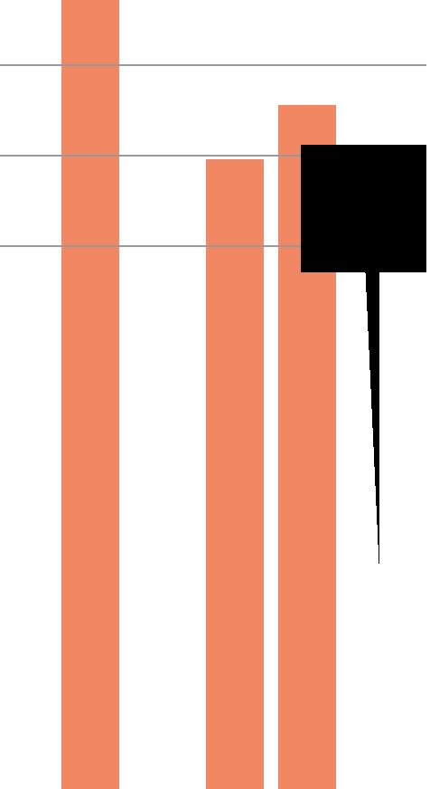
Crashes reported in Chesapeake

125
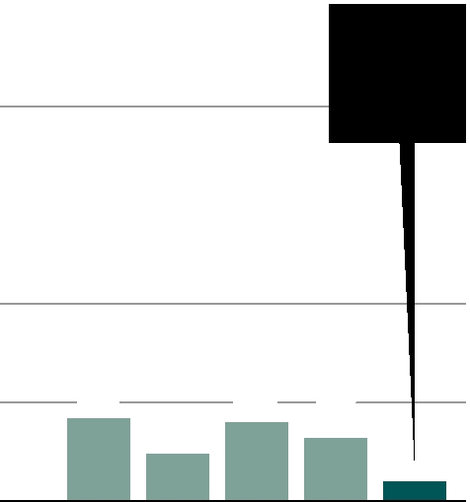

 | 5
100 | As of
100 | June 30
75 | June 30

50

25 | 21 | 12 | 20 | 16
0
 | 2008 | 2009 | 2010 | 2011 | 2012
Crashes reported in Norfolk
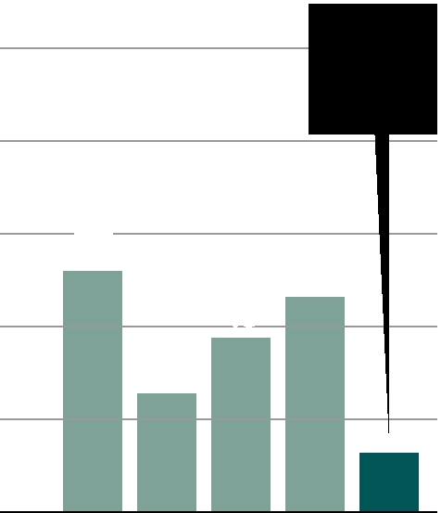

125 |  |  |  |  | 16
 |  |  |  | As of
100 |  |  |  | June 30
75 | 65
 | 65 |  |  | 58
50 |  |  | 47
 |  | 32
25
0
 | 2008 | 2009 | 2010 | 2011 | 2012
Crashes reported in Portsmouth

125
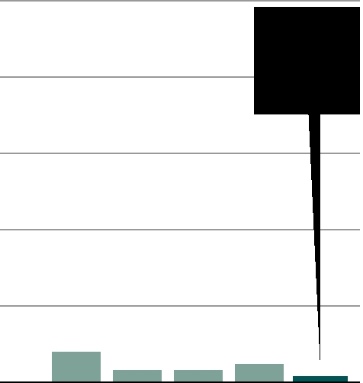

 | 2
100 | As of

June 30

75

50

25
10 | 4 | 4 | 6
0 | 4 | 4 | 6
2008 | 2009 | 2010 | 2011 | 2012
Crashes reported in Suffolk

125
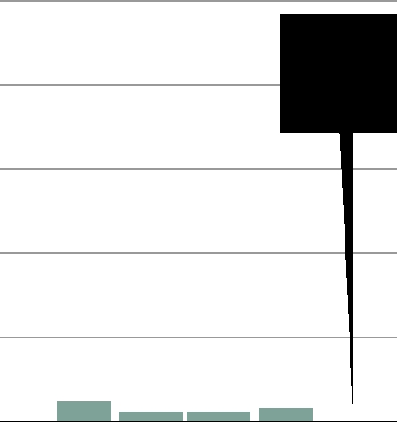

None
¹⁰⁰ As of

June 30

75

50

25

6 | 3 | 3 | 4
0
2008 | 2009 | 2010 | 2011 | 2012

Crashes reported |  |  |  |  | 34
in Virginia Beach
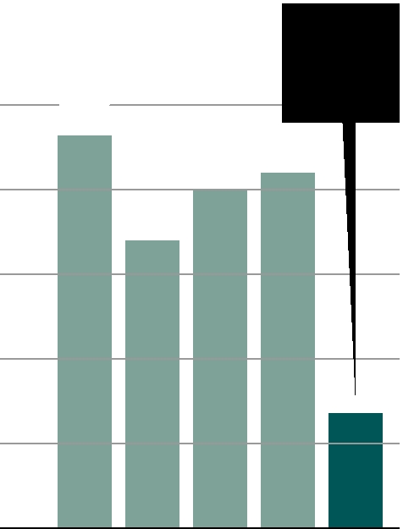  125 |  |  |  |  |  |  |  |  |  |  |  | As of
 | 116 |  |  | June 30
100 |  |  | 100 | 105
 |  | 85
75
50
25
0
 | 2008 | 2009 | 2010 | 2011 |  |  | 2012

150 |  |  | June 30
 | 136
125
100
75
50
25
0
2008 | 2009 | 2010 | 2011 | 2012

BY THE NUMBERS
Streets/areas with the most crashes |  | No improper action |  | Did not have the
Oceanfront (Virginia Beach) |  | or not stated |  | right-of-way
Oceanfront (Virginia Beach) |  | (465 out of 774) |  | (125)
 | 72 | (465 out of 774) |  | (125)
 | 72 | 60.1% |  | 16.1%
Virginia Beach Boulevard (V.B./Norf.) |  | 60.1% |  | 16.1%
54
Independence Boulevard (Virginia Beach)
18
Little Creek Road (Norfolk) |  | Disre- | Bicyclist
18 |  | gard- | action in
Tidewater Drive (Norfolk) |  | ed a | crashes
Tidewater Drive (Norfolk) |  | traf c
18 |  | traf c
18 |  | signal |  | Other:
First Colonial Road (Virginia Beach) |  | signal |  | Other:
First Colonial Road (Virginia Beach) |  | (37) |  | Other:
First Colonial Road (Virginia Beach) |  | (37) |  | disre-
17 |  | 4.8% |  | disre-
17 |  | 4.8% |  | garded stop
Granby Street (Norfolk) |  |  |  | sign, improper
14 |  |  |  | or unsafe lane
Hampton Boulevard (Norfolk) |  | On the wrong side |  | change, etc.
Hampton Boulevard (Norfolk) |  | of the road (49) |  | (98)
14 |  | of the road (49) |  | (98)
14 |  | 6.3% |  | 12.7%
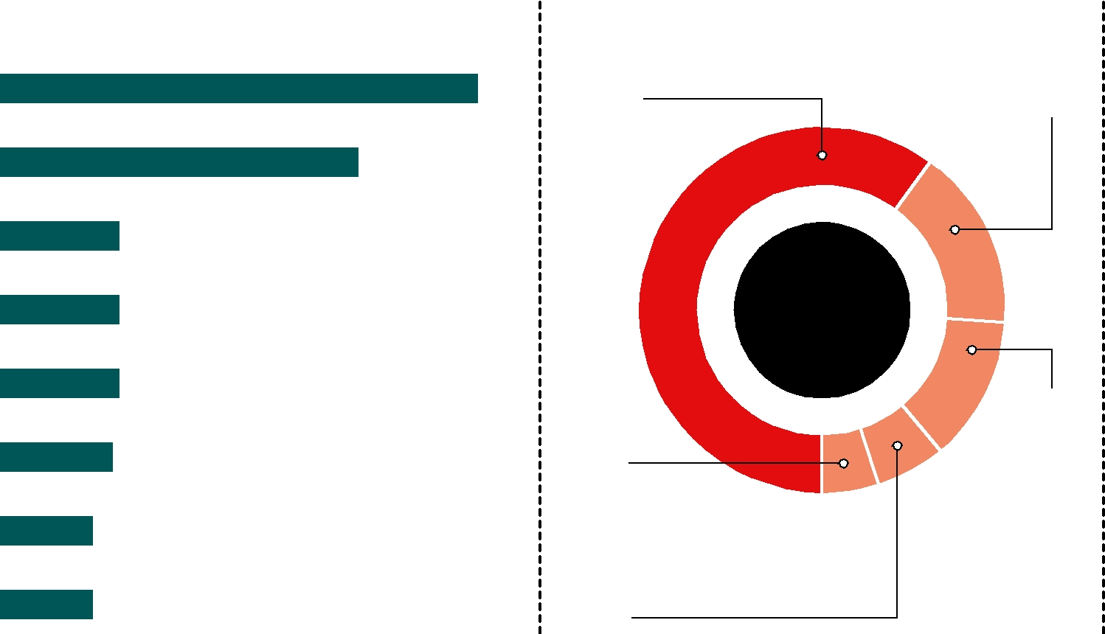

Angle | Not speci ed | Other:
(373 out of 774) | (233) | backed
48.2% | 30.1% | into,
 |  | object in
 |  | road,
 |  | etc.
 |  | (63)
 |  | 8.1%
 | Collision
 | type
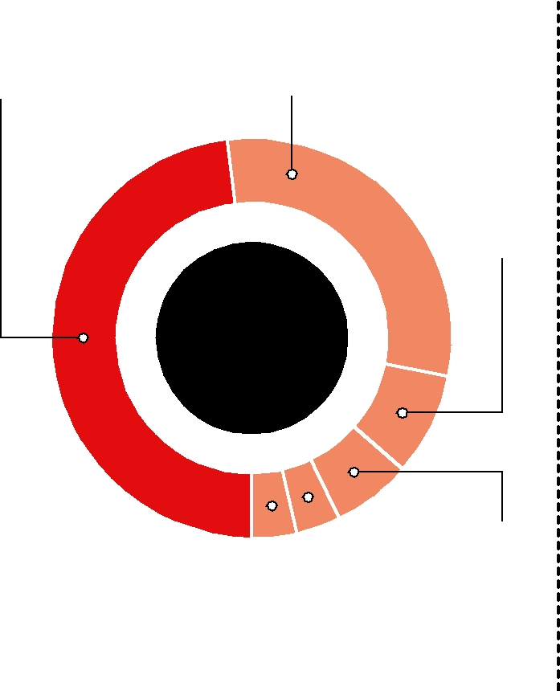

 |  |  |  |  | Sideswipe,
 |  |  |  |  | same
Rear-end |  | Head-on |  |  | direction
(27) |  | (28) |  |  | (50)
3.5% |  | 3.6% |  |  | 6.5%

Not issued or not stated |  |  | Issued
(550 out of 774) |  |  | (180 – 105 issued
71.1% |  |  | to vehicle driver,
 |  |  | 75 issued to
 |  |  | bicyclist)
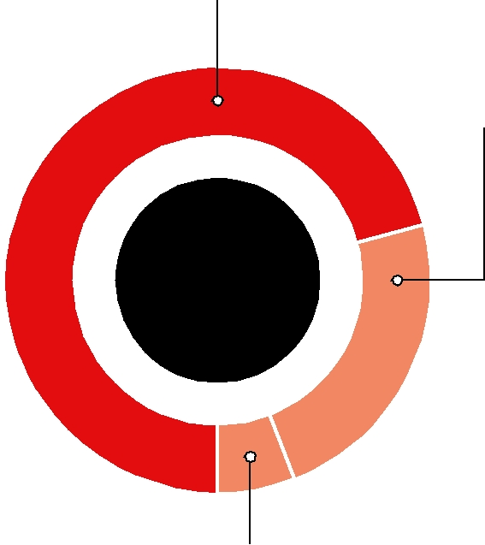

23.3%

Total

summonses

Pending (44)
5.7%

SOURCE: The Virginia Department of Motor Vehicles KATHY ADAMS, ROBERT D. VOROS | THE VIRGINIAN-PILOT

