Charge Standardization Project: Requirements Baseline Document (RBD)
November 20, 2003

Table Of Contents
I. Introduction 1
II. Summary Of Virginia’s Criminal Justice System 2
III. Data Standards 5
IV. Summary Of Deliverables 6
V. General Requirements 6
VI. Sub-Project Descriptions And Requirements 7
1. Magistrate System 8
2. OTN File 12
3. Courts Automated Information System (CAIS) at GDC, JDR, and Circuit Courts 14
4. Live Scan 17
5. Manual Fingerprint Cards / Card Scan Terminal 20
6. Local Inmate Data System (LIDS) 21
7. Computerized Criminal History (CCH) 23
8. New VSP Platform 24
9. Magistrate/OTN File - CAIS Interface 25
10. OTN File - LIDS Commitment/Release Interface 28
11. CCH – SCV Booking Status Interface 29
12. SCV – CCH OTN/VCC Interface 30
13. SCV - CCH Disposition Interface 31
14. Expanded Access To VCIN 32
15. Strategic Planning 32
16. Performance Evaluation 33
17. Project Management And Analysis 33
Attachment A: Glossary 34

I. Introduction
The Charge Standardization Project (CSP) is a partnership of several organizations that work together to improve criminal justice processes by fostering better cooperation, system integration and agreed upon standards.
The partnership is comprised of:
- Secretary of Public Safety (SPS)
- Department of Criminal Justice Services (DCJS)
- Supreme Court of Virginia (SCV)
- Virginia State Police (VSP)
- State Compensation Board (SCB)
Using the CSP Scope Document as a starting point, this document defines the “baseline” requirements that will drive subsequent project phases.
Please see the CSP Scope Document and Business Case for the background information that led to the development of this RBD. The “benefits” related to this project are described within the CSP Scope Document and the CSP Performance Measures.
All of these documents support more detailed planning efforts, including more detailed RBDs, to be developed by each of the agencies (SCV, VSP and SCB) responsible for developing or modifying computer applications.
Please note that a glossary of terms included in this document is provided in Attachment A.

II. Summary Of Virginia’s Criminal Justice System
Virginia’s adult felony and misdemeanor criminal justice processes are summarized below to provide a context for information provided later in this RBD. The information provided primarily covers processes covered within the scope of this project and processes outside of the project scope are generally excluded. In Illustration 1 (next page), the systems identified in red are included within the scope of this project.
Many misdemeanor and felony cases begin with a telephone call to a 911 operator requesting the assistance of a law enforcement officer. An officer will investigate the incident and make an arrest when sufficient information is available to bring charges before a magistrate. Alternatively, the officer may obtain a warrant before making the arrest. The magistrate will issue a warrant after probable cause has been established that an act has been committed that violates state law or local ordinances.
Upon arrest, the magistrate will determine if bail should be offered and, if so, establish conditions of bail. VSP’s criminal history records are used by magistrates to help make bail decisions. The magistrate also schedules the defendant’s initial appearance at district court. The information created by the magistrate is manually and electronically sent to the District Court.
The defendant may be released on “own recognizance” or after posting surety. Other bail conditions may also be applicable (e.g. no contact with victim). If the defendant cannot post surety, he/she will be committed to a local jail.
Usually prior to commitment or release, the defendant will be fingerprinted and a mug shot photograph taken. Fingerprinting usually occurs using a Live Scan device. Live Scan provides an automated link between the booking agency, criminal history and FBI systems. Jurisdictions with smaller caseloads often use manual fingerprint cards instead of Live Scan.
Most jurisdictions operate a local mug shot system. Most mug shot systems in Virginia function in a similar matter (e.g. use JPEG photo format, capture SIDs, etc.) but are not integrated at this time.
A new Virginia law, effective January 2003, will require certain violent offenders to submit DNA samples upon arrest. The samples are sent to Forensic Science for analysis.
The law enforcement officer will prepare an incident report, which is used by prosecutors to prepare for court.
If the defendant is committed, usually the defendant will be interviewed by local Pretrial Services staff, who are responsible for preparing a pretrial investigation report for the court. This report includes a bail recommendation for the judge presiding at the defendant’s initial appearance. Pretrial staff use criminal history and other sources to prepare the report.

Illustration 1
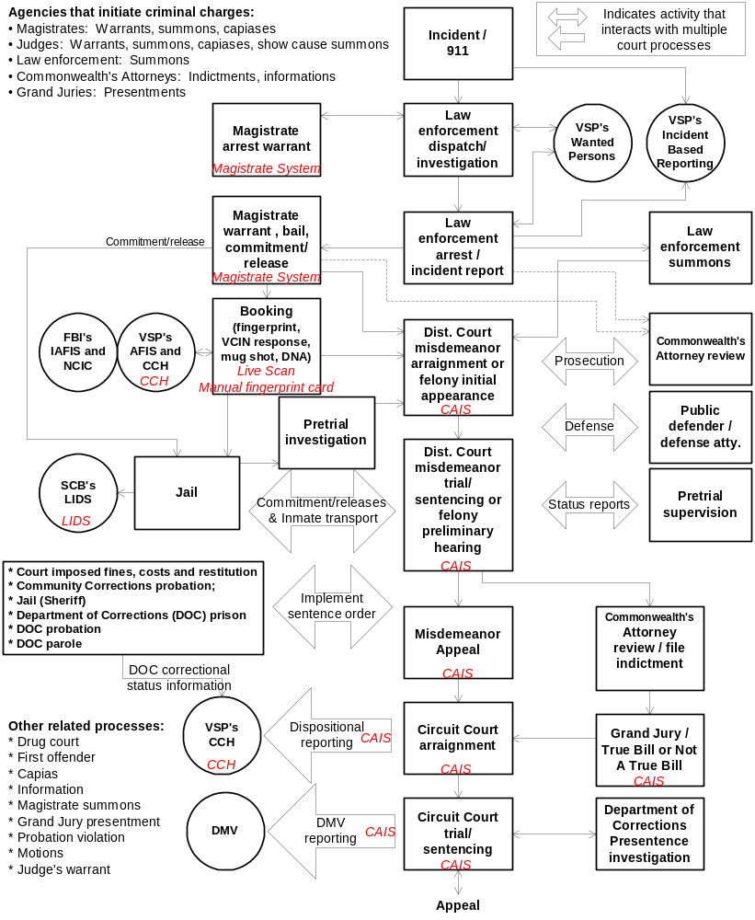
For misdemeanor cases, an arraignment is held in General District Court. The judge will read the charges, determine if the defendant has or needs counsel, accept a plea, review bail and schedule a trial if the defendant pleads “not guilty.” The trial will result in a finding (e.g. “guilty”), followed by sentencing if there is a finding of guilt. VSP’s criminal history is used as part of the sentencing process. Misdemeanor convictions may be appealed to Circuit Court within 10 days.
For felony cases, at the “initial appearance” in General District Court, the judge will read the charges, determine if the defendant has or needs counsel, review bail and schedule a preliminary hearing. Criminal history records are used by the judge, prosecutor and defense attorney to help determine the appropriate bail. Also, the defendant’s criminal history can influence other issues (e.g. if a juvenile should be tried as an adult, the appropriate charges in a given situation, etc.).
The felony preliminary hearing is used to certify there is probable cause to try as a felony. The judge can dismiss the charges if no probable cause is established, reduce the charges and/or certify the charges for Grand Jury. Often plea agreements are discussed at the preliminary hearing.
Certified charges are reviewed by the Commonwealth’s Attorney office. The Commonwealth’s Attorney has the option to modify the charges prior to filing an indictment with the Grand Jury. Also, the Commonwealth’s Attorney can initiate new charges by filing a “direct indictment.”
The Grand Jury will, again, assess probable cause. If probable cause is established, then a True Bill is filed with the court. Otherwise, Not A True Bill is filed.
A felony arraignment is held in Circuit Court. The charges are read, right to counsel reviewed, a plea is entered, the conditions of bail are reviewed and, if the plea is “not guilty,” a trial is scheduled. Again, plea agreement scenarios are usually discussed.
The judge or jury makes a finding (e.g. “guilty) and, if guilty, depending on the nature of the offense, the judge may ask DOC’s probation office to prepare a pre-sentence investigation report. A sentence hearing is conducted after the report is filed with the court. Criminal history records facilitate the sentencing process.
Sentences can be comprised of fines, costs, restitution, state or local probation, treatment, rehabilitation, jail if incarceration is less than one year, prison if incarceration is one year or more, and other sanctions.
If the defendant is sentenced to incarceration for one year or more, usually the offender will initially serve several months at the local jail and then DOC will transfer the inmate to prison for the remainder of the sentence.
A defendant has the option to appeal a court decision.
Charge dispositions are automatically reported by the courts to VSP’s criminal history database.
During case processing, information is shared between the agencies identified on the following illustration. A few of the automated interfaces are noted above. However, most information sharing occurs manually using paper or through discussion via telephone or in-person.

Illustration 2

III. Data Standards
An integral part of this RBD is the CSP Data Standards. The CSP Data Standards are provided as a separate document. The data standards define the information most likely to be shared between multiple criminal justice agencies. Standardized data can be leveraged to obtain a wide range of improvements to make criminal justice processes more effective. For example, data standards help to improve data quality and to reduce duplicate data entry.
For CSP, criminal justice data standards are being defined for the following areas:
Agencies | Court dispositions
Arrests | Events (primarily related to magistrate documents)
Bail | Jurisdictions
Charge details | Juvenile identifier
Commitment /release status | Offender information
Court case information

IV. Summary Of Deliverables
Below is a summary of the deliverables for CSP:
- OTNs: Implement Offense Tracking Numbers (OTNs) in the Magistrate System, OTN File, CAIS, LIDS, Live Scan, SP-180s, and CCH. SCB will require local jails to add OTNs to jail systems as part of their annual maintenance process.
- SIDs: Implement SIDs on the OTN File and LIDS. SCB will require local jails to add SIDs to jail systems as part of their annual maintenance process. Note: SIDs obtained from any source other than CCH should not be used for criminal justice integration.
- Data Standards: Implement data standards, as described in the CSP Data Standards, in the Magistrate System, OTN File and Live Scan.
- VCCs: Implement Virginia Crime Codes (VCCs) in the Magistrate System, OTN File, CAIS, and CCH.
- 2-D Bar Code Interfaces: The Magistrate System will create 2-D bar codes to be read by Live Scan. Standards will be published that will allow jails, Commonwealth’s Attorneys, law enforcement record systems, mug shot systems and public defenders to receive magistrate data using 2-D bar codes.
- New Booking Controls: Interfaces between CCH and the OTN File will be created, and fields added to CAIS, to increase the probability that offenders will be booked on each “reportable” offense.
- LIDS Quality Control: A new OTN File to LIDS interface will be developed that can be used by the SCB to assess the quality of data received from local jails.
- Access To VCIN: Expand access to VCIN based systems, particularly CCH, for magistrates and Commonwealth’s Attorneys.
- Strategic Plan: A plan will be developed describing the next phase of Virginia’s criminal justice integration efforts.
- Performance Measures: The benefits of this project will be evaluated. See the CSP Performance Measures Plan for additional details.

V. General Requirements
The requirements below are applicable to all of the sub-projects listed in the following section.
Note: The term “offender” is used throughout this document to mean both defendants and offenders.
Req# | Title | Description
 | Plans | Several plans shall be developed by the lead agency for each sub-project.  - Requirements Definition  - Work Breakdown Structure (WBS)  - Architectural Design (if new architecture is applicable)  - Detail Design  - Test Plan  - Implementation Plan (includes user training plan)  Each document will be submitted to partner agencies to facilitate the coordination of project tasks.
 | Technical Tools | The technical tools for new systems and replacement legacy systems should:  - Be in common use in the computing profession (e.g. employees and contractors can be hired or readily trained to obtain the necessary skill set).  - Utilize mainstream (e.g. open) standards when applicable (e.g. Windows, TCP/IP, SQL, etc.).  The agency responsible for each sub-project is the final decision-maker on project tools.
 | Document System | Development work performed as part of CSP shall be documented in sufficient detail to support the needs of staff that are responsible for system maintenance.

VI. Sub-Project Descriptions And Requirements
Below is a high-level illustration and detailed description of the sub-projects that are included in CSP. Note that CSP focuses on adult criminal case processes. Juvenile delinquency processing is not included in CSP.

Illustration 3
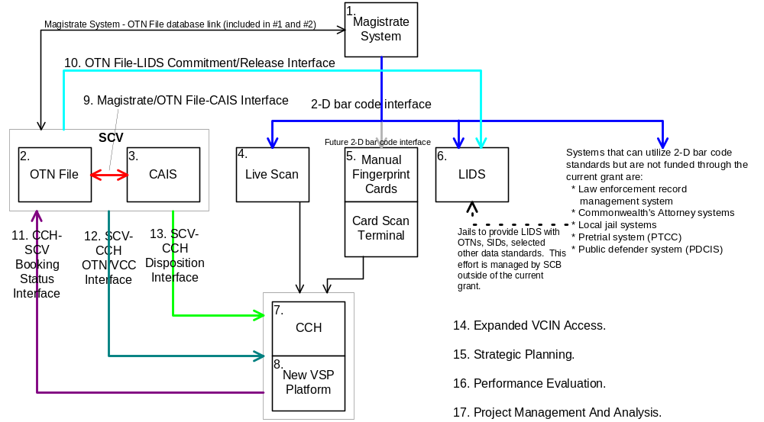

1. Magistrate System
Most serious offenses are initiated through one of the 129 magistrate offices located throughout the state. Currently the magistrates have an automated system that meets most of their internal needs but it was not designed to efficiently exchange data with external entities. It is necessary to improve the current system so it can interface efficiently with other systems. Other improvements, like the use of OTNs, VCCs and reduced duplicate data entry for magistrates will also be incorporated.
This sub-project will be managed by the SCV. Below is an overview of the functionality offered by the Magistrate System.
Illustration 4
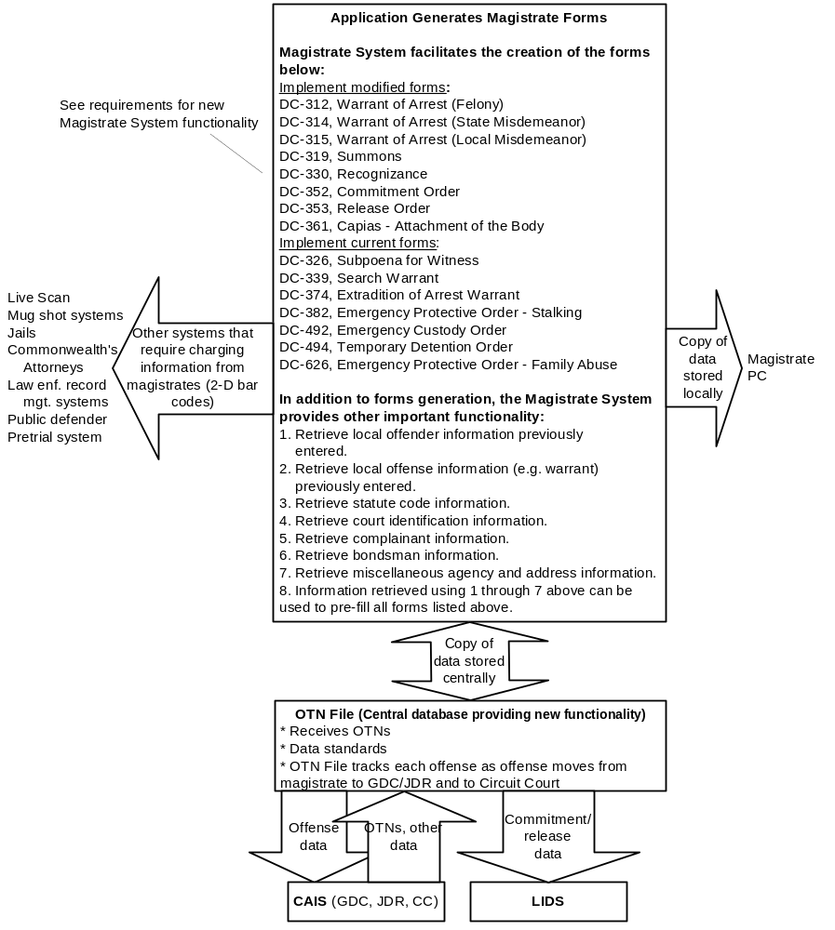

Req# | Title | Description
 | Magistrate System | Modified automated system to support magistrate processes and interfaces.
 | Current Magistrate System | Conceptually, the user interface of the modified system shall be similar to the current Magistrate System, except as modified by the requirements below. Illustration 4 lists the functionality provided by the current system.
 | Data Standards | The system shall use standard data fields (see CSP Data Standards) for processing modified forms (see illustration 4).
 | OTNs | The system shall assign all offenses a unique OTN and display OTNs on system screens, forms and reports selected by SCV. For OTNs generated by the Magistrate System, the OTN shall be comprised of the Magistrate warrant/summons number. The system shall track offenses using OTNs.
 | Booking Status / SIDs | When accessing court information, the system shall inform magistrates of the booking status of each offense. If a defendant has been booked, users shall be provided with the SID and DCN from VSP. Forms selected by SCV may also include the booking status, SID and DCN.
 | Booking Requirement | The system shall inform magistrates of the VSP booking requirement (i.e. CCH reportable flag) for each offense. Modified forms (see Illustration 4) shall include the booking requirement.
 | VCCs | Magistrates, with the assistance of the system, shall assign VCCs to each new offense that has a maximum penalty that includes any jail time. The VCCs shall be displayed on screens and printed on charging documents in a manner to be determined by the SCV. Note: This requirement is consistent with 2003 HB 2541.
 | Short Description Of Offense | The system shall provide users with standard short descriptions for each offense. The short descriptions shall be printed on charging documents and displayed on system screens.
 | Identification Of Stolen Property | If a crime involves stolen property, then the property should be generally described. SCV shall determine the best approach for capturing stolen property information in a consistent manner.
 | Events | The Magistrate System shall track basic case history events. The SCV shall determine which specific events will be included in CSP.
 | Event Generation | Certain events shall be automatically created by the system and stored in the OTN File.
 | Event Display | The system shall display certain events created by the Magistrate System and CAIS stored in the OTN File
 | Capture Latest Offender Data | When information describing a defendant has previously been entered (e.g. when creating an arrest warrant) and the defendant makes an appearance before magistrate, the magistrate shall attempt to determine if updated information is available and, if so, enter the data into the system. When appropriate, the latest data available shall be included on 2-D bar codes printed on recognizance forms, commitment orders and release orders, and shared with other systems electronically.
 | Forms | Users shall be able to generate the forms listed in illustration 4. Screens used to capture data printed on forms and forms printed by the system shall be modified or designed to comply with the CSP requirements. Changes to magistrate and court forms require the approval of SCV’s Office of Executive Secretary.
 | Laser Printer | Modified forms (see illustration 4) shall be printed on laser printers.
 | Minimal Data On Modified Forms | The following data will be added to charging documents and other modified forms (see Illustration 4) as determined by SCV:  - OTNs  - Booking requirement  - VCCs (if applicable according to H.B. 308)  - Short description of criminal violation  - Offense type and class  - 2-D bar code
 | Query And Retrieve Data | Users shall have the ability to retrieve the information listed in illustration 4 (e.g. offender and offense information) maintained in the OTN File (statewide) using OTNs, SIDs (e.g. for bail history), SSN, Name/DOB and other means selected by SCV. Users shall have the option to pre-load the data into forms that need to be generated.
 | Bail Information | Bail information shall be available to inform magistrates if a defendant is currently out on bail for another offense or if a defendant has been previously out on bail and when.
 | Interfaces | The Magistrate System shall exchange data with other systems as shown in illustration 4. See sub-projects that involve magistrate interfaces for more information.
 | Store Data For CAIS | The system shall automatically store data related to modified forms for CAIS.
 | OTN File | A central database, called the OTN File (sub-project 2), shall be the primary storage location for Magistrate System data. The magistrate PC will interface with the OTN File on a near real-time basis (specifics to be determined by SCV). The OTN File also receives OTNs and provides other functionality described in these requirements. The OTN File will store OTN-based data for CAIS and magistrates will have access to CAIS data stored in the OTN File.
 | Local Data Storage | Data will be stored locally in a manner similar to the current system to support data retrieval and back up procedures.
 | Modern PCs | The system shall be implemented on modern client personal computers.
 | Response Time | The system shall have an average response time of 5 seconds or less.
 | Hours Of Operation | The system shall be operational 24 hours and a day, seven days a week, excluding scheduled downtime maintenance periods.
 | Reliability | The system shall be operational 98% of the time, excluding scheduled downtime maintenance periods, and shall generally be reliable consistent with professional norms.
 | Maintainability | The system shall utilize a technical design that can be maintained on a scheduled basis.
 | Security | The system shall employ security measures as described below.
 | Security Plan | The SCV shall prepare a brief report that describes the level of security that is appropriate for this application and measures to be taken to achieve that objective.
 | Unauthorized Access To The Application And Servers | Firewalls, password protection, the removal of unnecessary applications from servers and other measures shall be taken to minimize the probability that persons can perform unauthorized actions that would impact the Magistrate System.
 | User Identification | Each user shall be required to have a unique user ID and password.
 | Test Plan | A test plan shall be developed and implemented to verify that the requirements of both CSP and the SCV have been met and that the system meets SCV’s performance expectations.
 | Reconnection With OTN File | The client functionality provided by the Magistrate System shall reside on client PCs. When PCs are disconnected from the LAN or WAN, the system should be able to provide updated data when the connection is reestablished.
 | User Manual / Training | Users shall be provided with a user manual and training on the new system and changes to processes.
 | Manual Back Up Procedures | Users shall have manual procedures, including copies of manual forms, in the event that the system is not available. The manual procedures shall ensure that the integrity of case data is maintained consistent with the requirements above.

2. OTN File
This new sub-system will support the Magistrate System and CAIS. The OTN File will ensure the integrity of case data as cases move through the judicial system. The OTN File will be largely based on CSP data standards and will provide services that can be leveraged to improve criminal justice integration. The OTN File provides an infrastructure that the SCV can build upon to meet both current and future case management challenges. This effort will be managed by the SCV.
Illustration 5
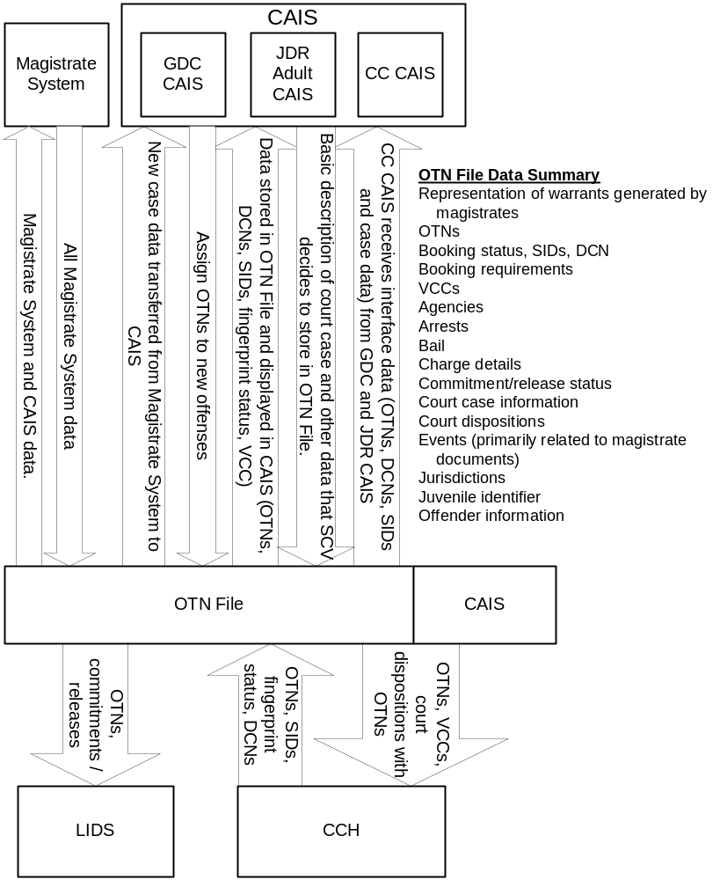

Req# | Title | Description
 | OTN File | New sub-system for Magistrate System and CAIS that supports CSP data, process and interface requirements.
 | Case Data | Basic case data for all magistrate and court cases with an OTN shall be stored in the OTN File. The specific data requirements will be determined by the SCV.
 | Case Integrity | The system shall ensure the integrity of case data as cases move through the judicial system. Automated and manual processes shall ensure that OTNs, SIDs, and DCNs shall remain with an offense from the moment that these record identifiers are assigned.
 | Data Standards | The OTN File needs to support the data storage requirements of both the Magistrate System and CAIS. The OTN File will store data using the data standards when feasible. The specific storage requirements will be determined by SCV. The type of information to be stored or otherwise available to the OTN File is listed in illustration 5. At a minimum, data standards shall be applied to OTNs, SIDs, DCNs, booking status, booking requirements, and VCCs.
 | OTNs | The system shall store OTNs from the Magistrate System and CAIS.
 | Booking Status / SIDs | The system shall inform users of the booking status of each offense. If a defendant has been booked, users shall be provided with the SID and DCN from VSP. See sub-project 11 for more information.
 | Booking Requirement | The system shall inform users of the VSP booking requirement (i.e. CCH reportable flag) for each offense.
 | VCCs | VCCs shall be stored for all offenses where a VCC has been provided on a charging or disposition document.
 | Events | The OTN File shall track basic case history events. The SCV shall determine which specific events will be included in CSP.
 | Capture Latest Offender Data | Magistrate System and CAIS users shall be encouraged to capture the latest offender and offense information. Any updated information applicable to the OTN File shall be stored in the OTN File.
 | Interfaces | The OTN File shall exchange data with other systems as shown in illustration 5. See sub-projects that involve OTN File interfaces for more information.
 | Hours Of Operation | The system shall be operational 24 hours and a day, seven days a week, excluding scheduled downtime maintenance periods.
 | Reliability | The system shall be operational 98% of the time, excluding scheduled downtime maintenance periods, and shall generally be reliable consistent with professional norms.
 | Maintainability | The system shall utilize a technical design that can be maintained on a scheduled basis.
 | Security | The system shall employ security measures as described below.
 | Security Plan | The SCV shall prepare a brief report that describes the level of security that is appropriate for the OTN File and measures to be taken to achieve that objective.
 | Unauthorized Access To The Application And Servers | Firewalls, password protection, the removal of unnecessary applications from servers and other measures shall be taken to minimize the probability that persons can perform unauthorized actions that would impact the OTN File.
 | System Interfaces | The architectural design shall be able to send and receive data from other systems on a near real-time basis.
 | Test Plan | A test plan shall be developed and implemented to verify that the requirements of both CSP and the SCV have been met and that the system meets SCV’s performance expectations.

3. Courts Automated Information System (CAIS) at GDC, JDR, and Circuit Courts
The requirements for CAIS describe changes necessary for CAIS to use new data fields and to interface with the OTN File and other systems. These changes will allow the courts to phase out the CCRE court disposition forms, the manual entry of DCNs, and provide staff with information needed to facilitate decision-making.
Currently CAIS is being migrated to a new database structure based on DB2. The modifications for CAIS will be coordinated with the DB2 migration.
This effort will be managed by the SCV. See illustration 5 for the relationship between CAIS and the OTN File.
Req# | Title | Description
 | CAIS | Modifications to CAIS to include new data requirements and to interface with OTN File.
 | Current CAIS System | The CSP requirements shall be implemented on CAIS either after or as part of the DB2 migration for GDC, JDR (adult) and Circuit Court.
 | Data Standards | The following fields shall be captured and displayed on the appropriate CAIS screens, forms and reports, as determined by SCV:  - OTNs  - SIDs  - Booking status and dates  - DCNs  - VCCs  - Booking requirement
 | OTNs | The system shall assign all offenses a unique OTN and display OTNs on system screens, forms and reports. CAIS will probably assign the first court case number as the OTN if no OTN was previously assigned. Court users and CAIS shall track each offense using the original OTN as offenses are processed through the court system. For example, when an offense is transferred to another jurisdiction, the offense will continue to use the original OTN.
 | Magistrate Warrant/  Summons Number | When cases are referred by magistrates to courts, the courts will receive OTNs (i.e. magistrate warrant/summons number) either automatically or manually from the magistrates. Upon the receipt of court cases, court clerks and CAIS will ensure that the magistrate assigned OTNs are registered in CAIS and the OTN File. The registration process shall ensure that OTNs are unique per offense and other standard edit criteria will be applied before each OTN is stored.
 | CA OTN Assignment | Upon the receipt of an indictment or information from a Commonwealth’s Attorney Office, court clerks will determine if the offenses listed are new offenses or offenses that were previously processed by any court. If the offenses are new, then unique OTNs shall be assigned to each offense. If the offenses were previously processed by any court, then the previously assigned OTNs shall continue to be used for processing.
 | Law Enforcement Summons | The agency summons number and agency ORI will be captured and stored. Then CAIS will assign an OTN (probably using the court case number) to each offense on the summons.
 | Booking Status / SIDs | The system shall inform users of the booking status of each offense. If a defendant has been booked, users shall be provided with the SID and DCN from VSP. Forms selected by SCV may also include the booking status, SID and DCN.  Procedures and practices shall be updated to use CAIS booking status information to ensure defendants and offenders are booked properly.
 | Booking Requirement | The system shall inform users of the VSP booking requirement (i.e. CCH reportable flag) for each offense.
 | Bookings With Manual Fingerprint Cards Or Without OTNs | When a defendant is booked with a manual fingerprint card or when a defendant is booked on Live Scan without an OTN, the booking agency will continue to send the CCRE court disposition forms to the courts in accordance with current procedures. Court staff will enter the DCNs into CAIS for these offenses.
 | VCCs | Judges and court staff shall assign a VCC to each new offense that has a maximum penalty that includes any jail time. (excluding offenses initiated by law enforcement and Commonwealth’s Attorneys). Also, VCCs shall be assigned to each disposition offense that has a maximum penalty that includes any jail time.  VCCs for new offenses initiated by law enforcement and Commonwealth’s Attorneys shall be captured when provided by the initiating agency.  The VCCs shall be displayed on screens and printed on charging and disposition documents in a manner to be determined by the SCV. Note: This requirement is consistent with 2003 HB 2541.
 | Short Description Of Offense | The system shall provide users with standard short descriptions for each offense. The short description shall be printed on forms and displayed on screens as determined by SCV.
 | Events | The system shall have basic event management capabilities as determined by SCV. It is understood that the ability to capture event information in CAIS will be limited.
 | Event Generation | Certain events shall be automatically created by the system and stored in the OTN File.
 | Event Display | The system shall display certain events created by the Magistrate System and CAIS that are stored in the OTN File.
 | Capture Latest Data | CAIS users shall be encouraged to capture the latest offender and offense information. Any updated information applicable to the OTN File shall be stored in the OTN File.
 | Forms | Screens used to capture data printed on forms and forms printed by the system shall be modified or designed to comply with the requirements below. Changes to court forms require the approval of SCV’s Office of Executive Secretary.
 | Minimal Data On Criminal Forms | Forms selected by the SCV shall print the following data in addition to the data normally printed on each form:  - OTNs  - SIDs (if available from VSP)  - DCNs (if available from VSP)  - Booking status and dates  - Booking requirement  - VCCs (if applicable according to H.B. 308)
 | Minimal Data On Charging Documents | In addition to the data normally on charging documents, the data above plus the following will also be included:  - Short description of criminal violation.  - Offense type and class.
 | Warrants Served As Summons | When a warrant is served as a summons, a procedure is needed to ensure that law enforcement agencies attach a copy of the warrant to the summons filed in court. This will allow court clerks to accurately capture the OTN (i.e. magistrate warrant number).
 | Query And Retrieve Data | Users shall have the ability to retrieve offender and offense information maintained in the OTN File (statewide) using OTNs, SIDs, SSN, Name/DOB and other means selected by SCV.
 | Interfaces | CAIS shall exchange data with other systems as shown in illustration 4 and 5. See sub-projects that involve CAIS and OTN File interfaces for more information.
 | DMV Information | The magistrates shall capture and send to courts DMV information needed by the courts for certain offenses (to be specified by statute tables). By capturing this information in CAIS, this will reduce data entry for court clerks who may not have the information needed to complete these fields accurately.
 | OTN File | The OTN File shall be implemented as a sub-system for CAIS. The OTN File will help to migrate CAIS to the data standards and facilitate interfaces between CAIS and other systems. See the OTN File (sub-project 2) for more information.
 | Test Plan | A test plan shall be developed and implemented to verify that the requirements of both CSP and the SCV have been met and that the system meets SCV’s performance expectations.
 | User Manual / Training | Users shall be provided with an updated user manual and training on changes to CAIS and processes.
 | Manual Back Up Procedures | Users shall have manual procedures, including copies of manual forms, in the event that the system is not available. The manual procedures shall ensure that the integrity of case data is maintained consistent with the requirements above.

4. Live Scan
The Live Scan devices are a critical component of the criminal justice system. Live Scan is used to help identify defendants and offenders and to capture arrest data about these individuals for entry into CCH.
Live Scan will be modified to include OTNs. Also, the CCRE disposition form, which is the source of various problems for the courts and CCH, will be phased out.
The devices currently used to enter Live Scan data will be replaced with PC based data entry processes that will offer capabilities that are not currently possible. For example:
- Easier to use screens.
- Ability to receive data using 2-D bar codes.
- May lower the cost of implementing Live Scan, which would make Live Scan accessible to more jurisdictions.
- Provide an architecture that is more maintainable and that would allow for future integration.
- Implement data standards to help improve data quality and interfaces with other systems.
Illustration 6 summarizes the architecture.
It is anticipated that about 100 Live Scan devices will be modified to allow for data entry using PCs.
Currently 80% of all bookings will utilize Live Scan. A goal for CSP is to have more than 90% of all bookings use Live Scan. CSP will offer a plan to achieve this goal as part of CSP’s strategic planning (see sub-project 15).
Several jurisdictions currently have automated interfaces between local systems and Live Scan systems. Minor modifications to these interfaces will be necessary to send the data to the new PC based data entry programs. One of the objectives if this effort is to minimize any negative impacts the change to PC based data entry programs may have on localities.
This sub-project will be managed by VSP.
Illustration 6
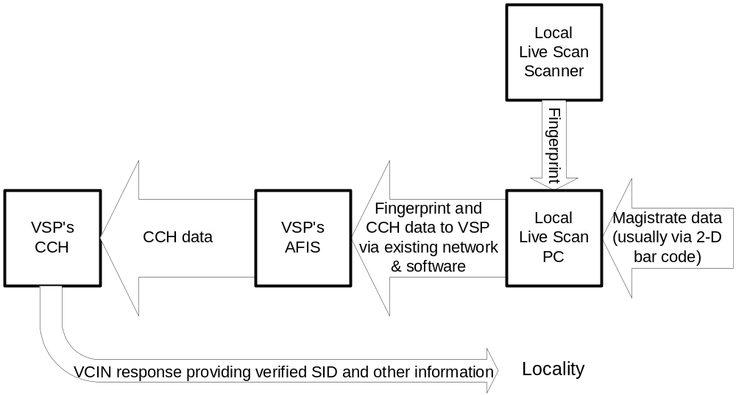

Req# | Title | Description
 | Live Scan | Implement OTNs and new PC module to replace current Live Scan data entry screens.
 | Current Live Scan And New PC Data Entry Module | For 80% of the existing Live Scan devices, the existing fingerprint scanning technology will continue to be used in conjunction with a new PC module. The PC module will facilitate the capture of Live Scan data, receive the fingerprint from the scanner, and interface with VCIN. Except as modified by CSP requirements (below), the functionality available through the new PC module shall be similar to current Live Scan systems as described in Virginia State Police Live Scan Certification document.
 | New Live Scan Specifications | The VSP specifications for new Live Scan devices purchased after the implementation of the CSP will be updated to include the new PC module and, perhaps, more cost-effective fingerprint scanners.
 | Data Standards | An objective of this sub-project is to start phasing-in CSP data standards. However, until CCH is moved to the new platform, it will not be possible to fully implement the data standards. VSP will determine how to phase-in the CSP data standards.
 | OTNs | Live Scan processes and the system will require users capture OTNs when magistrates and courts provide OTNs. However, Live Scan will continue to have the ability to capture offenses without OTNs (e.g. pre-CSP offenses) in a manner similar to current practice.
 | DCNs | The system shall assign all fingerprint transactions a DCN in a manner consistent with current practice.
 | 2-D Bar Codes | The system shall have the ability to receive data from the Magistrate System using 2-D bar coding. The 2-D bar code data will be formatted in accordance with the CSP data standards. Live Scan shall use this data to minimize the duplicate data entry of magistrate warrants.
 | Capture Latest Data | The system shall provide the capability for the booking officer to add (for example, additional aliases) or modify (for example, addresses) or delete information received from magistrates using 2-D bar codes. Booking officers shall be encouraged to enter the latest information available for an offender.
 | CCRE Court Disposition Form | When booking includes OTN, Live Scan shall not print the CCRE court disposition form. The system shall print a CCRE court disposition form when no OTN is provided and other times when a booking officer determines the form is needed. Note: During the initial pilot, the CCRE court disposition forms will be used.
 | Forms | Forms printed by Live Scan will be updated to include OTNs and other data standards included by VSP in this sub-project.
 | Live Scan – CCH Interface | The following information will be sent from Live Scan to AFIS and CCH:  - Same as current information (perhaps modified by data standards)  - OTNs
 | Local Interface Update | The Live Scan Local Interface Standard document will be updated to reflect the addition of the OTN field and the incorporation of the CSP data standards using the 2-D bar codes.
 | Live Scan PC | The Live Scan PC shall be a MS Windows application running on a standard PC. The PC shall be used for Live Scan data entry in place of the Live Scan data entry screens currently in use. The PCs shall be configured so they can operate other applications in addition to Live Scan (e.g. VCIN access, word processing). A FBI certified Live Scan printer shall be connected to the PC.
 | PC-Scanner Interface | The PC application shall interface with a minimum of 80% of the certified Live Scan systems installed Virginia. The PC application will support Live Scan scanners as a direct connect device or will support a standardized interface with legacy Live Scan machines so that the legacy Live Scan acts as an intelligent scanner in a manner consistent with the direct connect device.
 | Hours Of Operation | The system shall be operational 24 hours and a day, seven days a week, excluding scheduled downtime maintenance periods.
 | Reliability | The system shall be operational 98% of the time, excluding scheduled downtime maintenance periods, and shall generally be reliable consistent with professional norms.
 | Maintainability | The system shall utilize a technical design that can be maintained on a scheduled basis.
 | Security | The system shall employ security measures as described below.
 | Security Plan | The VSP shall prepare a brief report that describes the level of security that is appropriate for this application and measures to be taken to achieve that objective.
 | Unauthorized Access To The Application | Firewalls, password protection, the removal of unnecessary applications from servers and other measures shall be taken to minimize the probability that persons can perform unauthorized actions that would impact VCIN data.
 | User Identification | Each user shall be required to have a unique user ID and password.
 | Test Plan | A test plan shall be developed and implemented to verify that the requirements of both CSP and the VSP have been met and that the system meets VSP’s performance expectations.
 | User Manual / Training | Users shall be provided with an updated user manual and training on changes to Live Scan and processes.
 | Manual Back Up Procedures | Users shall have manual procedures, including copies of manual forms, in the event that the system is not available. The manual procedures shall ensure that the integrity of case data is maintained consistent with the requirements above.

5. Manual Fingerprint Cards / Card Scan Terminal
Currently about 20% are processed using manual fingerprint cards instead of Live Scan. The fingerprint cards need to be modified to include OTNs. The manual cards are processed at State Police using NSW (NIST Standard Workstation or Card Scan Terminal) so NSW needs to be expanded to include OTNs.
This sub-project will be managed by VSP.
Illustration 7
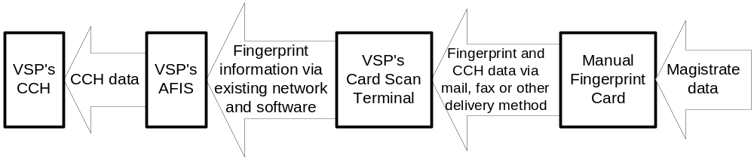
 | Title | Description
 | Manual Fingerprint Cards / Card Scan Terminal | Implement OTNs manual fingerprint cards and card scan terminals.
 | Current Processes And Data | Except as modified by CSP requirements (below), the processes and data currently used for manual fingerprint processing will continue to be used.
 | OTNs On Manual Fingerprint Card | A field to capture OTNs shall be added to the manual fingerprint card. Users shall be instructed to enter OTNs on the form when OTNs are available. When OTNs are not available, processing will continue in a manner similar to current processing.
 | OTNs On Card Scan Terminals | A field to capture OTNs shall be added to the card scan terminal software. When OTNs are not available, processing will continue in a manner similar to current processing.
 | CCRE Court Disposition Form | CCRE court disposition forms shall continue to be sent to courts in the same manner as current practice.
 | NSW Data Transmission | Data shall be entered into NSW and transmitted consistent with Virginia’s ANSI Type 1 and Type 2 requirements and current data standards, with the addition of OTNs.
 | Test Plan | A test plan shall be developed and implemented to verify that the requirements of both CSP and the VSP have been met.
 | Card Scan User Manual | Users shall be provided with an updated user manual and training on changes to Card Scan and processes.
 | CCRE Fingerprint User Manual | Users shall be provided with an updated user manual and training on changes to manual fingerprint forms and processes.

6. Local Inmate Data System (LIDS)
The state has about 80 local and regional jails supported by about 20 different automated systems. LIDS is a central repository for state jail information. Other states have struggled to integrate local jail information so Virginia is fortunate to have a ready-made solution in this area.
The SCB has the authority to mandate standards that specify how data will be submitted to LIDS. Local and regional jails that use vendor supplied systems have contract provisions that require their vendors to make any SCB mandated changes at no additional cost (the cost is included in the annual maintenance fee).
Also, LIDS provide jail record management services for about 30 jails in smaller jurisdictions.
LIDS will be modified to include standard record identifiers. Along with the OTN File-LIDS Commitment/Release Interface (sub-project 10), these modifications will make it possible to link LIDS to criminal justice data in other systems and to improve data quality for LIDS and CCH.
This sub-project will be managed by the SCB.
Illustration 8
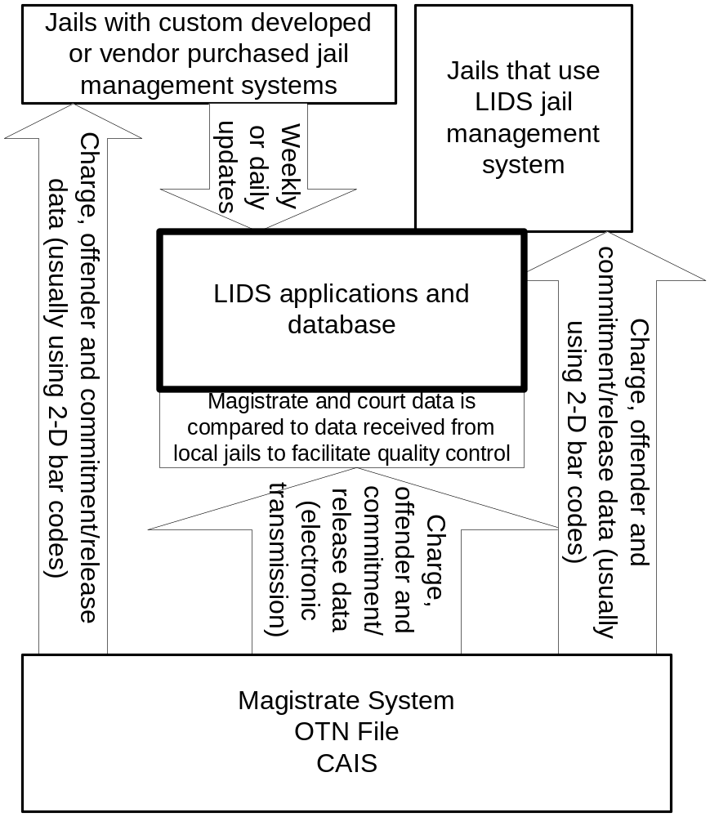

Req# | Title | Description
 | LIDS | Implement selected data standards, quality control, and to minimize duplicate data entry.
 | Current Systems | The CSP requirements below will be implemented on the current LIDS and jail management systems.
 | OTNs | LIDS and jail systems (as mandated by SCB) shall store and display OTNs on screens, forms and reports selected by the SCB and jails. OTNs will be used to track offenses on both LIDS and jail systems.
 | SIDs | LIDS and jail systems (as mandated by SCB) shall track offenders using SIDs. Jail procedures shall require jail staff to obtain fingerprint verified SIDs whenever possible. LIDS and jail systems shall store and display SIDs on screens, forms and reports selected by the SCB and jails. Note 1: LIDS will also receive SIDs from the OTN File–LIDS Commitment/Release Interface (sub-project 10). CCH is the original source for these SIDs, which is consistent with the intent of Note 2. Note 2: SIDs obtained from any source other than CCH should not be used for criminal justice integration.
 | VCCs | Jails already have the ability to capture VCCs and to pass that information to LIDS. However, given the H.B. 308 workgroup discussions, code citations that correspond to VCCs in the Magistrate System may not exactly match the code citations and corresponding VCCs in the current VCC table. SCB shall determine how to best handle this issue.
 | 2-D Bar Codes | 2-D bar codes generated by magistrates shall be used by jails to minimize duplicate data entry. It is understood that many localities will not be able to implement 2-D bar coding within the CSP project time frame.
 | Short Description Of Offense | LIDS and jails shall provide users with standard short descriptions for each offense. Standard short descriptions will be available on the 2-D bar codes and the Magistrate-LIDS interface. It is understood that many localities will not be able to implement standard short descriptions within the CSP project time frame.
 | Forms | Forms created by LIDS and jails systems will be updated to include OTNs, SIDs, VCCs and short descriptions. It is understood that many localities will not be able to implement this requirement within the CSP project time frame.
 | SCB Requirements For Jails | SCB has or will mandate jails to meet the following requirements:  - Implement OTNs  - Implement SIDs  - Implement VCCs  - Implement ability to receive data using 2-D bar codes (when cost-effective).  - Implement standard short description for each offense  Note: Modifications to jails systems mandated by SCB are usually covered by existing system maintenance agreements. As it relates to receiving data using 2-D bar codes, maintenance agreements can be used to develop mandated functionality but these agreements do not cover the purchase of the 2-D bar code readers (approximately $600).
 | LIDS Quality Control | LIDS shall compare data received from the Magistrate System with data received from jails to assess data quality. SCB shall determine the specific quality control criteria. Exception reports shall be generated to help staff identify potential problems.
 | Test Plan | For LIDS, a test plan shall be developed and implemented to verify that the requirements of both CSP and the SCB have been met.
 | User Manual / Training | Users shall be provided with an updated user manual and training on changes to LIDS and related processes.

7. Computerized Criminal History (CCH)
CCH is used to display rap sheet information, which supports decision-making throughout the criminal justice system.
CCH will be updated to process, store and display OTNs and VCCs. As CCH is migrated to a new platform (see sub-project 8) CSP data standards and other related requirements will be incorporated.
This sub-project will be managed by VSP.
See references to CCH in Illustration 5 (OTN File, sub-project 2), Illustration 6 (Live Scan, sub-project 4), and Illustration 7 (Manual Fingerprint Cards, sub-project 5).
Req# | Title | Description
 | CCH | Implement OTNs and VCCs in CCH.
 | CCH Enhancements | The CSP requirements below are enhancements to CCH functionality.
 | OTNs | CCH shall be enhanced to include OTNs in order to satisfy the following requirements:
 | OTNs | Link charge initiation to the correct offense booking using OTN.
 | OTNs | Link final court disposition to the correct charge initiation using OTN.
 | OTNs | Link final court disposition to the correct offense booking using OTN when OTN is provided with offense booking data. (see sub-project 13, SCV-CCH Disposition Interface)
 | SIDs | Link OTN to the correct SID when OTN is provided with offense booking data.
 | OTN history | Provide capability to display charge initiation, booking, and final court disposition information given OTN.
 | Criminal history | Provide capability to display rap sheet (criminal history record) given OTN.
 | Booking Status
 | Booking Status | Provide the capability for booking officer to determine if an offense has already been booked given OTN
 | Booking Status | Provide the capability for court official to determine if an offense has already been booked given OTN (see sub-project 11, CCH-SCV Booking Status Interface)
 | VCCs | CCH shall be enhanced to include VCC in order to satisfy the following requirement: Provide the capability to select criminal history information for statistical/analytical purposes based on VCC. VCC shall only be included in CCH when submitted through the SCV-CCH OTN/VCC Interface (see sub-project 12).
 | Screens | Screens (e.g. VCIN rap sheet) to be selected by VSP shall be updated to include OTNs and VCCs.
 | Reports | Reports (e.g. printed rap sheets) to be selected by VSP shall be updated to include OTNs and VCCs.
 | Test Plan | A test plan shall be developed and implemented to verify that the requirements of both CSP and the VSP have been met.
 | User Manual/Training | Users shall be provided with an updated user manual and training on the system changes.

8. New VSP Platform
VSP’s VCIN and CCH systems are the foundation for integration services beyond CSP. For example, VSP systems including CCH will be expanded to provide a wide-range of new integration services for the criminal justice community. These services are summarized in the Business Case and will be described in detail in the strategic plan for future integration efforts (see sub-project 15).
CSP will participate in an effort that will migrate several systems (CCH, Wanted Persons, Protective Orders, Sex Offender Registry, Firearm Check, Mentally Incompetent, Incapacitated or Involuntarily Committed Registry and Incident Based Reporting) from a proprietary mainframe platform to a platform that supports the use of “open” technologies. Also, as part of the strategic plan (sub-project 15), these systems and related processes will be evaluated to identify opportunities for integration.
The migration will include the implementation of the CSP data standards as outlined below. Since the CSP funding will only partially fund the migration to a new DBMS/platform, the requirements below reflect this perspective.
This sub-project will be managed by VSP.
Req# | Title | Description
 | New VSP Platform | Implement new DBMS and VSP platform for CCH and other criminal justice files.
 | Procurement | Procure new system. The new system will address the items below.
 | General | The newly procured system will provide at a minimum the functionality of the current systems plus the CSP requirements (described below and separately in other sub-projects for CCH).
 | Data Standards | Apply the appropriate CSP data standards to new CCH DBMS and application programs. Incorporate appropriate CSP data standards into interfaces with other criminal justice agency interfaces. Utilize OTNs and VCCs (see sub-project 7).
 | Data Conversion | Conversion of data for the CCH, Wanted Persons, Sex Offenders, Protective Orders, Firearms, Mentally Incompetent, and Incident Based Reporting system into new DBMS/platform.
 | Interface Conversions | Conversion/development of programs for existing interfaces for CCH to new platform.
 | Open Database Architecture/ GUI | The DBMS will be generally considered “open.” The system shall support GUI user interfaces where applicable.
 | Hours of Operation | The system shall routinely operate 24 hours a day, 7 days a week allowing for maintenance periods.
 | Maintainability | The system shall utilize a technical design that can be maintained on a scheduled basis.
 | Test Plan | A test plan shall be developed and implemented to verify that the requirements of both CSP and the VSP have been met and that the system meets VSP’s performance expectations.
 | User Manual / Training | Users shall be provided with an updated user manual and training on changes and related processes.
 | Funding | CSP will contribute funding to specific migration activities.
 | Applications / Hardware | Contribute funding for the planning, development, migration, conversion, procurement, testing, and installation of the new DBMS platform and related applications.
 | Disaster Recovery | Contribute funding towards the development of a disaster recovery plan for the systems listed above in the introduction for sub-project 8.
 | Training | Contribute funding for the execution of Training Plan

9. Magistrate/OTN File - CAIS Interface
This interface is critical to maintaining the integrity of court cases as cases move from magistrates to GDC or JDR, then to Circuit Court. The illustration below summarizes the services being supported by this interface.
A limited number of fields will reside on both the OTN File and CAIS. This data needs to be synchronized between the OTN File and CAIS, and the data may need to be converted before the data can be stored by the receiving system. To reduce the conversion workload, CAIS on-line screens will access data directly from the OTN File when feasible.
Illustration 5 (see OTN File, sub-project 2) and Illustration 9 below provide an overview of interface processing. This sub-project will be managed by SCV.

Illustration 9
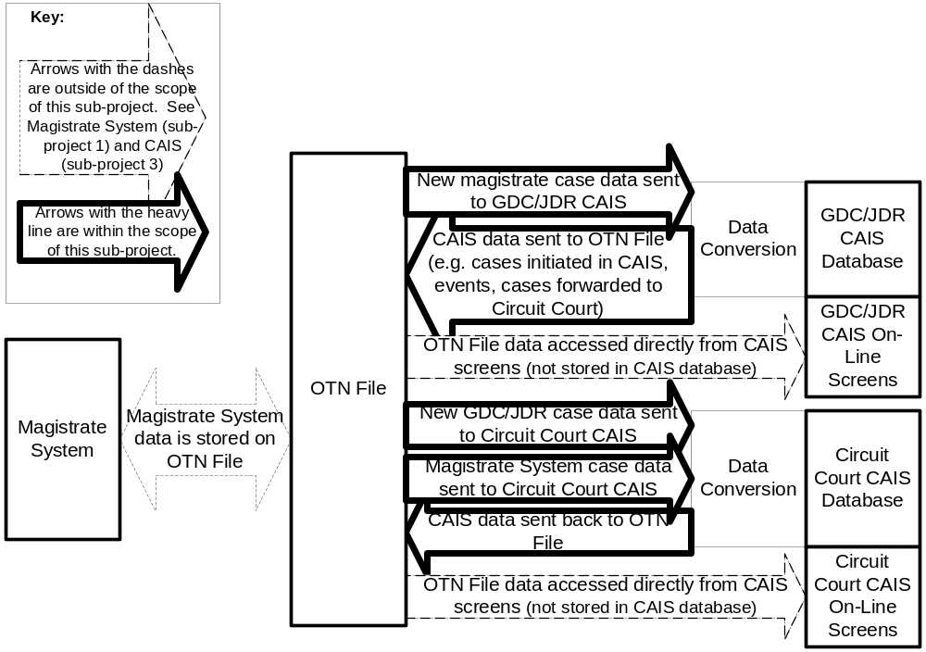

Req# | Title | Description
 | Magistrate/OTN File - CAIS Interface | Implement interfaces between OTN File and CAIS. Note: The receipt and assignment of OTNs is not covered in this sub-project since it is already covered in the Magistrate System (1), OTN File (2) and CAIS (3).
 | From OTN File To CAIS | Below are requirements related to this interface.
 | Triggers | The following actions will trigger the OTN File to update CAIS:  - Magistrate warrant or summons is executed and data is pulled from OTN File to GDC/JDR CAIS.  - Data fields on OTN File are updated that require replication to CAIS (either GDC/JDR or Circuit Court)(specifics to be determined by SCV).  - New case data (e.g. appeal or indictment) is pulled from OTN File to Circuit Court CAIS.
 | Data | The following information will be sent from the OTN File to CAIS. Specifics will be determined by SCV:  - OTNs  - Booking status, SIDs, DCNs  - Booking requirements  - VCCs.  - Case initiation document type - e.g. warrant (excluding search warrant), summons, capias, etc.  - Arrest information  - Bail information  - Charge details  - DMV information  - Commitment/release information  - Court case information  - Court hearing dates  - Juvenile identifier  - Offender information
 | GDC/JDR New Case Data Entry | Magistrate data representing a new case is automatically loaded into CAIS data entry screens and made available for editing by court staff at court case initiation.
 | Circuit Court New Case Data Entry | GDC/JDR data representing a new case for Circuit Court is automatically loaded into Circuit Court’s CAIS data entry screens and made available for editing by court staff at court case initiation.
 | Data Conversion – OTN File To CAIS | Standard data sent to CAIS shall be converted to CAIS data formats.
 | From CAIS To OTN File | Below are requirements related to this interface.
 | Triggers | The following actions will trigger CAIS to update the OTN File:  - Case initiated in CAIS (either GDC/JDR or Circuit Court).  - Data fields on CAIS are updated that require replication to OTN File (specifics to be determined by SCV).  - Event generated in CAIS that needs to be recorded in OTN File. It is understood that CAIS will include limited event capabilities during CSP.  - Court disposition information entered into CAIS.
 | Data | The following information will be sent from CAIS to the OTN File. Specifics will be determined by SCV after the data standards are available:  - OTNs  - Booking status, DCNs  - Booking requirements  - VCCs.  - Case initiation document type - e.g. warrant (excluding search warrant), indictment, summons, capias, etc.  - Arrest information  - Bail information  - Charge details  - DMV information  - Commitment/release information  - Court case information  - Court disposition information  - Court hearing dates  - Events  - Juvenile identifier  - Offender information
 | Data Conversion – CAIS To OTN File | CAIS data sent to the OTN File shall be converted to standard data formats.
 | Near Real-time interfaces | The exchange of data described above shall be near real-time.
 | Security | The security plan for the Magistrate System (1) and OTN File (2) shall include services provided by these interfaces.
 | Test Plan | The test plan for this sub-project shall be included in the Magistrate System (1), OTN File (2), and CAIS (3).

10. OTN File - LIDS Commitment/Release Interface
LIDS will be notified periodically through an interface with the OTN File of magistrate jail commitments and releases. Jail commitments and released entered into CAIS will also be forwarded to LIDS but some of the functionality may be limited during CSP.
LIDS will use the data for quality control purposes. SCV data will be compared to data received from jails. This sub-project will be co-managed by SCV and SCB.
Illustration 4, Magistrate System (1), Illustration 5, OTN File (2), and Illustration 8, LIDS (6) show the relationship between the Magistrate System and LIDS.
Req# | Title | Description
 | OTN File – LIDS Commitment/ Release Interface | Implement interface between Magistrate System, CAIS, OTN File with LIDS.
 | Triggers | The following actions will trigger the OTN File to send data to LIDS:  - Offender is committed to jail using Magistrate System or CAIS.  - Offender is released from jail using Magistrate System or CAIS.
 | Data | The following information will be sent from the OTN File to LIDS. Specifics will be determined by SCV and SCB. Only information specifically related to commitments and releases is applicable to this interface.  - OTNs  - SIDs (if booking information has already been sent from CCH to SCV per sub-project 11)  - VCCs.  - Case initiation document type - e.g. warrant (excluding search warrant), indictment, summons, capias, etc  - Arrest information  - Bail information  - Charge details  - Commitment/release information  - Court case information  - Magistrate or judge who issued commitment or release  - Offender information
 | Data Conversion | Standard data sent to LIDS shall be converted by LIDS to LIDS data formats.
 | Weekly interface | The exchange of data described above shall be, at a minimum, on a weekly basis.
 | Security | The security plan for the Magistrate System (1), OTN File (2) and LIDS (6) shall include services provided by these interfaces.
 | Test Plan | The test plan for this sub-project shall be included in the Magistrate System (1), OTN File (2), CAIS (3) and LIDS (6).

11. CCH – SCV Booking Status Interface
CCH will notify SCV of the booking status of each offense with an OTN. This will ensure that the judges and court staff have the latest booking information for each defendant. SCV will also store SIDs and DCNs, which helps to link court information with other systems.
This sub-project will be managed by VSP and SCV.
Req# | Title | Description
 | CCH – SCV Booking Status Interface | Implement interface between CCH and SCV to send booking status information to SCV systems.
 | Trigger | The following actions will trigger CCH to send data to SCV:  - New offense booking information is forwarded to CCH (SID identified) with OTN.  A very small number of CCH records require correction. VSP will notify the SCV of corrections in a manner to be determined by the VSP.
 | Data | The following information shall be sent from CCH to SCV:  - Transmission date  - Transmission types (new, corrected)  - OTNs  - DCNs  - SIDs  - Booking statuses (e.g. fingerprinted)  - Booking status dates.
 | SIDs, DCNs and Booking Status | SIDs, DCNs and booking status information shall be stored with the appropriate offense in the OTN File and/or CAIS. This data will support subsequent processing including CCH dispositional reporting (see sub-project 13).
 | No Matching OTN In CAIS | If the OTN File receives an OTN from CCH that cannot be matched to an OTN in the OTN File, then SCV shall inform VSP in a manner to be determined by SCV and VSP.
 | Frequency Of Interface | The SCV and VSP shall determine the frequency of the exchange of data.
 | Test Plan | A test plan shall be developed and implemented to verify that the requirements of CSP, VSP and SCV have been met.

12. SCV – CCH OTN/VCC Interface
The OTN File will notify CCH of each newly assigned OTN, the initial VCC assigned to each OTN and other data as agreed upon by SCV and VSP. The VCCs will be assigned to the CCH offense using OTNs. The OTNs and other related information may also be used by VSP for quality control purposes even though the development of quality control programs is not within the scope of CSP. This sub-project will be managed by SCV and VSP.
Req# | Title | Description
 | SCV – CCH OTN/VCC Interface | Implement interface between OTN File and CCH to send OTNs and VCCs to CCH.
 | Trigger | The following actions will trigger the OTN File to send data to CCH:  - New OTN is assigned to an offense in CAIS.  - New OTN is assigned by the Magistrate System.
 | Data | The following information will be sent from the OTN File to CCH. Specifics will be determined by SCV and VSP:  - OTNs  - SIDs (if booking information has already been sent from CCH to SCV per sub-project 11)  - VCCs  - Case initiation document type - e.g. warrant (excluding search warrant), indictment, summons, capias, etc  - Charge details  - Court case information  - Juvenile identifier  - Offender information
 | Data Conversion | Standard data sent by SCV to CCH shall be converted to CCH data formats.
 | Create OTN Sub-system at CCH | Create a sub-system at CCH that can receive and store all OTN-based records sent to CCH through this interface.
 | Frequency Of Interface | The SCV and VSP shall determine the frequency of the exchange of data.
 | Test Plan | A test plan shall be developed and implemented to verify that the requirements of CSP, VSP and SCV have been met.

13. SCV - CCH Disposition Interface
VSP and SCV have an existing automated interface between the CAIS and CCH. A weekly batch of final court dispositions is provided to CCH, and is matched to the correct arrest/charge using DCNs, which is found on both the arrest fingerprint card and the CCRE disposition form.
Adding the OTNs is an important step for improving the reliability of this interface and phasing out the use of DCNs. OTNs will allow for the automated matching of the final court disposition to the correct CCH arrest/charge when booking occurs before and after the final disposition. In those cases where booking occurs after a final court disposition, the CCRE disposition form is not available in court; therefore the CAIS-CCH interface does not include DCNs. Manual research is required to determine the corresponding arrest/charge fingerprint card. OTN’s will improve the completeness and timeliness of final court disposition information in CCH, which is widely used as part of VCIN, NCIC and NLETS to provide criminal justice information.
DCNs will continue to be used for offenses without OTNs (e.g. offenses initiated before the implementation of CSP).
This interface will also include the VCC for the final disposition and the VCC will be stored in CCH.
This sub-project will be co-managed by SCV and VSP.
Req# | Title | Description
 | SCV – CCH Disposition Interface | Update interface between SCV and CCH to send court dispositions using data standards including OTNs and VCCs.
 | Trigger | The following actions will trigger CAIS to send dispositions to CCH:  - Deferred disposition  - Final court disposition.  Note: Modifications to court dispositions is currently handled using the CCRE court disposition forms. SCV and VSP will agree on a new process that is not dependent upon the CCRE court disposition form.
 | Data | The following information will be sent from SCV to CCH. Specifics will be determined by SCV and VSP:  - OTNs (when available), DCNs (when available), SIDs (when sent from CCH to SCV per sub-project 11), VCCs (when available)  - Offender information  - Offense information  - Court case information  - Court disposition  - Court information
 | Data Conversion | Standard data sent by SCV to CCH shall be converted to CCH data formats.
 | Disposition Holding File | The disposition holding file shall be updated with OTNs and VCCs.
 | Assignment Of Dispositions With No Fingerprints | CCH shall automatically link OTN-based court dispositions with OTNs at CCH even when no fingerprint record is on file. However, the court disposition shall not be linked to SID until the fingerprint record is on file.
 | OTN Link To Disposition | Link court disposition to the correct charge using OTNs.
 | Frequency Of Interface | The SCV and VSP shall determine the frequency of the exchange of data, however, at a minimum the data will be sent by SCV to CCH at least once a week.
 | Test Plan | A test plan shall be developed and implemented to verify that the requirements of CSP, VSP and SCV have been met.

14. Expanded Access To VCIN
An important benefit of this sub-project is to improve the availability of CCH data for criminal justice staff. CCH is delivered through the VCIN State Police network. It is difficult for some staff to get convenient access to VCIN and, as a practical matter, this means that they do not have access to VCIN. VSP will soon update the technology used to access VCIN and this sub-project will provide funding for magistrates (minimum of 15 connections) and CAs (minimum of 15 connections) to increase the number of devices that have access to VCIN using this new technology. It is hoped that once of the value of this improved access is demonstrated, it will become a priority to locate funding to provide additional criminal justice agencies with VCIN access.

15. Strategic Planning
A strategic plan will be jointly developed that describes future integration opportunities. The plan will address the following issues:
- Interfaces from the OTN File to Wanted Persons.
- Interfaces from the OTN File for protective orders and other civil orders that require enforcement by law enforcement agencies, prosecutors and others.
- Improved integration for corrections agencies.
- Standards for interfaces between local and state criminal justice agencies.
- Improving post conviction fingerprint processing.
- Increase percentage of fingerprints using Live Scan to above 90%.
- Generally describe CSP data standards beyond what is included in the current phase.
- Messaging infrastructure to enhance interagency communications.
- Enhanced access to existing CAIS, LIDS, DOC, DMV Photos, and OTN files via VSP’s Virtual Private Network (VPN).
- Long term funding model for continued maintenance and support.
- Disaster recovery for CSP components.
- Electronic sentence orders.
- Electronic document management and electronic court filing.
- Making mug shots available through VCIN.
- Implementing OTNs at DJJ and updating court interfaces.
- Coordination of CSP activities as integration is expanded to include more criminal justice agencies.
- Monitoring of national Extensible Markup Language (XML) standards for criminal justice data.
- Expanded access to VCIN for courts, magistrates, Commonwealth’s Attorneys and other criminal justice agencies.
- Enhancing Commonwealth’s Attorneys information systems to receive OTNs.
- Automated workflow and event management capabilities.

16. Performance Evaluation
The following performance measures will be used to evaluate CSP:

- Expand access to VCIN for magistrates and Commonwealth’s Attorneys to help improve decision-making.
- Assign OTNs to new offenses initiated by magistrates and courts to improve case tracking and the exchange of data between agencies.
- Link OTNs with SIDs to improve data quality.
- Assign VCCs to new offenses initiated by magistrates and courts to provide data needed by policy makers, researchers and staff.
- Reduce the number of CCRE court disposition forms sent from booking agencies to courts to reduce processing errors and improve court efficiency.
- Reduce the number of court dispositions sent by CAIS to CCH that could not be matched with CCH fingerprint records. This improves the accuracy and timeliness of criminal history data.
  - Percentage that could not be matched automatically.
  - Percentage that could not be matched after manual review (includes offenders who were not booked).
- Reduce the amount of time required by VSP to research dispositions that could not be automatically matched with CCH fingerprint records. This improves VSP staff utilization.
- Reduce the number of offenses that should have been recorded in CCH and were not. This improves the accuracy of criminal history data.
- Reduce the number of duplicate bookings (i.e. fingerprinting). This improves processing efficiency.
- Improve data quality on LIDS and local jail management systems.
Please see the CSP Performance Measures Plan for data gathering methodologies and additional details.

17. Project Management And Analysis
A wide range of services are provided by DCJS, VSP, SCV and SPS that relate to multiple sub-projects. This includes:
- The management and coordination of the various sub-projects. This includes developing project plans and designs, scheduling, budgeting, managing the federal grant, grant monitoring and other related tasks.
- The analysis of integration issues and the establishment of integration standards.
Management and analytical tasks that relate to multiple sub-projects are usually grouped into this sub-project.

Attachment A: Glossary
Acronym | Definition | Acronym | Definition
AFIS | Automated Fingerprint Identification System | ORI | Originating Agency (NCIC)
CAIS | Court Automated Information System (SCV) | OTN | Offense Tracking Number
CAs | Commonwealth’s Attorneys | PDCIS | Public Defenders Commission Information System
CASC | Commonwealth's Attorney Services Council | PSI | Pre-Sentence Investigation
CC | Circuit Court | PTCC | Pre-Trial and Community Corrections Case Management System
CCH | Computerized Criminal History (VSP) | PTS | Pre-Trial Services
CCRE | Central Criminal Records Exchange (VSP) | SCB | State Compensation Board
CSP | Charge Standardization Project | SCV | Supreme Court of Virginia
DBMS | Database Management System | SID | State Identification number
DCJS | Department of Criminal Justice Services | SOR | Sexual Offender Registry (VSP)
DCN | Document Control Number | SP-180 | CCRE form used to capture manual fingerprints
DJJ | Department of Juvenile Justice | SPS | Secretary of Public Safety
DMV | Department of Motor Vehicles | USPO | United States Post Office
DOC | Department of Corrections | VACCIS | Virginia Automated Comprehensive Correctional Status Information System (DOC)
EFTS | Electronic Fingerprint Transmission Standard | VCAIS | Virginia Commonwealth's Attorney Information System
FIPS | Federal Information Processing Standards. | VCC | Virginia Crime Codes
GUI | Graphical User Interface | VCIN | Virginia Criminal Information Network (VSP)
IBR | Incident Based Reporting (NIBRS nationally and SCRIBE state) | VCSC | Virginia Criminal Sentencing Commission
ISO | International Organization for Standardization | VSP | Virginia State Police
LIDS | Local Inmate Data System (SCB)
Live Scan | Virginia State Police Electronic Fingerprint Capture/Transmission Device
NATMS | Networked AFIS Transaction Management System
NCIC | National Crime Information Center (FBI)
NIST | National Institute of Standards and Technology
OBSCIS | Offender Based State Correctional Information System

