
Figure 1 Massachusetts State Seal

DEPARTMENT OF MENTAL HEALTH
FORENSIC SERVICES

Pre-Arrest Law Enforcement-Based
Jail Diversion Program
Report

July 1, 2011 to January 1, 2014

OVERVIEW

There is a longstanding recognition that persons with mental illness are over-represented in the criminal justice system. While some arrests are necessary and appropriate, there are others in which individuals with mental illness might more appropriately be “diverted” into mental health and other treatment services in lieu of arrest and/or incarceration. The concept of “jail diversion” as it relates to the criminal justice system has many meanings. Different diversion programs target different points along the criminal justice continuum and a jail diversion program may relate to programs that provide alternatives to incarceration or those that avoid arrest and courts altogether.

Law enforcement-based jail diversion programs seek to redirect individuals with mental illness, substance use, and co-occurring disorders from the criminal justice system into treatment when appropriate and safe at the point prior to arrest. In addition, these programs seek to enhance public safety by identifying strategies that can be safe and effective in handling acute situations in which police are called regarding a person who is in an emotional crisis. This report provides information regarding Department of Mental Health (DMH) funded police-based jail diversion programs and summarizes the DMH supported mental health and law enforcement collaborative jail diversion initiatives in Massachusetts to date.

For Questions Regarding this Report Contact:

Karin Orr, LICSW
Area Forensic Director
Northeast Suburban Area
Department of Mental Health
Karin.orr@massmail.state.ma.us
617-626-8094

Or

Debra A. Pinals, M.D.
Assistant Commissioner
Forensic Services
Department of Mental Health
25 Staniford St.
Boston, MA 02114
Debra.pinals@massmail.state.ma.us
617-626-8094
NATURE OF THE PROBLEM

The need for jail diversion programs stems from several factors, including the following:

- People with mental illness and substance use disorders are over-represented in the criminal justice system compared to their prevalence in the general population.
- Around 7% to 10% of all police calls involve a person with a mental disorder and up to 31% of individuals in US jails suffer from serious mental illness.
- A portion of individuals with serious mental illness cycle in and out of the mental health, substance use and criminal justice systems and may, for a variety of reasons, receive minimal treatment.
- The TAPA Gains Center notes that people whose mental illness is untreated can sometimes act in ways that the general public considers to be frightening or threatening. When effective treatment is available, people with mental disorders and without substance use problems generally, except in rare circumstances, present no greater risk to the community than people in the general population.

Nationally, research is ongoing to evaluate data on jail diversion efforts as a means of addressing the problems identified above. Ongoing efforts to support service delivery models that look at the intersection of mental illness and the criminal justice system are important to ensure that individuals with mental illness are appropriately directed to treatment. Because mental illness is in and of itself not associated with criminal behavior, decreasing symptoms of mental illness as an overall and sole target may not be a sufficient intervention to reduce criminal recidivism or time spent in jail. Thus, jail diversion programs must consider broader goals of also decreasing criminal justice penetration for persons with mental illness and substance use disorders who may not otherwise have criminal tendencies. Jail diversion programs can alleviate jail overcrowding, reduce unnecessary prosecution and court costs, and reduce incarceration costs.

Police-base jail diversion can:
- Decrease criminal justice penetration for persons with mental illness and substance use disorders who may not have criminal tendencies but who need treatment
- Alleviate jail overcrowding
- Improve public safety

Jail diversion programs may also improve public safety. Effective programs help people with mental illness access appropriate treatment, help them live their lives with fewer symptoms, and can provide incentives to stay in treatment thereby minimizing or ending the costly cycling through crisis care. They can also help encourage strategies of working with individuals who may be in crisis in a way that can de-escalate behavioral disruption, thereby enhancing safety for all.

Diversion programs are a compassionate response to individuals with mental illness who need treatment and are not a public safety risk but might otherwise be incarcerated. It seems increasingly clear that individuals who receive appropriate mental health treatment in the community typically have better long-term outcomes.
HOW JAIL DIVERSION WORKS

A framework known as the Sequential Intercept Model helps clarify how and where to best intervene with people with mental illness in the criminal justice system. There are multiple points within five categories (or intercepts) where targeted interventions can affect individuals’ movement into or within the criminal justice system. The five main intercepts generally can be described as follows:

- Law enforcement / Emergency services
- Booking / Initial court hearings
- Jails / Courts, including specialty courts (drug, veteran, and mental health)
- Re-entry
- Community corrections / Community support

Various jail diversion programs typically target one of the five “intercept” categories. Diversions occurring through law enforcement and emergency services can redirect individuals from the entire criminal justice system, thereby avoiding contact with the multiple layers of subsequent criminal justice settings altogether. The Commonwealth’s DMH police-based diversion programs target the first intercept, Law enforcement / Emergency services, where some of the highest cost savings may be realized (e.g., avoidance of costs associated with booking, court processing, etc., unnecessary emergency room visits or hospitalizations through linkages to alternative points of care).

MASSACHUSETTS MODELS OF POLICE-BASED PRE-ARREST DIVERSION_______

DMH has worked since 2003 in the field of police-based jail diversion programs and for many more years before that on special programs related to ad hoc training of law enforcement officers on topics related to mental illness, mental health services, and crisis de-escalation.
In examining this rich history, and in looking at national models, DMH has continued to evolve its efforts toward developing grant-funded programs of police-based pre-arrest diversion and specialized law enforcement training. Successful jail diversion programs have common elements regardless the model type. DMH has kept these (below) elements in mind when developing requests for proposals for police-based jail diversion grant programs.

- Community-based interagency service coordination with a high level of cooperation and commitment between all parties
- Regular meetings of key partners
- Strong leadership
- Early and effective identification of candidates appropriate for the various diversion programs
- Liaisons accountable for linking the judicial, correctional, juvenile justice, and mental health systems
- Culturally competent participating staff who have expertise and interest in the criminal justice and mental health systems
- Mental health training for law enforcement to identify and skillfully and safely intervene when encountering those with behavioral health crises.

DMH has worked since 2003 in the field of police-based jail diversion programs and for many more years before that on special programs related to ad hoc training of law enforcement

The lead agency for the DMH-supported Police-Based diversion programs must be a police or sheriff or other local public agency (cities and towns may apply), and the police, sheriff or other public agency must play a key role in the program’s design, administration and operations to be considered for grant funding by the DMH.

Further, goals of all of pre-arrest jail diversion programs must include: 1) development of safe and effective programs to educate police and related personnel through training on topics related to mental health and emotional crises to help develop the knowledge base and practice of first responders; and 2) development or maintenance of meaningful community partnerships with behavioral health providers to facilitate diversion, when appropriate and safe, of adults and/or youth with mental illness or serious emotional disturbance from the justice system to community based treatment. In recent years, an additional emphasis has been supported to help divert youth and persons with a history of military service from arrest when appropriate.

In recent years, an additional emphasis has been supported to help divert youth and persons with a history of military service from arrest when appropriate.

Police-Based Crisis Intervention Teams (CIT)

Developed in Memphis, Tennessee, the CIT model, now internationally recognized as one of the leading police-based models to help individuals with mental illness that come into police contact, represents the development of a specialized law enforcement “team” and uses a systematic approach that links law enforcement and mental health provider communities and response capability. The CIT model attempts to maximize the abilities of the participating officers to respond to officer calls for individuals with emotional disturbances. It trains responding officers to identify and safely respond to individuals experiencing emotional disturbance, mental illness, and substance use. A CIT program is developed through rigorous 40-hour training on identification of mental illness, de-escalation techniques and local resources available to officers for referral. CIT training is typically offered to a minimum of 20% of volunteers from the police force and includes staff from each shift enabling officers with this specialty training to intervene and respond to mental health crises on any shift.

CIT goes beyond training …officers. It also involves the development of a local multi-agency community infrastructure, creation of formal policies of response to individuals in emotional crisis, and formalized diversion efforts…

This model goes beyond the training required of the individual CIT officers. It also involves the development of a local multi-agency community infrastructure, creation of formal policies of response to individuals in emotional crisis, and formalized diversion efforts between community partners and law enforcement. Arrangements are often made with local providers for “drop off” sites for police to bring individuals in crisis, thereby diverting individuals into the least restrictive treatment setting for the individual, and avoiding unnecessary emergency room visits and arrests. Goals of CIT programs include enhanced officer and community safety (data shows fewer injuries for all involved) and improved access to behavioral health services for individuals in need.

The number of CIT programs across the country has grown exponentially. Early data on this model suggests that officers who are CIT trained within police departments with a CIT infrastructure are better prepared, have greater confidence in responses to mental health calls, and have more empathy than non-trained officers when interacting with individuals who have mental illness and substance use disorders. Lower arrest rates and greater likelihood of treatment engagement were also noted for these integrated team models. Given emerging research related to CIT as a best practice, DMH has developed grant funding to increase the development of this model as one that may be effective in certain jurisdictions of the Commonwealth.

In Massachusetts, CIT training can also enhance the officer’s knowledge of local resources, including how to access Massachusetts Behavioral Health Partnership Emergency Service Providers (ESP) who can, when available and appropriate, arrive to a scene simultaneously with a CIT-trained officer to also offer further assistance in assessing a situation and potentially diverting a person from arrest. In this way, CIT police programs and ESP programs can work in partnership to serve their communities.

Mental Health Police-Based Programs (Co-response)

This model is a mental-health based diversion model that pairs a clinician, most often an emergency service clinician of the local ESP team, with police to co-respond to calls with mental health elements. The clinician in this model is embedded into the police department during their work hours. Calls in which clinicians participate deliberately involve individuals experiencing emotional distress and/or psychiatric symptoms that may also have co-occurring substance use issues.

Responding police officers determine whether a person is a candidate for jail diversion or must be arrested in any given situation. While on site with police, the mental health clinician evaluates the need for hospitalization, makes referrals, and later can provide follow-up services to link the individual to further treatment if needed.

Diversion from arrest to acute psychiatric inpatient care is the most frequent diversionary activity for this model, but post-booking diversion from lock up to inpatient services also occurs. In addition, the police-based clinicians provide a liaison to police in non-crisis situations like assisting police with wellness checks and death notifications and working with police in other non-criminal community encounters as needed. The presence of clinicians in a police station can further enhance police knowledge and skills as well as community partnerships with ESP programs.

This model developed across the country in various cities. The first of this co-response model in the Commonwealth, which helped spearhead jail diversion programming in the state overall, was developed by the Framingham Police Department in collaboration with Advocates, Inc., through private funding and has since been sustained through state DMH funding (see below).

Innovative models of Police-Based Jail Diversion

Innovative diversion programs combine components of different models noted in this document (e.g., Police Response or Mental Health Professionals and Police Based Response) with other elements to develop a community-specific program effective at identifying individuals with mental illness and diverting them from arrest. The “Innovative” program label was coined by DMH in an FY11 Request for Response that sought to address those diversion activities that develop organically within a community and may not fit neatly into one of the above defined models. Examples of Innovative programming include:

- police training to respond to incidents involving mental and behavioral health issues;
- use of a program coordinator to work with police to develop mechanisms of diversions from arrest, training and data collection; and/or
- development of police policies and approaches toward support for diversion of individuals with co-occurring disorders from criminal justice involvement into treatment
- development of opportunities for community problem-solving conferences to help leverage resources to assist individuals who may present repeated challenges to law enforcement, first responders and mental health service providers

For example, a police department may propose that a percentage of law enforcement and community services staff (e.g., police, psychiatric emergency service staff, emergency hospital staff, hospital security, dispatch, and college security staff) be trained together and hold regular meetings to develop seamless diversion opportunities to address that community’s needs.

Diversion innovations have included the use of Peer Specialists (generally someone with lived experience with mental illness). Examples of integrating peer specialists into law enforcement diversion programming include 1) training to sensitize police and other public justice-related professionals to issues affecting individuals with mental illness at risk of criminal justice contacts, 2) providing follow-up visits and/or case coordination to individuals who were diverted or deemed at risk of arrest, 3) providing a consumer voice to police and/or other public justice-related professionals in development of diversion protocols and policies, and 4) participating as a resource to police and/or other public justice agency as part of a broader specialized law enforcement program model.

Diversion innovations have included the use of Peer Specialists

Like all other police-based diversion models, an Innovative approach requires a working partnership between law enforcement and local mental health programs, including emergency service programs and working in partnership with the Department of Mental Health.

Mental Health First Aid (MHFA) Training for Police

Developed in Australia, MHFA model is a standardized training curriculum that has widespread application and has had a growing impact in the United States. In the police-based jail diversion context, it is used with law enforcement and others (e.g., dispatchers, EMT personnel) to educate officers and others in the first responder context on basic interventions for common mental health problems, substance use disorders, and crisis situations. The course is designed to increase mental health literacy, decrease mental health stigma, and increase early and appropriate access to help by people with mental health problems. Officers learn how to provide assistance in both mental health crisis and non-crisis situations. MHFA consists of a 12-hour course by a Certified Trainer to help individuals learn to identify, understand, and respond to signs of mental illnesses and substance use disorders. MHFA certification training is administered through Mental Health First Aid USA, which is managed by the National Council for Community Behavioral Healthcare, the Maryland Department of Health and Mental Hygiene, and the Missouri Department of Mental Health.
While MHFA is not in and of itself a police-based Jail Diversion Program, its training for officers provides one component to help advance officers’ ability to respond to mental health crises. Over the last two DMH grant initiatives, the Massachusetts DMH has funded this training as one potential key element of diversion activities for police departments looking to expand their knowledge related to persons with mental illness and to consider expansion of diversion capabilities. MHFA has been recognized by DMH more broadly as a priority training tool of first responders.

CURRENT POLICE-BASED PROGRAMS FUNDED BY DMH______________________

With appropriations provided by the Commonwealth, the programs currently funded by the Massachusetts DMH, along with the model utilized, are summarized in Figure 1 below. Most of the programs are funded by a fiscal grant mechanism. Some are funded through ongoing program appropriations.

Figure 1. Police-based jail diversion programs supported by DMH in FY 2014

City / Town / Provider | Grant/Funding start date | Diversion model
- Arlington | FY2010 | Co-response/MHFA
- Bedford | FY2013 | Innovative/MHFA
- Boston-B2 | FY2010 | Co-response
- Boston-D4 | FY2011 | Co-response
- Boston-C11 | FY2013 | Co-response
- Brockton | FY2011 | CIT
- Danvers | FY2014 | CIT/MHFA
- Egremont | FY2013 | CIT
- Fitchburg | FY2013 | MHFA/CIT
- Framingham | FY2008 | Co-response
- Holyoke | FY2014 | CIT/MHFA
- Marlboro | FY2010 | Co-response
- Northampton | FY2011 | CIT
- Quincy | FY2008 | Co-response
- Salem | FY2014 | CIT and p/t co-response
- Somerville | FY2012 (2/1/12) | CIT/MHFA
- Somerville (for Greater Boston & parts of Middlesex County) | FY2014 | CIT-TTAC*
- Taunton | FY2008 | CIT-like model
- Wakefield | FY2013 | CIT/innovative
- Waltham | FY2008 | Co-response/MHFA
- Watertown | FY2008 | Co-response
- Westfield | FY2014 | CIT
- Worcester | FY2012 (2/1/12) | Co-response/MHFA/CIT
- Behavioral Health Network in western MA (Holyoke, Westfield, Chicopee) | FY2014 | CIT-TTAC*

*A CIT-TTAC (CIT Training & Technical Assistance Center) is a new grant mechanism initiated in FY14 to create a hub for CIT development across a region. Each CIT-TTAC partners with surrounding towns and police departments for consolidated training, exploration of community partnerships and mentoring opportunities, and development of relevant protocols.

A CIT-TTAC (CIT Training & Technical Assistance Center) is a new grant mechanism initiated in FY14 to create a hub for CIT development across a region

POLICE DIVERSION PROGRAMS IN ACTION: CASE EXAMPLES
Below are examples of a few of DMH-supported police-based jail diversion activities.

Boston: Officers were called to respond to a local residence where a male teenager [known to local providers and police] was “out of control” and aggressive toward his mother. The Co-response clinician and officer heard the call over the Boston Police Department (BPD) radio and responded as they knew this family from prior responses. The individual has a history of impulsivity and anxiety when police are called to his residence and has a history of assaulting officers in an attempt to 'get away' when officers arrive. The JDP clinician and Officer were able to educate responding officers on the individual’s history in an attempt to reduce the anxiety of the situation for him. The individual was diverted from arrest for assault (he attempted to assault officers on scene) and was brought to Children’s Hospital where he entered treatment. The Boston Emergency Service Team (BEST) Bay Cove team took over follow up care, ensuring he received proper attention.

Boston’s Peer Specialist: Peer Support is an increasingly utilized service model for providing care to people with a variety of illnesses, including mental illness. Peer support is based on the notion that personal experience provides a unique and critical element in the recovery process. The Boston JDP provides a peer specialist who works with clients initially referred by the Boston Police Department and the BEST jail diversion clinicians. The peer specialist provides peer-to-peer supportive services (by phone, email and in person) for individuals with mental illness who come into contact with the Boston Police.

Brockton: Soon after the forty hours of CIT training was completed to fifteen Brockton police officers, one of the newly trained female CIT officers used her CIT skills to work with a man who had special martial arts abilities and made her concerned that he may use them to harm her. In addition to requesting Brockton Multi-Service Center (BMSC) respond to the scene (who were working on section 12 paperwork), the female officer also called her CIT Supervisor for Brockton PD and her Sergeant to come to the scene, as both of them also had martial arts skills.. When he walked into the home, the Sergeant observed a man sitting in a chair making gestures with his hands that were consistent with a form of martial arts, yet talking erratically. The Sergeant began by asking the gentleman what kind of karate he was using, and they engaged in a discussion focused on where they had trained in their martial arts and discovered that they had learned from the same teacher. Immediately the gentleman felt a bond with the Sergeant, and the Sergeant was more able to ask him what had occurred that made him so agitated. The Sergeant then went on to explain that the best thing to do at that time was to get him to the hospital for a psychiatric evaluation. The Sergeant explained options to the man, and the man chose to go without restraints and in the back seat of the Sergeant’s cruiser. While talking to the gentlemen, this gentleman admitted he needed help. He felt as though his violent temper might erupt and did not want that to happen, but had difficulty controlling it. The Sergeant provided reassurance and information about the steps involved with the Emergency Department (ED) visit and care he could receive afterwards.

Perhaps indicative of the empowering potential of dialogue, while the gentleman was waiting at the hospital ED, he helped calm another younger patient while he waited for a psychological evaluation.

Fitchburg: The Fitchburg Police Department had most of its officers trained in Mental Health First Aid (MHFA) and about 20% of trained in the Crisis Intervention Team (CIT) model. Over the summer of 2013, various members of the Police Department responded to a 37-year-old male’s apartment several times for calls including excessive noise, disturbing the peace, and suicidal threats. During one of their first interactions as MHFA-trained officers, the officers were able to de-escalate a situation with this person and no arrest was made. On the second occasion, his behavior could have warranted arrest for several charges including disturbing the peace. The MHFA-trained officers recognized, however, that he was suffering from a mental health crisis; they noted he appeared visibly upset, confused and was making suicidal threats in their presence. Instead of arresting him, they decided to contact the Emergency Services Provider (Community HealthLink) and had him taken to the Emergency Department for assessment of his need for a psychiatric hospitalization.

Marlborough: The Marlborough JDP clinician assisted an older woman who was recently widowed, the mother of an adult with developmental disabilities and who had many other financial/health/family concerns. She reported that she did not think that she could handle all the stressors and she began drinking alcohol to the point where her family was extremely concerned. The family called the police for a wellbeing check and, although there were no immediate safety concerns, the clinician was able to get the woman to understand more about the potential disadvantages of drinking with her medical condition, the signs and symptoms of depression, and to educate the family. The mother was provided a crisis counseling appointment the following day to facilitate engagement in mental health treatment and support.
Worcester: A 911 call was placed by a concerned father in November 2013 to check on the well being of his young adult son. The son was expressing suicidal thoughts and was not answering his phone or door. The father requested police assistance in gaining entry to his son’s apartment to see if his son required medical assistance. The Fire Department was dispatched and gained entry though an opened window, but the son was not there.
Worcester Police Department’s Crisis Intervention Unit reviewed the week’s calls and flagged this call for follow up. The case was given to a CIT officer who contacted the father. During this conversation, the officer learned that the son served in the military for two years in Iraq and had a difficult time reintegrating back into civilian life. The father told the officer that his son served honorably in Iraq and returned home to find a promising career, only to have increasing difficulties, likely related to acute symptoms of Posttraumatic Stress Disorder (PTSD), resulting in a 100% disability determination by the Veteran’s Administration.
The father stated that his son was so bothered by the nightmares, that he began to use alcohol and drugs to cope, causing him to miss work. The son became angry and self-destructive, and became involved in drug dealing, resulting in threats of harm to his life. With many relationships damaged, the father stated that his son had become suicidal and clearly expressed his wish to die as well as a desire to use his combat training to kill the drug dealers that have been threatening him. The father believed his son would act on these thoughts, motivating him to contact the police for a wellness check.
The CIT officer coordinated transportation of this man to Community HealthLink, the local Emergency Service Provider, to evaluate his level of risk and address his suicidal thoughts. Following this assessment, he was held pending a psychiatric hospitalization.
The CIT officer also contacted the Commonwealth’s Department of Veterans Services SAVE team and convened a meeting at the Worcester Police Department the next day to introduce family members to the peer specialist of the SAVE team. The SAVE team listened to the family’s concerns and informed them of services that were available to the son. It was clear to the CIT officer that the family took comfort in knowing that their son is not the only soldier that has returned with these types of issues. While the family and the SAVE team spoke and developed a plan for their son.
Within a day or two, the son was placed in an intensive VA sponsored detoxification facility with counseling to treat his co-occurring disorder. Upon completion of this program, the veteran will attend a program designed to integrate soldiers back into the civilian world by giving them copings skills needed to reenter the workforce and to foster healthy relationships.
In addition to the services mentioned above, the veteran was assigned a court advocate to help him with his legal affairs. Lastly, the veteran’s family was also offered services, by the VA and CHL, to help them deal manage the stress and learn how to best support their family member in crisis. Having a CIT trained officer helped to heighten awareness of community connections and addressing individuals in crisis.
FUNDING HISTORY

State funding to DMH for police-based jail diversion programs has evolved, with the initial funding appropriated in FY 07 of 400K for grant and programmatic expenditures. In FY13 grant funding availability increased to $585K which allowed the expansion of programs into new communities. Programmatic funding encompassed $205K, for a total of $790K allocated to law enforcement-based jail diversion services in FY13. Further expansion occurred in FY 14 of $331K, for a total of $1,121,000 dedicated to police-based jail diversion programs in FY 14.

PROGRAM DATA

Data collection is viewed as a programmatic priority to ensure an ability to evaluate outcomes related to expenditures. Data collection and standardized outcome assessments have been an important component of DMH funded law enforcement-based diversion programs.

DMH goals include the ability to capture data related to diversion outcomes for all programs, regardless of program model. Thus, data collection efforts continue to evolve and change as the number and type of programs has expanded. The database and data collection system shifted in FY12 allowing programs to enter their own program data and forward it to DMH for the diversion program database. With the rollout of this new process, there were significant refinements and additional data points made to the initial database (used from FY07 to FY11). CIT and MHFA programs began submitting quantitative data into the statewide database in January 2013. Previously, CIT and MHFA programs submitted narrative reports quarterly and their data was aggregated in past reports. Utilization of the new database began in January 2013 and complete fiscal year data from this database will appear in future reports.

CIT AND MHFA TRAINING

Four police departments had CIT or MHFA diversion models in FY12 and between them they provided 2,156 hours of training to 232 officers. In FY13, seven departments provided an additional 4,980 hours of training to 244 officers on identification of mental health and substance use (CIT & MHFA), de-escalation skills (CIT) and on local community resources (CIT). In FY2013, MHFA-trained officers responded to 370 calls and there were 251 responses by CIT officers.

In FY12 and FY13 over 7000 hours of mental health training was provided to 476 officers through DMH-supported Crisis Intervention Team and Mental Health First Aid Training.

CIT police-based programs include training curricula that are developed based on national models of CIT training as well as technical assistance from the Department of Mental Health Forensic Services. In addition to core elements, local providers and other stakeholders also participate in these trainings.

Figure 2 below illustrates aggregate data from all jail diversion models in the Commonwealth on the nature of initial calls received by Police Department dispatch that are ultimately identified as involving mental health and/or substance use issues. Not surprisingly the majority of calls present as psychiatric crises, but noteworthy is that some calls come in as a domestic dispute (involving dispute between people residing together) or general disturbance.

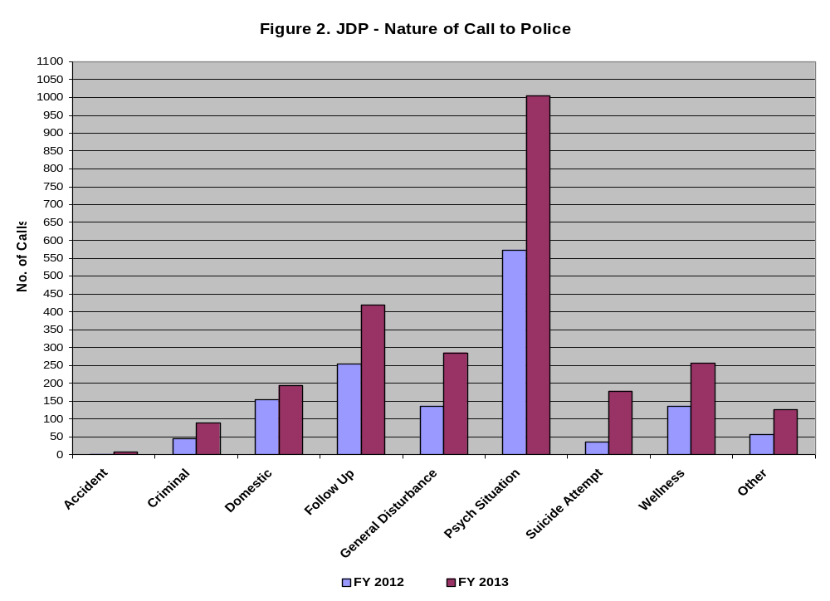
Figure 2 JDP Nature of calls to Police chart

Figure 3 below analyzes the number of calls where diversion from arrest was an option during what was considered a call involving an emotionally disturbed person. For the large majority are calls, arrest (and thus diversion) is not an option. The frequency of arrestable events ranges from 19 to 35% of all police calls to JDP programs. Diversion from arrest is not an option when charges are mandated by law, when police feel public safety needs supersede an individual’s mental health issues, or when a police call does not involve arrestable behavior.

The diverted group represents diversion from charges or diversion from custody in situations where a clinician responded with an officer but where an arrest could have occurred; i.e., community based or inpatient services were provided in lieu of arrest and filing of charges. Those not diverted were ultimately charged and entered the criminal justice system.

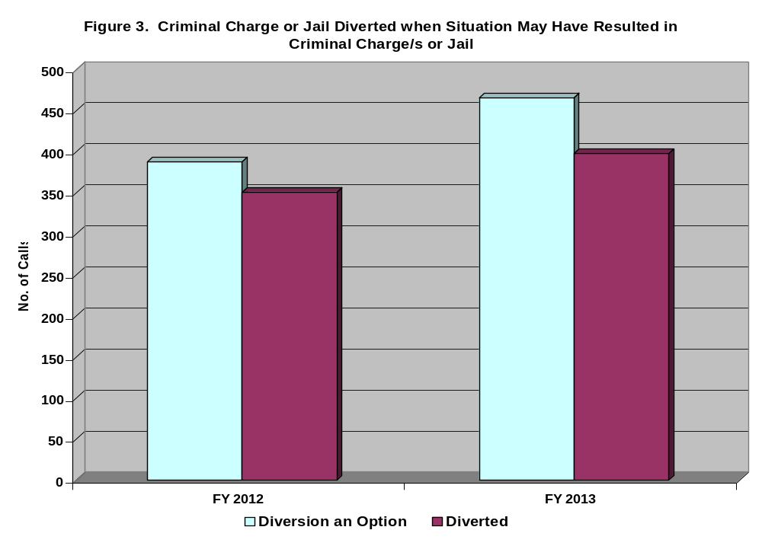
Figure 3: Chart of Criminal Charges or Jail Diverted when Situation May Have Resulted in Criminal Charges or Jail.

Statewide, the rate of diversion for all program types ranges from 73% to 92% of those calls where diversion from arrest was an option. Of that percentage, Figure 4 below summarizes the most frequently occurring potential or actual charges/actions of those individuals who were diverted. Predictably, minor charges make up the largest number of those that are diverted from arrest. “Actual” charges means that occasionally a criminal charge is attached but the individual is diverted from custody through JDP intervention.
Figure 4: Diverted Charges by Category
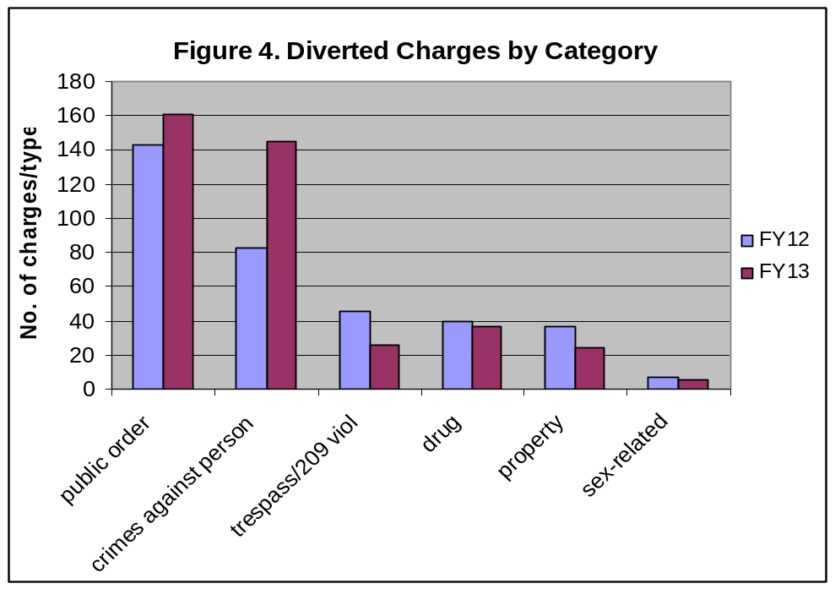

Figure 5 below shows the most frequent diversion dispositions. Section 12 referrals for inpatient psychiatric care and referrals to one’s current community based Provider are the most frequent diversion dispositions. The category of “other” dispositions includes a majority of clinical assessments within protective custody. With the increasing number of CIT programs in the state, on site de-escalation by officers is increasingly used in lieu of filing charges and sometimes in lieu of psychiatric hospitalization.
Figure 5: Diversion Dispositions 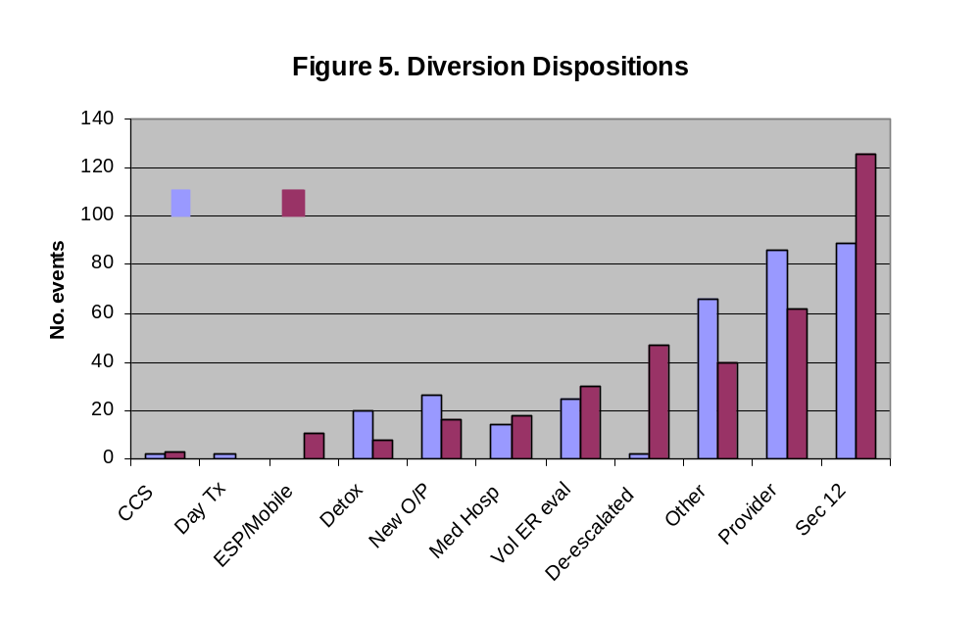

Figure 6 below represents the aggregate data from FY2012 and 2013 and illustrates the primary clinical issues associated with co-responders to calls in which mental health and/or substance use was involved, based on a best estimation of the co-responding mental health clinician. Almost half (42%) of the responses by jail diversion programs in FY12 and FY13 involved individuals with mood instability. The second most frequent contact (26%) is with individuals who have both mental health and substance use issues recognized at the point of contact. Although at the time of presentation some of these issues are difficult to sort out, less than 5% of the time diversion responses involve individuals who exhibit only symptoms of substance use, though calls involving these individuals may be more frequent for police-responses. Diversion to mental health and substance use services are important components of jail diversion activities.

Figure 6: Pie chart presenting Psychiatric Issues (FY’s 2012 & 2013)
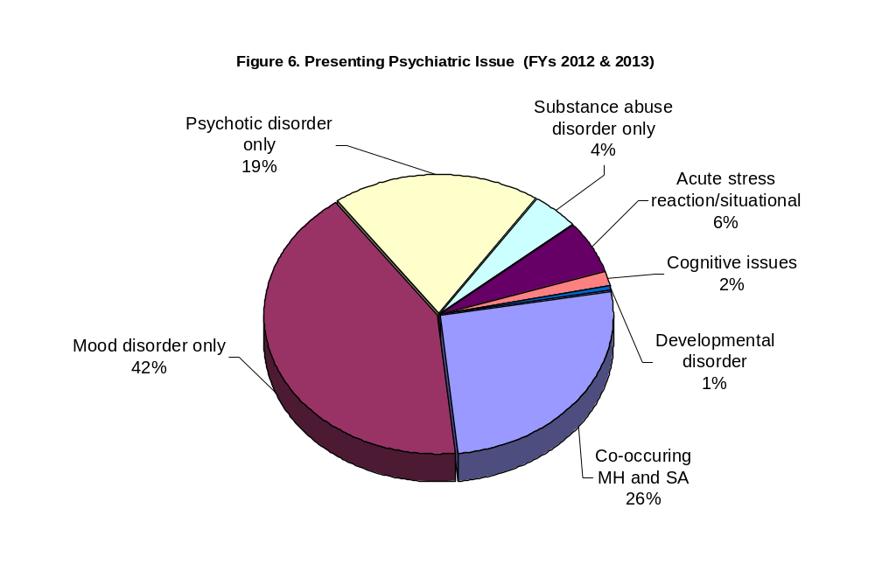

Figure 7 below shows the activities jail diversion programs engage in when diversion from arrest is not relevant to the call (i.e. non-criminal situations). The most frequent activity (25%) is participating in safety checks in the community, often at the request of family or friends of someone known to have mental health issues. For some, without this specific program intervention, subsequent contact with the police would be more likely. Police officers report that such contacts improve the relationship between the community and police department since the contact is supportive rather than punitive.
Figure 7: Pie Chart Program activities when not for diversion (FYs 2012 & 2013)
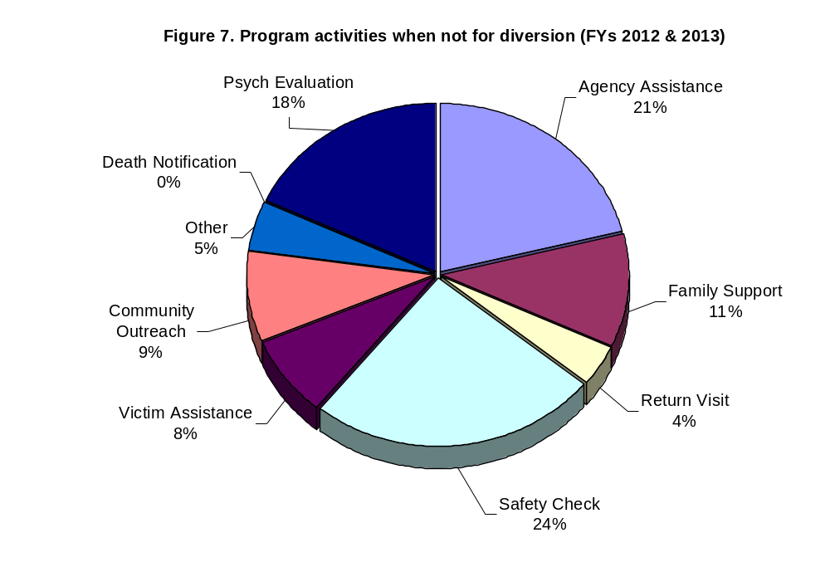
Figure 8 below illustrates aggregate data on the primary health insurance of those individuals who were the subject of a jail diversion assessment or intervention (inclusive of non-arrest events) in FY12 and FY13, when known. Twenty six percent of individuals involved in diversion events have Massachusetts Behavioral Health Partnership (MBHP) – and another 13% were covered by an alternative Medicaid provider. Overall 39% were covered by some form of Medicaid. For 38% of this population, the insurance status of the individual was unknown. Approximately 3% of the group was known to be uninsured. Insurance status is not known for a moderate number of contact events because by definition they are crisis driven and not dependent on insurance status, and insurance status is not always ascertainable during the crisis contact.
Figure 8: Primary Insurance (FYs 2012 & 2013)
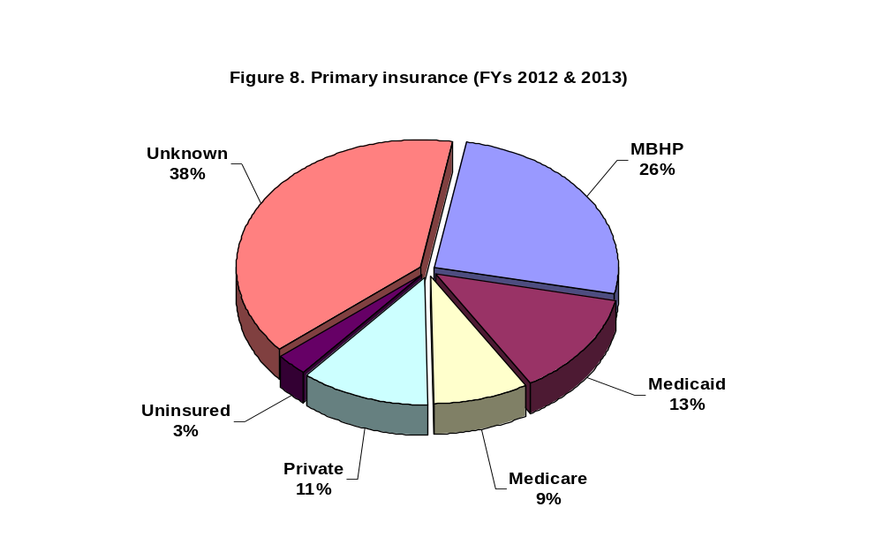

SPECIAL POPULATIONS: VETERANS AND YOUTH

Beginning in FY10 DMH requests for responses included language that asked grantees to address how they would meet the needs of individuals with mental illness as well as the needs of two specific populations, veterans and youth.

Veterans: Two and one half million people were deployed in the last ten years and of that number, 75% were deployed more than once. Nationally, around 7% of the general population is a veteran of one war or another. Individuals who have served in the military, particularly those who have faced combat and multiple tours of duty are at increased risk of experiencing mental health sequelae and/or substance use difficulties. This, combined with trauma histories, may increase the risk of behavior that rises to the level of police attention (e.g., erratic driving, dramatic irritability due to trauma symptoms or brain injury). Estimates indicate that 10% of prison populations are comprised of persons with a history of military service, and veterans returning from multiple tours of duty may be at increased risk of involvement in the criminal justice system.

Given concerns that veterans may be increasingly represented in the criminal justice system, a variety of programs has been initiated to divert veterans from jails and prisons and to assist incarcerated veterans. DMH has established a court-referred veterans’ diversion program and has included a priority to veterans in its police-based jail diversion strategies. This has included special veteran-focused trainings for police and other justice personnel and linkages to veterans’ service organizations.

Identifying a veteran during a police response can be complicated, but in FY12 and FY13 we diverted from incarceration 17 individuals with a known history of military service. In addition to targeted “diversion”, additional contacts and assessments made by specially trained officers or co-responding jail diversion clinicians from the DMH jail diversion programs in FY12 including interventions for 92 individuals identified as having served in the military. For FY13, 167 events involved individuals who served in the military. It is anticipated that as grantees become more familiar with the need to identify individuals with a history of military service, that additional supports and responses will become available.

Of the veterans encountered by the jail diversion programs, Figure 9 below shows that 60% were between the ages of 27-45; 18% were between the ages of 46-65 and 18% were over 66 years old, suggesting the programs are working with Vietnam era veterans as well as veterans of more recent conflicts. Future planning involves ongoing development of mechanisms to improve data collection to help identify service members and veterans and link them to partnering agencies, programs and services. For example, beginning later in FY14, DMH is partnering with the Department of Veterans Services SAVE team to support 2.5 Veterans Justice Peers whose goals are to assist veterans in the justice system.

Figure 9: Military Service History by Age (FYs 2012 &2013)
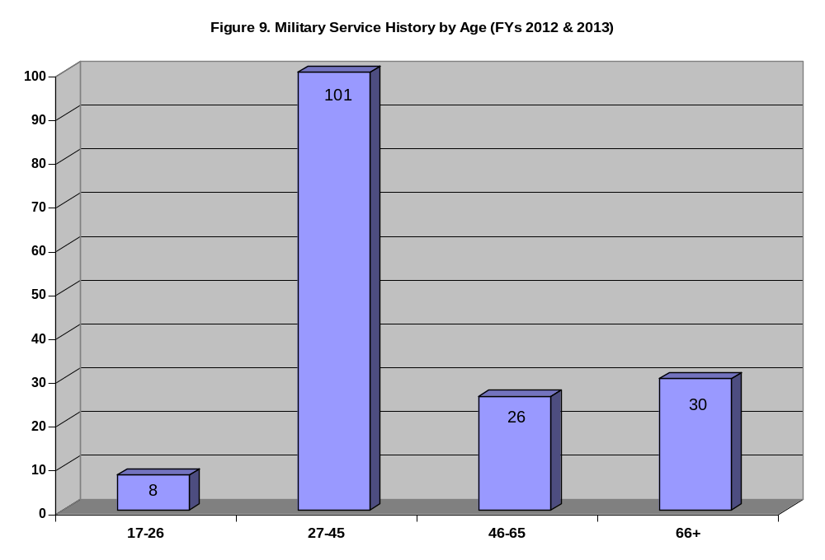

Youth: The largest number of diversion assessments is with individuals between the age of 46 and 65 (30%) while the second most frequent assessment contact (29%) is with individuals between 27 and 45. A percentage of contacts by police with youth occur and are often qualified as “domestic” calls to residences by parents about a disruptive child. Ongoing work collaborating with efforts of the Department of Youth Services and other stakeholders related to the Juvenile Detention Alternative Initiative (JDAI) is expected for youth at risk of detention. In addition, future data collection efforts will examine situations in which families and youth may benefit from specific referrals.

REGARDING COST SAVINGS: SOME THEORIES OF COST AVOIDANCE

Projecting cost savings of jail diversion programs is challenging as treatment and criminal justice costs are often examined separately, and cost estimates do not include an analysis of long-term savings or expenditures. In the short term, national data shows that diversion programs initially shift costs from criminal justice to the mental health system. Typically more intensive services are needed when someone is in crisis, but longer term savings get realized over time as treatment need and costs decrease as well as decreases in future criminal justice involvements.

As part of a cost-avoidance projection, some have begun to look at savings obtained if police are able to divert individuals both from arrest and from emergency room utilization when those levels of intervention are not necessary. Specifically, significant savings to hospital Emergency Rooms would be realized through pre-arrest, police-based diversion programs by decreasing unnecessary visits to Emergency Rooms (an estimated savings $3,000 to $4,000 each visit – not including police time away from their shift). Further savings are realized to local communities and municipalities through improved coordination between services, potentially reduced injury by increased officer training and skills development, and collaboration with clinical providers who can work with individuals over time so that police are freed to respond to public safety matters.

Savings may also be realized downstream if appropriately targeted mental health services are provided and costly cycling between systems lessens. National data suggests that jail diversion programs can alleviate jail and emergency room over-crowding, reduce the costs of incarceration, shrink court dockets, and decrease unnecessary prosecution.

DMH has begun collecting data on diversions from Hospital Emergency Rooms in order to better track estimated cost savings by the Commonwealth’s grantee Police-based jail diversion programs. These and other savings are estimated in the below table:

Total # events | N=2174 | @ est. cost per event | Estimated potential savings realized 7/1/11 to 6/30/13
Diverted from Emergency Room | 1312 | $3,500 | $4,592,000
Diverted from Arrest | 768 | $2,000 | $1,536,000
Diverted from Jail custody | 400 (estimate) | $130/day  x 4 days | $208,000
ESTIMATED COST SAVINGS FOR TIME PERIOD |  |  | $6,336,000⁺

⁺Costs not factored into this estimated savings include court fees, public defender and district attorney salaries, police costs for court appearances, potential for reduced injury and related costs, and other miscellaneous cost.

CONCLUSION

The prevalence of individuals with mental illness and co-occurring substance use disorders in jails and prisons is higher than in the general population. Nationally, alternatives to incarceration have gained momentum as a humane and cost effective strategy to reduce criminal justice costs and improve access to health care without compromising public safety. Early identification of individuals with mental health needs at each level of contact with the criminal justice system can improve their access to care and improve long-term treatment outcomes. Effects of these types of interventions are increasingly showing promise with benefits to society and potential for cost savings. Thus, based on our experience with police-based jail diversion initiatives to date, the following points are worth noting:

- Resources allocated to police-based and other jail diversion activities, nationally and locally, are providing safe, successful, and cost-effective strategies for individuals with mental illness at risk of contact with the criminal justice system.

- DMH police-based diversion programming has allowed the development of standard approaches to diversion, development of a shared data set and ongoing evaluation of interventions provided.

- The Commonwealth of Massachusetts continues to realize multiple benefits since the creation of Police-based jail diversion programs, especially related to improved collaborations between police, courts, jails and prisons, human services and mental health provider agencies, and emergency service programs, as well as overall improved individual outcomes without compromising public safety.

Early identification of individuals with mental health needs at each level of contact with the criminal justice system can improve their access to care and improve long-term treatment outcomes.

Additional resources used to develop this report:
- DMH Statewide Diversion database
- The National GAINS TAPA Center (Technical Assistance and Policy Analysis)
- 1 in 31: The Long Reach of American Corrections in Massachusetts by The PEW Center on the States (2009).
- CMHS National GAINS Center. (2007). Practical advice on jail diversion: Ten years of learning on jail diversion from the CMHS National GAINS Center, Delmar, New York
- Reuland M, Schwarzfeld M, Draper L. Law enforcement responses to people with mental illness: A guide to research-informed policy and practice. Council of State Governments Justice Center, New York, New York. 2009, available at http://www.ojp.usdoj.gov/BJA/pdf/CSG_le-research.pdf

Steadman, H. J., F. Osher, P. C. Robbins, B. Case, and S. Samuels Prevalence of Serious Mental Illness among Jail Inmates. Psychiatric Services 60 (2009): 761–65.
Consensus Project publication: Fact Sheet: Law Enforcement and People with Mental Illness (http://consensusproject.org/downloads/fact_law_enforcement.pdf). The Criminal Justice/Mental Health Consensus Project, coordinated by the Council of State Governments Justice Center, is an unprecedented, national effort to help local, state, and federal policymakers and criminal justice and mental health professionals improve the response to people with mental illnesses who come into contact with the criminal justice system
The National GAINS TAPA Center (Technical Assistance and Policy Analysis) for jail diversion provides assistance to help communities design, implement and operate integrated systems of jail diversion. The center provides an array of on-site, web-based, and telephone technical assistance to enhance the capacities of communities and states to develop jail diversion programs that are sustainable, effective, and accountable as part of their strategies for mental health system transformation.
Steadman, Henry, Dupuis, Seth and Morris, Laura. "For Whom Does Jail Diversion Work? Results of a Multi-Site Longitudinal Study" Paper presented at the annual meeting of the American Psychology - Law Society, TBA, San Antonio, TX, 2012-06-21.
The Sequential Intercept Model of Jail Diversion; Psychiatric Services 57:544-549, April 2006
TAPA Center for Jail Diversion; Psychiatric Services. 1999 Dec; 50 (12):1620-3
With data from the United States Department of Veteran Affairs and the 2010 United States Census
Noonan ME, Mumola CJ: Veterans in State and Federal Prison, 2004. Washington, DC: U.S. Department of Justice, Bureau of Justice Statistics. NCJ 217199, 2007
Based on Cost Simulation Project from Chester City, PA, 06-07 provided by Policy Research Associates, Inc.
Savings estimate based on abstracted data from information in these reports/articles: Washington State Hospital Association: Potentially Avoidable Emergency Room Use (February 20122); New York Times (12/26/13) Health Care Costs for Mentally Ill Soar and Hospitals Seek Better Way; “How Much Will I Get Charged for This?” Patient Costs for the Top Ten Diagnoses in the Emergency Department. PLOS ONE (plosone.org) February 2013, vol. 8, issue 2, e55491.
1 in 31: The Long Reach of American Corrections in Massachusetts by The PEW Center on the States, 2009.
1 in 31: The Long Reach of American Corrections in Massachusetts by The PEW Center on the States (2009).

