Massachusetts
Department of Mental Health

Forensic Mental Health Services:
A Five Year Review
(FY2004-FY2008)

Overview of Forensic Services

As part of its overall operations, the Department of Mental Health (DMH) provides forensic mental health services to the Commonwealth. Within the Division of Mental Health Services, Forensics operations include court-based forensic mental health assessments and consultations regarding persons who are facing criminal charges and civil commitment proceedings. These court-based services involve individual statutory and non-statutory evaluations regarding persons with mental health and substance abuse difficulties as well as mental health liaison to court personnel. To ensure high quality operations, Forensic Services oversees training and certification for the clinical forensic evaluators engaged in this work. Forensic Services also provides a clinical risk management function for the Department of Mental Health regarding certain persons with violence histories and histories of problematic sexual behavior. In addition, Forensic Service staff oversees jail diversion initiatives in multiple regions, interagency collaboration regarding mental health services within criminal justice and juvenile justice service systems, as well as direct case coordination and assistance for DMH clients who are transitioning from prisons, jails, and other places of detention to the community.

In this Forensic Services report, we review DMH forensic activities within Forensic Services for 2004 to 2008. We hope that this offers an opportunity to view the work of our staff and to understand and inform service provision planning. The report is organized into sections, based on major activity type within Forensic Services. Questions about the material presented here may be directed to Debra Pinals, M.D., Assistant Commissioner, Forensic Mental Health Services, at 617-626-8071.

1. Adult Court Clinics

The adult court clinics provide forensic mental health services to the District and Superior Court Departments of the Massachusetts Trial Court. This includes a range of evaluation, referral and consultation/liaison services. The DMH adult court clinics:

- Fulfill the statutory obligations of the Department of Mental Health under M.G.L. c. 123;
- Assist the courts in identifying and assessing criminal defendants/offenders with mental illness;
- Assist the courts in assessing respondents brought before the court for civil commitment evaluations related to substance abuse and/or mental illness;
- Provide a link between the criminal court and mental health services;
- Seek to reduce unnecessary hospitalization of persons with mental illness and maximize service linkages to help reduce symptom relapse with the potential of reducing the penetration of persons with mental illness into the criminal justice system.

Court clinic services are provided by a multi-disciplinary staff consisting of psychiatrists, doctoral-level psychologists, licensed clinical social workers, and other licensed mental health professionals. Figure 1.1 illustrates the types of statutory evaluations that were conducted by court clinicians from FY 04 to FY 08.

Figure 1.1 Adult Court Clinic Statutory Evaluations FY04 - FY08
0
1000
2000
3000
4000
5000
6000
FY04
FY05
FY06
FY07
FY08
Sec 12a/e
Sec 15a/e
Sec 16, 18, 19
Sec 35 Civil and Criminal

2. Juvenile Court Clinics

The Juvenile Court Clinic system is jointly administered by the Juvenile Court Department of the Trial Court and the Massachusetts Department of Mental Health. The Department of Mental Health oversees contract procurement and management of the providers to the system through its Juvenile Forensic Services Manager.

Since 1996, the juvenile court clinic system has been operating under a formal Interagency Service Agreement (ISA) originating with the Juvenile Court Department to the Department of Mental Health (DMH).

With the exception of DMH staff in Suffolk and Berkshire Counties, the Juvenile Court Clinics are operated by contracted vendors. Contracts for Juvenile Court Clinic Services are based on counties. Each county is under the judicial administration of a First Justice. The specific services provided by the Juvenile Court Clinics are shaped by the Director of the Juvenile Court Clinic for each county in collaboration with the First Justice in order to take into account local needs and local availability of services through state and private service providers.

Juvenile Court Clinics provide the following services:
- Court-ordered forensic evaluations, including recommendations for management and intervention with court-involved youth and families to minimize the likelihood that they will continue to be court involved or will require scarce and expensive deep-end juvenile justice, mental health, and/or social services;
- Referring families to services provided through state agencies;
- Referring families to services available through local educational, social service, mental health, and health providers; and
- Specialized intervention services and court consultations that are not readily available in communities (e.g., juvenile sexual offender groups, juvenile fire-setter groups, juvenile anger management groups, adolescent life-skills groups, drug and alcohol psycho-educational groups).

In addition to Delinquency and Youthful Offender cases, Juvenile Court Clinics provide comprehensive court-ordered evaluations in Child in Need of Services (CHINS), Care and Protection cases and other cases within the jurisdiction of the Juvenile Court. These cases include emergency evaluations of persons who may require urgent admission to psychiatric hospitals, and “second opinions” for youth in state custody who are administered antipsychotic medications. Figure 2.1 illustrates an overview of the numbers of juvenile statutory and non-statutory evaluations conducted over a five year period.

Number of Services Provided
Figure 2.1 Juvenile Court Clinic Services FY04 - FY08
2454
2548
2273
2141
2605
951
1276
1391
1345
743
0
500
1000
1500
2000
2500
3000
FY04
FY05
FY06
FY07
FY08
Fiscal Year
Statutory Evaluations
Non Statutory Services

3. Contract Reprocurement

Adult and Juvenile Court Clinics are staffed by DMH employees and employees of contractors. Both Adult and Juvenile Court Clinic contracts were put out to bid in FY 08 for the first time since FY 2000. They will be in effect through FY 2011. Results of the contract awards are shown in Tables 3.1 and 3.2.

Table 3.1 Adult court clinics
Area | Contract Maximum Obligation per year | Contract Award
MetroBoston/Metro Suburban | $472,187 | Forensic Health Services Inc. of Delaware
Northeast | $576,460 | Team Coordinating Agency, Inc.
Central | $479,970 | Center for Health and Development, Inc.
Southeast | $978,802 | Forensic Health Services Inc. of Delaware
Western | $752,385 | Behavioral Health Network, Inc.

Table 3.2 Juvenile court clinics
County | Annual Contract Maximum Obligation | Contract Award
Barnstable, Bristol, and Plymouth | $1,142,290 | Justice Resource Institute, Inc.
Essex | $488,910 | Children’s Friend and Family, Inc.
Berkshire, Franklin, Hampden, and Hampshire | $781,858 | Behavioral Health Network, Inc.
Middlesex | $714,888 | Adolescent Consultation Services, Inc.
Norfolk | $230,760 | Mass General Physicians Organization, Inc.
Worcester | $487,891 | Community HealthLink Inc.
Suffolk | $429,316 | Mass General Physicians Organization, Inc.

4. Forensic Admissions to Inpatient Facilities

Forensic Services intersects with DMH inpatient efforts. Most admissions precipitated by a court order under M.G.L. Chapter 123, s. 15(b) begin with a court clinic screening evaluation under s. 15(a). Figure 4.1 shows the total number of screening evaluations of competence to stand trial and/or criminal responsibility conducted at the courthouse and the number of defendants subsequently sent for inpatient evaluation. Figure 4.2 shows where the s.15(b) commitments are admitted. Figure 4.3 shows the number of overall DMH admissions that were forensic evaluation commitments in FY 07 and FY 08.

Figure 4.1 15a Evaluations that Result in 15b Admissions
0
200
400
600
800
1000
1200
1400
1600
1800
2000
FY04
FY05
FY06
FY07
FY08
Fiscal Year
15a
15b

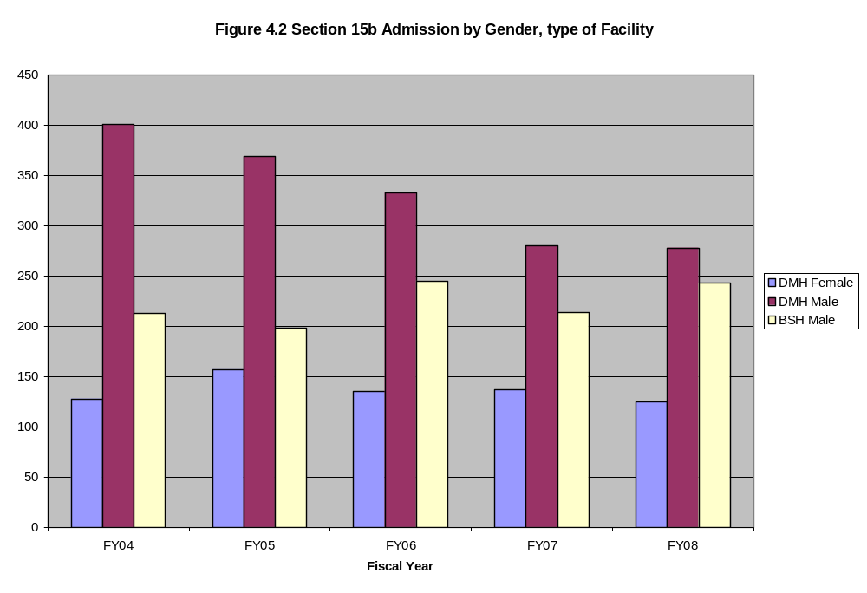

Figure 4.3 Inpatient Admissions and number of Forensic Admissions
FY 07 and FY 08
188
171
142
153
155
126
148
148
472
438
390
398
398
380
404
401
0
50
100
150
200
250
300
350
400
450
500
FY07
Quarter 1
FY07
Quarter 2
FY07
Quarter 3
FY07
Quarter 4
FY08
Quarter 1
FY08
Quarter 2
FY08
Quarter 3
FY08
Quarter 4
Forensic Admissions
All Admits

In addition, staff who provide inpatient forensic evaluations have been certified as Designated Forensic Professionals via Forensic Services training and certification activities. They typically also attend Forensic quarterly meetings with Area Forensic Directors and Area court clinic staff as well as the annual DMH Forensic In-service training.

Liaison activities between Inpatient Forensic Services and Bridgewater State Hospital (BSH) have been ongoing for many years. Many Area Forensic Directors serve as the liaison for admissions stepping down from BSH to DMH facilities. In addition, a DMH-BSH Committee meets on a regular basis. From this committee’s work a Memorandum of Understanding between the DMH and BSH was developed.

5. The Forensic Transition Team

The Forensic Transition Team (FTT), established in 1998, is a program that supports the Department of Mental Health’s (DMH) initiative to improve the quality of life for adults with serious and persistent mental illness who become incarcerated or detained in correctional settings. FTT Coordinators are boundary spanners who work between systems that include DMH site offices, public safety agencies and community service providers. The program enhances continuity of care by engaging clients before their release, summarizing psychosocial and criminal information for the service providers and monitoring clients’ status for three months post-release. Figure 5.1 illustrates the number of cases with FTT involvement.

FTT services include:
- Preparing DMH eligible inmates for the transition from jail or prison to community mental health care by meeting with inmates and working closely with DMH Site Offices to develop a post-release service plan;
- Assisting correctional mental health clinicians in identifying persons appropriate for referral for DMH continuing care services;
- Assisting DMH Area and Site staff with the Eligibility Determination process;
- Monitoring the legal status of persons who are already DMH clients when they become incarcerated and informing DMH case management staff and other service providers with updated information in order to facilitate continuity of care;
- Collaborating with Site staff and community providers in the post-release period;
- Providing consultations and information to DMH Area and Site staff regarding all aspects of criminal justice system operations.

130
282
106
372
84
382
120
431
119
438
0
50
100
150
200
250
300
350
400
450
Number of Cases
FY04
FY05
FY06
FY07
FY08
Fiscal Year
Figure 5.1 Forensic Transition Program Completed Cases FY04-08
Re Entry
Case Coordination and Monitoring
Re-Entry cases are those that are released from county and state incarceration into the community with an established plan for DMH services. Such cases are kept open for 3 months post-release. Case coordination and monitoring cases include: pre-trial tracking of incarcerated DMH clients as their cases proceed through the justice system, cases in the process of DMH eligibility determination, limited referral services to non-DMH eligible persons, and cases of persons who are civilly committed to the Massachusetts Treatment Center and those on forensic commitments to Bridgewater State Hospital.

- Juvenile Forensic Transition Services

In 2005, the DMH Forensic Services created the Juvenile Forensic Transition Services Coordinator (JFTC) position. It was created as an initiative to mirror the Adult Forensic Transition Team and specifically provides a means for the Department of Youth Services (DYS) to consult directly with the Department of Mental Health (DMH) for youth who were being served by the statewide DYS Butler Center program, which houses DYS’ most clinically complex male population. The JFTC assists the Butler Program and DYS in identifying early on those youth who appear to have serious mental illness and by preparing the information necessary for their submission to the appropriate DMH Area for Eligibility Determination.

The JFTC also offers information about area specific resources that might be better suited to the needs of youth who would not or are not determined eligible for DMH services. Additional responsibilities include the Statewide DYS Detention Population, Juvenile Court Clinic short-term case coordination, and enhanced risk management skill acquisition through Motivational Interviewing Technique Training, Juvenile Fire-setting Training and Co-occurring disorder training with a specific focus on youth with Substance Abuse Disorders.

- Jail Diversion Programs

Jail Diversion Programs (JDP) are designed to divert individuals with mental illness, substance abuse and co-occurring disorders from the criminal justice system while improving access for these individuals to appropriate treatment and case management in the community. There are many models that are designed to achieve these goals, including pre-arrest initiatives, mental health court initiatives, and even re-entry services for people at risk of re-incarceration.

The first JDP to be supported by the state is the Framingham Jail Diversion Program. It began when the Framingham Police reached out to Advocates, Inc., which managed the local Emergency Services Program. The program was initially based on the “Memphis Model” (specialized police training) but moved beyond training of officers to placing crisis clinicians along with officers when responding to mental health calls to the police department. The program initiated on 4/1/03 with 3-year private & Foundation funding. The Framingham program has received numerous awards and is cited in state legislation as a model program. It received a total of $120K in earmarked State funding through DMH in FY08.

Also in FY08, Massachusetts partially or fully funded seven JDPs through DMH, six of which were pre-arrest models, and one that operates at multiple points of intercept and is based on the Memphis Model.

The State's FY08 DMH budget earmarked $300K to fund five pre-arrest JDP initiatives; $60K (for two consecutive years) was awarded to five municipalities or police departments: Lawrence (with Health & Education’s [HES] team); Milford (with Riverside’s crisis team); Taunton/Attleboro; Waltham (with Edinburg's crisis team) and Watertown (with Edinburg's crisis team). Seed grants were dispersed to municipalities / police departments in late FY07. A statewide JDP database is maintained by DMH Forensic Services, with data submitted monthly from all JDP programs.

FY08 data reflects that most police crisis responses occur in residences and on streets in the respective communities, which is a hallmark of the Framingham model of pre-arrest jail diversion program. JDP clients are variously diverted into new outpatient referrals, inpatient (section 12) hospitalizations, respite, day treatment & detoxification services, depending on region and program type. All JDP programs divert individuals that range in age from 3 to > 65 years, with the most frequently occurring age range of 27 - 45. The large majority of JDP clients are unemployed and living in temporary housing arrangements or public shelters. When police responded with JDP clinicians to non-arrest situations (around 70% of calls), the two primary purposes of the JDP responder was to provide a safety check or mental status evaluation. Between 1/10 and 1/3 of the JDP clients are known to police.

Diversion from arrest rates vary depending on the demographic of the region. In addition to diversion from arrests, a decrease in emergency room visits seen with JDP intervention for this population suggests a significant cost savings to the State.

Figure 7.1 shows the overall activity level for all the JDPs. Figure 7.2 show the detail of the outcomes for those cases in which an arrest was possible, but a diversion from criminal justice involvement and arrest occurred.

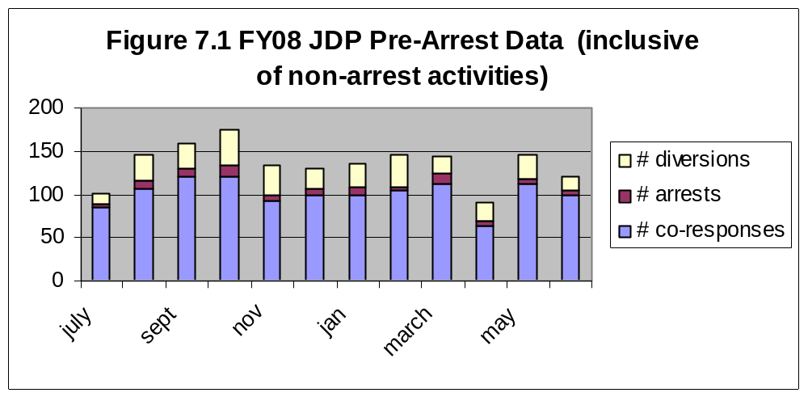

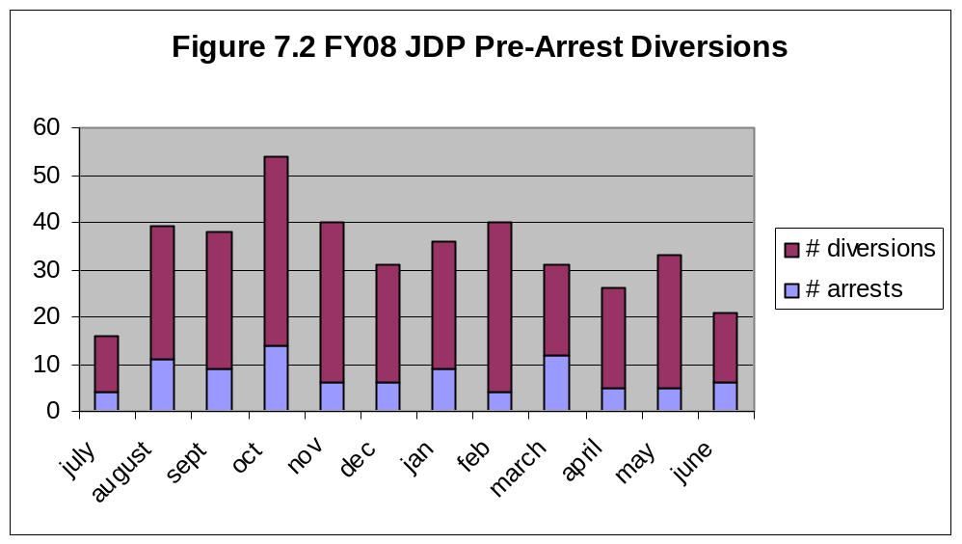

8. The MI/PSB Program

The Mentally Ill/Problematic Sexual Behavior (MI/PSB) Program is a Forensic Services initiative that began in July of 2000 and is designed to address the treatment and risk management needs of individuals under the care of the Massachusetts Department of Mental Health (DMH) who present with serious mental illness and co-occurring problematic sexual behavior(s) and/or sexual offending behavior(s). MI/PSB services are available to varying degrees across all six DMH areas in both in-patient and out-patient settings.

Primary MI/PSB-specific services can include, but may not necessarily be limited to:

- Assessment;
- Psychopharmacological consultation/treatment;
- Clinical and system consultation;
- Risk management planning;
- Treatment
- In-service training
- Area-based case review and tracking
- Mental Health Professional training opportunities

The most significant progress within the development of MI/PSB services over the past five years includes the following:

- Increased, through limited, accessibility of MI/PSB services for community clients, including:
  - The establishment of an MI/PSB-specific outpatient treatment team at the Massachusetts Mental Health Center in the Metro-Boston area.
  - Collaboration with the Carson Center in the Western Massachusetts area to provide MI/PSB-specific outpatient treatment.
  - Development of contracted MI/PSB treatment in the Central Massachusetts area.
  - Collaboration with New England Forensic Associates and Clearview Center outpatient programs that provide sex offender-specific treatment for individuals and in groups in the Northeast area.
  - Western Massachusetts Area investment in MI/PSB-specific assessment services.
  - Enhanced MI/PSB Services in the Southeast area including hiring of MI/PSB area clinical coordinator and re-constitution of Area and hospital based steering committees.

- The investment in and the nearly statewide utilization of video-teleconferencing technologies to maximize MI/PSB resource distribution, increase MI/PSB service availability, increase clinical supervision capacity and improve program efficiency.

- The re-establishment of the MI/PSB Statewide Steering Committee (formerly identified as the M/PSB Clinical Advisory Committee) to develop MI/PSB clinical service guidelines and protocols.

- Increased training opportunities including:

  - Providing clinical training opportunities for student trainees including doctoral practicum placements, doctoral internship placements, post-doctoral fellowships, training for psychiatric residents, etc.
  - Specialized trainings including the MI/PSB Summit (2006), Fred Berlin, M.D. (2008), Steve Hart, Ph.D. (2008).
  - When available, limited support for attendance at conferences for MI/PSB and Forensic Staff

Challenges facing the ongoing development of MI/PSB-specific services include: staff pay, levels, retention, and adequate training, limited resources for outpatient assessment, treatment and specialized residential services, complex interplay of zoning laws for certain leveled sex offenders and provision of needed services, and the emerging PSB issues presented by youths under the care of DMH who are transitioning to adult services.

9. Forensic Services Training and Certification

The DMH Forensic Services, through a contract with the Law and Psychiatry Program of the University of Massachusetts Medical School, Department of Psychiatry, provide specialized training for court clinicians, community providers and non-mental health personnel. Refer to Figure 9.1 for the total number of persons trained annually.

Designated Forensic Professional (DFP) Certification: The certification process was designed to train and certify forensic mental health professionals who provide forensic mental health services under the auspices of DMH in Massachusetts. The certification objective is to assure excellence in the quality of such services by conformity to standards established by Forensic Services. The designation process is designed to fulfill this objective, and to implement designation as required by DMH regulations 104 CMR 3.07 and 3.20. This training provides foundational education for clinicians involved with both juveniles and adults in the public sector forensic system in Massachusetts.

Block Grant Training: This training addresses the concerns of community providers for risk management training for clients with involvement in the criminal justice system. Forensic Services works with the UMASS Medical School Law & Psychiatry Program to develop and provide training to community staff, residential providers, and DMH case managers on complex cases for forensically involved clients. Training for community providers and DMH case managers provides knowledge and skills to aid in the treatment and management of clients with histories of violence and criminal involvement. The curriculum has included An Overview of the Criminal Justice System; Sex Offender Treatment in the Community: What Mental Health Providers Should Know; Risk Management/Protecting Personal Safety; and From Cells to City Streets: The Clinical Impact of Doing Time.

Training for non-mental health personnel and others: Members of Forensic Services provide training for personnel both within DMH and also from the community, such as: emergency personnel, Correctional and DMH case workers, local police, the Massachusetts Parole Board and many others. These trainings conducted by Area Forensic Directors, members of the Forensic Transition Team and other experienced forensic service staff are held on an on-going basis every year to provide a solid informational base regarding the needs of persons with mental illness in the community, particularly those who may require additional assistance with forensic and substance abuse issues. Some topics presented this year include The Forensic Mental Health System in Massachusetts, Comprehensive Community Crisis Intervention Training, Overview of DMH Community Services and the Forensic Transition Team and others.

Mentally Ill/ Problematic Sexual Behavior (MI/PSB) Training: The MI/PSB Program sponsored the following formal trainings in FY08: “Psychopathy and the use of the PCL-R”; “Risk for Sexual Violence Protocol”; and “Sex Offenders: Criminals or Patients? “, in addition to numerous on-site local trainings of staff and residential providers.

Overall, Forensic Services engages numerous staff and providers with training opportunities across a variety of venues, as illustrated in Figure 9.1.

Figure 9.1 Forensic Trainings Number of
Attendees FY04 - FY08
0
500
1000
1500
2000
2500
FY04
FY05
FY06
FY07
FY08
Total number
Attendees
At DMH
Forensic
Trainings

10. Mandatory Forensic Review (MFR) Program

DMH Policy # 00-1, re-issued on 1/5/2000, requires that certain patients in
DMH facilities are reviewed prior to the granting of defined levels of privileges and/or discharge. Patients covered by this policy are thought to be at relatively high risk. The policy states that patients with histories of particular criminal charges (e.g. serious offenses against person) must receive a Mandatory Forensic review (so-called “Mandatory/Mandatory” reviews). Patients transferred to DMH facilities after having been committed to Bridgewater State Hospital constitute a second category. These patients must be referred for review, but the need to conduct a full review is discretionary (“Mandatory/Discretionary” reviews).

DMH Forensic Services is charged with providing these risk assessments. All reviews are conducted by Designated Forensic Professionals. The reports are assessed by a senior reviewer, so designated by the Assistant Commissioner of Forensic Services.

Figure 10.1 shows the number of Mandatory Forensic Reviews referred and conducted. Figure 10.2 shows the number of Mandatory Forensic Reviews referred and conducted by facility for FY04 – FY08. Facilities vary in terms of the numbers of MFR’s that are required to be completed based in part on the concentration of persons at those facilities who are stepped down for continuing care inpatient services from Bridgewater State Hospital.

Figure 10.1 Total Statewide MFR for FY04 - FY08

0
50
100
150
200
250
FY04
FY05
FY06
FY07
FY08

Figure 10.2 MFR by Facility FY 04- FY08
0
10
20
30
40
50
60
70
80
ELMHC
SCFMHC
MBMHU
KINDRED
QMHC
Pocassett
TSH
TWKS
WBSH
WOSH
FY04
FY05
FY06
FY07
FY08

In an effort to create a more efficient and effective MFR program, an alternate model was developed and piloted at Tewksbury State Hospital in 2007-2008. In brief, instead of having the MFR consultant conduct a review at the point that treatment teams felt the patient was ready for privileges and/or discharge, the consultant works with the team essentially from the point of admission. Preliminary anecdotal data suggests that this approach has not resulted in any substantial improvement of the process and further efforts are being explored regarding MFR policy revisions based on feedback from providers, consumers and staff.

11. Quality Improvement Program

DMH regulations 104 CMR 33.04 (2) (d) and 104 CMR 33.04 (3) (d) require that all Designated Forensic Psychiatrists and Psychologists (DFPs):
- Make forensic mental health reports available for review by the Assistant Commissioner;
- Participate in periodic reviews of his or her forensic mental health work by a Forensic Mental Health Supervisor;
- Participate in approved forensic mental health training programs.

The Forensic Services Continuous Quality Improvement (CQI) Program was designed to address these requirements. To that end, numerous projects have been conducted over the last five years. Representative projects are described below.

- Section 15(a) Peer Review Project-Court Clinics
This project focused on peer review of 15(a) reports. Court clinicians around the state were divided into small groups and given several 15(a) reports to review. An effort was made to include clinicians from different parts of the state in each group. There were several goals for this project: to ensure that 15(a) reports submitted to the courts met certain standards, to broaden participants’ knowledge of the disparate ways various issues are handled among clinicians and courts, and to standardize work processes and products to the extent appropriate. All court clinic DFPs and DFP candidates participated in this on-going project.

- Section 15(b) Peer Review Project-DMH inpatient facilities and Bridgewater State Hospital
This project was analogous to the 15(a) Peer Review, but focused on 15(b) reports conducted by DFPs and DFP candidates who are hospital-based. To date, nearly all DFPs working in inpatient sites in the system have participated in this project.

- Expert Testimony Project-Court Clinics
Court clinic staff (psychology, psychiatry and social work) were given a semi-structured interview (developed by the Court Clinic CQI committee) consisting of six questions about expert testimony. They conducted this interview with one or more of the judges in the courts they routinely cover. Results of this project will be used to inform DFP training efforts and to identify issues handled differently among District and Superior Court justices. Results of the project will be conveyed to relevant judicial bodies. All DFPs in the court clinic system as well as numerous forensic social workers participated in this project.

- Section 35 Project-Court Clinics
Court Clinic DFPs are charged with conducting evaluations related to the need for commitment of alcohol and/or substance abuses, and testifying to these recommendations in the District Courts. This project looked at procedural and clinical standards for commitment across the state. A s. 35 procedures survey was completed by each clinician, as it pertained to the courts they cover. Secondly, section 35 case summaries were distributed to court clinicians (DFP and social work staff), each raising one or more clinical issues involved in conducting these evaluations. Clinicians met in small discussion groups to exchange thoughts about these issues. All DFPs in the court clinic system as well as numerous forensic social workers participated in this project.

A final report and executive summary of findings was generated from this project. As it happened, there was increased attention focused on the s. 35 law and process at around the same time. The report/summary was shared with many of the stakeholders involved in looking at the statute itself.

12. Pre Arraignment Protocol

The Pre-Arraignment Protocol (PAP) is a legal-clinical assessment process that enables local Police Departments to obtain as needed psychiatric hospitalization for persons they have arrested but are not able to bring immediately to court for an arraignment. This process involves the police, local Emergency Services Programs, on-call Designated Forensic Professionals (DFP), and the "on-call judge" system operated by the Judicial Branch. The role of Forensic Services is to oversee this process, maintain collaborative contacts with the stakeholders, and to collect, analyze and report data. Figure 12.1 shows the number of annual assessments by DFPs and subsequent commitment outcome.


Figure 12.1 PAP DFP Assessments FY 04 - FY08
0
20
40
60
80
100
120
140
160
180
FY 04
FY 05
FY 06
FY 07
FY08
# Persons not committed to
hospital
# Persons committed to
hospital

13. Criminal Offender Record Information (CORI) and Sex Offender Registry Board (SORB)
CORI
DMH Forensic Services has direct access to Criminal Offender Record Information for any purpose consistent with approved criminal justice duties and responsibilities. Under DMH Policy #01-1, a CORI report shall be requested for each person admitted to a DMH-operated or contracted adult inpatient facility.
Access to CORI reports of patients admitted to DMH Facilities shall be solely for clinical purposes of risk assessment; for purposes of completing an acute forensic evaluation pursuant to M.G.L. chapter 123, section 15, 16, 17 or 18; for review of discharge decisions and/or for investigating elopements. CORI reports may be used in ongoing evaluation of the potential risk of a patient, and shall be reviewed for consideration, if determined to be relevant, in risk assessment for clinical decisions concerning increased inpatient privileges and discharge readiness.
DMH Forensic Services serves as liaison to facilities to assist with any CORI- related issues. DMH Forensic Services also has responsibility for authorizing access to CORI records for all staff so designated in DMH Policy #01-1, for maintaining the individuals’ Agreements of Non Disclosure (AON), and for training all DMH facility staff regarding CORI.
SORB
The Massachusetts Sex Offender Registry Law (MGL Chapter 6, §§ 178C-178P) created the Sex Offender Registry Board (SORB), which is responsible for establishing and maintaining a registry of sex offenders in the Commonwealth. Individuals who have been convicted of specified sex offenses are required to register with the SORB upon their release from custody and to keep SORB informed of any changes in residential or work addresses. The Department of Mental Health has been considered a “custodial agency” of individuals (patients) admitted to the facilities it operates. (However, a review of this statutory interpretation is currently underway, prompted by a recent change in the SORB law.)
Forensic Services staff queries the SORB database as required by Commissioner’s Directive 17. Forensic Services then notifies facilities as to whether or not the patient is listed in the SORB in order for the inpatient treatment team to properly assist such client in meeting their obligations under the law.
DMH Forensic Services also has responsibility for accessing Criminal Offender Record Information (CORI) and Sex Offender Record Information (SORI) from the Criminal History Systems Board’s Criminal Justice Information System (CJIS).
Each year, Forensic Services assists with over 2000 CORI and SORI inquiries.

14. Summary

DMH Forensic Services function at the intersection of the public mental health system with the entire spectrum of criminal justice agencies: from police, courts (including probation), adult corrections, DYS, to Parole. In doing so, it carries out the mission of DMH in a variety of ways. By cultivating and promoting partnerships with justice agencies, DMH Forensic Services helps to insure that persons with mental illness who become involved with the criminal justice system are treated with respect. By diverting persons with mental illness away from arrest when appropriate, such persons are provided access to needed services and continue to live, work and be a part of their community. By linking persons with mental illness who are being released from correctional facilities, DMH Forensic Services helps them to re-establish lives in their communities. Figure 14.1 shows the total number of individuals served in this manner. Figure 14.2 shows the Forensic Services budget for FY 08, based on approximately $12.5 Million in operating expenses for that fiscal year.
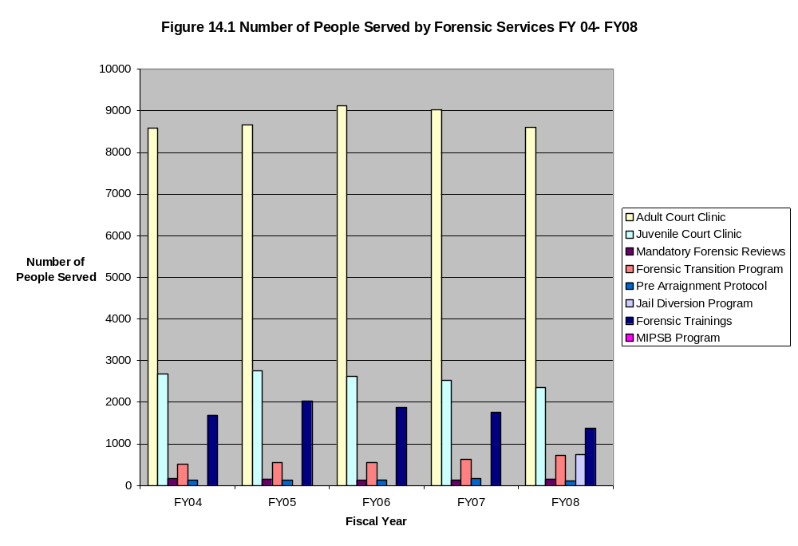

Figure 14.2 FY08 Forensic Budget

Approximate FY08 Operating Expenses: $12.5 M
44%
40%
4%
2%
2%
3%
4%
1%
0%
Adult Court Clinic
Juvenile Court Clinic
Forensic Transition Team
Mentally Ill/ Problematic Sexual Behavior
Mandatory Forensic Reviews
Forensic Certification and Training
Jail Diversion
Pre Arraignment Protocol
CORI/SORB linkage
This report reviews an array of activities provided via DMH Forensic Services in the Commonwealth, in the hopes of providing a foundation for a better understanding of the intersection of DMH operations with the court and criminal justice system.

*****************************************************

