DEPARTMENT OF MENTAL HEALTH
FORENSIC MENTAL HEALTH SERVICES

REPORT on DMH-OPERATED
PRE-ARREST JAIL DIVERSION PROGRAMS
7/1/06 to 10/1/09

Report of October 2009

DEPARTMENT OF MENTAL HEALTH
FORENSIC MENTAL HEALTH SERVICES

REPORT on DMH-OPERATED PRE-ARREST JAIL DIVERSION PROGRAMS
7/1/06 to 10/1/09*
Report of October 2009

OVERVIEW

To alleviate the growing number of mentally ill people in the criminal justice system, many states across the country have developed a variety of interventions that include jail diversion programs. Diversion programming seeks to divert individuals with mental health needs from the criminal justice system into community based care to reduce the penetration of persons with mental illness into the criminal justice system. This report provides information regarding pre-arrest jail diversion generally and summarizes the DMH pre-arrest jail diversion initiatives in Massachusetts to date, outlining how state funds have been utilized.

NATURE OF THE PROBLEM

The need for jail diversion initiatives stems from three overarching facts:

- People with mental illness and substance abuse disorders are over-represented in the criminal justice system compared to their prevalence in the general population. 7% to 10% of all police calls involve a person with a mental disorder and 15% to 31% of individuals in US jails suffer from serious mental illness.
- A portion of individuals with serious mental illness cycle in and out of the mental health, substance abuse and criminal justice systems and, for a variety of reasons, receive minimal treatment.
- The TAPA Gains Center notes that people whose mental illness is untreated can, in some instances, act in ways that the general public considers to be frightening or threatening. When effective treatment is available, people with mental disorders and without substance use problems present no greater risk to the community than people in the general population.

Jail diversion programs can help alleviate jail over-crowding, reduce costs of incarceration and unnecessary prosecution, and reduce costs related to expensive medical services that may not be needed. Effective programs can also help people with mental illness live their lives with fewer symptoms and access appropriate treatment that can provide support and incentives for staying in treatment and can help end the costly cycling through crisis care. Jail diversion programs are also sought after because of a hope that they can improve public safety. A great deal of research is being conducted nationwide to evaluate data regarding jail diversion efforts as a means of achieving these goals.

In addition to financial benefits, jail diversion also yields humanitarian benefits for people with mental illness who might otherwise be incarcerated. People who receive appropriate mental health treatment in the community usually have better long-term prognoses and are less likely to act in ways that scare others and are less likely make contact with the criminal justice system. Society benefits when people with mental illness receive appropriate treatment instead of incarceration.

HOW JAIL DIVERSION WORKS

Jail diversion programs are specifically designed to identify and divert individuals with mental illness from the criminal justice system into appropriate treatment in the mental health system. A model to help clarify how and where to best intervene with mentally ill people in the criminal justice system is known as the Sequential Intercept Model. It outlines the multiple points (or intercepts) in the systems where targeted interventions can prevent people from entering or moving further into the criminal justice system. The earliest points of intercept maximize results through efficiency and cost savings. Fewer individuals are likely to be diverted at subsequent points.

Community stakeholders can come together and review what strategies are available; they can develop targeted strategies that will evolve to maximize diversion of people with mental illness from the criminal justice system and link them with appropriate community-based treatment. Intervention points for diversion can be grouped into three broad categories:

- Primary diversion
- Pre-arrest: initial contact with police in the community
- Pre-booking detention: if symptoms of mental illness are observed in lock up, a clinician can assess for treatment needs
- Pre-adjudication: commitment for competency/criminal responsibility and/or a pre-trial probation disposition that supports treatment compliance
- In jail: screening & services for inmates in need of mental health treatment
- Secondary diversion
- Cross match of jail and prison populations with the mental health client caseload to identify detainees in need of mental health treatment
- Post adjudication or after a guilty finding, detainee receives probation or judicially-monitored community treatment (e.g., as in a Mental Health court or a condition of probation).
- Continuity of care
- Re-entry - ensures continuous treatment (medication, follow-up appointments, insurance & benefits) in transition from incarceration to community.
- Criminal justice monitoring (probation, parole, judge-mandated) to help clients stay engaged in needed treatment

Elements of successful programs

The primary goal of any diversion program is to reduce or eliminate the time people with psychiatric disorders spend in jail by redirecting them from the criminal justice system to community based treatment. Jail diversion programs require extensive collaboration and effort to succeed, but successful jail diversion programs have certain elements in common regardless of the type or model of jail diversion program. Six critical components make diversion programs work:

- Community-based interagency service coordination with a high level of cooperation and commitment between all parties
- Regular meetings of key players
- Liaisons responsible for linking the judicial, correctional, and mental health systems
- Strong leadership
- Early and effective identification of jail diversion candidates
- Case managers who reflect the diversity of their clients with expertise in criminal justice and mental health

MASSACHUSETTS STATE-FUNDED MODELS OF PRE-ARREST DIVERSION

With appropriations provided by the Commonwealth, the programs currently in place through the Department of Mental Health in Massachusetts are outlined below.

Pre-arrest Jail Diversion Programs (JDPs): To date, the most widely used pre-arrest model in the Commonwealth is a police based diversion model that pairs an emergency service clinician with police to co-respond to calls with mental health elements. Calls in which JDP clinicians are involved primarily and deliberately involve those individuals thought to be experiencing emotional distress and/or psychiatric symptoms who also may have co-occurring substance use difficulties. In this model, the police determine whether a person is a candidate for jail diversion. Then, while on site with police, a crisis clinician evaluates the need for hospitalization, makes referrals and can provide follow-up services to monitor treatment compliance, freeing the officers for public safety duties. In addition, these clinicians serve a role as a liaison to police in non-crisis situations, assisting with wellness checks and working with the police in community encounters as needed.

Comprehensive Community Intervention Team (CCIT): The Taunton jail diversion program is based on a model that trains police officers and other stakeholders in how to manage mentally ill people in the community so as to decrease injury to all and increase the likelihood of mentally ill individuals being identified for care. What is different about the Taunton model is that it includes the free-of-charge training to first responders, local treatment providers, and a variety of agency employees, so that the entire community is engaged in ensuring that individuals have access to needed treatment. And rather than having a specially trained cadre of officers, the CCIT model extends the offer of training to any officers in the police department for round the clock coverage.

In addition to the bi-annual training of community members and first responders, the CCIT program hosts a monthly case conference on families and/or individuals in need of treatment who are at risk of coming in contact with or furthering contact into the criminal justice system. From this conference, comprehensive treatment plans are put into place with multi agency support.

CASE EXAMPLES

Below are examples of jail diversion from the programs currently funded with legislative grants from the Commonwealth.

Lawrence
A Hispanic male in his early twenties has frequent contacts with the police, often for malicious damage to cars. Recently, his mother contacted the police to report that he had destroyed his bedroom furniture and attempted to assault her. On interview by the police and JDP clinician, domestic assault charges were diverted and he was sent to an inpatient facility for psychiatric treatment. During the hospitalization, the young man was diagnosed with Paranoid Schizophrenia that had gone untreated prior to contact with the JDP. Since discharge from the hospital, the young man has been engaged in mental health services, leading detectives to drop the property damage charges. The police later learned that he believed cars were controlling his thoughts which led to his need to damage the cars.

Milford
A mother called police to report that her 13-year-old son was increasingly difficult to manage at home and that he just assaulted her (after his parents took away his video game as a behavioral consequence). The JDP clinician rode with the police officers to the house and interviewed the child and his parents, learning that he is an adopted child with a severe trauma history. His parents reported that he had always been “moody” but is now becoming increasingly controlling, oppositional and violent. Instead of arresting the child on Domestic Assault charges, the police referred him to the JDP clinician to assess his treatment needs. The child was hospitalized that night and discharged within days back to his family with Family Stabilization services in place to monitor and assist the parents in keeping the family safe.

Waltham
The jail diversion clinician responded with the police on a Domestic Disturbance call. On arrival, police observed four involved individuals: one who was exhibiting some symptoms of mental illness, her mother, her brother-in-law and an infant. All of the adults were agitated and the situation was escalating with concern for physical violence. Police learned that the brother-in-law had been threatening to send his sister-in-law to the hospital or jail since that morning. Police had responded to this home previously and had noted the escalating pattern of behavior with potential for violence resulting in charges of Domestic Abuse and/or need for involvement of the Department of Children and Families. The JDP clinician educated all parties about their rights and commitment criteria and an understanding was mediated regarding the woman's mental health needs and follow up care. The clinician has continued to check in with the family every few weeks and reports that the situation is now much calmer.

Framingham
A resident from an apartment building called 911 to report fire alarms sounding in her building. When Fire and Police arrived, an individual ran out of the building, screaming obscenities and ignoring officers’ commands. The JDP clinician recognized the individual as a person familiar to the crisis team and who has a mental health diagnosis and trouble controlling his emotions in stressful situations. During the JDP clinician’s evaluation, the person revealed that he had accidentally burned a potato in his microwave and was unable to control his embarrassment and was angry that the police and fire department were called. He was eventually redirected by the diversion clinician and was able to apologize to the officers and fire fighters. He agreed to utilize the Psychiatric Emergency Services phone support after returning to his apartment to help him manage his emotions safely. The client was diverted from Disorderly Conduct and Disturbing the Peace charges.

Watertown
A father called the police because his teenage son was being destructive. The son was throwing furniture and verbally abusing his parents in the presence of his three younger siblings. The son was reportedly angry because his father refused to give him money and his parents were afraid for the family’s safety. Police recognized this house and family as one that they had been to previously for similar circumstances. Officers requested the youth speak with the JDP clinician, who assessed that the family needed extra support to stabilize their home. The father reported the younger children were beginning to act out and behave similar to the son with the difficult behavior. The clinician was able to involve the family with a Family Stabilization Team and the Malicious Destruction charges were diverted.

Taunton
The Taunton Police were called to a home where an adolescent boy was accused of sexual misconduct with a young neighbor. Following the filing of the complaint, the multi-agency Crisis Intervention Team met to conference the family’s needs. The case conference occurred with eleven (private & state) agencies represented. From this meeting, a broad range of recommendations and services were put in place, including:
- Identification of a contact person at the local Department of Children and Families (DCF) office to coordinate care and track the family’s progress
- Voluntary services from DCF to support the family while additional agency supports were identified
- Identification of a person to provide a psychological evaluation
- Referral to a Developmental Disabilities group
Charges have moved forward, but the young boy and his family are accessing the support and treatment that he has not had in the past. He is being closely monitored and more thorough assessments have been requested to clarify additional treatment needs. Because his treatment needs are being identified at this stage, additional diversion opportunities may become available as adjudication moves forward. Meantime, public safety is being maximized in the most cost effective and humane manner for the boy, his family, and the neighbor.

FUNDING HISTORY

The first pre-arrest jail diversion program in the Commonwealth was developed in Framingham in April 2003 with private and foundation funding. In FY07, after gaining support within the Legislature, the State earmarked $100K to support program operations. The FY08 State budget added $20K to the program budget for training of other jail diversion start ups and to allow for two full time responders to provide 80 hours of diversion coverage each week.

The Commonwealth’s FY07 budget allocated $300K to fund five pre-arrest diversion initiatives; $60K was awarded to five police departments. The communities selected were Lawrence, Milford, Taunton, Waltham and Watertown. In FY08, the Norfolk District Attorney sought and received a $50K federal planning grant to develop a pre-arrest diversion program in Quincy, implemented that year with $80K in state support.

Fiscal year ’09 9-C cuts reduced funding to all of the diversion programs by 50%, though the funding level for the Framingham JDP, which was the longest running program, was later restored to 100% funding by Governor Duval Patrick.

Currently the Framingham JDP operates with two full-time clinicians and has back up coverage provided by the Advocates, Inc. Emergency Service team. Advocates Inc. has successfully sought private and foundation funding in collaboration with the Marlborough Police Chief to begin a full time pre-arrest diversion program in that city.

As of September 2009, the Lawrence, Waltham, Milford and Quincy programs are operating with between 50% and 75% of their original funding and they are seeking private grants to supplement their operations. The Framingham JDP remains fully funded. The Taunton program continues to operate a community-based model with am award amount that is further reduced from the other programs and is utilizing in-kind support from involved agencies. The JDP in Watertown and some of those in other areas are seeking private grants to maintain and/or develop operations. Because of reduced funding, some of the Jail Diversion Programs are at risk in FY10.

FISCAL YEAR 2009 DATA

Data on the state-operated JDPs has been collected as programs have come online. The data system is evolving and over time would have the capacity for greater sophistication. In the meantime, the following datapoints are presented as an overview to understand the JDP operations.

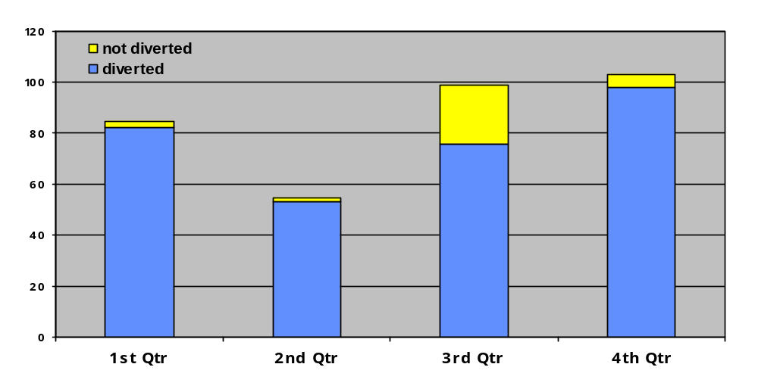FY09 Statewide Diversions by Quarter

Statewide, the average rate of diversion for the six pre-arrest jail diversion programs ranges from 76% to 96% of all calls where diversion was possible. In other words, “diverted” represents diversion from charges in those situations where an arrest could have occurred i.e., non-arrest with provision of community based services and diversion from police custody – e.g., to a psychiatric inpatient unit. The “not diverted” group includes those who were ultimately charged and entered the criminal justice system.

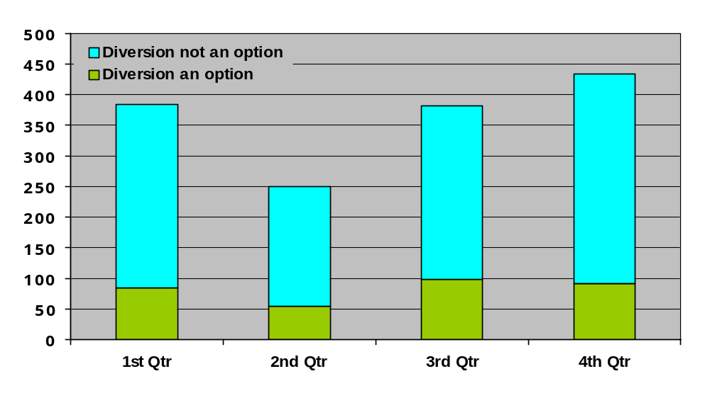FY09 Statewide Assessments by Quarter

This graph (FY09 Statewide Assessments by Quarter) represents the number of assessments provided by the jail diversion programs statewide for FY09. Each column indicates the total count of JDP events for each quarter in FY09. The blue section of each column signifies the number of events for which the JDPs responded and provided some service, but where arrest (and thus diversion from arrest) was not needed.

FY09 JDP Activities When Not for Diversion
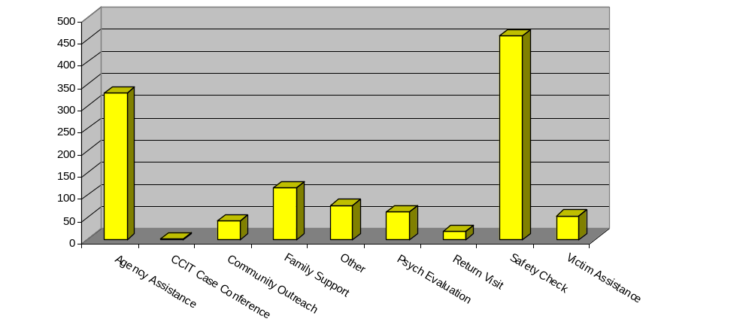

This graph (FY09 JDP Activities When Not for Diversion) shows what activities JDP clinicians are engaged in police calls where diversion is not an option. The most frequent activity is participating in Safety Checks in the community with police officers for persons who are known to have mental health issues and where, without the JDP clinical intervention, subsequent contact with the police may be more likely.

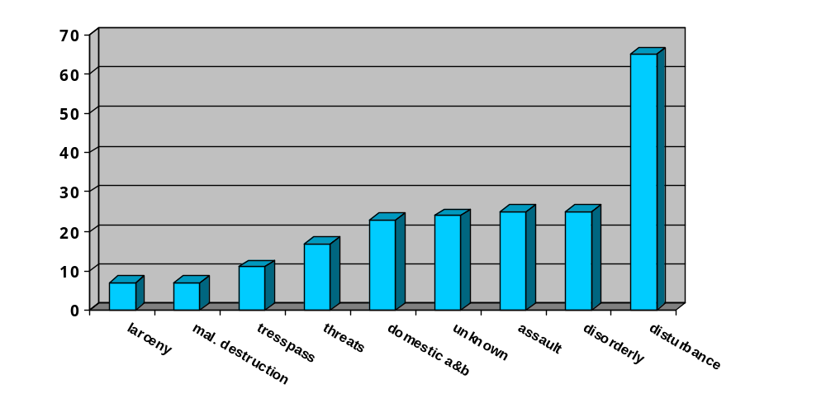FY09 Charges of Individuals Diverted

This graph (FY09 Charges of Individuals Diverted) summarizes the nine most frequently occurring potential or actual charges of those individuals who were diverted. Predictably, minor charges make up the largest number of those that are diverted from arrest into community services or hospitalization. Actual charges means that occasionally a criminal charge is attached but the individual is diverted from custody with the help of the JDP intervention.

FY09 Nature of JDP Clinician responses
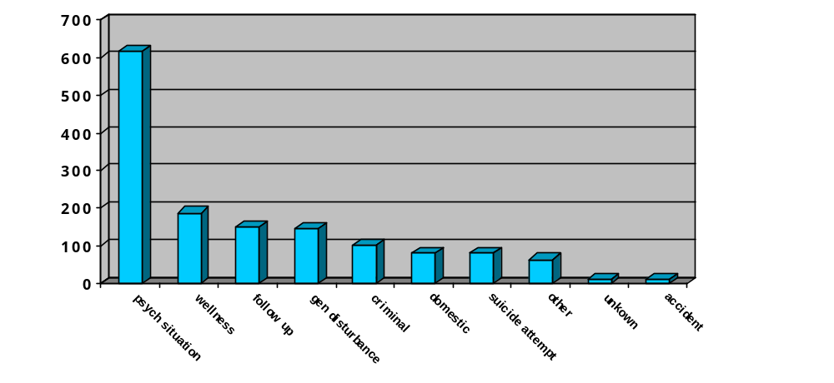

The above graph (FY09 Nature of JDP Clinician Responses) represents the type of calls to which JDP clinicians respond. The largest number (43%) is calls that police characterize as situations involving a psychiatric crisis. Wellness checks are the second most frequent type of call, and the third category, described as “follow up,” are calls that police respond to when a JDP clinician is not available but request the clinician to follow up at a later time.

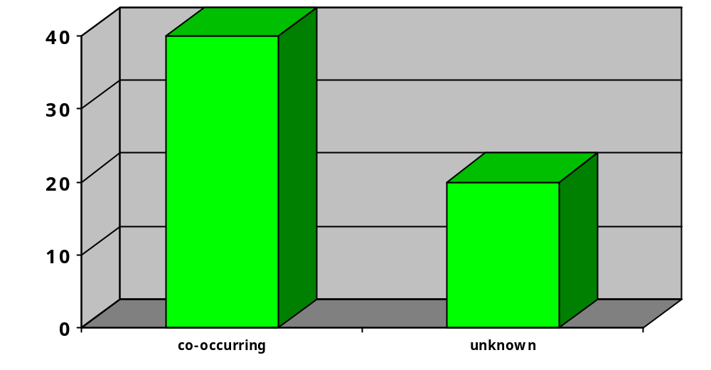FY09 JDP Data on Co-occurring Emotional/mental health and Substance Use issues
40%
20%
Given the nature of the JDP model, JDP clinicians only respond to calls that police dispatchers screen in as involving an emotional disturbance, and these individuals may have mental health treatment histories although the majority of individuals are not those that would be otherwise eligible for Department of Mental Health services. However, many also have co-occurring mental health and substance use issues. This graph reflects the percent (40%) that also have a co-occurring substance abuse issue. The crisis nature of the calls makes it impossible to know in each event to what degree substance problems exist, accounting for the 20% “unknown” bar in this graph.

DISCUSSION REGARDING COST SAVINGS

Projecting cost savings of jail diversion programs is a challenging activity and is dependant on the ability to distinguish between “real” and “paper” savings to each system involved. In the short term, nationally, data has shown that diversion programs shift costs from criminal justice to the community mental health system. Typically, more intensive services are needed when someone is in crisis, so that longer term savings get realized over time as treatment need and costs decrease and future criminal justice involvements are reduced. Savings are also realized as targeted mental health services are provided and costly cycling between systems lessens. National data seems to point toward demonstrating that jail diversion programs have the potential to help alleviate jail and emergency room over-crowding, reduce the costs of incarceration, shrink court dockets and decrease unnecessary prosecution. Additional data is being gathered and examined nationally to explore how these improvements, as well as improvements in mental health outcomes, can positively impact on public safety goals.

Pre-arrest, police based diversion programs also save money by reducing the number of visits to emergency rooms (a potential savings of $4K in medical costs alone, not counting police time). There is cost-effectiveness of the co-response model frequently used in the Commonwealth because using a clinician to manage the large number of non-criminal calls to the police frees police to manage enforcement and criminal matters in their community. In addition, many of the JDP clinicians can work closely with the newly procured adult mobile crisis intervention teams as they may be from the same provider agency or have partnerships with these providers.

It is essential to distinguish between immediate cost savings and future cost avoidance. National data suggests that longer term savings are realized when treatment costs lessen as a person’s service needs decrease and future criminal justice involvement is reduced. Even if the differential costs between diversion and incarceration are minimal, dollar costs must be considered in relation to achieving desired consumer and system level outcomes

An effort to specify cost savings was made through the Jail Diversion Cost Simulation Model took place in Chester County, PA. This study emphasized some important facts about jail diversion programming: (1) Jail diversion without linkage to appropriate and effective community-based services may reduce jail days, but it will not result in improved public health outcomes; (2) To achieve improvement in individual-level public health outcomes, nothing is more important than access to effective services; and (3) In general, a post-booking jail diversion program will produce cost savings compared to a treatment-as-usual group after 18 months to 24 months.

Achieving results predicted by the study is dependent upon accurate screening and assessment for individuals who are clinically appropriate for diversion, and linking those diverted individuals to the right services at the right level. There is no substitute for intensive, appropriate services.

JDP providers have discussed estimated cost savings of the Massachusetts programs. In addition, data collection instruments are beginning to gather information regarding these potential cost savings. Estimated costs saved by the pre-arrest diversion programs in MA diverting 100 individuals, based on discussions with JDP providers include:
- Diverted 100 (estimate) people from emergency rooms
Estimated $3,500 each visit = $350,000
- Diverted 100 (estimate) people from ambulance ride
Estimated $500 each = $50,000
- Diverted 100 people from booking
Estimated Booking Costs $2,000 per event = $200,000
- Persons Diverted from Jail
Estimated in MA of $130/day 6 for 100 individuals diverted (using conservative estimate of 4 jail day per diverted Individual) = $52,000
- Total estimated savings from diverting 100 individuals = $ 652, 000⁺
- Total estimated savings from diverting 200 individuals (FY09 actual figures surpassed this amount)= $1,304,000⁺
- ⁺Not factored into estimated savings are costs resulting from court costs including fees, public defender and district attorney salaries, police costs for court appearances, and other miscellaneous costs
- Available information supports that these estimated savings have been achieved without any known compromise to public safety in the individual cases that have been handled by JDP.

CONCLUSION

Nationally, alternatives to incarceration are gaining momentum to reduce criminal justice costs and improve access to health care without compromising public safety. In the last two decades, the incarcerated population has grown exponentially and persons with mental illness have been incarcerated at a rate disproportionate to that of the general population. Early identification of individuals with mental health needs at every level of contact with the criminal justice system can improve their access to needed care and reduce contact with the criminal justice system. Downstream effects of these types of interventions are increasingly showing promise with benefits to society and potential for cost savings. Thus, based on our experience with pre-arrest jail diversion initiatives to date, the following points are worth noting:

- The Massachusetts Department of Mental Health has begun to realize multiple types of benefits in the years of operation of jail diversion programs.

- Utilizing a centralized focus and management for these programs has also allowed the development of a shared data set and expected outcomes.

- Resources allocated to jail diversion activities, both nationally and locally, have been able to provide an effective and cost-effective strategy across multiple domains.

Resources Used:
1. DMH Jail Diversion Database;
2. The National GAINS TAPA Center (Technical Assistance and Policy Analysis); 1 in 31: The Long Reach of American Corrections in Massachusetts by The PEW Center on the States (2009).
3. CMHS National GAINS Center. (2007). Practical advice on jail diversion: Ten years of learnings on jail diversion from the CMHS National GAINS Center, Delmar, New York
4. Reuland M, Schwarzfeld M, Draper L. Law enforcement responses to people with mental illness: A guide to research-informed policy and practice. Council of State Governments Justice Center, New York, New York. 2009, available at http://www.ojp.usdoj.gov/BJA/pdf/CSG_le-research.pdf;

The National GAINS TAPA Center (Technical Assistance and Policy Analysis) for jail diversion provides assistance to help communities design, implement and operate integrated systems of jail diversion. The center provides an array of on-site, web-based, and telephone technical assistance to enhance the capacities of communities and states to develop jail diversion programs that are sustainable, effective, and accountable as part of their strategies for mental health system transformation. *Data presented in this report reflects information from 7/1/08 to 6/30/09 (FY09)
The Sequential Intercept Model of Jail Diversion; Psychiatric Services 57:544-549, April 2006
TAPA Center for Jail Diversion; Psychiatric Services. 1999 Dec; 50 (12):1620-3
CMHS GAINS Technical Assistance & Policy Analysis Center for Jail Diversion Human Services Research Institute. Jail Diversion Cost Simulation Model – Beta Test, Overview. Travis County, TX. 9 – 06 to 9 – 07. 6 1 in 31: The Long Reach of American Corrections in Massachusetts by The PEW Center on the States, 2009.

