
Centerlines - README

Disclaimer:
The City of Richmond assumes no liability either for any errors, omissions, or inaccuracies in the information provided regardless of the cause of such or for any decision made, action taken, or action not taken by the user in reliance upon any maps or information provided herein.
All GIS layers and datasets are owned by the City of Richmond and cannot be modified, re-distributed, and/or re-sold without a sub-licensing agreement. All guarantees of validity expire once a dataset leaves the City of Richmond firewall or physical premises. Acknowledgement of the City of Richmond GIS would be appreciated in products derived from these data.

"Any determination of topography or contours, or any depiction of physical improvements, property lines or boundaries is for general information only and shall not be used for the design, modification, or construction of improvements to real property or for flood plain determination." Subsection C of § 54.1-402 -State of Virginia

Why do we provide Shapefile format?

While our goal is to provide most of the frequently used GIS data for consumption by the public and for professional uses, we are not able to allocate the resources that would be required to duplicate our data into a myriad of data formats for every conceivable user. Nor will we entertain adhoc requests for data processing.

For these reasons, the shapefile format is being used to support the GIS community. Additionally, there are many AutoCAD suites that can import shapefiles. Please contact Autodesk for more information regarding this.

If you need to convert shapefiles to AutoCAD or digital exchange format (e.g. DXF), and you do not have access to ArcGIS software to perform the conversion, nor AutoCAD software, then it will be the user’s responsibility to locate freeware from the internet to do so.

All shapefiles include their metadata files which can be reviewed in ArcCatalog (*.xml)

On-line Metadata is also available from the following:
http://eservices.ci.richmond.va.us/services/gis/metadata/pp/sp

The following shapefiles are all available

- Street Centerlines
- Bike Route
- Trails
- Markers (Trail Waypoints)

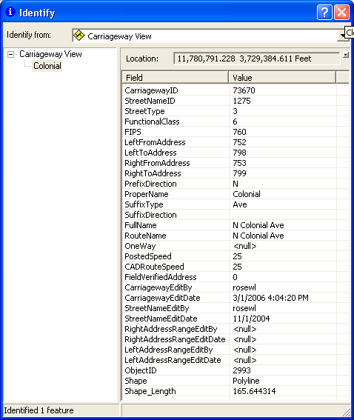
CarriagewayID = uniqueID for
every segment.

StreetType:
1 – Highway
2 – Arterial
3 – Secondary
4 – Alley
5 – Ramp
6 – Private
7 – Highway Interchange

FIPS:
760 – Richmond
041 – Chesterfield
087 – Henrico
Attributes Centerlines

