NGA Office of GEOINT Sciences
Coordinate Systems Analysis (CSAT)
August 2005 (Updated January 2006 and March 2007)

THE UNIVERSAL GRID SYSTEM
- Universal Transverse Mercator (UTM)
- Military Grid Reference System (MGRS)
- Universal Polar Stereographic (UPS)
- United States National Grid (USNG)

A simplified definition and explanation of UTM and related systems

THE UTM SYSTEM

UTM coordinates are based on a family of 120 Transverse Mercator map projections (two for each UTM zone, with one for each N/S hemisphere).

- The earth is divided into 60 zones, each 6° wide in longitude (with the exception of a few non-standard-width zones for Svalbard and southwest Norway). See Figure 1.

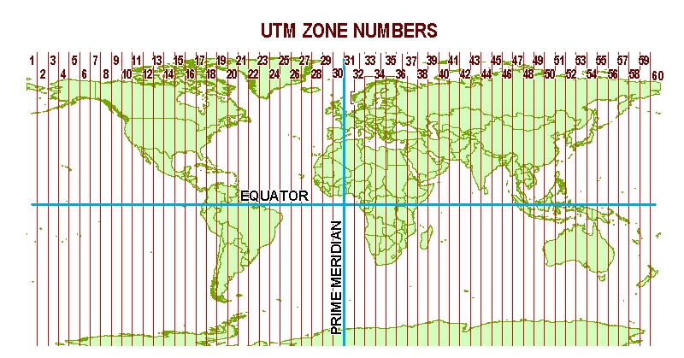
Figure 1.

- Numbering of zones begins at 180° and proceeds eastward.
  - Zone 1 is from 180°W to 174°W,
  - Zone 2 is from 174°W to 168°W, and so on.
- Each zone has a central meridian.
  - Zone 1 central meridian is 177°W,
  - Zone 2 central meridian is 171°W, and so on.
- The X value, called the Easting, has a value of 500,000m at the central meridian of each zone (Figure 2).
- The Y value, called the Northing, has a value of 0m at the equator for the northern hemisphere (Figure 3), 10,000,000m at the equator for the southern hemisphere.

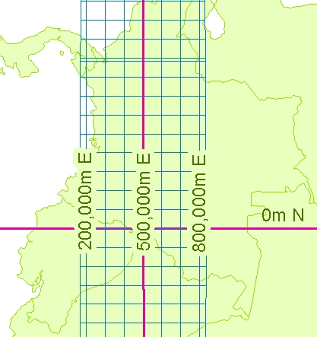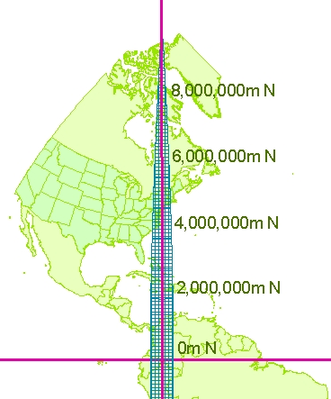

Figure 2. Easting values. Figure 3. Northing values.

- UTM is limited to the area between 84°N and 80°S. Beyond that, Universal Polar Stereographic (UPS) coordinates are used. See section on UPS.

REFERENCING / EXPRESSING A POSITION IN UTM COORDINATES

- In the UTM system, positions are expressed as Easting / Northing, e.g. “580817mE, 4251205mN”. In some cases, the letters are left off, e.g. “580817 4251205”.
- If positions occur near UTM zone junctions, the UTM zone may also be specified, e.g. “580817mE, 4251205mN, Zone 15”.
- Since the above expresses two possible positions on the earth, the hemisphere may also be specified, e.g. “580817mE, 4251205mN, Zone 15, Northern Hemisphere” (Figure 4).

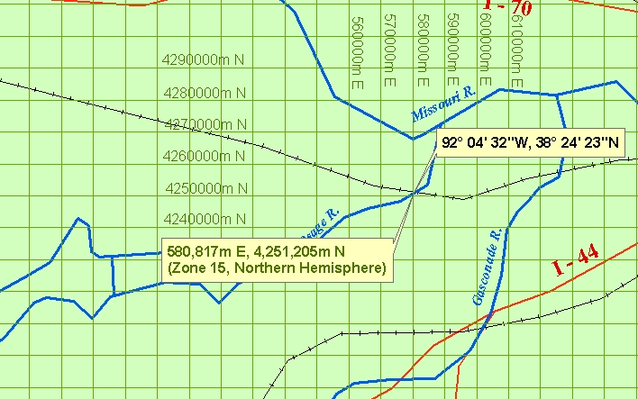

Figure 4. Example of position expressed in both Lat/Long and UTM coordinates.

- Many systems abbreviate the above, representing the hemisphere as a single letter, “N” for northern hemisphere, and “S” for southern hemisphere, e.g. “15N 580817 4251205”.
- CAUTION: IN MANY SYSTEMS, THE LETTER AFTER THE ZONE NUMBER DESIGNATES A LATITUDINAL BAND, NOT A HEMISPHERE. MORE ON THIS BELOW.

MGRS

The Military Grid Reference System (MGRS) is an alpha-numeric system for expressing UTM / UPS coordinates. A single alpha-numeric value references a position that is unique for the entire earth. The components of MGRS values are as follows:
(Example: 15SWC8081751205)

- The first two characters represent the 6° wide UTM zone.
  - Leading zeroes are included so that Zone 9 is “09”.
  - For polar areas outside the UTM area, these characters are omitted.
- The third character is a letter designating a band of latitude.
  - Beginning at 80°S and proceeding northward, the 20 bands are lettered C through X, omitting I and O.
  - The bands are all 8° high except band X, which is 12° high.
  - Outside the UTM area, A and B are used near the south pole, Y and Z near the north pole.
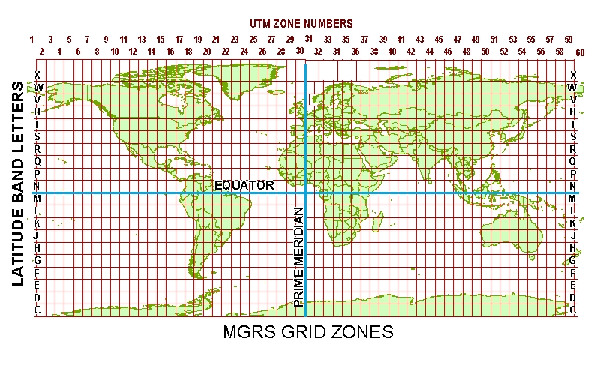

- The vertical UTM boundaries and horizontal latitudinal band boundaries form (generally) 6° X 8° Grid Zones. Hence, the first three letters of the MGRS value, e.g. “15S”, are referred to as the Grid Zone Designator (GZD).
- The fourth and fifth characters are a pair of letters identifying one of the 100,000-meter grid squares within the grid zone (or UPS area). See Figure 6.

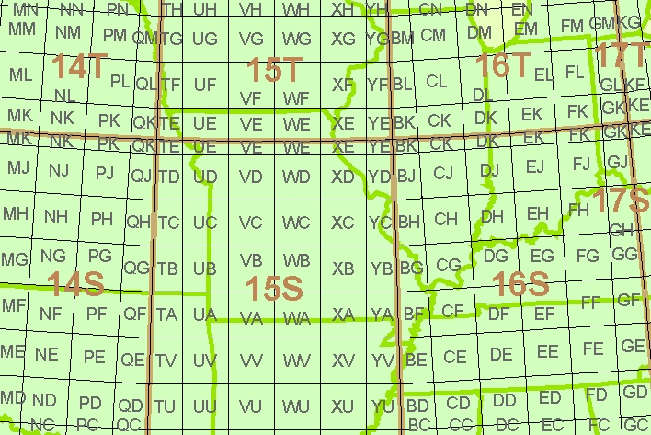
Figure 6.
In this sample area, the Grid Zone Designators are shown in brown. The smaller gray letters are the100,000-meter grid square identifiers. The example point “15SWC8081751205” is located in square “WC” near the center of the figure.

- The remaining characters consist of the numeric Easting and Northing values within the 100,000-meter grid square (Figure 7).

- MGRS coordinates may be rounded to reflect lesser refinement. For example:
15SWC8081751205 is at one-meter refinement.
15SWC80825121 is at 10-meter refinement.
15SWC808512 is at 100-meter refinement.
15SWC8151 is at 1000-meter refinement.

- There are two lettering schemes for the 100,000-meter grid square identifiers. Generally, one scheme is used for WGS-84, and the other is used for older ellipsoids associated with local datums. Example:
15SWC8081751205

is on WGS-84. When converted to NAD-27 datum, Clarke 1866 ellipsoid, its value is:

15SWN8083350993

The 100,000-meter grid square “WC” for WGS-84 generally coincides with the grid square “WN” for Clarke 1866.
See the section on USNG for further guidance.

Figure 7.
Magenta arrows show how MGRS easting and northing values are determined from within the 100,000-meter grid square. The MGRS value of this position is 15SWC8081751205.
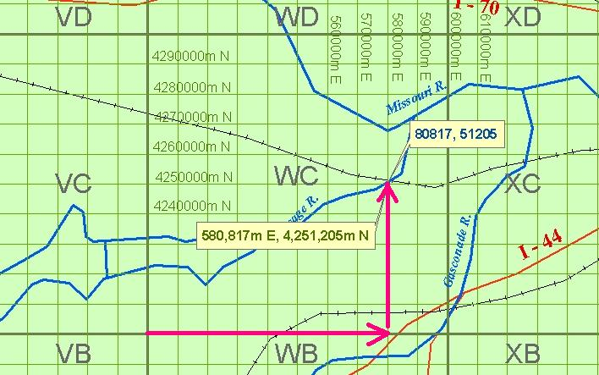

THE LETTER AFTER THE UTM ZONE NUMBER: IS THAT A HEMISPHERE OR A LATITUDINAL BAND?

Since the creation of UTM, developers have interpreted the rules for expressing an earth-wide unique UTM position in one of two ways:

- By including an “N” or “S” after the zone number to specify a hemisphere.
- By including the 8° latitudinal band designator (see the section on MGRS) after the zone number.

Example: The position at 92°W, 38°N, expressed in UTM coordinates, is:

587798m E, 4206287m N, Zone 15.

This reference is valid for two positions on the earth. In order to make it unique for only one position worldwide, i.e. 92°W, 38°N:

- Developer #1 includes an “N” to specify northern hemisphere:
15N 587798 4206287

- Developer #2 includes the 8° latitudinal band designator:
15S 587798 4206287

This situation is causing confusion among users and developers. The two 8° latitudinal bands, from 0° to 8°N and from 32°N to 40°N, are assigned the designations “N” and “S”, respectively. These designations are often mistaken for hemisphere designations.

Technical Manual 8358.1 contains the authoritative definition of UTM. NGA will soon publish an updated version of TM 8358.1, which will provide clarification on this issue.

THE UNIVERSAL POLAR STEREOGRAPHIC (UPS) SYSTEM

UPS coordinates are based on a family of two Polar Stereographic map projections, one for each pole.

- The origin of the UPS coordinate system is the pole (north or south), where X=2,000,000m and Y=2,000,000m.
- The X-axis lies along the meridians 90°E and 90°W.
  - Moving from the pole (north or south), X-values (Eastings) increase along the 90°E meridian.
- The Y-axis lies along the meridians 0° and 180°.
  - Moving from the north pole, Y-values (Northings) increase along the 180° meridian.
  - Moving from the south pole, Y-values (Northings) increase along the 0° meridian.

THE UNITED STATES NATIONAL GRID (USNG)

USNG is functionally equivalent to MGRS. The main difference between the two systems is in the method for specifying the datum. In MGRS, an alternate lettering scheme is used for the 100,000-meter grid square designator when the position is referenced to an older datum (see section on MGRS). The USNG does not use the alternate lettering scheme, but simply specifies the datum after the position reference. For example, a position on the NAD 27 datum is reported in the two systems as follows:

MGRS: “15SWN8083350993”
USNG: “15SWC8083350993 (NAD 27)”

