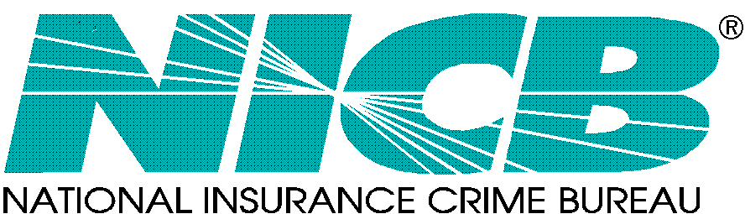Contact: Frank Scafidi May 17, 2010
916.979.1510 www.nicb.org
fscafidi@nicb.org

Car Thefts Continue Downward Spiral
Western Cities Still Popular Among Car Thieves

Des Plaines, IL – The National Insurance Crime Bureau (NICB) reported today that 2009 marked the nation’s sixth consecutive year of declining vehicle thefts in the United States.

For 2009, the 10 Metropolitan Statistical Areas (MSA) with the highest vehicle theft rates are:

2009 Ranking 2008 Ranking
- Laredo, TX 2
- Modesto, CA 1
- Bakersfield, CA 5
- Stockton, CA 6
- Fresno, CA 10
- Yakima, WA 3
- San Francisco/Oakland/Fremont, CA 9
- Visalia/Porterville, CA 11
- Las Vegas/Paradise, NV 7
- Albuquerque, NM 8

NICB’s Hot Spots report examines vehicle theft data obtained from the National Crime Information Center (NCIC) for each of the nation’s MSAs. MSAs are designated by the Office of Management and Budget (OMB) and often include areas much larger than the cities for which they are named. For example, the Laredo, Texas MSA includes all thefts within the entire county of Webb in addition to the city of Laredo.

Of the 366 MSAs within the United States, 304 (83 percent) of them reported lower thefts than they experienced in 2008. As suggested in the FBI’s 2009 preliminary semi-annual crime report published last December, vehicle theft may drop by as much as 18 percent from 2008’s numbers once the final figures are tabulated in the fall.

For the complete information on Hot Spots, please visit www.nicb.org.

“This is great news on the vehicle theft front,” said Joe Wehrle, NICB president and chief executive officer. “Six straight years of vehicle theft reductions are the result of a lot of hard work on the part of law enforcement, prosecutors, legislators, NICB member companies, NICB personnel and insurance industry trade groups who have contributed expertise and energy to have an impact on this crime.”

NICB recommends the following actions under its “layered approach” to vehicle theft protection:

Common Sense — The common sense approach to protection is the simplest and most cost-effective way to thwart would-be thieves. Secure your vehicle even if parking for brief periods. You should always:
- Remove your keys from the ignition
- Lock your doors /close your windows
- Park in a well-lit area
Warning Device — The second layer of protection is a visible or audible device which alerts thieves that your vehicle is protected. Popular second layer devices include:
- Audible alarms
- Steering column collars
- Steering wheel/brake pedal lock
- Brake locks
- Wheel locks
- Tire locks/tire deflators
- Theft deterrent decals
- Identification markers in or on vehicle
- VIN etching
- Micro dot marking

Immobilizing Device — The third layer of protection is a device which prevents thieves from bypassing your ignition and hot-wiring the vehicle. Some electronic devices have computer chips in ignition keys. Other devices inhibit the flow of electricity or fuel to the engine until a hidden switch or button is activated. Popular third layer devices include:
- Smart keys
- Fuse cut-offs
- Kill switches
- Starter, ignition, and fuel pump disablers
- Wireless ignition authentication

Tracking Device — The final layer of protection is a tracking device which emits a signal to police or a monitoring station when the vehicle is stolen. Tracking devices are very effective in helping authorities recover stolen vehicles. Some systems employ “telematics” which combine GPS and wireless technologies to allow remote monitoring of a vehicle. If the vehicle is moved the system will alert the owner and the vehicle can be tracked via computer.

Discounts are available to the public for a select group of theft deterrent and recovery devices through NICB’s Web site.

About the National Insurance Crime Bureau: headquartered in Des Plaines, Ill., the NICB is the nation’s leading not-for-profit organization exclusively dedicated to preventing, detecting and defeating insurance fraud and vehicle theft through information analysis, investigations, training, legislative advocacy and public awareness. The NICB is supported by more than 1,100 property and casualty insurance companies and self-insured organizations. NICB member companies wrote over $319 billion in insurance premiums in 2009, or more than 78 percent of the nation’s property/casualty insurance. That includes more than 93 percent ($151 billion) of the nation’s personal auto insurance.
Anyone with information concerning vehicle theft and insurance fraud can report it anonymously by calling toll-free 1-800-TEL-NICB (1-800-835-6422), or by visiting our Web site www.nicb.org. You may also text your information to TIP411, keyword “FRAUD” and remain anonymous if you so desire.

###

