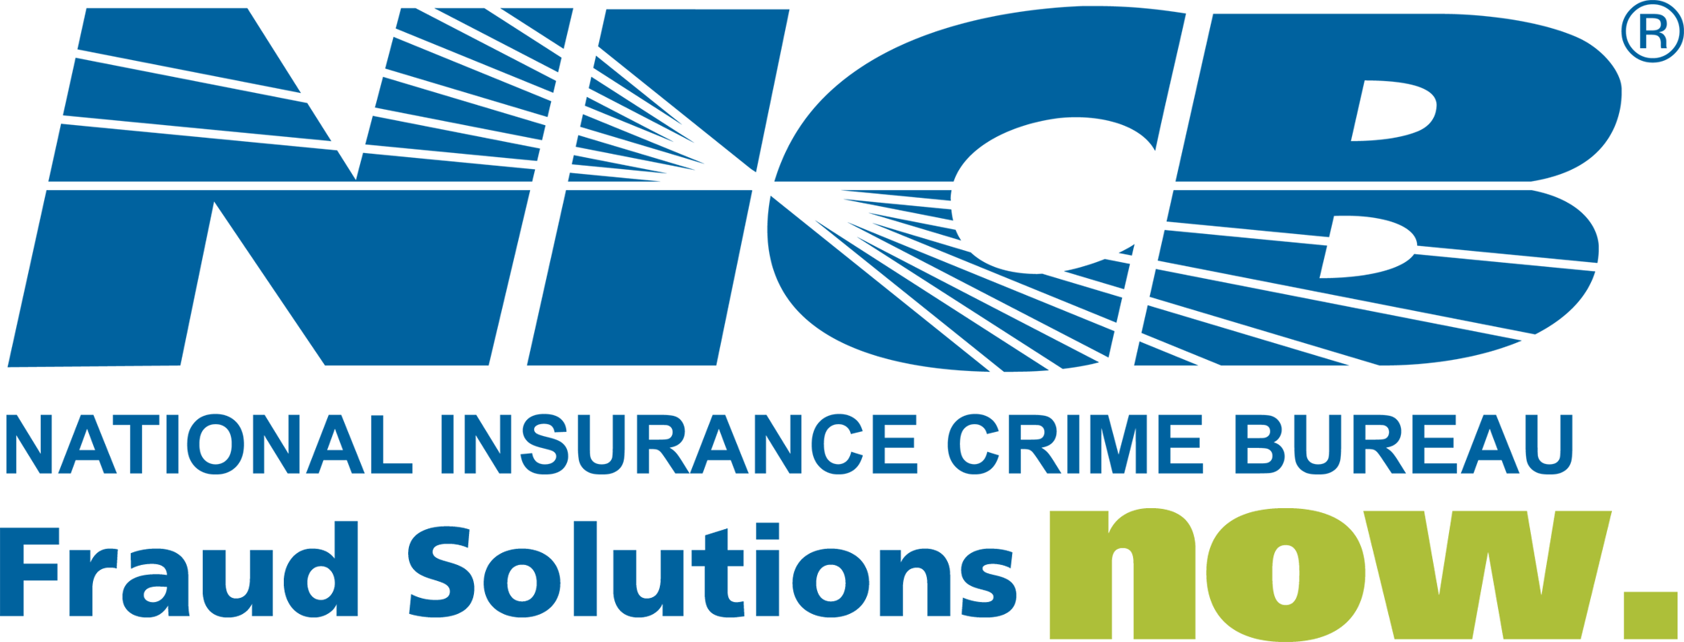

Contact: Frank Scafidi August 24, 2009 916.979.7025
fscafidi@nicb.org

HOT WHEELS: VEHICLE THEFT CONTINUING TO DECLINE

DES PLAINES, Ill. – Hot Wheels 2009, the National Insurance Crime Bureau’s (NICB) companion study to its popular Hot Spots auto theft report, examines data reported to the National Crime Information Center (NCIC) and determines the vehicle make, model, and model year most reported stolen in 2008. See the full report at www.nicb.org.

For 2008, the most stolen vehicles* in the nation were:

1. 1994 Honda Accord
2. 1995 Honda Civic
3. 1989 Toyota Camry
4. 1997 Ford F-150 Pickup
5. 2004 Dodge Ram Pickup
6. 2000 Dodge Caravan
7. 1996 Jeep Cherokee/Grand Cherokee
8. 1994 Acura Integra
9. 1999 Ford Taurus
10. 2002 Ford Explorer

Certain models of older cars and trucks are popular with thieves because of the value of their parts. Frequently, the parts can be stripped from a car at a chop shop and sold for at least twice as much as the value of the vehicle on the used car market. Newer models are also more difficult, but not impossible to steal thanks to anti-theft technology incorporated by the manufacturers.

Although the final numbers have not yet been released, the preliminary 2008 FBI Uniform Crime Report (UCR) shows that vehicle theft is on pace to record a decrease of 13.1 percent from 2007 numbers. That would make 2008 the fifth consecutive year of declining vehicle thefts. Moreover, if the preliminary figures hold total thefts for 2008 would be below 1 million vehicles—the lowest annual total in over 20 years.

“This is great news for vehicle owners, law enforcement and the insurance industry,” said Joe Wehrle, NICB’s president and chief executive officer. “It takes years of sustained effort to deliver the kinds of reductions that we are enjoying today. NICB joins with our member companies in acknowledging the great work performed by law enforcement and our investigators in the fight against vehicle theft.

“Comprehensive legislation, aggressive enforcement and rigorous prosecution are the three essential components to a winning crime control program. NICB is proud to contribute to each of those areas through our national legislative affairs program and our network of experienced investigators,” Wehrle said.

NICB provides law enforcement with local resources for identifying and recovering stolen vehicles as well as training and information analysis in the detection and prevention of vehicle theft and insurance crime.

As good as this news is, however, vehicle theft is still a costly drain on our economy and a tremendous hassle for victims. To protect their investment, vehicle owners are urged to follow NICB’s “layered approach” to auto theft prevention by employing simple, low-cost suggestions to make their vehicles less attractive to thieves.

NICB’s four layers of protection are:

Common Sense: Lock your car and take your keys. It’s simple enough but many thefts occur because owners make it easy for thieves to steal their cars.

Warning Device: Having and using a visible or audible warning device is another item that can ensure that your car remains where you left it.

Immobilizing Device: Generally speaking, if your car won’t start, it won’t get stolen. “Kill” switches, fuel cut-offs and smart keys are among the devices which are extremely effective.

Tracking Device: A tracking device emits a signal to the police or to a monitoring station when the vehicle is stolen. Tracking devices are very effective in helping authorities recover stolen vehicles. Some systems employ “telematics” which combine GPS and wireless technologies to allow remote monitoring of a vehicle. If the vehicle is moved the system will alert the owner and the vehicle can be tracked via computer.

Considering a used vehicle purchase? Don’t buy a headache, check in with VINCheckSM, NICB’s free vehicle history service at www.nicb.org.

You can help stop this criminal activity by reporting suspected insurance fraud and vehicle theft to NICB at 1-800-TEL-NICB (1-800-835-6422) or by texting to TIP411 keyword “Fraud.” You may also report fraud and theft by visiting our web site www.nicb.org. All tips can be anonymous.

About the National Insurance Crime Bureau: headquartered in Des Plaines, Ill., the NICB is the nation’s leading not-for-profit organization exclusively dedicated to preventing, detecting and defeating insurance fraud and vehicle theft through information analysis, investigations, training, legislative advocacy and public awareness. The NICB is supported by more than 1,000 property and casualty insurance companies and self-insured organizations. NICB member companies wrote nearly $343 billion in insurance premiums in 2008, or more than 82 percent of the nation’s property/casualty insurance. To learn more visit www.nicb.org.

* This report reflects only stolen vehicle data reported to NCIC in 2008. No further filtering of information is conducted, i.e., determining the total number of a particular make and model currently registered in the U.S. for comparison purposes.

# # #

