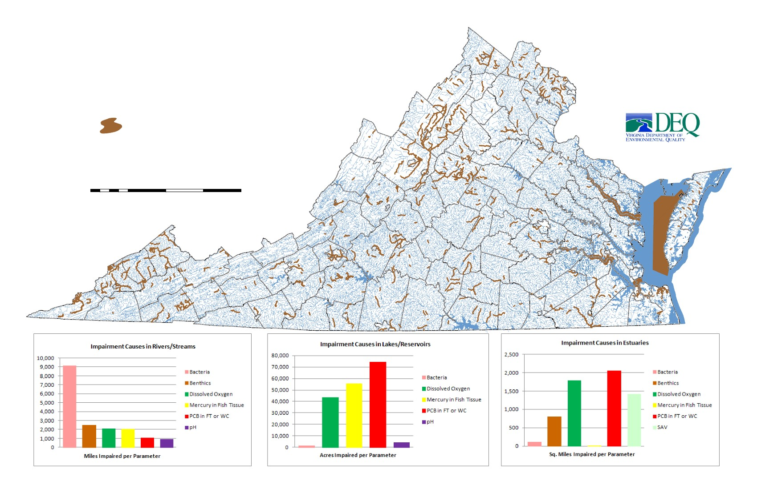
Benthic Impairments in Virginia for 2012
Benthic Impairments
Sources: Virginia Department of Environmental Quality
Virginia Department of Conservation and Recreation
United States Geological Survey
0
12.5
25
50
75
Miles
100
«
draft
Note:
Benthics are Not Applicable

