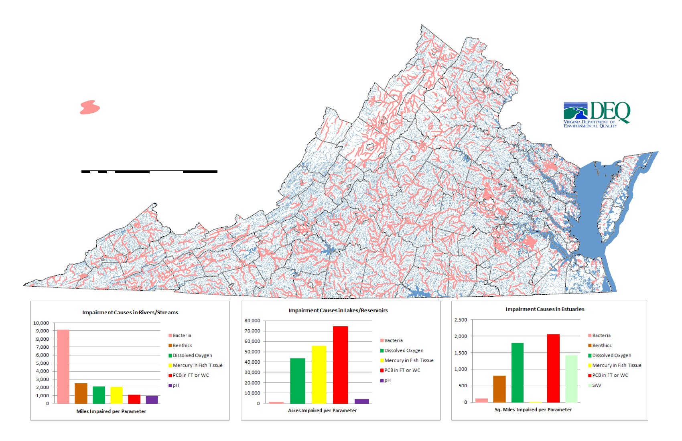
Bacteria* Impairments in Virginia for 2012
Bacteria Impairments
* Bacteria includes Enterococci (in salt water only),
Escherichia coli (E.coli), and/or Fecal Coliform
Sources: Virginia Department of Environmental Quality
Virginia Department of Conservation and Recreation
United States Geological Survey
0
12.5
25
50
75
Miles
100
«
draft
Note:
Benthics are Not Applicable

