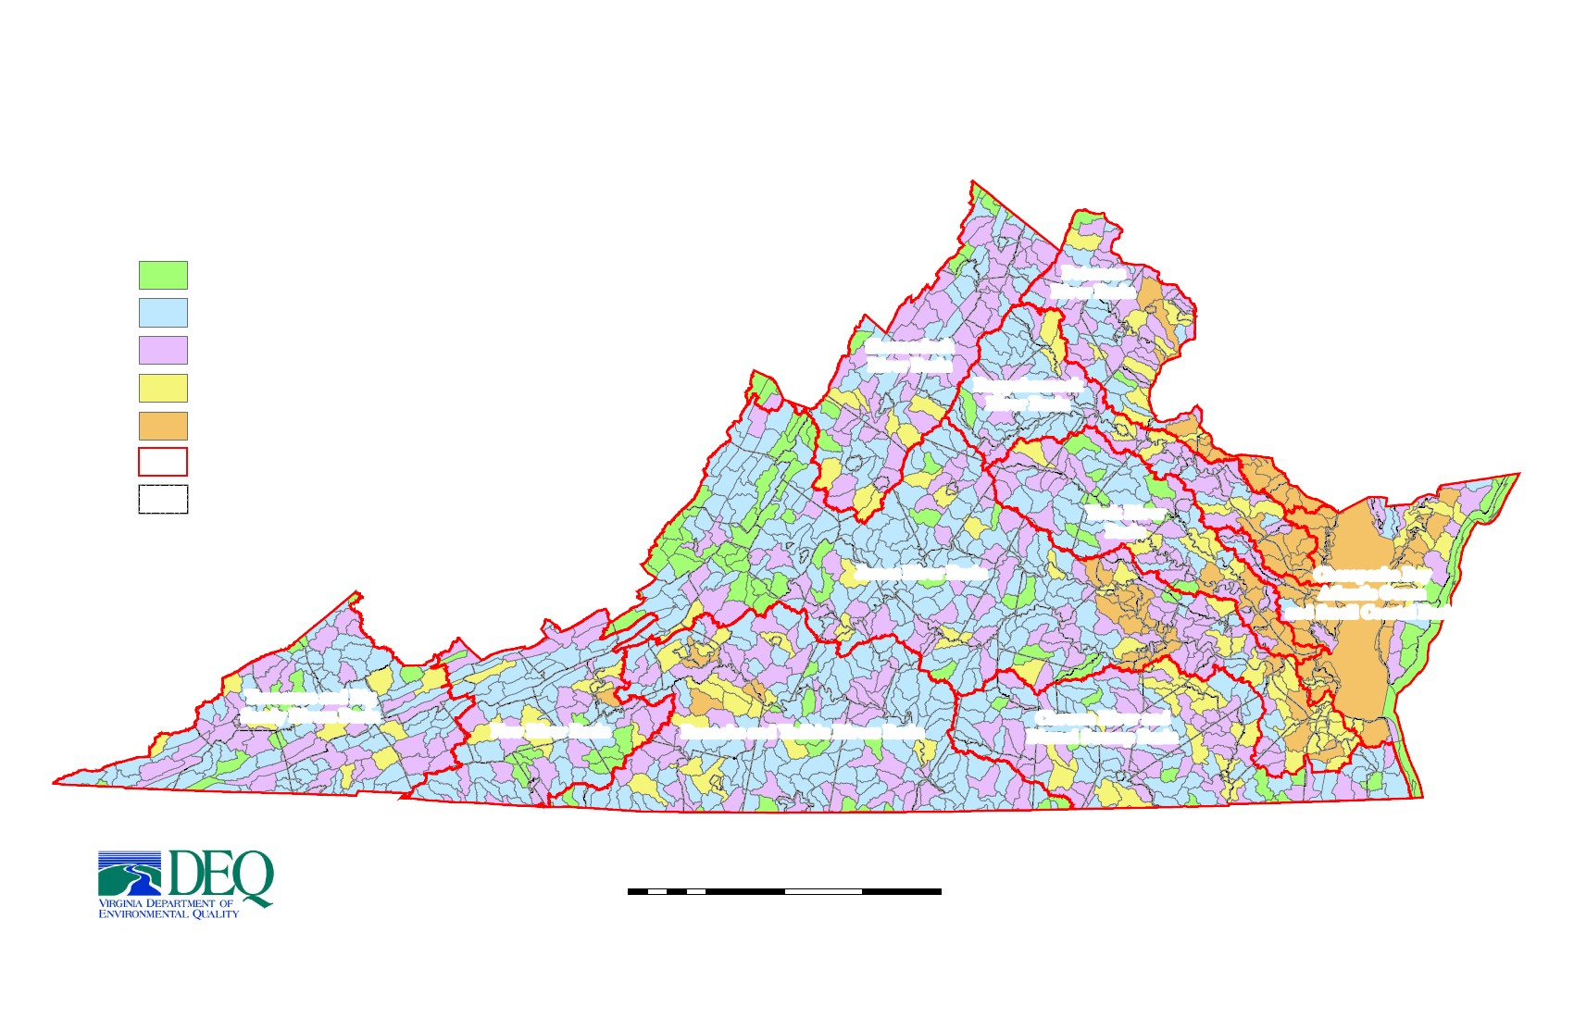
Distribution of Impaired* Waters in Virginia's Watersheds
Number of Impaired Segments per Watershed (All Impairments)
0 (144 watersheds - 12%)
Warren
Frederick
Winchester
Clarke
Loudoun
Potomac
River Basin
Fairfax
Fauquier
Manassas ParkFairfax
Manassas
Prince William
Arlington
Alexandria
1 - 2 (566 watersheds - 45%)
3 - 5 (354 watersheds - 28%)
6 - 9 (114 watersheds - 9%)
Harrisonburg
Shenandoah
Shenandoah
River Basin
Rockingham
Rappahannock
Page
Culpeper
Rappahannock
River Basin
Madison
Greene
Orange
Stafford
Fredericksburg
10 or more (69 watersheds - 6%)
Major River Basin Boundaries
Bath
Highland
King George
Spotsylvania
Augusta Staunton
Waynesboro
AlbemarleCharlottesville
Caroline
Louisa
Westmoreland
Jurisdiction Boundaries
Alleghany
Covington
Rockbridge
Fluvanna
Lexington
Buena Vista
Nelson
Goochland
York River
Basin
Hanover
Essex
Richmond
Northumberland
Accomack
King & Queen
King William
Middlesex
Lancaster
Amherst
Botetourt
Craig
Lynchburg
Roanoke
Buchanan
Tazewell
Giles
SalemRoanoke
Bland
Pulaski
Floyd
Wythe
Smyth
Pittsylvania
Lee
Scott
Bristol
Washington
Grayson
Galax
Carroll
Patrick
Martinsville
Henry
Danville
Franklin
Montgomery
Radford
Bedford
Bedford
James River Basin
Buckingham
Cumberland
Powhatan
Richmond
Henrico
Chesterfield
Amelia
Prince Edward
Nottoway
Dinwiddie
Charlotte
Lunenburg
Sussex
New Kent
Gloucester
Appomattox
Charles City
Chesapeake Bay
Atlantic Ocean
and Small Coastal Basin
Mathews
Northampton
Dickenson
Wise
Norton
Campbell
Hopewell
Colonial Heights
Prince George
Petersburg
James City
WilliamsburgYork
Surry
Poquoson
Newport News Hampton
Isle of Wight
Norfolk
Portsmouth
Virginia Beach
Tennessee and Big
Sandy Rivers Basin
Russell
New River Basin
Roanoke and Yadkin Rivers Basin
Halifax
Chowan River and
Dismal Swamp Basin
Brunswick
Southampton
Emporia
Greensville
Franklin
Suffolk
Mecklenburg
Chesapeake
«
* Excludes Category 4B (Effluent Limited) Waters
Miles
100
Sources: Virginia Department of Environmental Quality, 2012 Water Quality Assessment
Virginia Department of Conservation and Recreation
0
12.5
25
50
75
draft

