Fair Market Rents For The
Section 8 Housing Assistance
Payments Program

Overview 1
FMR Standard 1
Data Sources 1
FMR Areas 2
Calculation Process 2
Figure 1: FMR Calculation Process – Prior to FY 2008 3
Figure 2: FMR Calculation Process – FY 2008 4
Based on Decennial Census 5
Based on American Community Survey (ACS) 7
Based on Local RDD Surveys 9
State Minimum FMRs for Nonmetropolitan Counties 10
Review of Public Comments 10
FMR Exceptions 10

U.S. Department of Housing & Urban Development
Office of Policy Development & Research
July 2007 (rev.)

Overview
Fair Market Rents (FMRs) are primarily used to determine payment standard amounts for the Housing Choice Voucher program, to determine initial renewal rents for some expiring project-based Section 8 contracts, to determine initial rents for housing assistance payment (HAP) contracts in the Moderate Rehabilitation Single Room Occupancy program (Mod Rehab), and to serve as a rent ceiling in the HOME rental assistance program. The U.S. Department of Housing and Urban Development (HUD) annually estimates FMRs for 530 metropolitan areas and 2,045 nonmetropolitan county FMR areas. By law the final FMRs for use in any fiscal year must be published and available for use at the start of that fiscal year, on October 1.

FMR Standard
FMRs are gross rent estimates. They include the shelter rent plus the cost of all tenant-paid utilities, except telephones, cable or satellite television service, and internet service. HUD sets FMRs to assure that a sufficient supply of rental housing is available to program participants. To accomplish this objective, FMRs must be both high enough to permit a selection of units and neighborhoods and low enough to serve as many low-income families as possible. The level at which FMRs are set is expressed as a percentile point within the rent distribution of standard-quality rental housing units. The current definition used is the 40th percentile rent, the dollar amount below which 40 percent of the standard-quality rental housing units are rented. The 40th percentile rent is drawn from the distribution of rents of all units occupied by recent movers (renter households who moved to their present residence within the past 15 months). HUD is required to ensure that FMRs exclude non-market rental housing in their computation. Therefore, HUD excludes all units falling below a specified rent level determined from public housing rents in HUD's program databases as likely to be either assisted housing or otherwise at a below-market rent, and units less than two years old.

Data Sources
HUD uses the most accurate and current data available to develop the FMR estimates. Three sources of survey data are used:

- The Decennial Census provides statistically reliable rent data for use in establishing base year FMRs. The 2000 Census data were first used for the FY2005 FMRs.

- The American Community Surveys (ACS) collects decennial census long-form style data. The first full implementation of the ACS was in 2005, and was used in the FY2008 FMRs. The 2005 ACS can, in some cases, provide a new basis for 2005, or, for most cases, be used to update the 2000 Census base FMR to 2005. It is likely that ACS data will be used more extensively when the estimates using 3-yr and 5-yr average data for smaller census areas are published.

- Random digit dialing (RDD) telephone surveys are based on a sampling procedure that uses computers to select statistically random samples of telephone numbers, dial and keep track of them, and tabulate the responses to the calls. RDD surveys are conducted in a limited number of areas each year to assess housing market conditions.

Base year FMR estimates are updated and trended forward using CPI data for rents and utilities. CPI data are available for 102 metropolitan FMR areas. Regional CPI factors are used to update the base year estimates for all FMR areas that do not have their own CPI survey. There is a lag of 15 months in the use of the most recent CPI and the midpoint of the FMR.

Additionally, HUD augments its knowledge of housing market conditions through the use of the American Housing Surveys (AHS). The AHS are conducted by the Bureau of Census for HUD and have accuracy comparable to that of the decennial census. AHS data enable HUD to develop revisions between Census years for the 44 largest metropolitan areas that are surveyed on a revolving schedule of 11 areas annually.

FMR Areas
HUD defines FMR areas as metropolitan areas and non-metropolitan counties. With a few exceptions, the most current Office of Management and Budget (OMB) definitions of metropolitan areas are used. HUD uses the OMB definitions because of the generally close correspondence between them and housing market areas. FMRs are intended to be housing market-wide rent estimates that provide housing opportunities throughout the geographic area in which rental units are in direct competition. Exceptions include a small number of metropolitan areas whose revised OMB definitions encompass areas that are larger than HUD's definitions of housing market areas. These exception areas are denoted as “HUD Metro Fair Market Rent Areas,” (HMFAs).

Calculation Process
HUD uses similar procedures to calculate FMRs, whether they are based on decennial Census data, ACS Data or RDD surveys. The main difference is in the way base year FMR estimates are developed from each of the sources of survey data. The procedures used to calculate FMRs and the differences in the base year estimates are explained below. Figures 1 and 2 provide flow charts for the evolution of the FMR calculation process.

Beginning with the FY 2005 FMR publication, HUD developed and maintains a web-based “FMR Documentation System.” For any area of the country selected by the user, the documentation system provides a page containing a summary of how the selected years’ FMRs were derived starting with the 2000 Census benchmark and including any subsequent re-benchmarking using local RDD, AHS or ACS data. The tables on the summary page include links that provide complete details on how the data were developed. HUD publishes a version of the documentation system to coincide with each publication of FMRs in the Federal Register. Examples of the calculation process can be found in exhaustive detail using the FMR documentation systems maintained by the Department. Please see the following website (http://www.huduser.org/datasets/fmr.html) and select the FMR Documentation System for the year in which you are interested.

With the release of 2000 decennial Census information, FY2005 FMRs were “re-benchmarked” to incorporate all 2000 Census information into the FMR creation process. This re-benchmarking was accomplished by computing 2000 Census 40th percentile base rents. For FY2005, FY2006 and FY2007 FMRs, annual updating between 2001 and 2004 used local CPI data, RDD results, or Regional RDD results as appropriate.

Beginning in FY 2008, change factors detailing the change in rents from the 2000 Census to the current ACS data year (for FY2008 this is 2005) were employed to update rents from 2000 to the current ACS data year. From the ACS year, local or regional CPI information is used to further update the rent estimates. From the latest CPI information (for FY 2008, this was 2006) to the midpoint of the FY for which the FMRs are being calculated, a national trend factor is applied.

Figure 1: FMR Calculation Process – Prior to FY 2008
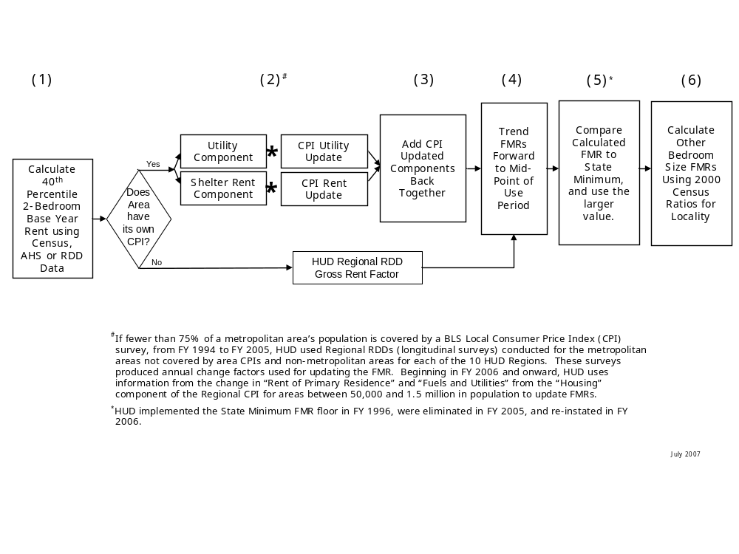

Figure 2: FMR Calculation Process – FY 2008
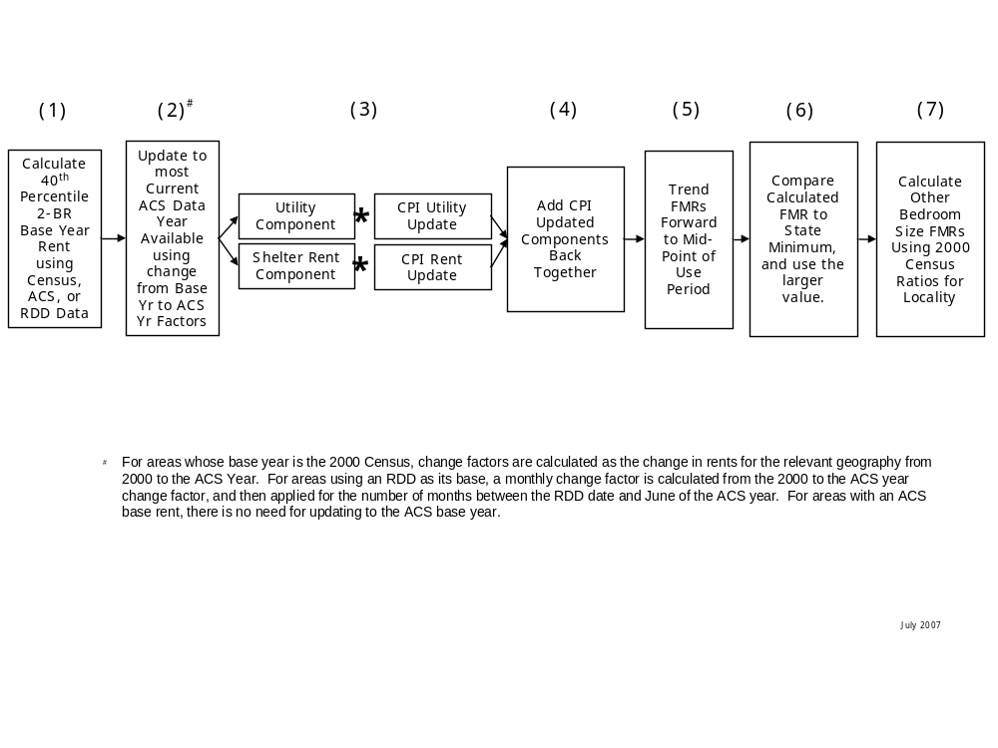

Based on Decennial Census

1. Develop Base Year FMR Estimates

HUD uses Census data on units occupied by recent movers to calculate a 40th percentile rent for each FMR area. Units that are newly constructed and those that have the types of housing deficiencies identifiable with Census data are removed before making the calculation. Furthermore, HUD excludes units below the public housing rent threshold.

The 1980 decennial census was used as the basis of the FMRs beginning in 1983; the 1990 decennial census was used as the basis of the FMRs beginning in 1994; and the 2000 decennial census was used as the basis of the FMRs beginning in 2005.

2-3. Update Base Year FMR Estimates

Because of lags in processing the survey data, most Census-based FMR estimates are first put into effect 3 to 5 years after the data are collected. Updates are made:

- If the FMR Area has its own CPI survey, the Census base year gross rent estimate is divided into shelter rent and utility components, using the ratio of utilities to gross rents paid by renters who pay for their utilities. The shelter rent and utility components are then updated separately, using the local CPI data on rent and utility cost changes.
(b) If the Census area does not have its own CPI survey, the base year rent is updated using Regional CPI data, for the period before FY1994, and for the period after FY2006. Between FY1994 and up to and including FY2005, regional rent surveys were conducted to provide annual update factors by metropolitan and non-metropolitan area for the 10 HUD regions.
4. Trending

The 40th percentile rent estimates are then trended based on an annual projection factor, to the midpoint of the fiscal year in which they will be used. This step is done by prorating national rent data by the actual number of months between the date of the Census survey and the midpoint of the fiscal year for which the FMRs apply.

- State Minimum Comparison

Following the application of the trending factor, the “candidate” 2-bedroom FMR is compared to the State Minimum FMR calculated for the current year. If the “candidate” 2-bedroom FMR is less than the state minimum, the state minimum value is used throughout the rest of the process; otherwise, the “candidate” 2-bedroom FMR is finalized and used in determining the other bedroom size FMRs.

6. Bedroom Size Adjustments

For most areas the ratios developed from the 2000 Census are applied to the two-bedroom FMR estimate to derive FMRs for other bedroom sizes. Exceptions to this procedure are made for areas with local bedroom intervals below the normal range. For these areas the bedroom intervals selected are the minimums determined after outliers had been excluded from the bedroom ratio distribution of all metropolitan areas. In addition the ratios used for three-bedroom and larger units are higher than those that would result from the actual market relationships. This step increases the likelihood that large families that are the most difficult to place will be successful in finding Section 8 eligible housing.

Based on American Community Survey (ACS)

The 2005 ACS data provides specific estimates for areas with 65,000 or more in population. Eventually, average ACS data will be available for every area of the country.

1. Develop Base Year FMR Estimates
HUD is largely replacing the accumulated 2001 through 2005 FMR update factors from various sources with a 2000 Census-to-2005 ACS update factor. HUD uses ACS data in different ways according to how many two-bedroom standard quality and recent mover sample cases are available in the FMR area or its Core-Based Statistical Area (CBSA). Random digit dialing (RDD) surveys performed between 2001 and 2005 may also be used under certain conditions. FMR areas are classified into four ACS data availability categories:

- ACS-1: FMR Areas which have at least 200 sample cases of two-bedroom standard quality rents. ACS-1 areas may be Metropolitan Statistical Areas (MSAs), sub-areas assigned CBSA base rents, other sub-areas, or large nonmetropolitan counties.

- ACS-2: FMR Areas which are sub-areas of CBSAs where the sub-area is not assigned the CBSA base rent, and the sub-area does not have at least 200 sample cases of two-bedroom standard quality rents, but the CBSA containing the sub-area does have at least 200 sample cases of two-bedroom standard quality rents.

- ACS-3: FMR Areas which are MSAs or nonmetropolitan counties that have fewer than 200 sample cases of two-bedroom standard quality rents, or sub-areas of CBSAs that have fewer than 200 sample cases of two-bedroom standard quality rents.

- ACS-4: FMR Areas that have at least 200 sample cases of two-bedroom recent mover rents. ACS-4 areas may be entire MSAs, sub-areas assigned CBSA base rents, other sub-areas, or large nonmetropolitan counties. By definition, these areas are a subset of ACS-1 areas.

In ACS-1 FMR areas, the 2000 Census to 2005 ACS update factor is the ratio of the 2005 ACS two-bedroom standard quality rent to the 2000 Census two-bedroom standard quality rent for the FMR Area.

In ACS-2 FMR areas, the 2000 Census to 2005 ACS update factor is either (1) the ratio of the 2005 ACS two-bedroom standard quality rent to the 2000 Census two-bedroom standard quality rent for the CBSA containing the FMR Area, or (2) the ratio of the 2005 ACS two-bedroom standard quality rent to the 2000 Census two-bedroom standard quality rent for the entire state (or population weighted average of states) containing the FMR area, whichever brings its 2005 updated rent closer to the value of its CBSA's 2005 updated rent.

In ACS-3 FMR areas, the 2000 Census to 2005 ACS update factor is the ratio of the 2005 ACS two-bedroom standard quality rent to the 2000 Census two-bedroom standard quality rent for the parts of the state not in ACS-1 or ACS-2 areas containing the FMR area, or the population-weighted average factor across such parts of the states containing each multi-state FMR area. In cases where there are fewer than 200 sample cases of 2005 ACS two-bedroom standard quality rents in the parts of the state not in ACS-1 or ACS-2 areas, HUD uses the ratio of the 2005 ACS two-bedroom standard quality rent to the 2000 Census two-bedroom standard quality rent for the entire state containing the FMR area as the update factor.

In ACS-4 FMR areas, the local 2005 ACS recent mover rent becomes a new base rent for 2005 if the updated 2000 Census base rent is outside its 90 percent confidence interval and the recent mover rent is greater than the local standard quality rent. This means the ACS is used to replace the updated 2000 base rent with a 2005 local ACS base rent.

2-3. Update Base Year FMR Estimates

Because of lags in processing the survey data, most ACS-based FMR estimates are first put into effect 2 or 3 years after the data are collected. They are then updated using CPI survey data. If the FMR Area has its own CPI survey, the ACS-based gross rent estimate is divided into shelter rent and utility components, based on these components in the ACS as updated using the ratio of utilities to gross rents paid by renters who pay for their utilities. The shelter rent and utility components are then updated separately, using the local CPI data on rent and utility cost changes. If the Census area does not have its own CPI survey, the base year rent is updated in a similar manner using Regional CPI data instead.

4. Trending

Trending is the same as for the Census-Based FMRs.

5. State Minimum Comparison

The State Minimum Comparison is the same as for Census-Based FMRs.

6. Bedroom Size Adjustments

The bedroom size adjustment is the same as for the Census-based FMRs.

Based on Local RDD Surveys

1. Develop Base Year FMR Estimates

HUD uses the RDD technique to obtain random samples of one- and two-bedroom units occupied by recent movers. One-bedroom rents are increased by the Census two-bedroom to one-bedroom ratio to convert them into two-bedroom-equivalent rents.

RDD surveys exclude public housing units, newly built units, seasonal units, units owned by relatives, and units not rented for cash. The surveys do not specifically exclude substandard units because there is no practical way to determine housing quality from telephone interviews. A HUD analysis conducted to address this issue has shown that the slight downward RDD survey bias caused by including some substandard units is almost exactly offset by the slight upward bias that results from surveying only units with telephones.

On average, approximately 50,000 telephone numbers need to be contacted to achieve the target survey level of at least 200 interviews of eligible recent movers.

2-4. Updating and Trending

Most RDD surveys are put into effect in the next available FMR year. For them all that is necessary is to trend the results with the standard projection factor for the number of months between the survey and the midpoint of the FMR year.

If the RDD is not used immediately the updating and trending is a little more complex. In brief, the updating is based on a combination of the standard trending factor and whichever local or regional CPI or RDD rent change factors are applicable.

- State Minimum Comparison

The State Minimum Comparison is the same as for Census-Based FMRs.

6. Bedroom Size Adjustments

The bedroom size adjustment is the same as for the Census-based FMRs.

State Minimum FMRs for Nonmetropolitan Counties
In response to numerous public concerns that FMRs in rural areas were too low to operate the program successfully, HUD has implemented a minimum FMR policy. The policy establishes the FMRs at the higher of the local FMR or the State-wide average FMR of non-metropolitan counties, subject to a ceiling rent cap. The rationale for having a state minimum FMR is that some low-income, low-rent nonmetropolitan counties have Census-based FMR estimates that appear to be below long-term operating costs for standard quality rental units and raise concerns about housing quality. Housing quality problems are limited in most parts of the country and have little impact on FMR estimates. The exception to this generality within the continental United States occurs in some nonmetropolitan areas with unusually low rents. State minimum FMRs have been set at the respective state-wide median nonmetropolitan rent level, but are not allowed to exceed the U.S. median nonmetropolitan rent level. T

Review of Public Comments
HUD publishes FMRs in the Federal Register, first as proposed estimates for public comment and then for final effect. The proposed FMRs are usually published in mid-April, with a 60-day period allowed for comments. By law the final FMRs for use in any fiscal year must be published and available for use at the start of that fiscal year, on October 1.

The purpose of the public comments process is to identify areas where local government officials or residents believe the FMRs are too high or too low. Public Housing Agencies and other organizations responsible for operating the Section 8 programs submit most comments. To be considered for FMR revisions, the comments must include statistically valid rental housing survey data that justifies the recommended changes.

HUD prefers that the rental data be obtained through a well-conducted RDD survey. PHAs and other organizations that want to use the RDD survey technique may obtain a copy of Random Digit Dialing Surveys: A Guide to Assist Larger Public Housing Agencies in Preparing Fair Market Rent Comments. Small PHAs may wish to use the simplified methods described in Rental Housing Surveys: A Guide to Assist Smaller Public Housing Agencies in Preparing Fair Market Rent Comments. Both may be obtained from HUD USER at 1-800-245-2691.

FMR Exceptions
To ensure successful program operation, the Section 8 program rules allow for FMR exceptions to compensate for variations in rent levels and rental housing characteristics that exist within individual housing markets. Upon approval by HUD, a PHA may exceed the published FMRs by up to 20 percent for specified geographic submarkets of a larger FMR area. Requests for FMR exceptions may not be granted for more than 50 percent of an FMR area (as measured by population). Such requests must document the program-related need for the higher rents. Geographic area exceptions are usually a small part of the entire FMR area and must be contiguous areas.

Standard-quality rental housing units have the following attributes: Occupied rental units paying cash rent; Specified renter on 10 acres or less; With full plumbing; With full kitchen; Unit more than 2 years old, and Meals not included in rent.
FMRs were initially set at the 45th percentile, but were reduced to the 40th percentile, beginning with the FY1995 FMRs. The vast majority of areas remain at the 40th percentile rent. However, certain areas are assigned the 50th percentile rent. Fiftieth percentile FMRs were established by a rule published on October 2, 2000, that also established the eligibility criteria used to select areas that would be assigned 50th rather than the normal 40th percentile FMRs. The objective was to give PHAs a tool to assist them in de-concentrating voucher program use patterns. The three FMR area eligibility criteria were: 1. FMR Area Size: the FMR area had to have at least 100 census tracts. 2. Concentration of Affordable Units: 70 percent or fewer of the tracts with at least 10 two-bedroom units had at least 30 percent of these units with gross rents at or below the 40th percentile two-bedroom FMR; and, 3. Concentration of Participants: 25 percent or more of the tenant-based rental program participants in the FMR area resided in the 5 percent of census tracts with the largest number of program participants. The rule also specified that areas assigned 50th percentile FMRs were to be re-evaluated after three years, and that the 50th percentile rents would be rescinded unless an area has made at least a fraction of a percent progress in reducing concentration and otherwise remains eligible. (See 24 CFR 888.113.)
Regional RDDs were longitudinal surveys conducted for the metropolitan areas not covered by area CPIs and non-metropolitan areas for each of the 10 HUD Regions. These surveys produced annual change factors used for updating the FMR and were last used for the FY2005 FMRs. Regional CPI change factors, first used in the FY2006 FMRs, continue to be used.
However, the state minimum is used if it exceeds the Census data for the area; see the following section.
State Minimum FMRs were first used in FY1996. In FY2005, state minimums were eliminated because the 2000 Census created public use microdata areas (PUMA) for nonmetropolitan counties that did not have a sufficient sample to provide their own FMR estimates. However, there continued to be problems with rents for some nonmetropolitan counties that could not use PUMA data, so state minimum were reinstituted in FY2006.

