9042 Neher St.

Orlando, FL 32827

Sept. 25, 2019

Greetings,

I was pleased to learn of a maunfacturing engineer position opening at Ascend Performance Materials. I am looking to further my professional development as an engineer within the industry, and feel that this opportunity would help me demonstrate the skillset that I’ve developed. Also, I wanted to commend Ascend on creating such a valuable, respected company in the industry.

As a result of having an aptitude of leadership experience, my ability to make decisions and solve challenging issues would make an instant impact on this team. In two years interning with an engineering firm, I’ve been privileged to have led teams in improving water purity measures, optimizing manufacturing processes, and in the testing of new concepts. This body of work includes using code to shorten a factory process from forty-five minutes to five. It also entails the redesign of electrode heads to generate cleaner quantitative output. It’s this experience in both product and process improvement that has really sparked my interest in this position.

As far as education is concerned, I have two semesters left at the University of Florida and have taken the prerequisite classes to succeed as R&D engineer, doing so with a 3.21 GPA. I am currently enrolled in the second semester of Unit Operations Lab, Kinetics & Reactor Design, Economic Processes & Optimization, and Chemical Materials. I have also added a minor in business administration and have taken several programming classes in an attempt to diversify my portfolio. Each of these things have enhanced my ability to solve problems and optimize systems, both of which are key parts of any job.

Aside from that though, nearly all of the occupations I’ve held have come with a strong personal relations element. It taught me from a young age how to appropriately interact with clients over a phone, face to face, or over and desk and that’s something I can bring that would be applicable immediately. It’s because of this that I would have no difficulty fitting in. Thank you for your time and consideration, I look forward to hearing from you very soon.

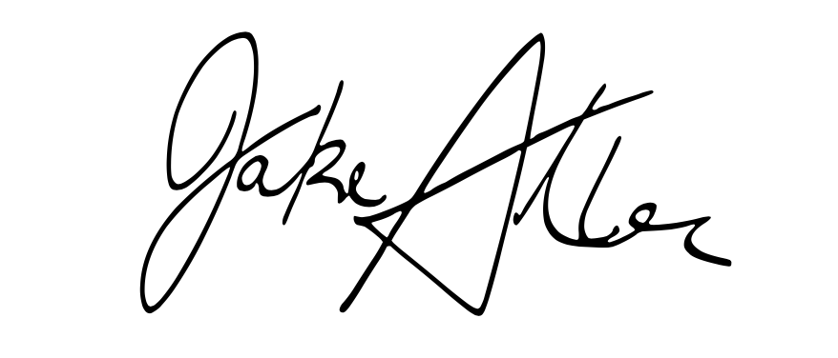Best regards,

Jake Albin

Chemical Engineering Student, University of Florida