**Level 0 – Marionette**

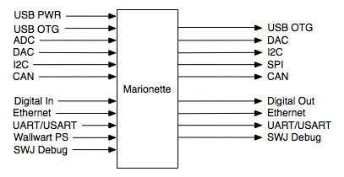

|  |  |
| --- | --- |
| Module | Marionette DAQ |
| Inputs | * USB PWR: USB 2.0, 5V DC, 500mA * USB OTG: high-speed 480 Mb/s * SPI Network: SPI1-42 Mbits/s, SPI2 and 3 – 21Mbits/s * I2C Network: 100/400 kHz * CAN: 2.0B Active Network * ADC: 12bit resolution * Digital Input: * UART/USART * Wallwart power supply 12V * Ethernet: 10/100 Mbits/s * SWJ – serial wire JTAG debug port |
| Outputs | * SPI Network * I2C Network * CAN Network * DAC: 12bit resolutoin * Digital output: * UART/USART: * USB OTG: * Ethernet: 10/100 Mbits/s * SWJ – serial wire JTAG debug port |
| Funcationality | Multifunction data acquisition device |