Team Members

Chelsea Throop

Carlos Mariscal

Jeff Alcoke

Luis Santiago

Saida Akhter

**Fall**

14

**1930 SW Fourth Ave, Portland, Oregon 97201**

08

**Fall**

# NES LockBox

T06 – System Design and Model

**Lock Box – Level 0**

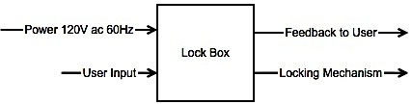

|  |  |
| --- | --- |
| **Module** | **Lock Box** |
| Input | * User input via NES (Nintendo controller) * Power: 120V AC, 60Hz |
| Outputs | * User feedback via LCD * Digital signal to Solenoid style lock |
| Functionality | * Use the NES controller to input an unlocking combination. |

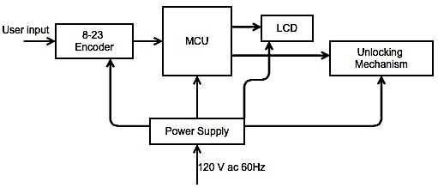**Lock Box - Level 1**

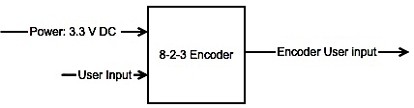**Encoder - Level 0**

|  |  |
| --- | --- |
| **Module** | **Encoder** |
| Input | * User input via NES (Nintendo controller). 8 bits were only one signal may be on at any given time. * Power: 3.3 V DC |
| Outputs | * Encoder User Input. 3bit signal. |
| Functionality | * This encoder will take an 8 input signal and encode it to a 3- bit signal. Which will be feed into the MCU |

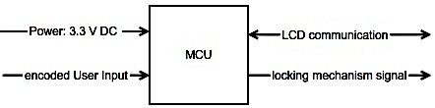**MCU - Level 0**

|  |  |
| --- | --- |
| **Module** | **Microcontroller** |
| Input | * Encoded User Input from Encoder 3 bits * Power: 3.3 V DC * LCD communication via I2C |
| Outputs | * LCD communication via I2C * Signal to Unlock/Lock, digital signal 3.3 V or 0V |
| Functionality | * The MCU control the operation of the entire system |

**LCD - Level 0**

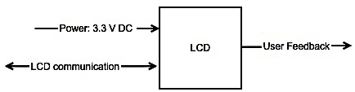

|  |  |
| --- | --- |
| **Module** | **LCD** |
| Input | * LCD communication via I2C * Power: 3.3 V DC |
| Outputs | * LCD communication via I2C * User feedback (text) |
| Functionality | * The MCU control the operation of the entire system. |

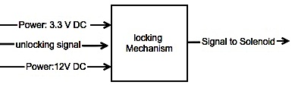**Locking Mechanism - Level 0**

|  |  |
| --- | --- |
| **Module** | **Lock Mechanism** |
| Input | * Unlock signal from MCU, digital signal 3.3V or 0V * Power: 12V DC * Power: 3.3 V DC |
| Outputs | * Unlock signal to Solenoid, the input signal turns ON/OFF a transistor which in turn allows current to flow through the Solenoid |
| Functionality | * The Locking mechanism takes a low current signal for from the MCU and puts out a high current signal to the Solenoid |

**Power Supply - Level 0**

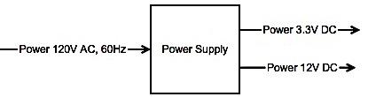

|  |  |
| --- | --- |
| **Module** | **Power Supply** |
| Input | * Power: 120V AC, 60 Hz |
| Outputs | * Power: 3.3V DC * Power: 12V DC |
| Functionality | * This module will supply power to the all the modules of Lock Box |