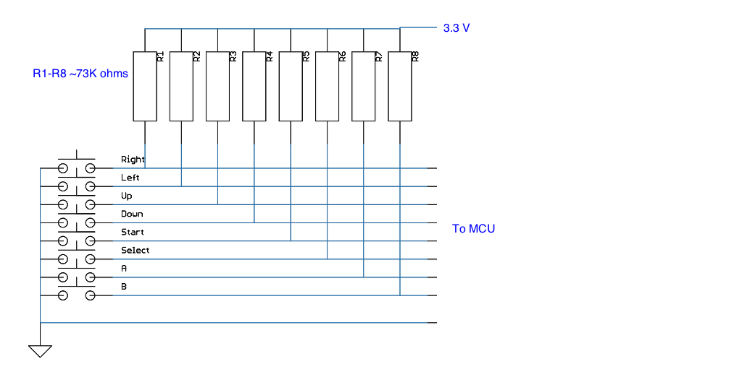

Controller interface to MCU

1. Using 8 to 3 encoder

* Reduces amount of wires needed 3 wires for 8 inputs.
* Cannot use multiple button presses simultaneously due to the fact that that are only 8 possibly combinations or 8 bits available, so if we wanted to do for example a routine that was activated when start and select where pressed at the same time would not be possible
* Increases complexity to design ( more part to place on schematic and board layout)

1. Using 8 GPIO pins on MCU

* Simpler design
* Need 8 digital pins on MCU so leaves us with fewer pins for other peripherals( may not need them anyways).
* Will need to implement more code for small delays in digital reads
* More distinct combinations of button presses 2^8=256
* Will need 10 wires total 8-buttons plus 2 for V+ and GND

Physical connector needs to be decided after deciding interface

1. Original NES connector

* Not doable if we use 10 wire interface
* Cool, but will take more work to manufacture a socket (4x)

1. Ribbon cable

* Simple, can get connector off the shelf