**Linear Regression**

For the given data, initially importing required packages and creating data frame using pandas

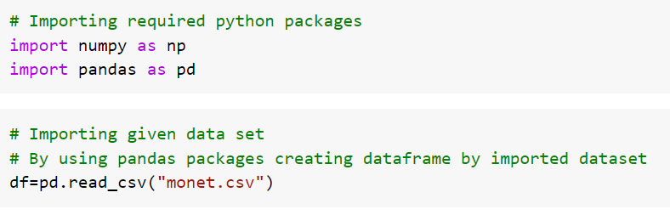

Checking the dataframe if there is any null values, by using isnull

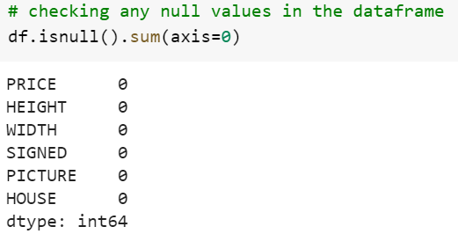

Creating the new column by using given data columns such as SIZE=WIDTH*HEIGHT

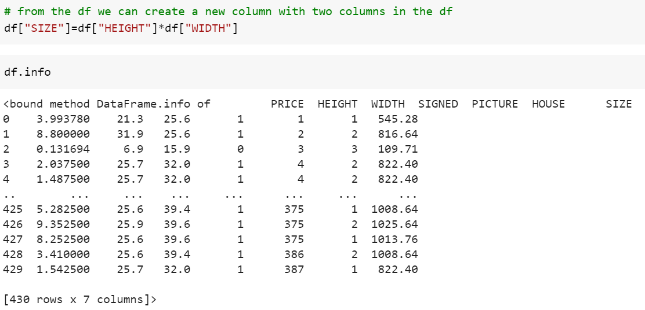

Checking the shape of data before creating new column and after new column

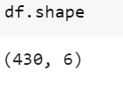 -> it shows 430 rows and 6 columns

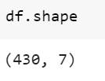 -> it shows 430 rows and 7 columns ( new column is SIZE)

**MODEL 1 :-**

Creating the linear regression for SIZE and price of the given dataset.

The PRICE is dependent variable and the SIZE is independent variable.

From the sklearn package, splitting the data into 80% as training data and 20% as test data.

After splitting the data checking the shape of the data, is correctly or not. Calculating through the shape from train and test.

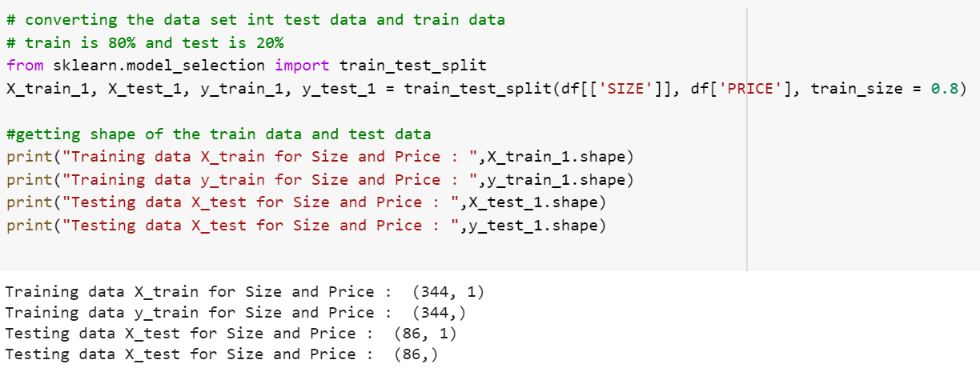

The training data set as 344 rows and trained data set as 86 rows, total rows are 430 rows

The regression model for SIZE and PRICE

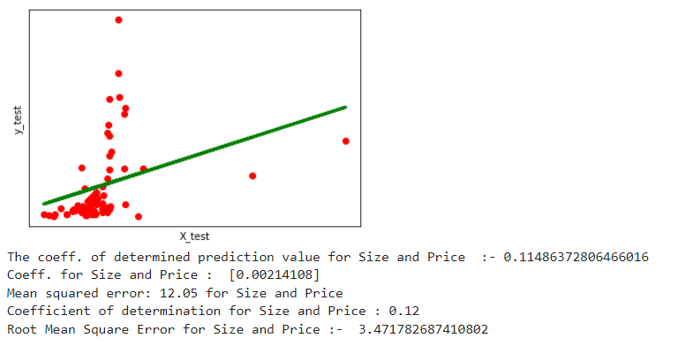

**MODEL 2:-**

The regression model for WIDTH and HEIGHT.

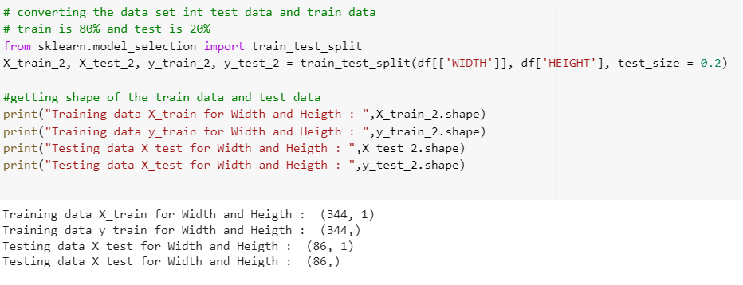

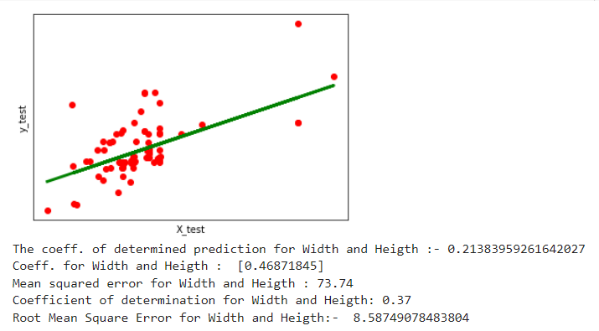

**Model 3:-**

**Multvariant Linear Regression**

Creating dataframe with correlation from the dataframe.

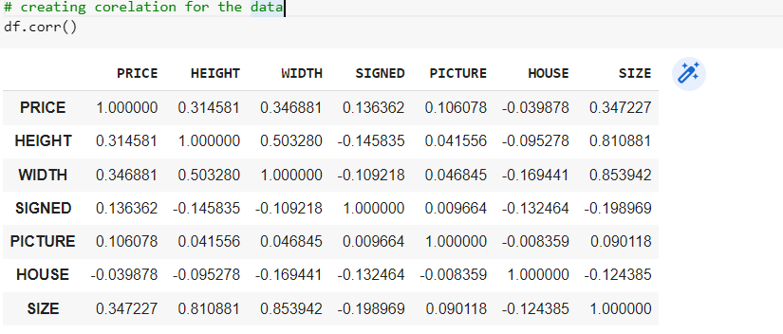

The correlation for each other column, where same column values results 1, different column gives different values.

Creating dummy vales for the selected column (SIGNED).

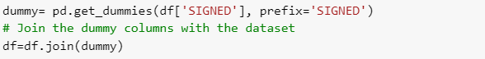

The dataframe after creating dummy values

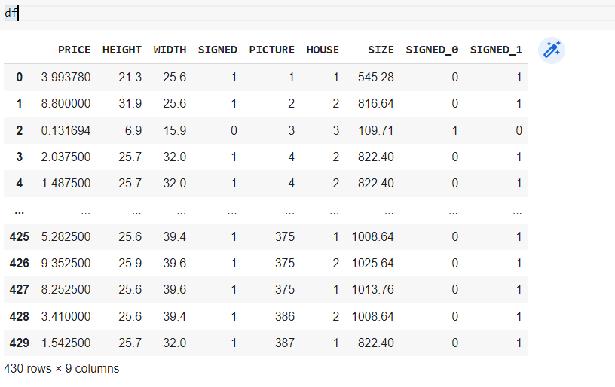

Which in results gives 2 different columns such as SIGNED_0,SIGNED_1.

Selecting the multiple columns for the regression. As shown below

