# Logistic Regression

**About The Model**

It’s a machine learning algorithm which is used to predict the probability of categorical dependent variable.

The dependent variable in the data contain as 0 (failure,etc..) & 1 (success,etc..).

**Binary or Binomial Regression:** The dependant variable has just two potential outcomes in this sort of classification: 1 or 0. For example, these variables may indicate success or failure, yes or no, victory or loss, and so on.

**Multinomial Regression:** The dependent variable in this form of classification might have three or more potential unordered outcomes, or it can have no quantitative meaning. These variables might stand for "Type A," "Type B," or "Type C," for example.

**Ordinal Regression:** In this classification, the dependent variable may have three or more quantitatively significant ordered outcomes or outcomes. With ratings ranging from 0 to2, these factors might indicate "poor" or "excellent," "very good," or "Excellent."

**Dataset**

The given data is red wine quantity, 1599 rows with 12 columns. Data set loaded as **df** using pandas package.

The column name are ['fixed acidity', 'volatile acidity', 'citric acid', 'residual sugar',

'chlorides', 'free sulfur dioxide', 'total sulfur dioxide', 'density',

'pH', 'sulphates', 'alcohol', 'quality']

**Data Pre-Processing**

Getting the all the data columns, their types and the count of rows. The float values are 11 columns and the other is int type

Checking the data with any null values.

Creating new column using the quality, as Quality of Wine with quality less than 7 is **“0”** & other as **“1”**.



Getting count values of new column

**Data visualization**

In the below fig., created plots for the each variable in the data set.

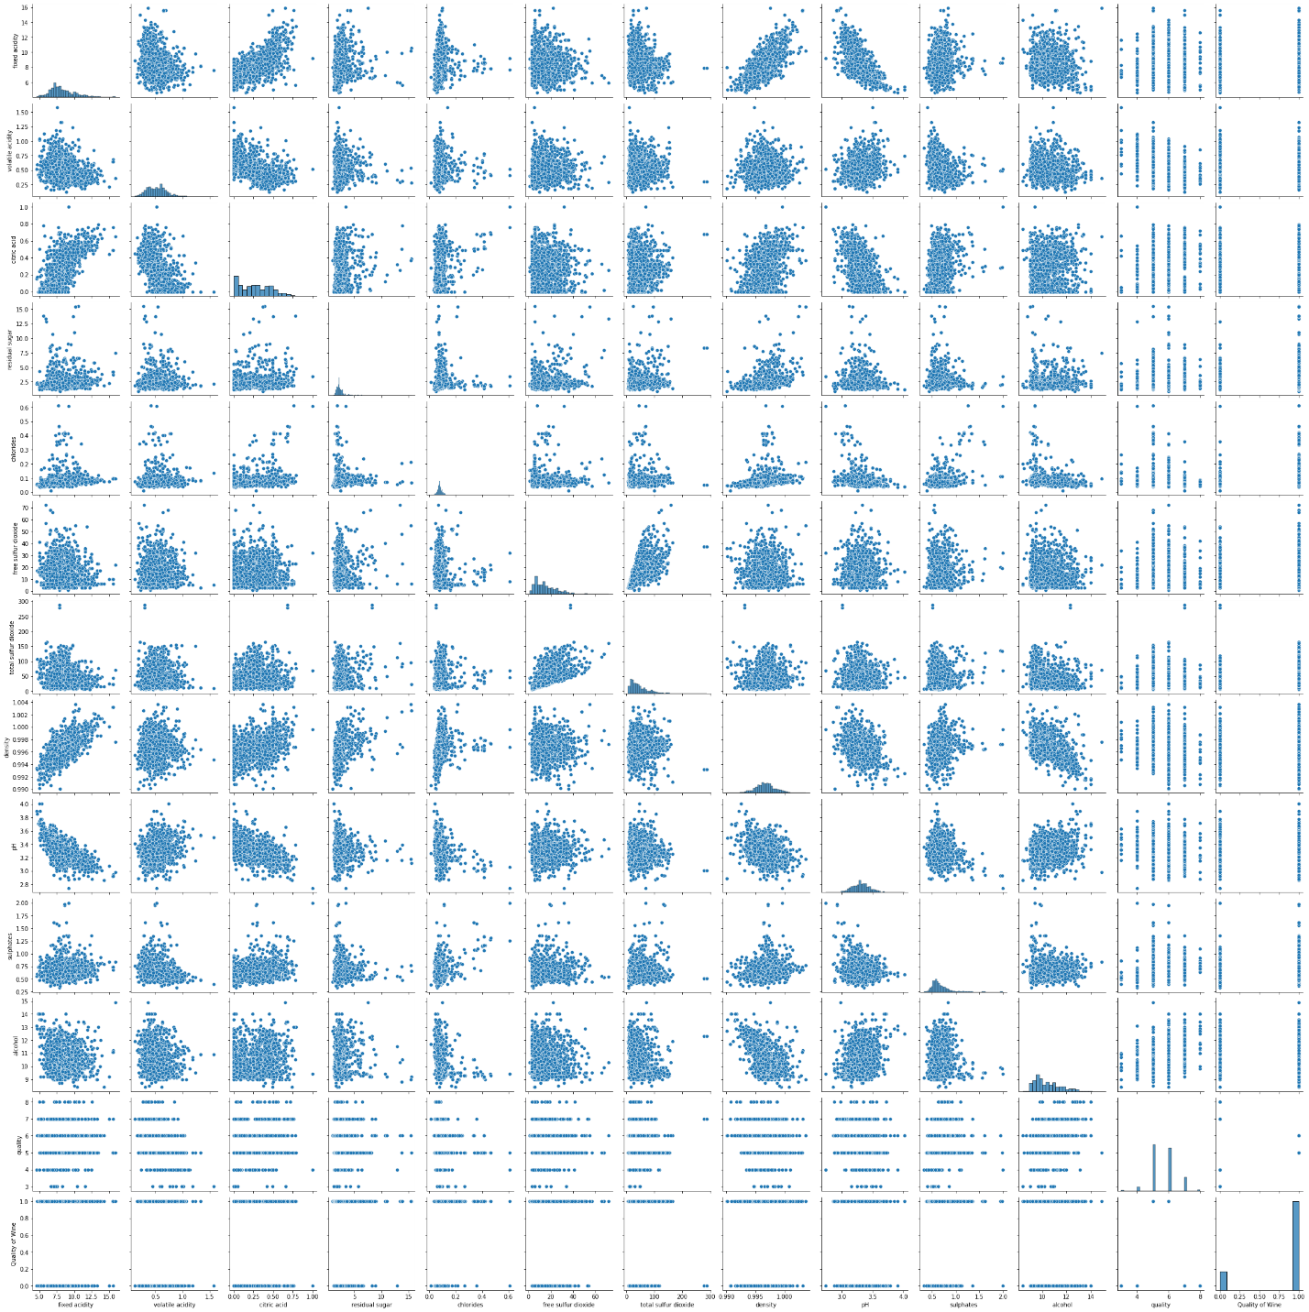

The fig. below shows correlation matrix with plot and the heat map.

**Splitting the data**

The given data set is spitted into 2 parts initially **X** as all the data columns with out “Quality of Wine” & **y**  as only “Quality of Wine” column.

The data set splitted int training dataset & test dataset with train data as 80% and test data as 20% (where test_size =0.2)

The training and testing is done by sklearn package.

**Applying the model**

Applying the logistic regression from sklearn package by importing, with maximum iteration is 10000, cross validation is 80 & class type is **multinomial.**

**Prediction results and test score**

The accuracy for the predicted data is 98%.

**Metrics**

Calculating the accuracy score, Confusion matrix, Recall score & Precision score.

**Conclusion**

The result of confusion matrix are, that we have 315+0 correct predictions and 0+5 incorrect predictions( the values are taken from results of confusion matrix above).

The accuracy of the test data is 98%, which shows the quality of the wine is red.

The Recall score for the test data is 1.0 and predicted data score is 0.0

The precision score for the test data is 0.98.