Q.1) The given circuit represent basic one bit …………………………………………….. circuit. Show information flow via each connecting wire for input x=1 and y=1(Mark on circuit).

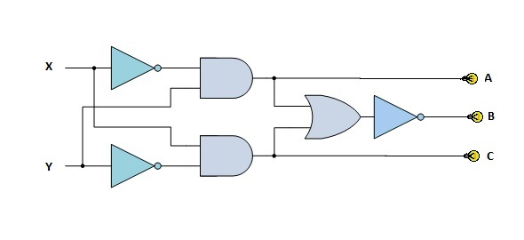



Q.2) Name and Explain the basic steps in CPU Information Processing Cycle(Maximum two or three line for each step).

**Fetch:** This part of the cycle is where the next step of the program is fetched from system memory by the processor and the instruction is stored in the control unit.

**Decode:** The instruction that was stored in the control unit from the fetch process is decoded by the control unit to get ready for execution.

**Execute:** The control unit sends signals throughout the processor to execute the instruction it just decoded (i.e sending a signal to the ALU to perform a calculation, then store the results in registers). Program counter is incremented by one to signal for the next fetch.

**Store:** The control unit sends the results of the instruction to system memory.