BeeSmart Spelling Bee
Comprehensive App Whitepaper (v2.1)

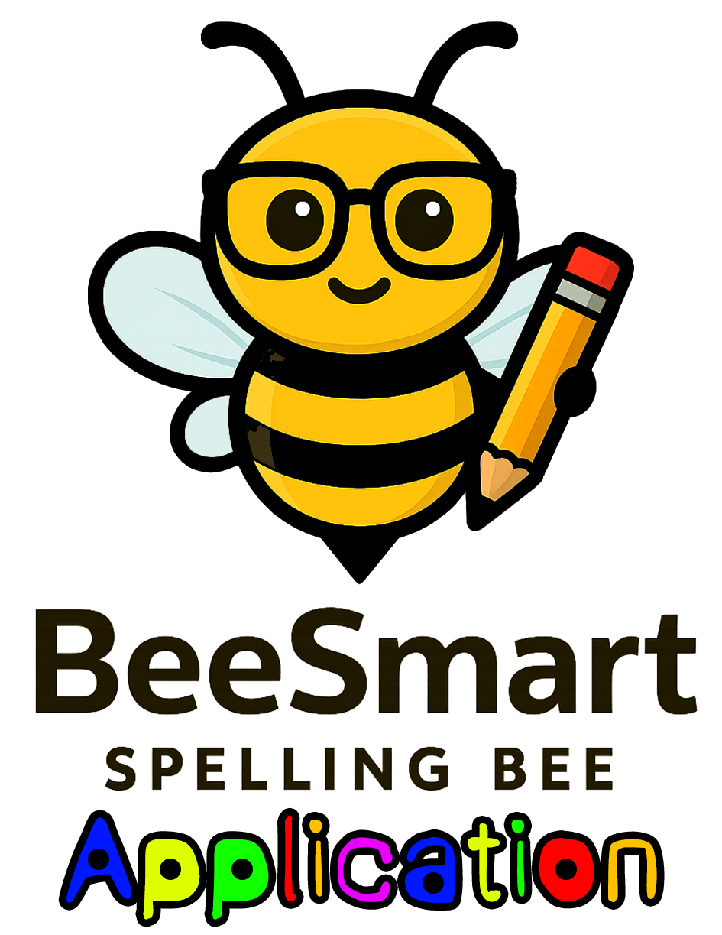

Prepared by Altech Computer Services, LLC
https://beesmartspelling.app
Effective Date: October 31, 2025

Contents
1. App Identity & Positioning 3
2. iOS App Store Metadata 3
3. Google Play Listing Metadata 4
4. Features, Accessibility & UX Notes 4
5. Monetization Model & Tier Structure 5
6. Compliance, Data Safety & Privacy Notes 5
7. Privacy Policy 5
8. Terms of Use 6
9. Reviewer Notes & Test Access 6
10. Localization Plan 6
11. Next Steps & Launch Checklist 6

1. App Identity & Positioning
App name: BeeSmart Spelling Bee
Subtitle: Fun spelling practice for kids
Tagline: Learn, hear, and master words—your way.
BeeSmart Spelling Bee helps kids master spelling and vocabulary with kid-friendly definitions, phonetic hints, and keyboard answers. Learners can upload word lists from CSV, TXT, DOCX, PDF, or images (OCR) and practice in a playful, distraction-free quiz environment.
Target Audience:
Primary: Elementary and middle school students (ages 6–13)
Secondary: Parents and teachers who curate word lists
Categories:
iOS: Education (Primary). Kids (6–8 or 9–11)
Google Play: Education > Learning
Unique Value:
• Multi-format uploads (CSV/TXT/DOCX/PDF/images via OCR)
• Built-in kid-friendly dictionary and phonetic spelling
• Keyboard answers; hints without revealing the word
• Session-based progress tracking
• Designed for classrooms and home practice

2. iOS App Store Metadata
App name: BeeSmart Spelling Bee
Subtitle: Fun spelling practice for kids
Promotional text: Build confidence with friendly definitions, phonetic hints, and feedback. Upload word lists from files or photos and practice in kid-safe, ad-free sessions.
Long Description:
BeeSmart Spelling Bee makes spelling practice simple and fun. Upload files (CSV/TXT/DOCX/PDF) or worksheet photos using built-in OCR. Each word includes a kid-friendly definition, example, and optional phonetic spelling. Kids answer via keyboard, ask for hints, and track streaks.
Highlights:
• Multi-format uploads (CSV, TXT, DOCX, PDF, OCR)
• Kid-friendly definitions and phonetics
• Keyboard input (voice input planned)
• Streak tracking and progress feedback
• Ad-free and privacy-focused
Keywords: spelling, kids, vocabulary, phonics, education, quiz, practice, classroom, teacher, OCR, worksheet

3. Google Play Listing Metadata
Short description: Master spelling with kid-friendly definitions, phonetic hints, and easy list uploads.
Full Description:
BeeSmart Spelling Bee helps kids build spelling skills with friendly definitions and hints. Import lists from CSV/TXT/DOCX/PDF or photos (OCR). Kids practice by typing answers, track streaks, and build confidence.
Features:
• Import word lists from files or photos
• Kid-friendly dictionary
• Keyboard answers
• Progress tracking
• Ad-free and secure
Category: Education > Learning
Data collected: Uploaded word lists (User content)
Diagnostics: Optional crash logs
Encryption: HTTPS in transit
Data deletion: Users or parents can request deletion

4. Features, Accessibility & UX Notes
• High-contrast visuals and large buttons
• Kid-friendly UI with clear typography
• Keyboard-only input (voice planned)
• Parental gate for purchases or external links
• Accessibility features for VoiceOver and TalkBack

5. Monetization Model & Tier Structure
Freemium launch model with earn-or-buy avatar unlocks.
Registered users start with: Cool Bee, Builder Bee, Brother Bee, Detective Bee.
Avatar | Category | Unlock Requirement
Al Bee | Classic | 20,000 Honey Points or $1.99
Astro Bee | Adventure | 18,000 Honey Points or $1.99
Biker Bee | Action | 15,000 Honey Points or $1.99
Diva Bee | Entertainment | 12,000 Honey Points or $1.99
Franken Bee | Fantasy | 25,000 Honey Points or $2.99
Professor Bee | Profession | 22,000 Honey Points or $2.99
Queen Bee | Royal | 28,000 Honey Points or $2.99
Robo Bee | Tech | 30,000 Honey Points or $2.99
Superbee | Fantasy | 26,000 Honey Points or $2.99
Vamp Bee | Fantasy | 24,000 Honey Points or $2.99
Ware Bee | Fantasy | 27,000 Honey Points or $2.99
Zom Bee | Fantasy | 25,000 Honey Points or $2.99
Earn new avatars via Honey Points or small purchases:
Premium avatars ($1.99 each or bundle): Al Bee, Astro Bee, Biker Bee, Diva Bee, Superbee, Queen Bee, Robo Bee, Ware Bee, Zom Bee.

6. Compliance, Data Safety & Privacy Notes
• COPPA and GDPR compliant
• No third-party ads or data sales
• HTTPS encryption and secure storage
• Parental gates for purchases and external links
• Optional teacher/parent accounts (email/username only)

7. Privacy Policy
BeeSmart Spelling Bee collects only minimal data necessary to deliver functionality. We do not show third-party ads or sell personal information. Uploaded word lists and quiz performance are stored securely and periodically deleted. Parents may request data deletion via privacy@beesmartspelling.app.
Full policy available at: https://beesmartspelling.app/privacy

8. Terms of Use
BeeSmart Spelling Bee is licensed for personal, educational, or classroom use. Accounts for teachers/parents may be required for advanced features. By using the app, you agree to abide by the Privacy Policy and Terms of Use. The application is governed under Texas law.
Full terms: https://beesmartspelling.app/terms

9. Reviewer Notes & Test Access
Test Accounts:
Student: student_demo / Password: REVIEW-ONLY
Teacher: teacher_demo / Password: REVIEW-ONLY
Test Steps:
1. Upload a sample CSV (50Words_kidfriendly.txt)
2. Start quiz using keyboard input
3. Request a hint and confirm answer feedback
4. Try OCR upload using a sample worksheet
5. Verify /health endpoint availability

10. Localization Plan
Phase 1: en-US
Phase 2: es-US, en-GB (localized text, descriptions, and screenshots)
Future: bilingual definitions with teacher-curated wordbanks

11. Next Steps & Launch Checklist
• Finalize privacy and terms pages
• Verify reviewer demo accounts
• Test iOS and Android builds
• Add parental gate verification
• Submit to App Store and Play Console
• Enable data deletion link in app
• Begin localization efforts for Spanish/UK English

