**Assignment 1**

**Due, Sunday, February 8, 2015 up to 100**

**Monday, February 9, 2015 up to 90**

**Tuesday, February 10, 2015 up to 80**

**Wednesday, February 11, 2015 up to 70**

**Beyond 2/11/2015, beg for mercy from Professor Whiting!**

**Deliverables**

To complete this assignment you must submit your source code .c file to Webcourses.

**Introduction**

The goal of this assignment is to write an application that reads in a data file and stores the data as a linked list.

**References**

Text book, Chapter 2.

Source code examples on Webcourses, LinkedList.c

Online tutorials:

<http://www.cprogramming.com/tutorial/c-tutorial.html>

<http://fresh2refresh.com/>

<http://www.tutorialspoint.com/c_standard_library/>

**Tasks and Rubric**

|  |  |  |
| --- | --- | --- |
| Activity | | Points |
| Create a linked list node to include | char name[50];  int id;  struct node *next; | 10 |
| main() | - Call the function to read in the data file as a linked list  - Provide the user a menu of the following options:  1. Insert  2. Display  3. Delete by ID  4. Delete by Name  5. Exit  - Use a conditional statement to evaluate the user’s selection  -- if option 1, call function to insert a new student  -- if option 2, call function to display the linked list  -- if option 3, call function to delete by id number  -- if option 4, call function to delete by student name  -- if option 5, exit the program | 10 |
| Function to read the data file as nodes in a linked list | Read in the contents of data file "AssignmentOneInput.txt" into the node data structure | 10 |
| Function to insert a new student | Prompt the user for the student’s name  Prompt the user for the student’s id number  Populate an instance of the linked list node with the data  Add the new node to the existing linked list | 10 |
| Function to display the linked list | Traverse the linked list and display the data of each node | 10 |
| Function to delete by id number | Prompt the user for the student’s id number  Traverse the linked list to find the entered id number  If it exists delete it and inform the user it has been deleted  If it does not exit inform the user the entered id number was not found | 10 |
| Function to delete by name (Displayed name based on Option 2) | Prompt the user for the student’s name  Traverse the linked list to find the entered name  If it exists delete it and inform the user it has been deleted  If it does not exist inform the user the entered name was not found | 10 |
| Exit the program | Write the appropriate code to exit the program | 5 |
|  | Source compiles with no errors | 10 |
|  | Source runs with no errors | 10 |
|  | Source includes comments | 5 |
| Total |  | **100** |

Example output after application starts and reads in the data file, the user selects option 2 from the menu

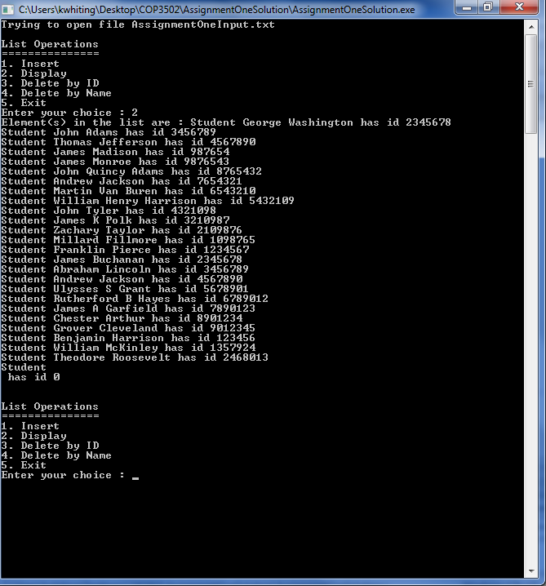

Figure 1 Option 2 Display, After Application Start

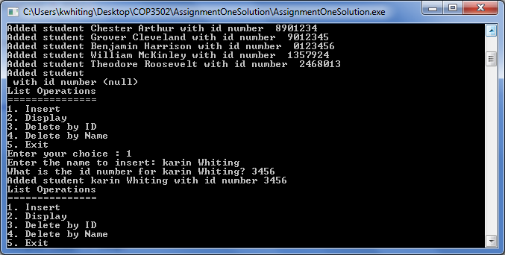

Figure 2 Option 1 Display

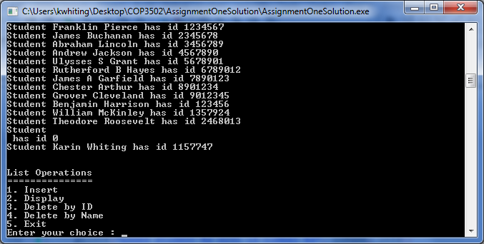

Figure 3 Option 2 Display, After Option 1

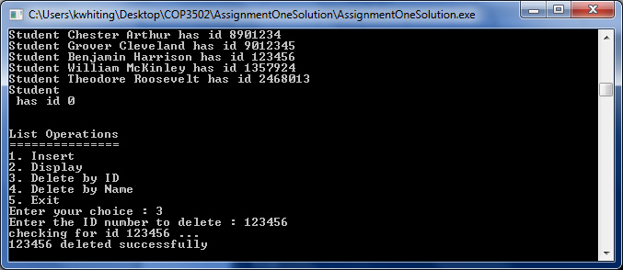

Figure 4 Option 3 Display

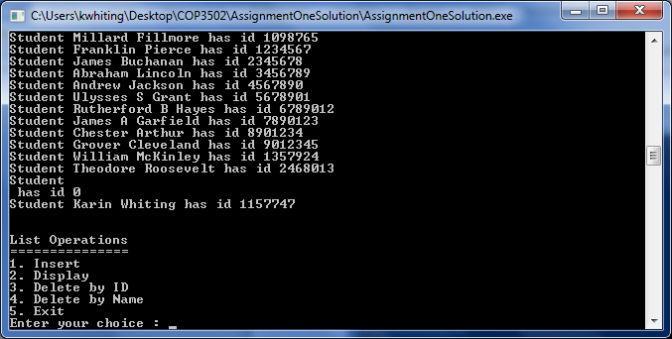

Figure 5 After Option 3, Option 2 Display

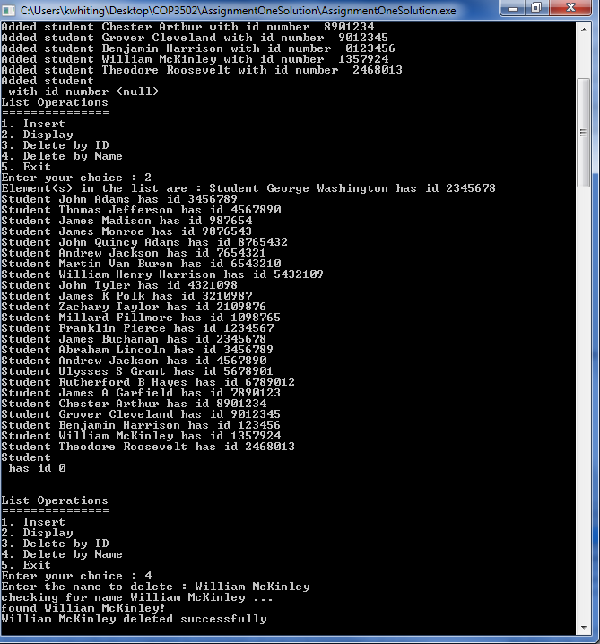

Figure 6 Option 4 Display

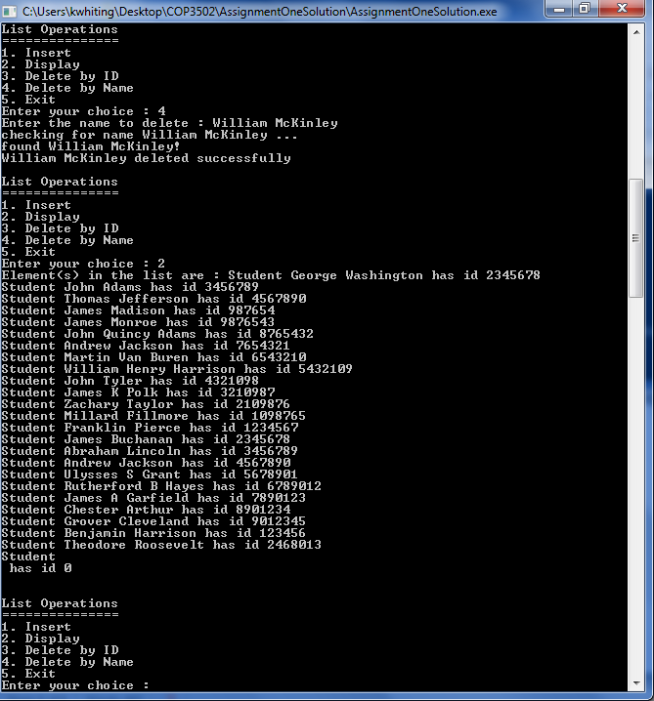

Figure 7 Option 2 Display, After Option 4