**Assignment 3**

**Due, Sunday, March 29, 2015 up to 100**

**Monday, March 30, 2015 up to 90**

**Tuesday, March 31, 2015 up to 80**

**Wednesday, April 1, 2015 up to 70**

**Beyond 4/1/2015, beg for mercy from Professor Whiting!**

**Deliverables**

To complete this assignment you must submit to Webcourses:

1. source code .c file

**Introduction**

This assignment provides practical experience with permutation recursion.

**References**

1. Text book
2. Source code examples on Webcourses,, Recursion.c, Permutations.c
3. Online tutorials:
   1. <http://www.cprogramming.com/tutorial/c-tutorial.html>
   2. <http://fresh2refresh.com/>
   3. <http://www.tutorialspoint.com/c_standard_library/>

**ATTENTION MAC USERS!**

If you are using a Mac operating system and Code::Blocks, I understand that you have to fully qualify the path to the files for the program to run. I ask that before you submit your assignment please remove the fully qualified path so that the **fopen("AssignmentThreeInput.txt", "r");** function call has only the file name. Thank you!

If you are using a Mac operating system and Xcode, place your .txt files in the directory Products, where the .exe is written to you don’t have to use a fully qualified path, just use the file name.

**Tasks and Rubric**

|  |  |  |
| --- | --- | --- |
| Activity | | Points |
| Read in the data file | Read in the contents of data file "AssignmentThreeInput.txt" | 10 |
| Provide information to the user | For each word in the file, display to the user which word is currently being permutated (see Figure 1) | 5 |
| Permute each word in the file | Permute each word in the file for all possible arrangements using all letters | 10 |
| Write permutations to a data file | Write out the permutations of each string contained in the input file as “AssignmentThreeOutput.txt” | 10 |
| Test Case | Perform Test Case, results in expected outcome | 40 |
| Compile | Source compiles with no errors | 10 |
| Run | Source runs with no errors | 10 |
| Comments | Source includes comments | 5 |
| Total |  | **100** |

**Perform the following test case**

|  |  |  |
| --- | --- | --- |
| Test Case | | |
|  | **Action** | **Expected outcome** |
| Test case | Run application | 1. Data file AssignmentThreeInput.txt is read in 2. Each word in the file is permuted 3. Console display updates to inform user what the application is doing 4. Data file AssignmentThreeOutput.txt is written out and matches provided example |

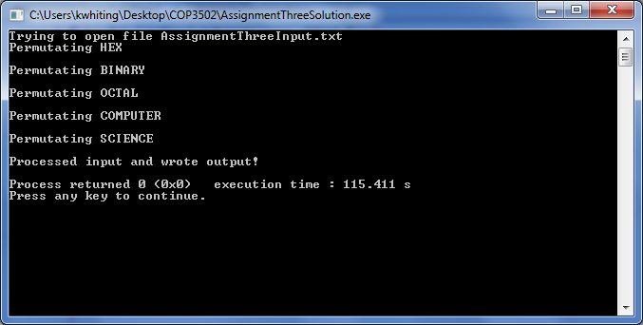 Figure 1 Application Run