EEL4742 PROGRAMMING PROJECT SPRING 2014

GOAL: To write an assembly language program that implements a small Debugger program similar to the one used on many embedded systems.

STEPS:
- Write a subroutine the prints 2 ASCII numbers in HEX format (one byte) to the display using the OUTA_UART subroutine. (????) (DONE)

- Write a subroutine the inputs and echo’s to the screen two valid ASCII HEX format characters from the keyboard using the INCHAR_UART subroutine. (DONE)

- Write a subroutine that calls the subroutine in step 1 twice to output 4 ASCII numbers in HEX format. (DONE)

- Write a subroutine that calls the subroutine in step 2 twice to input 4 valid ASCII HEX format numbers. (DONE)

- Write a subroutine that calls the subroutine in step 4 twice to input two sets of 4 valid HEX format numbers separated by a space (i.e. XXXX YYYY). (DONE)

- Write a subroutine to print a carriage return and a line feed. (DONE)

- Write a program / subroutine that changes memory at address XXXX.

Command Format: M XXXX QQQQ
Where QQQQ is the 4-digit HEX number to be stored in location XXXX.
Where QQQQ is the ASCII input of "p", which skips the present line and moves to the next higher address XXXX + 1.
Where QQQQ is the ASCII input of "n", which skips the present line and moves to the next lower address XXXX - 1.
Where QQQQ is the ASCII input of " "(space), exits the modify memory routine and returns the user to the input prompt.

- Write a subroutine / program to display memory as a 4 digit HEX number and an ASCII character between the values of ($21 to $7E) from addresses XXXX to YYYY. You should display 16 bytes (8 words) per r line.

Command Format:
D 0100 0112
Ex:
0100 3132 3330 4100 FE00 0203 0405 3941 4243 1230A.......9ABC
0110 41 ED 42 A.B

- Write a subroutine that implements a sixteen bit calculator that can add and subtract.

Format: Command Input 1 Input 2 Result

HA 0012 0034 R=0046 ADD
HS 0034 0012 R=0022 SUB

For each calculator operation the status flags C, V, N, and Z should be displayed.

- Combine all of the commands together into one main program that looks for an input command and executes appropriate subroutine Step 1 – Step 9. The main function of your program should print a CR and a LF, print the prompt character “>”, wait for a user input and then jump to the appropriate subroutine.

Hint: Write all of your subroutines preserving the registers. This way it will be easy to combine all of the subroutines into one program.

REQUIREMENTS:
Due: Tuesday: April 21, 2015 at 9:00 AM

To be included on a CD to be turned in:
(65 pts.) The complete folder generated by Code Composer with all of its files as shown below.

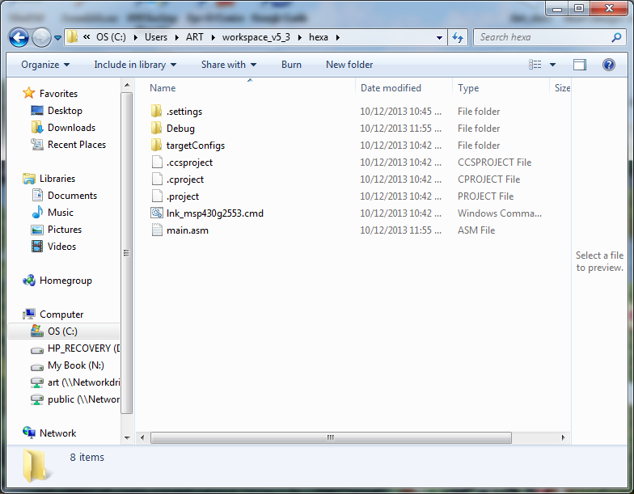

(+15) Steps 1 – 5
(+5) Step 6
(+15) Step 7: Modify memory command (M)
(+15) Step 8: Display memory command (D)
(+15) Step 9: The 16 bit calculator (HA, HS and
Status Flags of V, N, C, and Z)

(35 pts.) A report including in a *PDF format:
(+10) Commented assembly code *.ASM (on CD)
(+10) A test procedure on how to test you program.
This is a step by step procedure that tells how to test each element of the program. It must be detailed enough so the user can follows each step. This is similar to the steps in a cookbook.
(+15) A user manual describing how to use your program.
This instructs the user how to use the program. It tells the user how to use the program.

A printed copy of the project report which includes the test procedure and the user manual.

WHAT IS TO BE TURNED IN:
All of the requirements given above on a CD (or USB memory) with the CD in a protective sleeve and the hardcopy report.

No late projects will be accepted. A late project will be given a grade of 0.

