**Guidelines for Writing Team Contract (adapted from [1])**

ECE 211/212 are courses based on projects performed by teams of students. Teamwork, like most other things, is best learned through repeated practice. Developing Team Contract should help your team function more smoothly and effectively.

**Rationale**

As discussed in [2], there are five stages of team development: forming, storming, norming, performing, and adjourning. During the *forming* stage, teams tend to communicate in indirect polite ways rather than more directly. The *storming* stage, characterized by conflict, can be often be productive, but may consume excessive amount of time and energy. In this stage it is important to listen for differing expectations. Next, during the norming stage, teams formulate roles and standards, increasing trust and communication. This norming stage is characterized by agreement on procedures, reduction in role ambiguity, and increased unity of the team. These developments generally are precursors to the *performing* stage, during which teams achieve their goals, are highly task oriented, and focus on performance and production. When the task has been completed, the team *adjourns*.

To accelerate a team’s development, a team contract is generated to establish procedures and roles in order to move the team more quickly into the performing stage. This process of generating a team contract can help jump-start a group's collaborative efforts by immediately focusing the team members on a definite task. The group members must communicate and negotiate in order to identify the quality of work they all wish to achieve, and the level of group participation and individual accountability they all feel comfortable with.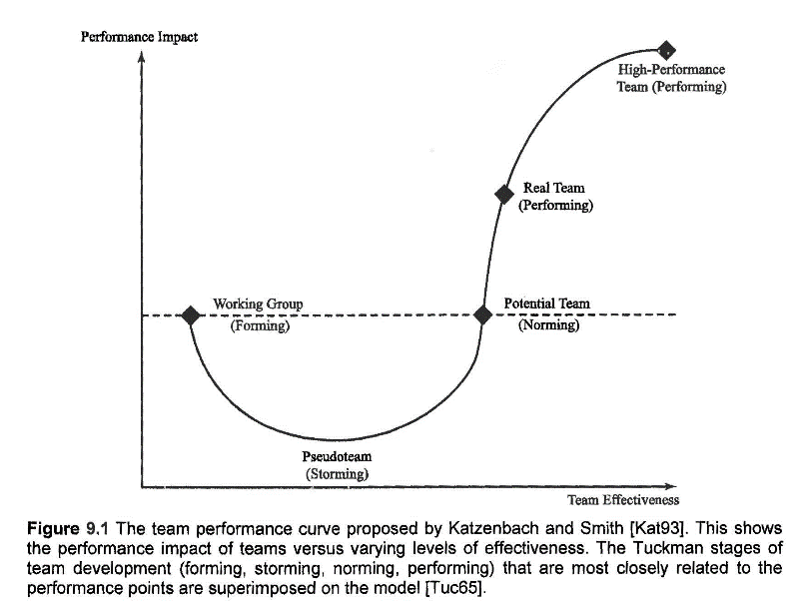

Successful team performance depends on personal individual accountability. In a team environment, individuals are usually effectively motivated to maximize their own rewards and minimize their own costs. However, conflicts can arise when individualistic motives or behaviors disrupt team-oriented goals. For example, conflict can stem from an unequal division of resources. When team members believe they are receiving too little for what they are giving, they sometimes reduce their effort and turn in work of lower quality. Such "social loafing” occurs most frequently when individual contributions are combined into a single product or performance, and individual effort is perceived as unequal. At this point, some individual team members may take on extra responsibilities while other team members may reduce their own efforts or withdraw from the team completely. These behaviors may engender anger, frustration, or isolation—resulting in a dysfunctional team and poor quality of work. However, with a well-formulated team contract, such obstacles can usually be recognized and avoided.

**Team Contract Assignment**

Your team contract template is divided into three major sections:

1. establishing team procedures
2. identifying expectations
3. specifying the consequences for failing to follow these procedures and fulfill these expectations

Since the basic purpose of this team contract is to accelerate your team's development, to increase individual accountability for team tasks, and to reduce the possibility for team conflict, make your contract **as specific as possible** by specifying:

1. each task as detailed as possible,
2. each step in a procedure or process as detailed as possible,
3. the exact person(s) responsible for each specific task, and
4. the exact time and exact place for completion or submission of each task.

The more specifically you describe your team expectations, roles, and procedures, the greater chance you have for a successful team experience.

Once your team contract has been developed, your team is ready to begin work on collaborative assignments. However, you may soon find that your team is not working as well as you had hoped. This is normal but needs to be attended to immediately. Perhaps your team is simply not following the established contract procedures or roles as strictly as you should be, or perhaps you need to change some of the procedures or roles as outlined in your contract. Call a team meeting immediately to discuss and resolve the challenges your team is facing; do not delay. Seek guidance from your instructor, TA, or undergraduate helper to resolve any conflicts so that you will have the most positive team experience possible.

[ We will address these when we go through one Sprint and you know more about how Scrum functions. Some specific comments re: Scrum setup:

* defining roles – development team, product owner, scrum master
* define specific expertise for each member (EPL or similar)
* time(s) for sprint retrospectives; what will be the result of those?
* Expectations for daily meetings
* Daily meetings need not be documented but any other meetings, such as sprint retrospectives, should have a more formal set of notes for which you will be given a template.
* Sprint retrospective discussion and conclusions have some mandatory parts that should be included in this contract (we will do this in v2.0). ]

Course instructor reserves the right to remove team members that do not show sufficient level of commitment or perform poorly. Consequences of such removal are discussed in course syllabus.

Use the Team Contract template to discuss and finalize your team roles, procedures, and standards. Complete, sign, and submit a scanned copy of your finalized contract on D2L.

**TEAM CONTRACT**

**ECE 211 / 212 Team # _4_____**

**Team Members:**

1) _Gabrielle Hladik________________ 4) __ ZhengZhang___________

2) ____Garth Crawford________________ 5) _______________________________

3) ____Jana Al-Huneidi_________________

|  |
| --- |
| **Team Procedures** |

1. Day, time, and place for regular **daily Scrum meetings**:

Tuesday & Thursday at 5:15pm

1. Day, time, and place for regular **Sprint retrospective meetings**:

Tuesday & Thursday at 5:15pm

1. Preferred method of **communication**, e.g., e-mail, cell phone, wired phone, face-to-face, in a certain class, in order to inform each other of team meetings, announcement, updates, reminders, problems:

Slack, text, and Zoom meetings

1. **Decision-making policy** (authority, expert, average, authority after discussion, minority, majority, consensus):

We go with the idea that the majority agrees on

1. Method for setting and following meeting **agendas** (Who will set each agenda? When? How will team members be notified/reminded? Who will be responsible for the team following the agenda during a team meeting? What will be done to keep the team on track during a meeting?):

Gabrielle is responsible for scheduling. We have a group chat set up for instant notifications, and dedicated zoom meetings, as well as a slack channel.

1. Method of **record keeping** (Who will be responsible for recording & disseminating minutes? How & when will the minutes be disseminated? Where will all agendas & minutes be kept? Note: some will be done on Trello):

Jana will be responsible for record keeping through trello.

1. How will collaboration on writing the final report be handled? (tools used? Distribution of tasks?)

Google Docs will be used to write the report. Based on the skill set of each member, the tasks will be distributed. Everyone will contribute to the report.

|  |
| --- |
| **Team Expectations** |

**Work Quality**

* 1. **Project standards** (What is a realistic level of quality for team presentations, collaborative writing, individual research, preparation of drafts, peer reviews, etc.?):

We expect to split the speaking time between everyone, as well as help each other out and back-check each others work when we split the workload.

* 1. **Strategies** to fulfill these standards:

Do practice presentations before-hand. Create a draft for the report and have it checked, revised, and back-checked before submission. This goes for all the other aspect of the project as well.

**Team Participation**

1. Strategies to **ensure cooperation and equal distribution of tasks**:

We will update each other on the workload we have and how far along we get. If a team-member is falling behind, we will figure out a game plan to split the work so that we are able to keep on track. We will hold each other accountable for the work assigned to each team member.

1. Strategies for **encouraging/including ideas from all team members**:

We will share all our ideas during the zoom meetings, then evaluate each idea based on our design matrix we made to see which idea would work best for the task at hand. We will also ask our scrum master for reference, if something is or is not a good idea.

1. Strategies for **keeping on task**:

Creating a gantt chart to establish a timeline for the tasks, setting deadlines for each task.

1. Preferences for **leadership** (informal, formal, individual, shared):

shared

**Personal Accountability**

1. Expected individual **attendance, punctuality, and participation** at all team meetings:

Our goal is to have an equal amount of participation, but if someone has a different schedule, we will work together to set up some remote work that they can do, and work around to set up a better meeting time that works for them. We expect attendance 90% of the time, understanding that people get busy- just need to have a heads up beforehand.

1. Expected level of responsibility for **fulfilling team assignments, timelines, and deadlines**:

We intend to split all responsibilities relatively equal between each other. We will all check up on our trello board a minimum of 2-3 times per week to make sure we are staying on track with our deadlines of tasks.

1. Expected level of **communication with other team members**:

Expected to communicate during meetings, as well consistent updates from team members on progress.

|  |
| --- |
| **Consequences for Failing to Follow Procedures and Fulfill Expectations** |

1. Describe, as a group, you would handle **infractions** of any of the obligations of this team contract:

If in this case we experience any issues, we would first communicate to the member the issue and what they can do to resolve it.

1. Describe what your team will do **if the infractions continue**:

If it persists, then we will first go to the scrum master, then go to the instructor if need be.

***************************************************************************

1. *I participated in formulating the standards, roles, and procedures as stated in this contract.*
2. *I understand that I am obligated to abide by these terms and conditions.*
3. *I understand that if I do not abide by these terms and conditions, I will suffer the consequences as stated in this contract.*

1) ___Gabrielle Hladik____________________________date___6/25/20_______________

2) ___Garth Crawford_______________________________date___6/25/20______________

3) ____Jana Al-Huneidi____________________________date____6/25/20______________

4) __Zheng_Zhang_______________________________date__6/25/20_______________

5) ___________________________________________________date__________________

[1] Adapted from <https://cns.utexas.edu/images/CNS/TIDES/teaching-portal/Team_Contract.doc>

[2] Ford and Coulston, Design for Electrical and Computer Engineers, McGraw-Hill, 2008