**Tree Definition**



What is a tree?

A tree is a non-linear data structure that consists of a root node and potentially many levels of additional nodes that form a hierarchy. A tree can be empty with no nodes, consist of one node, called the root, or, one or more subtrees.

What is a node?

The generic term A, B, … I are the nodes of a tree, similar to nodes in a linked list. Data of one sort or another may be stored at each node. It is the connection between the nodes which characterize a tree.

What is a root node?

The top node of the tree is A

What is a parent node?

It is the converse notion of a child. Node A is the parent of B and C, C is the parent of F, G and H. B is the parent of D and E. H is the parent of I.

What is an ancestor node?

It is a node reachable by repeated proceedings from child to parent. A is the ancestor of D and E. A is also the ancestor of F, G and H. A is the Ancestor of I. C is also the ancestor of I. A is the grand grandparent but we use the term ancestor.

What is a grandparent?

A is the grandparent of D, E, F, G H. C is the grandparent of I.

What is a descendent node?

A descendent node is a node reachable by repeated proceedings from parent to child. B, C, D, E, F, G, H, I are all descendants of A.

What is a sibling node?

Sibling nodes are nodes with the same parent. B is a sibling of C and C is a sibling of B. G and E are not siblings but F, G and H are siblings.

What are children nodes?

D, E are children of B. B and C are children of A. F,G, H are children of C and I is the child or H.

What is a leaf?

D, E, F, G and I are called the leaves of the tree. If you just turn it upside down, then the extremities would be the leaves.

What is an external node?

A node with no children

What are internal nodes?

A, B, C, and H are internal nodes. A node which is not a leaf is called an internal node.

What is the degree of a node?

The number of children it has. B has a degree of 2. C has a degree 3 and H has degree 1. The leaves have degree 0.

What is the level of a tree?

It is the distance of a node from the root. Root is at level of 0. The children of the root are at level 1. The children of those nodes are at level 2. D, E,F ,G and H are at level 2.

What is a height?

The height of a node is the number of edges on the longest downward path between the root and a leaf. The maximum level in the below tree is 3.

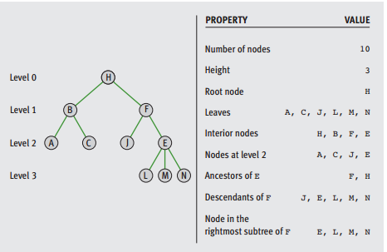

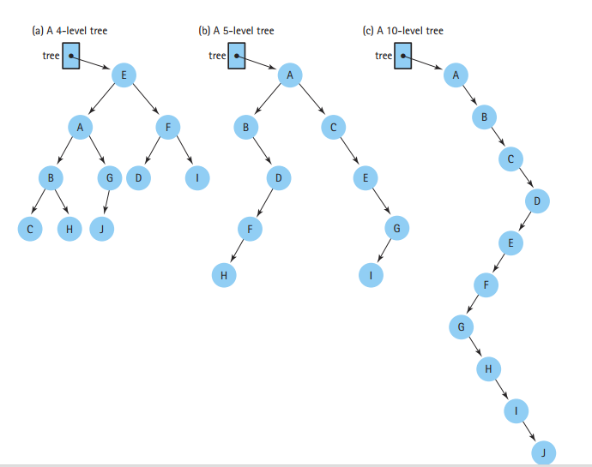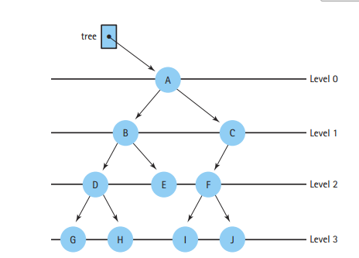

**Binary trees**

What is a binary tree?

A binary tree is a structure with a unique starting node (the root), in which each node is capable of having two nodes. A general tree is distinguished from a special category called binary tree. A unique path exists from the root to every other node.

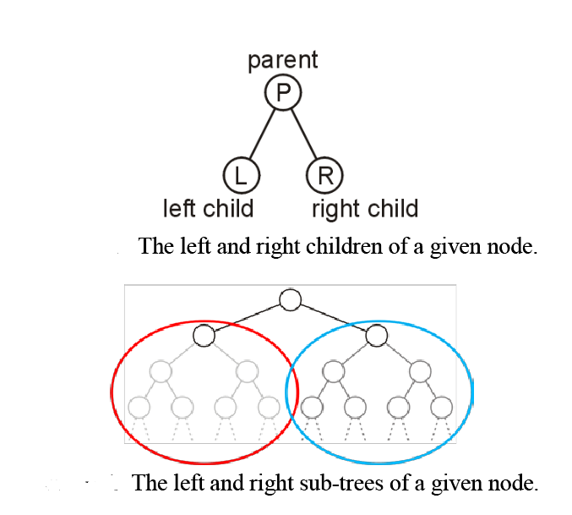

This is not a valid tree because there are two paths to D

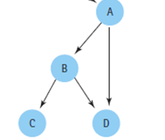

What is a binary search tree?

Binary Search tree is a binary tree in which each internal node x stores an element such that the element stored in the left subtree of x are less than or equal to x and elements stored in the right subtree of x are greater than or equal to x.

1. Left child node is smaller than its parent Node
2. Right child node is greater than its parent Node

|  |  |
| --- | --- |
|  |  |

What is a full tree?

A full binary tree is a tree in which every node other than the leaves has two children.

What is a complete tree?

A complete binary tree is a tree in which every level, except possibly the last, is completely filled, and all nodes are as far left as possible.

What is a perfect tree?

All leaf nodes have the same depth. It is possible for a binary tree to be both full and complete but not perfect. All perfect trees are both full and perfect. Kind of like all squares are rectangles but not all rectangles are squares.

|  |  |
| --- | --- |
|  |  |

