**InClassAssignment1(Group of two)  
CS160-02  
Introduction to Data Science  
Spring 2023**

**Working on Techniques for Analyzing Data**

**Instructions:** Complete the following activities for this project.

1. Create a new GitHub repository named Assignment1_XXX, where XXX are your initials.
2. Using excel (to generate the result) and word documents (type answers and paste the results) work on the following questions and submit your work using **pdf** format.
3. What are the differences between data analysis and data analytics?

* **Data analysis provides personal experience (hands-on) for exploration and evaluation. Data analytics is a term describing the overall practices of activities as they relate to data.**

1. Comment on variable types of Murder, Assault, and urban pop.

* **All three are independent, and continuous. The categorical are nominal.**

1. What is the difference between interval and ratio data?

* **Interval data does not have an absolute zero. Ratio data data does have an absolute zero, and can go below.**

1. What is descriptive analysis? Represent the data of Murder, Assault, and urban pop. Comment on the distribution.

* **Descriptive analysis is the first type of analysis performed on a data set. Typically, it will be applied to larger volumes of data. The distribution for these graphs is positive. All of the graphs are**
* **positive-skewed**
* **, is**Chart, histogram

  Description automatically generated
* 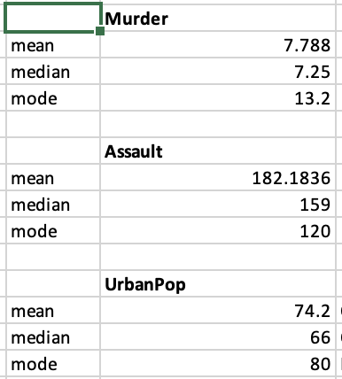

1. What is a measure of dispersion? Calculate the interquartile range of those three variables

* **A measure of dispersion are values that represent the spread of the data. You measure the dispersion by finding the Interquartile ranges from Quartile 1 and Quartile 3.**
* Graphical user interface, application, table, Excel

  Description automatically generated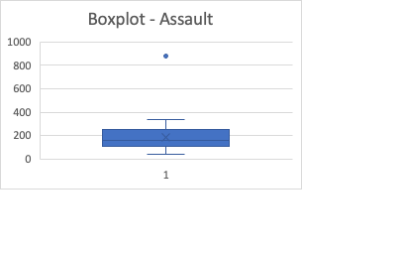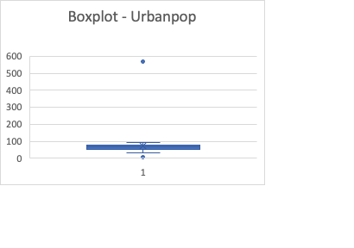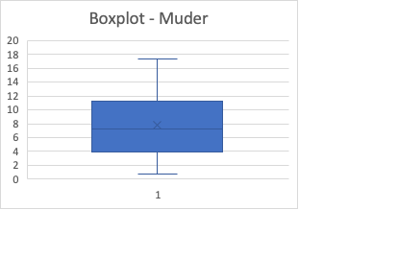

1. What is the measure of centrality? Find the measurement of centrality: mean, median, mode

* **The number(s) that describe the center of a distribution.**

1. What are diagnostic analytics? Find diagnostic analysis for pair of variables.

* Graphical user interface, text, application

  Description automatically generated

**The correlation between Murder and Assault is positive, which means that as murder rates increase, assault rates also increase.**

**The correlation between Murder and Urban Population is negative, which means as murder increases, urban populations decreases.**

**The correlation between Assault and Urban Population is negative, which means as assaults increase, urban population decreases.**

1. Using the instructions provided by GitHub, create a git repository named DS160**InClassAssignment**, and push your pdf file to it. Each of you needs to submit your work.

**Submission:**

Paste a link to your GitHub repository in the area provided for this assignment and submit it by class time.