Integrating donor project intelligence into FieldFlow
A wireframe for adding the JalJeevik Ango donor-compliance features to the existing platform
Technical wireframe, prepared for the development handoff

1. Starting point
FieldFlow is a working product, not a blank slate: an Express monolith on App Engine (~140 routes) serving a React SPA, backed by Neon Postgres, with two features already split out to Cloud Run -- Notebook and Report-writer -- using a Strangler Fig pattern. The team's own technical documentation is explicit about why: single repo, single deploy -- monolith on purpose, because there isn't enough volume yet to justify microservices.
The donor project intelligence concept (document vault, MIS tracking, compliance calendar, financial tracker, Ask AI, auto-reports) was prototyped separately as a browser-only demo. This document wireframes how those features join FieldFlow as new pieces of the existing system, rather than as a second, disconnected platform.

2. What already exists
Component | What it does today | Where
React SPA | Single-page app served by the monolith, Firebase client auth | src/, dist/
App Engine monolith | Express, Node 22, ~140 routes, Firebase token verification, rate limiting | server.js, routes/
Neon Postgres | Shared database, one organisation per tenant | db/migrations/
Notebook service | Stateless AI notebook (chat, audio, tts, study guide, slide deck) -- first Strangler Fig extraction | services/notebook/
Report-writer service | Owns rw_profiles, rw_glossary, rw_drafts, rw_feedback with a restricted DB role -- DDD bounded context on Cloud Run | services/report-writer/
Gemini LLM gateway | lib/gemini.js -- streaming SSE calls to Gemini 2.5 Flash/Pro, used by both the monolith and the Cloud Run services | lib/gemini.js
WhatsApp / Glific | Meta WhatsApp Cloud API integration, flow engine, broadcasts | routes/whatsapp.routes.js, routes/wa-platform.routes.js

3. What gets added
New piece | What it adds | Lands in
Donor routes module | New Express router in the monolith: project/portfolio CRUD, compliance schedule, financial (budget vs UC), MIS indicators -- same pattern as the other 140 routes. | Monolith (Phase 0)
Donor tables | New Postgres tables (donor_projects, compliance_items, mis_indicators, financial_records, donor_documents) scoped by organization_id, alongside the existing schema. | Postgres (Phase 0)
Donor vault service | New stateless Cloud Run service that parses uploaded MoUs, budgets, UCs, and MIS Excel/CSV files -- same shape as the Notebook service, proxied the same way once volume justifies it. | Cloud Run (Phase 1)
Ask AI for donor docs | Reuses the existing Gemini gateway and ai_interactions/ai_memories tables -- no new AI stack, just a new context builder that pulls project, compliance, and financial data before the call. | Existing AI layer
Donor report types | New report templates (monthly progress, donor update, compliance status, financial summary) added to the existing Report-writer service's rw_drafts flow, not a separate service. | Report-writer (extended)

4. How a request flows

Uploading a donor document
The React SPA uploads to a new endpoint in the donor routes module. Small files are parsed inline in the monolith at first; once volume grows, the same proxy-with-circuit-breaker pattern used for Notebook routes the parsing work to the new Donor vault Cloud Run service, keeping the monolith responsive. Extracted data (budget lines, MIS rows, compliance dates) is written to the new Postgres tables.

Dashboards and trackers
MIS, financial, and compliance dashboards read directly from the new Postgres tables through the donor routes module -- plain CRUD and aggregation, no different from the existing reports or performance-review routes, so there's no case for a dedicated service here yet.

Ask AI
A project lead's question is handled by the existing AI layer (lib/gemini.js, ai_interactions, ai_memories). A new context builder gathers the relevant project's MIS, financial, and compliance rows plus recent document text before calling Gemini, following the same pattern as buildOrgContext for the Notebook and AI chat routes.

Generating a donor report
Monthly progress, donor update, compliance status, and financial summary reports are new draft types inside the existing Report-writer service, alongside its current rw_profiles / rw_glossary / rw_drafts flow -- reusing its DB role, templates, and feedback loop rather than building report generation twice.

5. Rollout phases
- Phase 0 -- add the donor routes module and new tables to the monolith and Postgres; ship the Document Vault, MIS tracker, Compliance calendar, and Financial tracker as new pages in the existing React SPA.
- Phase 1 -- wire Ask AI for donor projects into the existing Gemini gateway and AI memory tables.
- Phase 2 -- add donor report types to the Report-writer service's draft flow.
- Phase 3 -- extract the Donor vault as a Cloud Run service via the existing Strangler Fig proxy, once document parsing volume makes that worthwhile -- the same trigger that justified Notebook and Report-writer.

6. Visual design direction
The first wireframe pass used an invented teal and sand palette that had no connection to the real product. This revision instead pulls its design tokens straight from the codebase -- src/theme/colors.ts and the hero-card and PillRow patterns already built in DashboardPage.tsx and OverviewPage.tsx -- so the donor compliance screens look like FieldFlow, not a bolted-on app.
Token | Value | Used for
Sidebar / brand | #341272 | Jaljeevika primary purple -- 60px icon-only sidebar, rounded right corners
Dark accent | #1D0752 | Active pill-tab fill, dark hero card, AI insight banner
Page background | #F5F3FB | Soft lavender -- the app canvas behind every card
Positive / impact | #16a34a | Outreach hero card, on-track flags, the quick-report action button
Warning | #D97706 / #B45309 | Near-limit budget heads, certificates expiring soon
Danger | #DC2626 | Overdue compliance items, under-spent budget heads
Pill track (unfilled) | #DDD6FE | Light violet -- the unfilled segments in every PillRow
Two structural choices carry the whole design: the existing 60px icon-only purple sidebar gains one new icon (a shield) for Donor compliance, and the existing pill-shaped tab bar pattern is reused for its sub-sections (Document vault, MIS and targets, Compliance, Financial, Ask AI) exactly as Overview already does for Reports, Media, and Impact. Progress is shown with FieldFlow's own ten-segment PillRow, not a new invented motif. Real project names and their existing chip colours (Kosi Sahajivan, UNDP ECRIC, Jal Nidhi-Herbalife, Dasara) are used throughout instead of the fictional demo project names.
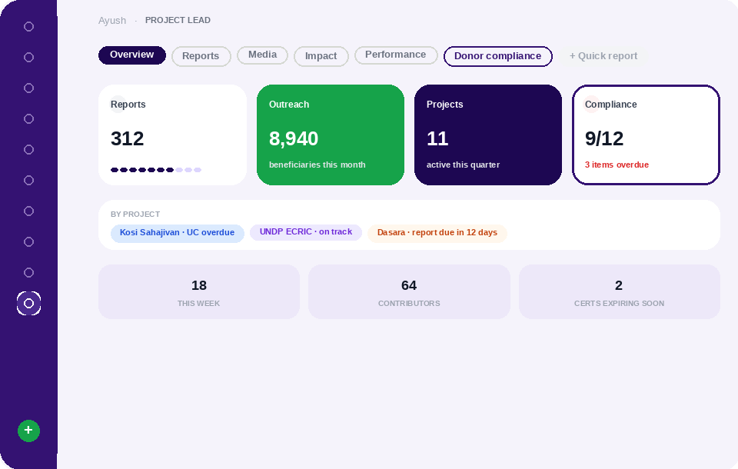
Fig 1 -- Overview page: existing Reports, Outreach, and Projects cards alongside a new Compliance card and donor summary panel
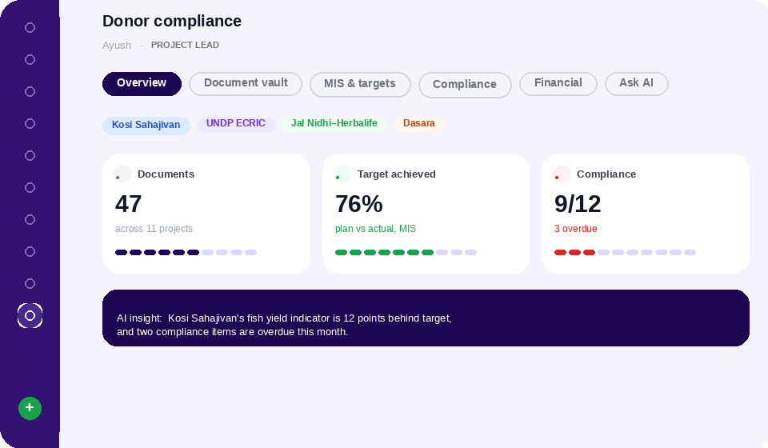
Fig 2 -- Donor compliance section landing view, opened from the new sidebar icon
Four more screens in the same style -- document vault, MIS and targets, compliance calendar, and the financial tracker -- are saved alongside this document as PNG files in the donor-compliance-wireframes folder (02 through 05).

7. Related visuals
The architecture diagram showing how the new donor pieces slot into FieldFlow's existing monolith, Postgres, and Cloud Run layers is available in the chat thread alongside this document.

