PETIT MUHARTO KARTODIRDJO + JEREMY ALLAN
ONE MAN AIR FORCE
Bob Freeberg, RI-002, and Indonesia’s Struggle for Freedom
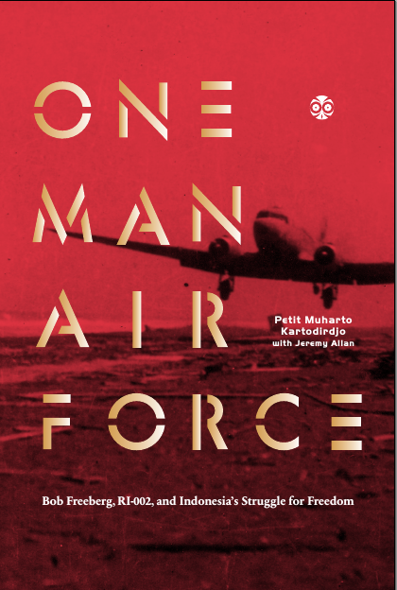
On 30 September 1948, American pilot Bobby Earl Freeberg fired up the twin engines of his war-surplus C-47 cargo airplane, designated RI-002, for a mission to transport 250 kilograms of gold bullion from Java to Sumatra in preparation for an expected Dutch invasion of Indonesian territory. RI-002 then vanished, the wreckage only found 30 years later in the remote Sumatra highlands.
The mysterious disappearance of Bob Freeberg was the final, ironic twist in one of the most dramatic―and least-known―chapters in the story of Indonesia. For sixteen months, Bob Freeberg ran the Dutch blockade, flying in critical supplies such as medicines, and carrying out the diplomats and experts who would make the case for Indonesian independence to the world.
Now, the story of Bob Freeberg is told by the Indonesian who knew him best. Indonesian Air Force Captain Petit Muharto Kartodirdjo flew with Freeberg as official mission leader and (unofficial) copilot, until being promoted and reassigned to headquarters shortly before the tragic final flight. One Man Air Force is the dramatic account of the birth of a nation, of two idealistic young men from opposite ends of the globe forging a close friendship, and a compelling tale of Petit Muharto’s efforts in later life to solve the mystery of his friend’s disappearance.
One Man Air Force was written by Canadian author Jeremy Allan, a long-time resident of Indonesia who has dedicated his career to telling the story of Indonesia, and the stories of Indonesians, in books and publications of global appeal. Working from a manuscript supplied by the family of the late Petit Muharto, Jeremy Allan has told the tale of a dashing young pilot risking his life for an aspiring republic in a story that artfully combines history, revolution, adventure, thrills, and mystery in an exotic tropical setting.
For more information about One Man Air Force please contact: jeremy@jeremyallan.com

