**EVENT SPONSORSHIP PROPOSAL:**

Seminar and book launch :

*One Man Air Force – Bob Freeberg, RI-002, and Indonesia’s Struggle for Freedom,* a book by Petit Muharto Kartodirdjo and Jeremy Allan

Date: 8 November 2018

Venue: TBD

**Event Description:**

As part of its 35th anniversary celebrations this year, The Jakarta Post is organizing this half-day event for book launching, a panel discussion and book signing.

“One Man Air Force” is about the adventures of Bob Freeberg, an American aviator who piloted his war-surplus C-47 transport plane to break the Dutch tight blockade during the early years of Indonesia’s independence struggle. In the book, Air Force Major Petit Muharto Kartodirdjo, his Indonesian co-pilot, tells the story of Freeberg’s forgotten and unappreciated historical contribution to that struggle, undertaking huge risks as he flew what became the Indonesian Air Force’s first plane, shuttling Republican leaders, troops and essential goods between 1947 and 1948.

Muharto passed away in 2000, leaving an unfinished, but largely complete, first draft of his manuscript. A decade later, Canadian journalist friend Jeremy Allan was invited to work with Eko Muhatma, Muharto’s son, to finish the book. For more details on the book, please see the enclosed flyer.

The seminar features Jeremy Allan talking about the book and the writing process, Eko Muhatma discussing his father’s role in Indonesian history, and and a senior Indonesian journalist/scholar reviewing the book. The discussion presents a noted historian, an active/retired senior Indonesian Air Force officer, and a journalist/columnist. Allan will sign copies of the books.

**Audience:**

By invitation, up to 200 people . Scholars/researchers of history, military and international relations, active/retired military officers, diplomats, government officials, journalists, book publishers, business people and avid book readers.

**Introduction to One Man Air Force**

The United States played a major role in supporting Indonesia's struggle for independence. Indonesia's founders consciously modeled themselves after George Washington, Thomas Jefferson, and other American counterparts, and American representatives championed the formation of the three-member commission charged with resolving the dispute between the Republican government and the Netherlands.

Another notable American contribution is largely forgotten. While statesmen debated in the halls of diplomacy, a lone American aviator ran the Dutch blockade in a ramshackle war-surplus C-47 proudly emblazoned with the first Indonesian aircraft identification number: RI-002. From June 1947 to September 1948, Bob Freeberg, a veteran Navy pilot from Kansas, dodged Dutch air patrols to fly from Jogjakarta and Bukittinggi to neighboring nations, hauling cargoes to trade for essential items such as medicine -- and, crucially, transporting diplomats tasked with making their nation's case for self-determination on the global stage. Freeberg's contribution to founding the Indonesian nation came to an abrupt end in October 1948, when RI-002 disappeared into the mountains of southern Sumatra while transporting a cargo of Republican gold. With few resources and under constant Dutch harassment, the government could not search the rugged highlands for the wreckage. As the Indonesians devoted their time and resources to completing their struggle for independence, RI-002, and Bob Freeberg, was left to rest on a remote mountainside.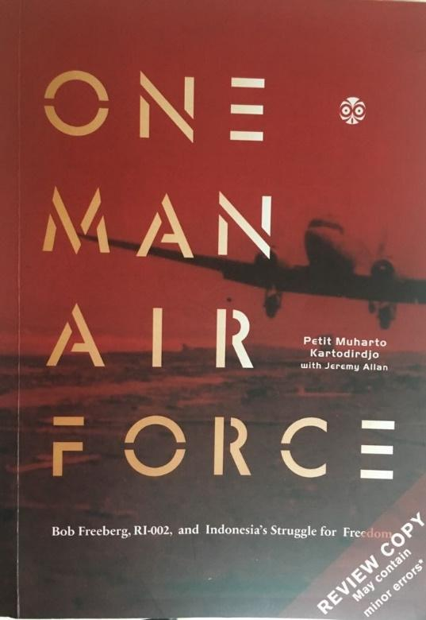

Forty years later, Jeremy Allan, a Canadian author resident in Indonesia, interviewed retired Indonesian Air Force Major Petit Muharto Kartodirdjo, Freeberg's co-pilot for most missions of RI-002, as part of a series on Indonesian aviation history for The Jakarta Post. Muharto showed the resulting article to colleagues and acquaintances, and was appalled to discover that few were aware of Bob Freeberg's immense contribution to the Indonesian nation. Muharto devoted the remaining years of his life to investigating the mystery of the last flight of RI-002 as a tribute to his friend and, in his view, a hero of his nation.

Muharto recorded the results of his investigations in an English-language manuscript he finished in 1997. But because of the 1998 Asian Financial Crisis, followed by Muharto's ill health and death in 2000, the manuscript was never published. A decade later, a chance encounter between Jeremy Allan and Muharto's son resulted in an agreement to rework the manuscript into a form more appealing to the modern reading public. The dry investigative report was transformed into “One Man Air Force”, a lively, compelling account of two idealistic young men from opposite sides of the world risking their lives to fullfil their dreams.

One Man Air Force will be launched, 70 years after RI-002 crashed into a remote mountainside. This event will occur at a pivotal time, as Indonesia, America, and the Netherlands rediscover and reassess their shared history. This inspiring tale of blockade-running adventure is a timely reminder that the contributions of foreigners were essential to the formation of the modern nation.