**Constructor and destructor**

1. Write a c++ program to create a class for a bank account with a constructor and a destructor

#include<iostream>

using namespace std;

class BankAccount {

string accountHolder;

double balance;

public:

BankAccount(string holder, double initialBalance) {

accountHolder = holder;

balance = initialBalance;

cout << "BankAccount created for " << accountHolder << " with balance " << balance << endl;

}

~BankAccount() {

cout << "BankAccount for " << accountHolder << " is being closed." << endl;

}

};

int main() {

BankAccount account("Prudhvi", 5000.0);

return 0;

}

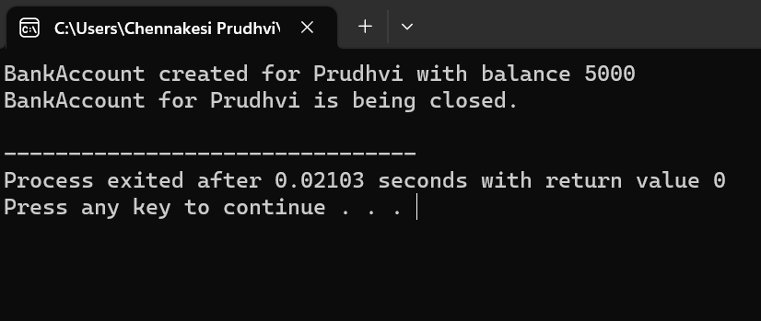

1. Write a c++ program to create a class for a car with a constructor and a destructor

#include<iostream>

using namespace std;

class Car {

string brand;

string model;

public:

Car(string b, string m) {

brand = b;

model = m;

cout << "Car " << brand << " " << model << " created." << endl;

}

~Car() {

cout << "Car " << brand << " " << model << " destroyed." << endl;

}

};

int main() {

Car myCar("Toyota", "Camry");

return 0;

}

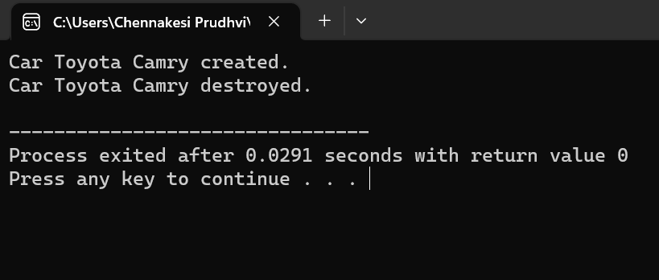

1. Write a c++ program to create a class for a rectangle with a constructor and a destructor

#include<iostream>

using namespace std;

class Rectangle {

double length;

double width;

public:

Rectangle(double l, double w) {

length = l;

width = w;

cout << "Rectangle created with length " << length << " and width " << width << endl;

}

~Rectangle() {

cout << "Rectangle destroyed." << endl;

}

double area() {

return length * width;

}

};

int main() {

Rectangle rect(5.0, 3.0);

cout << "Area of the rectangle: " << rect.area() << endl;

return 0;

}

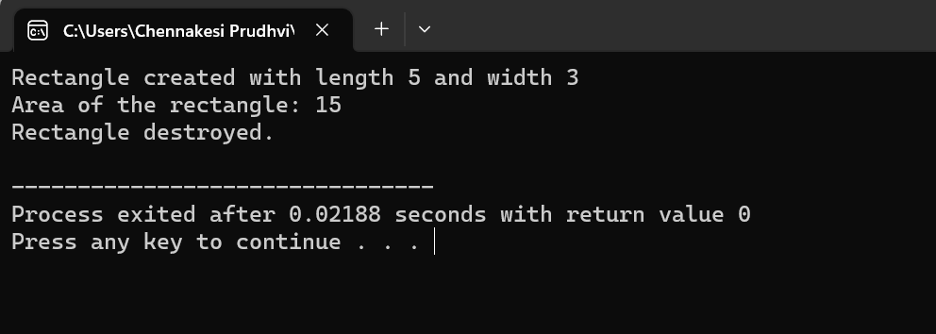

1. Write a c++ program to create a class for a book with a constructor and a destructor

#include<iostream>

using namespace std;

class Book {

string title;

string author;

public:

Book(string t, string a) {

title = t;

author = a;

cout << "Book \"" << title << "\" by " << author << " created." << endl;

}

~Book() {

cout << "Book \"" << title << "\" destroyed." << endl;

}

};

int main() {

Book myBook("1984", "George Orwell");

return 0;

}

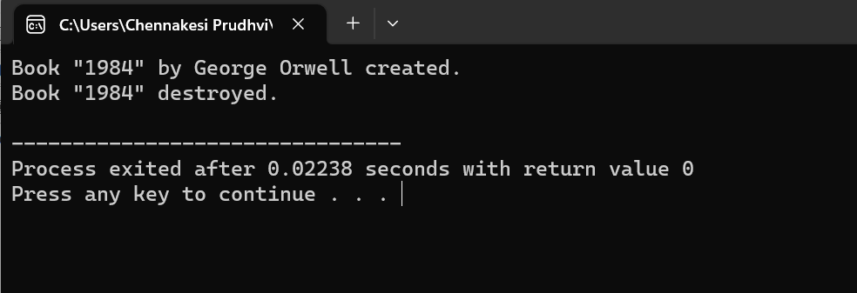

1. Write a c++ program to create a class for student with a constructor and a destructor

#include<iostream>

using namespace std;

class Student {

string name;

int age;

public:

Student(string n, int a) {

name = n;

age = a;

cout << "Student " << name << " of age " << age << " created." << endl;

}

~Student() {

cout << "Student " << name << " destroyed." << endl;

}

};

int main() {

Student student1("John", 20);

return 0;

}

