Deployment of Web Application to Azure App Services
Step-by-Step Guide with Screenshots

Step 1: Create a Web App in Azure Portal
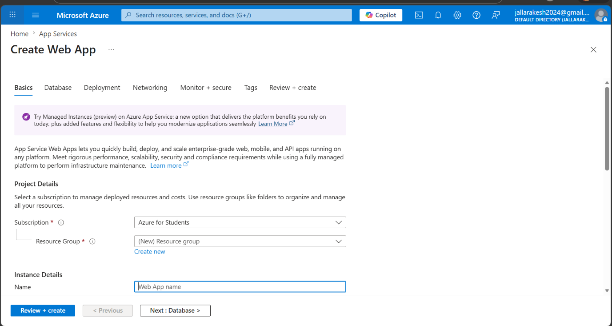
What to do on this screen:
- Go to portal.azure.com and search for "App Services" in the top search bar.
- Click "Create" to open the Create Web App wizard.
- Under "Subscription", select your subscription (e.g., Azure for Students).
- Under "Resource Group", click "Create new" and give it a name, or select an existing one.
- Under "Name" in Instance Details, type your Web App name (e.g., web-1). This becomes your URL: web-1.azurewebsites.net.
Note: The name must be globally unique across all Azure accounts.

Step 2: Verify the Web App is Running
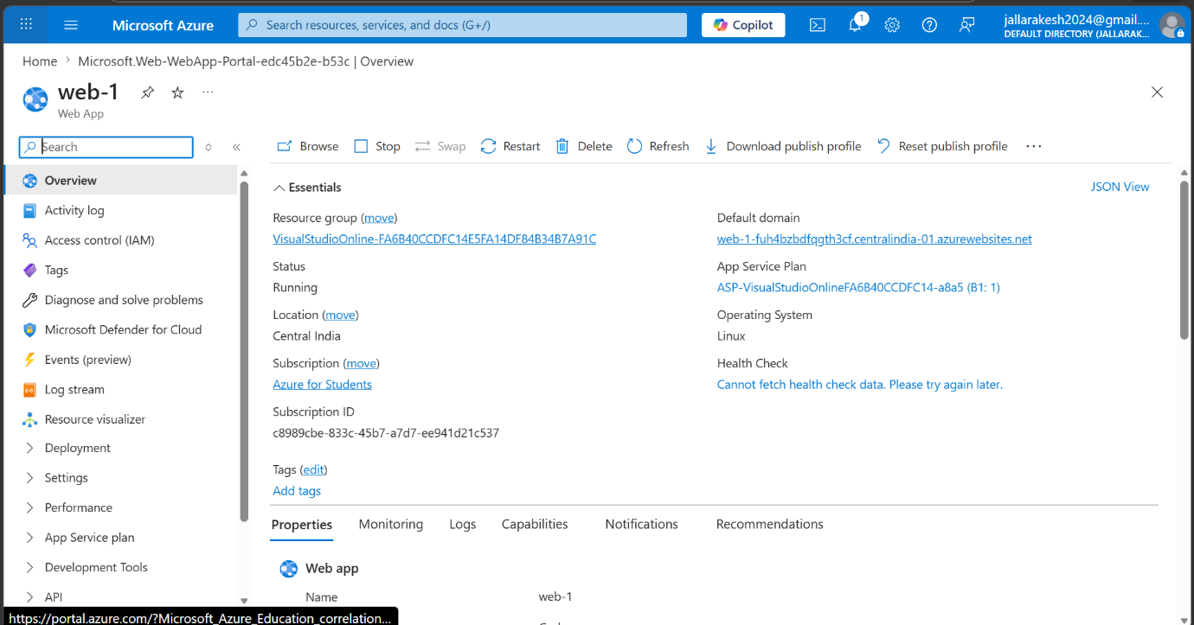
What to do on this screen:
- After creation, you will be taken to the Web App Overview page.
- Verify the Status field shows "Running".
- Note down the Default Domain URL (e.g., web-1-fuh4bzbdfqgth3cf.centralindia-01.azurewebsites.net). This is where your app will be accessible.
- The Operating System should show "Linux" and Region should match what you selected during creation.
Note: If Status is not Running, click Restart in the top toolbar.

Step 3: Open Azure DevOps and Navigate to Repos
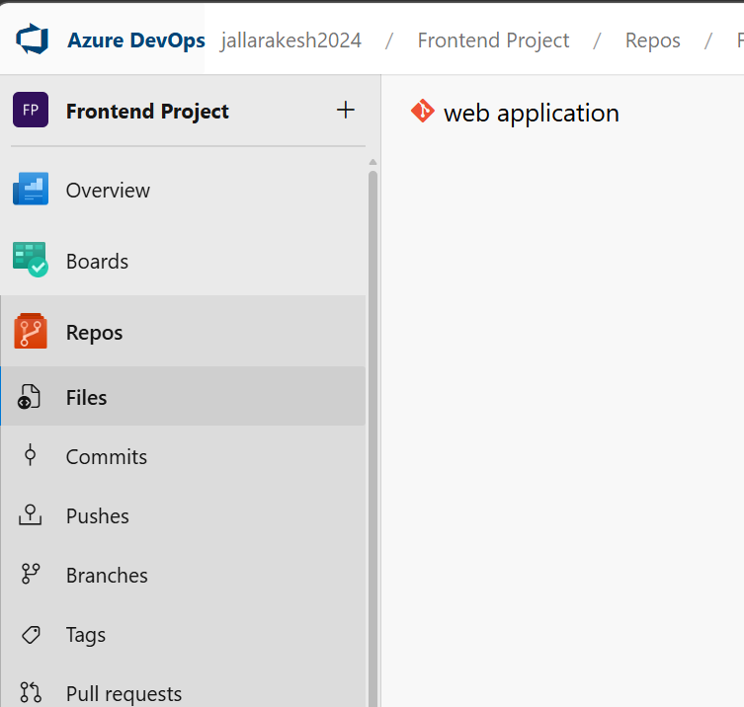
What to do on this screen:
- Go to dev.azure.com and open your Organization (e.g., jallarakesh2024).
- Open your Project (e.g., Frontend Project).
- In the left sidebar, click "Repos" to expand the repository section.
- Click "Files" under Repos to see your repository.
- You should see your repository listed on the right (e.g., "web application").
Note: If no repository exists yet, click "Initialize" to create one.

Step 4: View the Empty Repository
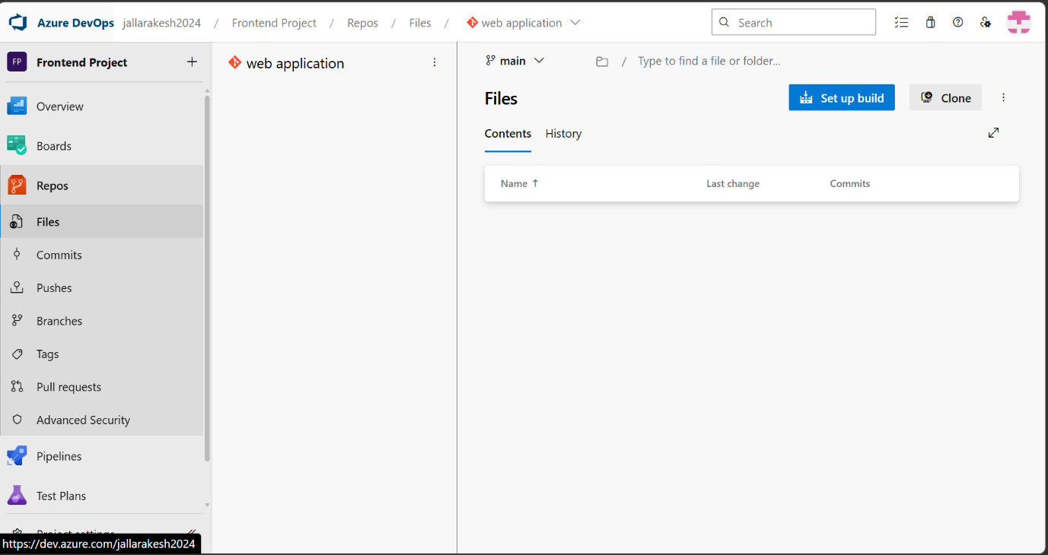
What to do on this screen:
- You are now inside the "web application" repository under the "main" branch.
- The Files tab is selected and the repo is currently empty (no files yet).
- You will push your local project files here using Git in the next steps.
- Note the "Set up build" button at the top right — you will use this later to create your pipeline.
Note: Copy the Clone URL by clicking the "Clone" button — you will need it to link your local project.

Step 5: Push Your Code from VS Code
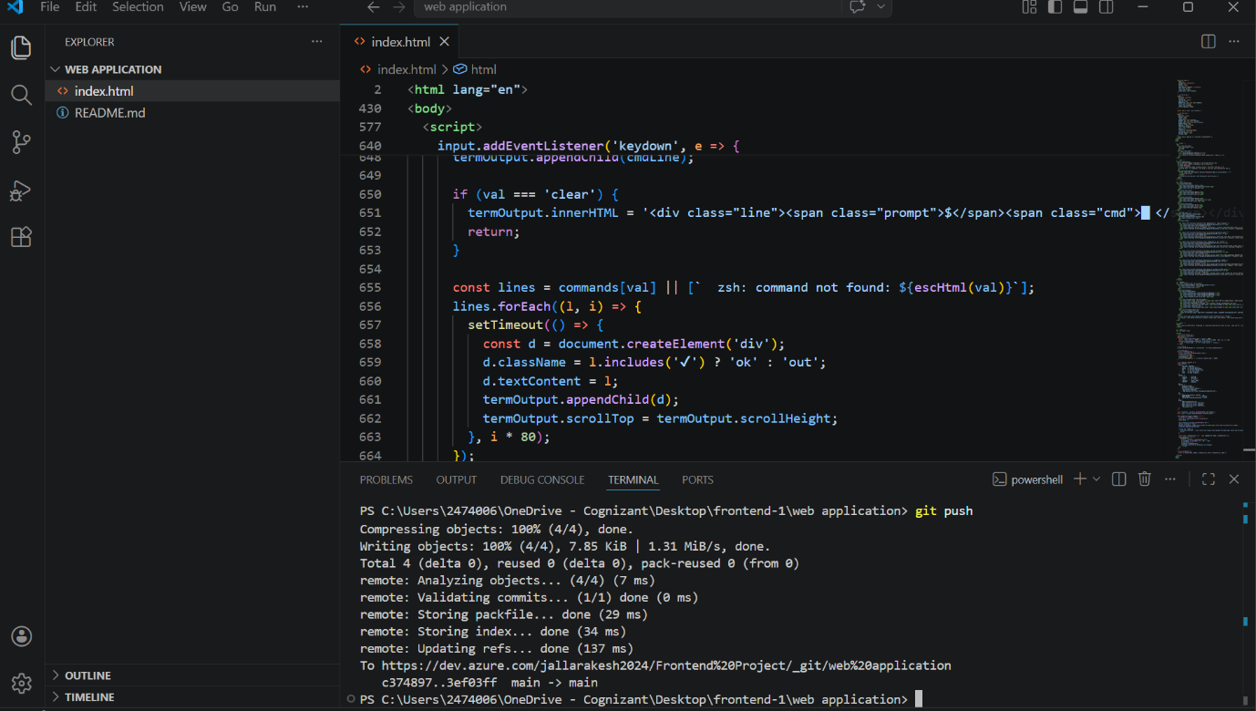
What to do on this screen:
- Open your project folder in VS Code (index.html and README.md should be present).
- Open the integrated terminal in VS Code (View > Terminal or Ctrl+`).
- Run the following commands to push your code to Azure DevOps:
git add .
git commit -m "V1"
git push
- The terminal should confirm the push with a message showing objects written and refs updated.
Note: If prompted for credentials, sign in with your Azure DevOps account.

Step 6: Confirm Files Appear in Azure DevOps Repo
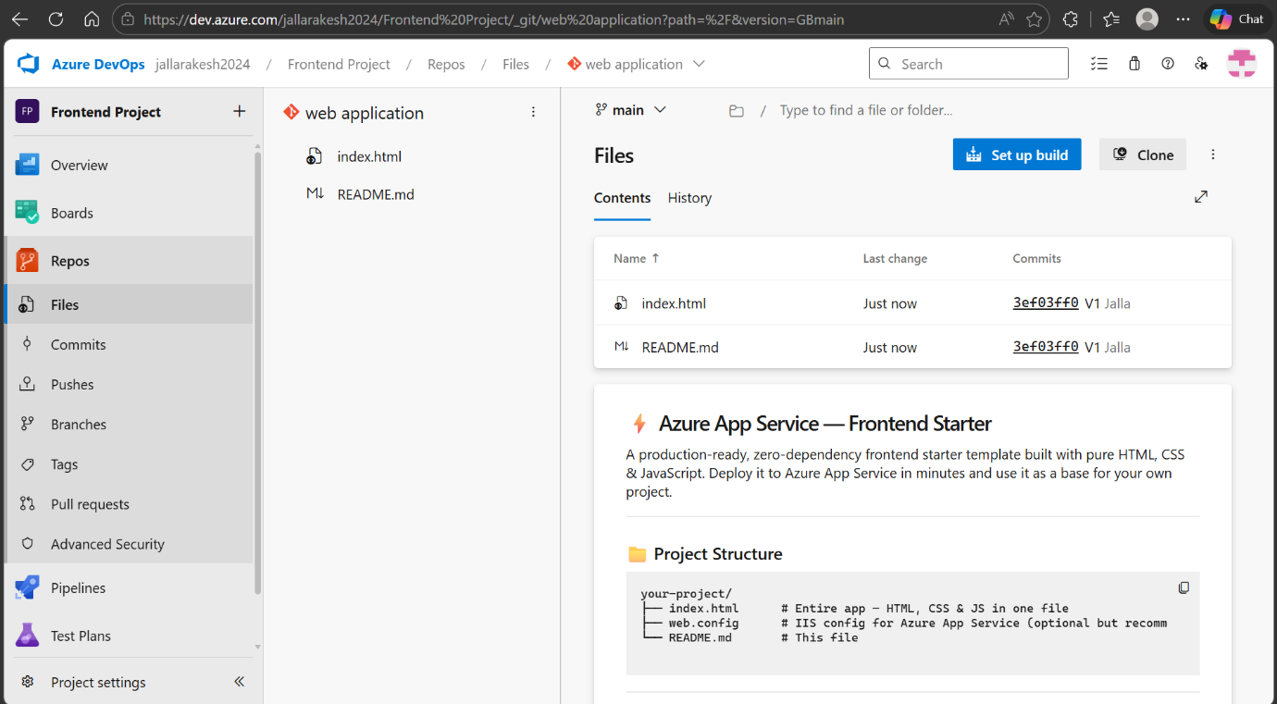
What to do on this screen:
- Go back to Azure DevOps > Repos > Files.
- You should now see "index.html" and "README.md" listed under the main branch.
- The Last change column should show "Just now" confirming the push was successful.
- The README.md preview is shown at the bottom of the page.
Note: Click on index.html to verify its contents are correct before creating the pipeline.

Step 7: Create a New Service Connection
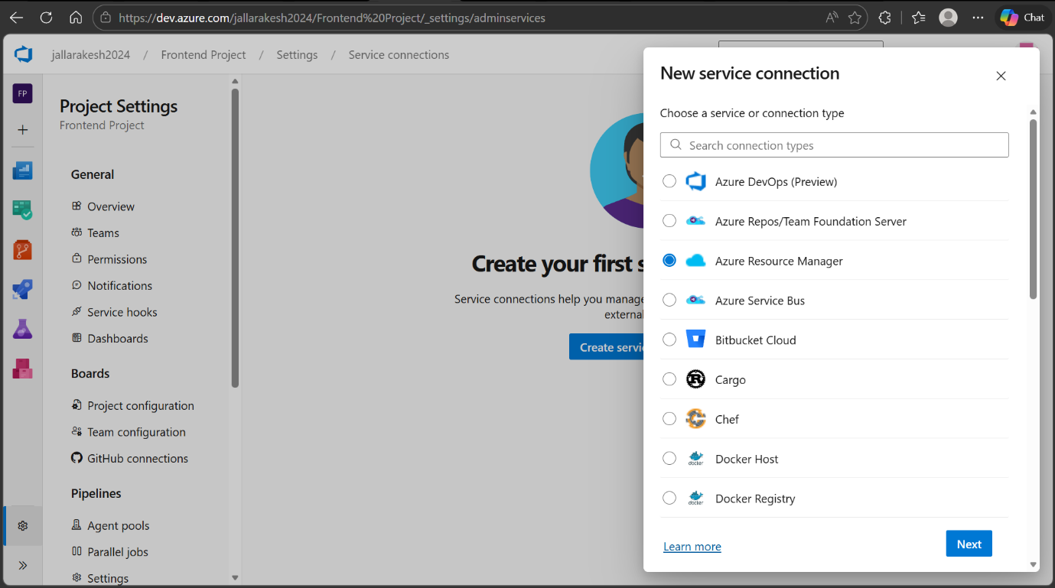
What to do on this screen:
- Go to Project Settings (bottom-left gear icon) > Service connections.
- Click "Create service connection" or "New service connection".
- A panel slides in showing connection types. Select "Azure Resource Manager".
- Click "Next" to proceed to the configuration screen.
Note: Azure Resource Manager is the correct type for connecting to Azure App Service.

Step 8: Configure the Service Connection
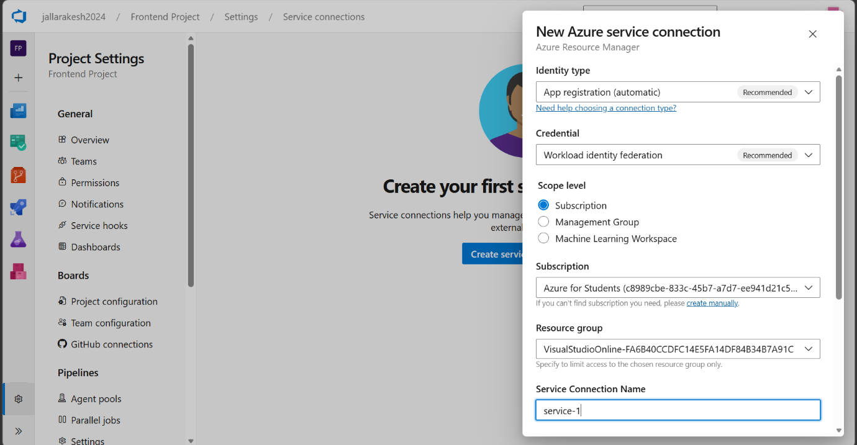
What to do on this screen:
- Identity type: leave as "App registration (automatic)" (Recommended).
- Credential: leave as "Workload identity federation" (Recommended).
- Scope level: select "Subscription".
- Subscription: select your Azure subscription from the dropdown (e.g., Azure for Students).
- Resource group: select the resource group where your web-1 app lives.
- Service Connection Name: type "service-1" (this is the name referenced in your YAML pipeline).
- Click "Save" to create the connection.
Note: Make sure to name it exactly "service-1" so it matches the pipeline YAML.

Step 9: Verify Service Connection Created Successfully
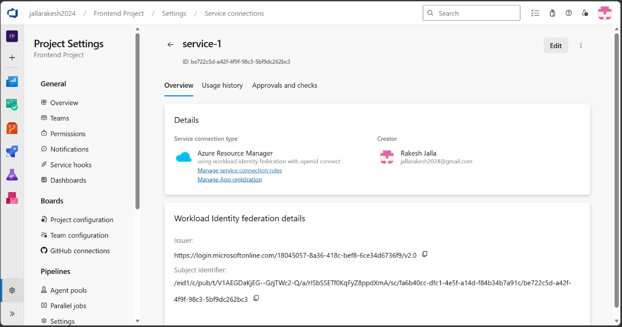
What to do on this screen:
- You are now on the service-1 overview page.
- Confirm the Service connection type shows "Azure Resource Manager using workload identity federation with openid connect".
- The Creator field should show your account name confirming you created it.
- The Workload Identity federation details section shows the Issuer and Subject identifier — these are auto-configured, no action needed.
Note: If the connection shows a warning or error, click "Edit" and re-verify the subscription and resource group.

Step 10: Go to Pipelines and Create First Pipeline
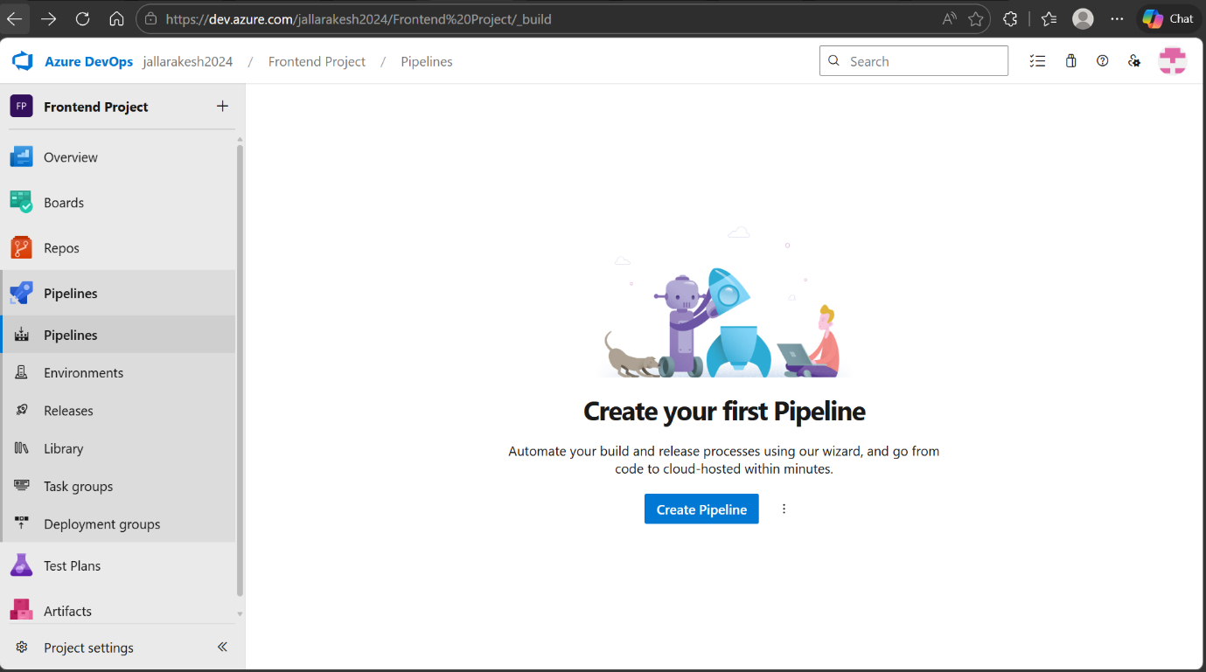
What to do on this screen:
- In the left sidebar, click "Pipelines" then click "Pipelines" again in the sub-menu.
- You will see "Create your first Pipeline" screen since no pipeline exists yet.
- Click the "Create Pipeline" button to start the pipeline creation wizard.
Note: If you already have pipelines, click the "+ New pipeline" button at the top right instead.

Step 11: Select the Repository
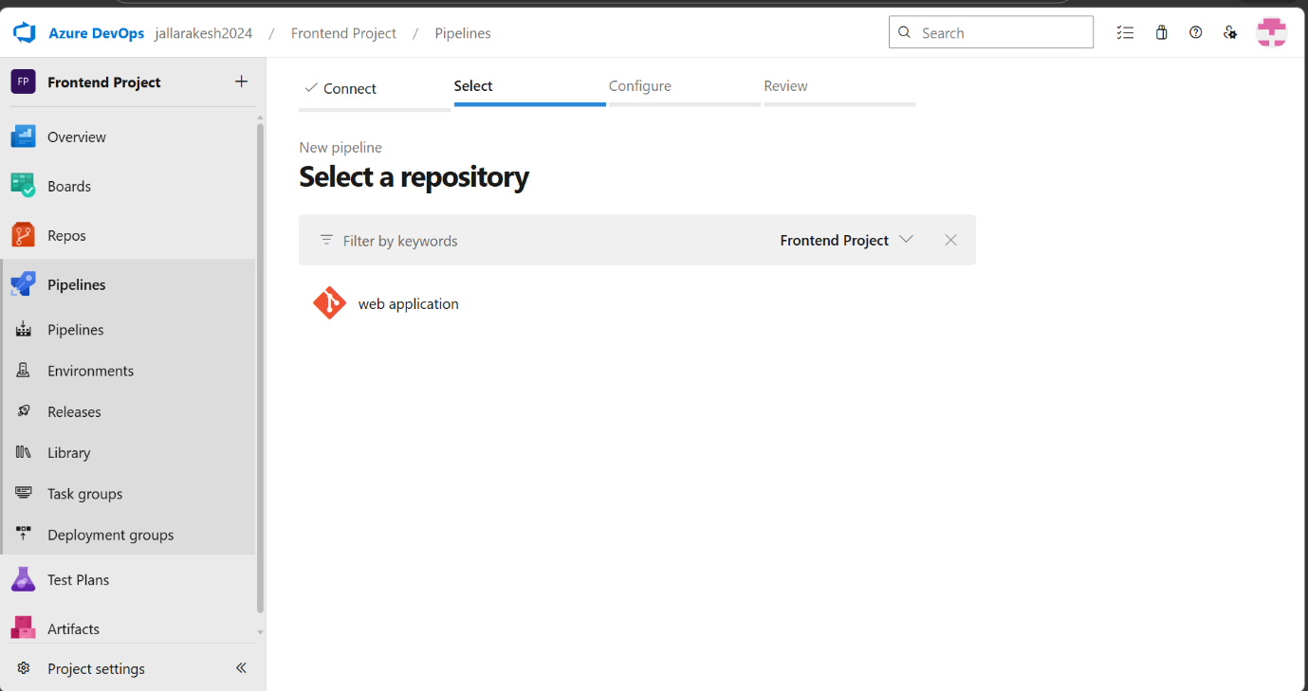
What to do on this screen:
- The wizard shows 4 steps: Connect, Select, Configure, Review.
- You are on the "Select" step.
- Click on "web application" (your repository) from the list to select it.
- This tells the pipeline which repo to monitor for code changes.
Note: If you have multiple repositories, use the "Filter by keywords" box to find yours.

Step 12: Review and Save the Pipeline YAML
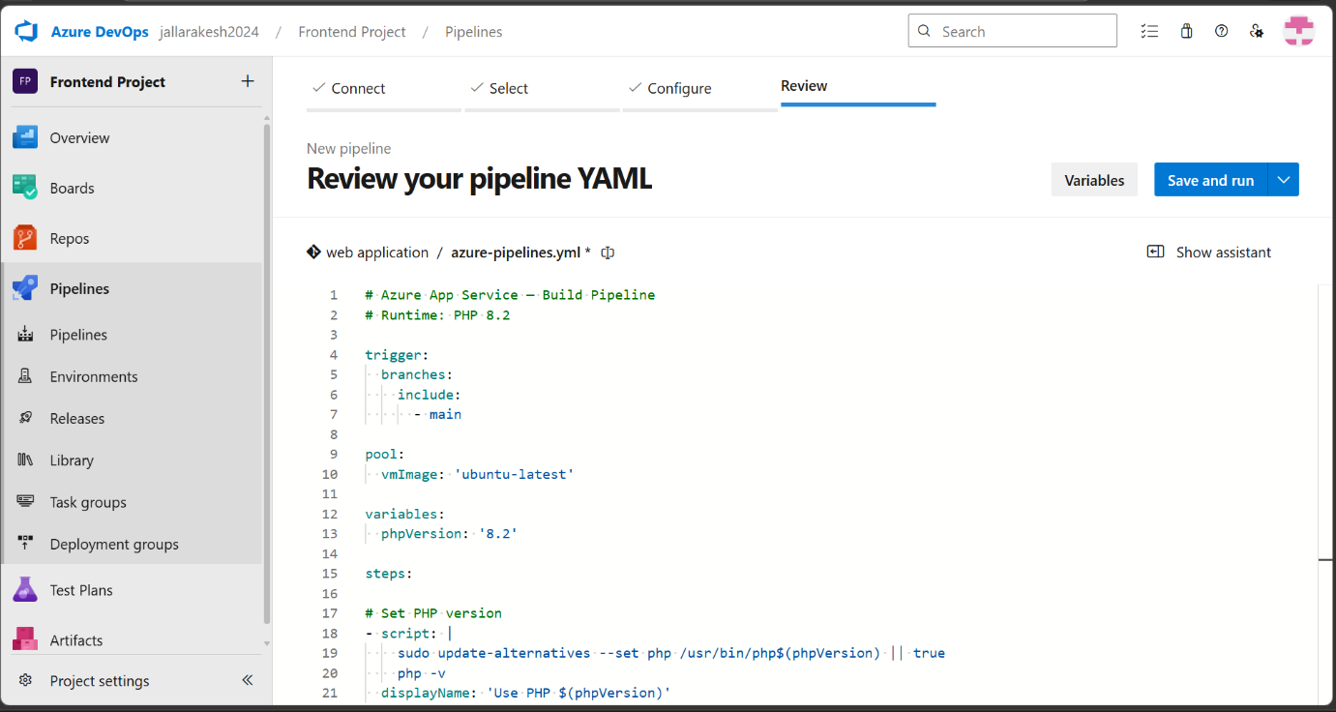
What to do on this screen:
- You are on the "Review" step showing the azure-pipelines.yml file.
- Replace the default YAML content with the Build Pipeline YAML provided (PHP 8.2 build with ArchiveFiles and PublishBuildArtifacts tasks).
- Review the YAML to confirm trigger is set to "main", phpVersion is "8.2", and the artifact name is "drop".
- Click "Save and run" to commit the YAML file to your repository and trigger the first build.
Note: The YAML file will be committed as azure-pipelines.yml in the root of your repo.

Step 13: Verify the Build Succeeds
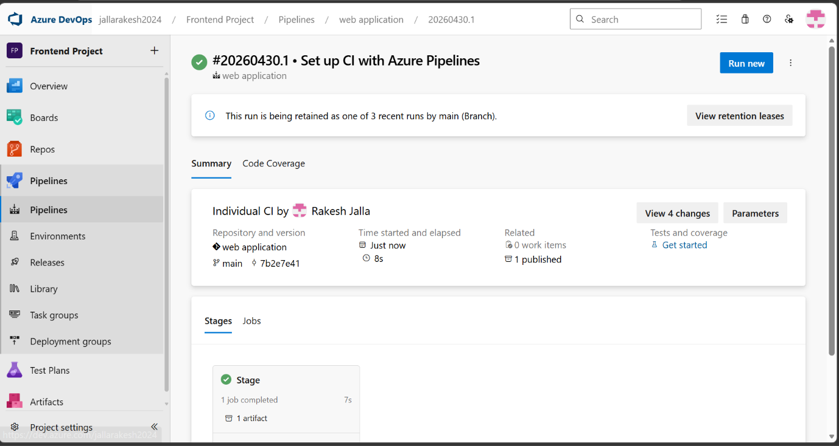
What to do on this screen:
- After saving, the pipeline runs automatically. Wait for it to complete.
- You should see a green checkmark with the build number (e.g., #20260430.1).
- The Stage section shows "1 job completed" and "1 artifact" published.
- The elapsed time should be around 7-8 seconds for this simple project.
- Click on "1 artifact" to verify the drop zip was published correctly.
Note: If the build fails, click on the failed job to read the error log and fix accordingly.

Step 14: Navigate to Releases and Create New Pipeline
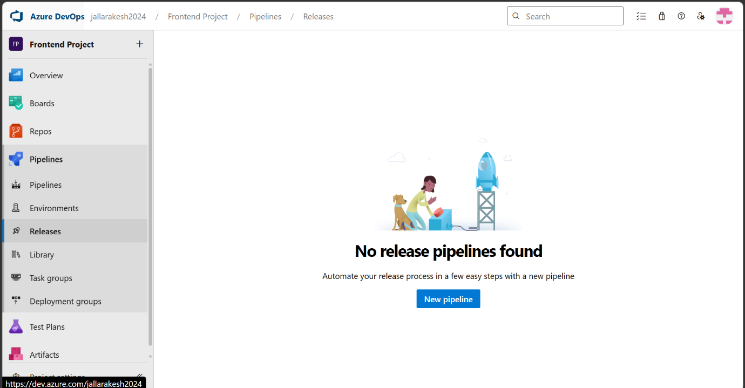
What to do on this screen:
- In the left sidebar under Pipelines, click "Releases".
- You will see "No release pipelines found" since none exist yet.
- Click the "New pipeline" button to start creating your release pipeline.
Note: The Release pipeline is separate from the Build pipeline. Build compiles/packages the code; Release deploys it to Azure.

Step 15: Configure the Release Stage with Azure App Service
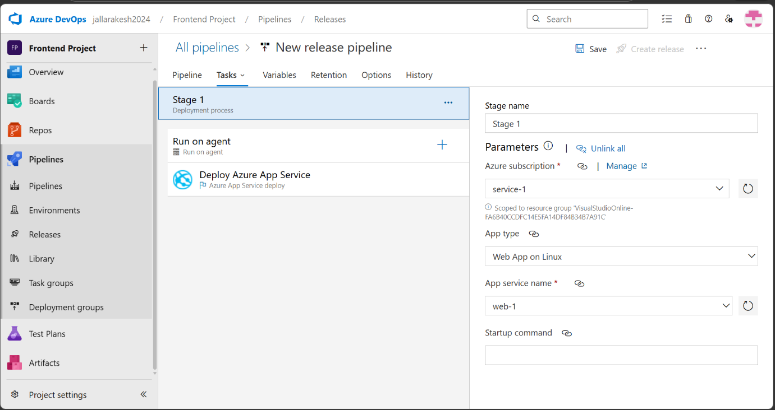
What to do on this screen:
- A template selector appears. Choose "Azure App Service deployment" and click Apply, or start with an Empty job.
- You are now on the Tasks tab for Stage 1.
- Click on "Deploy Azure App Service" task to configure it on the right panel.
- Azure subscription: select "service-1" from the dropdown.
- App type: select "Web App on Linux".
- App service name: select "web-1" from the dropdown.
- Leave Startup command blank for a static HTML app.
Note: If web-1 does not appear in the dropdown, click the refresh icon next to the App service name field.

Step 16: Add Artifact and Enable CD Trigger
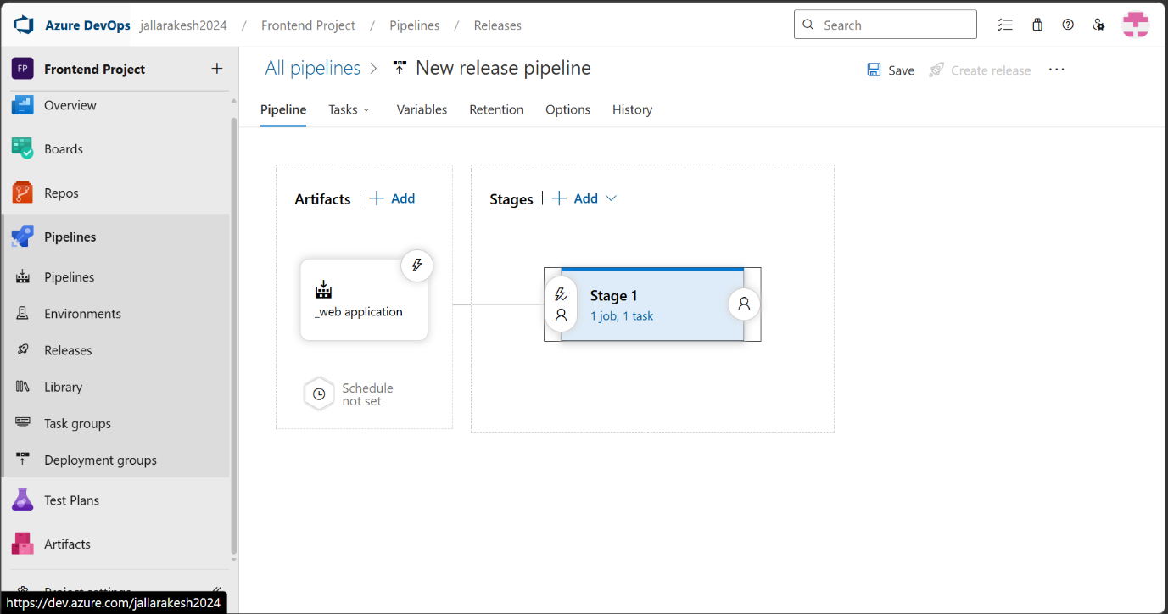
What to do on this screen:
- Click on the "Pipeline" tab at the top to see the Artifacts and Stages canvas.
- Click "+ Add" under Artifacts to link your build pipeline.
- Select your build pipeline ("web application") and set the default version to "Latest".
- Click Add to save the artifact source.
- You should now see the "_web application" artifact box connected to Stage 1 on the canvas.
Note: The artifact is what gets deployed — it is the zip file created by the Build pipeline.

Step 17: Enable Continuous Deployment Trigger
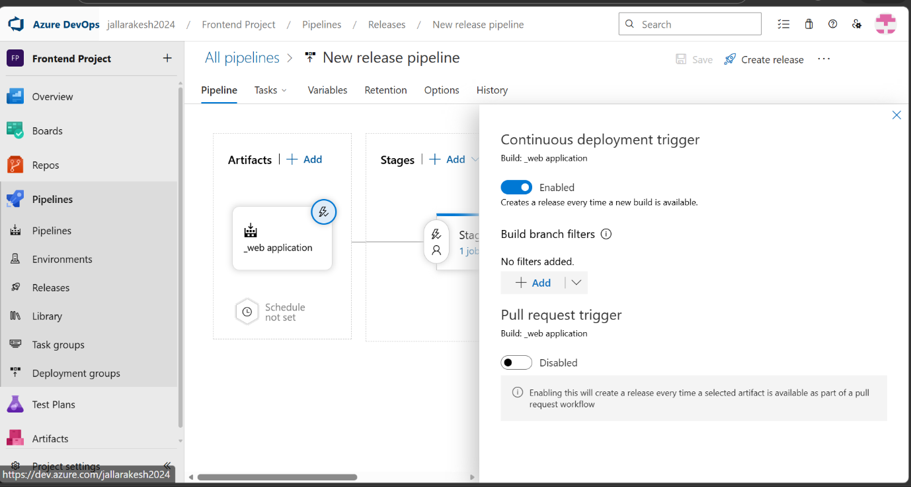
What to do on this screen:
- On the Pipeline canvas, click the lightning bolt (⚡) icon on the top-right of the artifact box.
- A panel slides in showing "Continuous deployment trigger".
- Toggle the switch to "Enabled". It should turn blue.
- This means every time a new build artifact is produced, a release is automatically created and deployed.
- Leave Pull request trigger as Disabled.
- Click the X to close the panel, then click "Save" at the top.
Note: This is the key step that enables full CI/CD — build triggers on code push, and release triggers on build completion.

Step 18: Confirm Releases are Deploying Automatically
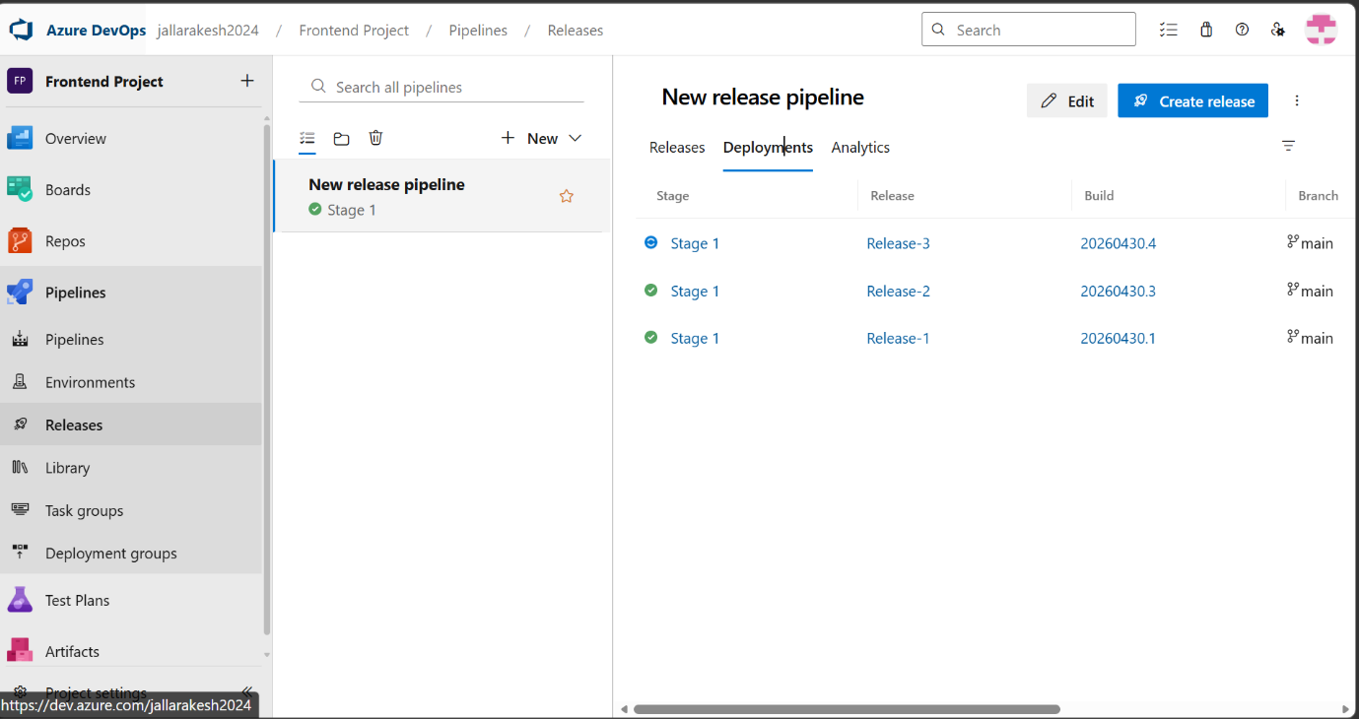
What to do on this screen:
- Go back to Pipelines > Releases and click on your release pipeline.
- Click the "Deployments" tab to see deployment history.
- You should see multiple successful releases (Release-1, Release-2, Release-3) each linked to a build number.
- Each row shows Stage 1 completed (green checkmark), the Release name, Build number, and Branch (main).
Note: If you make a code change and push to main, a new row should appear here automatically within seconds.

Step 19: Verify the Live Application on Azure
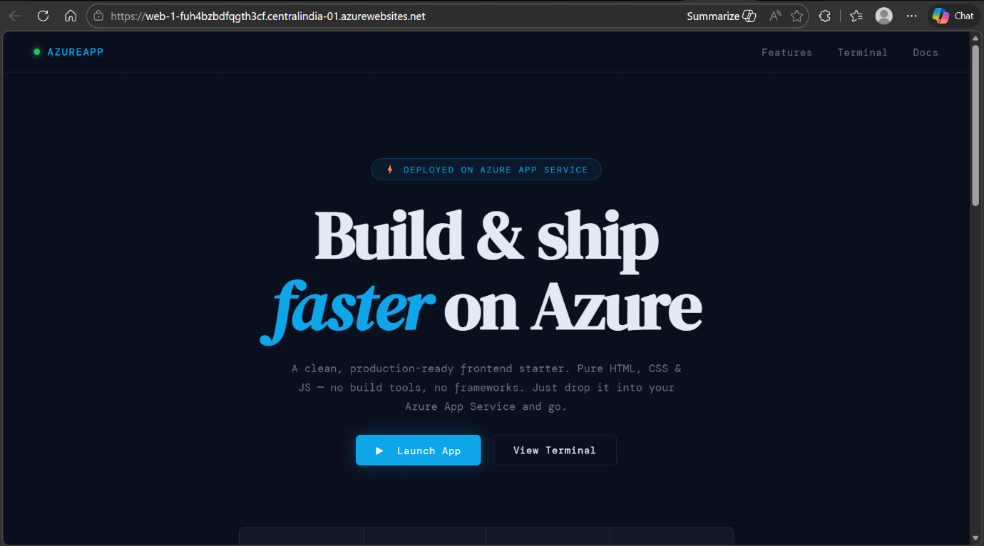
What to do on this screen:
- Open a browser and navigate to your Azure Web App URL (e.g., https://web-1-fuh4bzbdfqgth3cf.centralindia-01.azurewebsites.net).
- You should see the deployed frontend application loading — the dark-themed "Build & ship faster on Azure" page.
- Test the navigation links (Features, Terminal, Docs) to confirm they work.
- Try clicking "Launch App" and typing commands in the terminal widget to verify JavaScript is running.
- The green pulsing dot in the top-left navbar confirms the app is live.
Note: If you see a default Azure page or 404, wait 1-2 minutes for the deployment to propagate, then refresh.

Deployment Complete!
Your web application is now live on Azure App Service with full CI/CD automation.

