Planning and Implementation of Azure SQL Database
Step-by-Step Guide with Screenshots
Step 1: Create SQL Database — Project Details
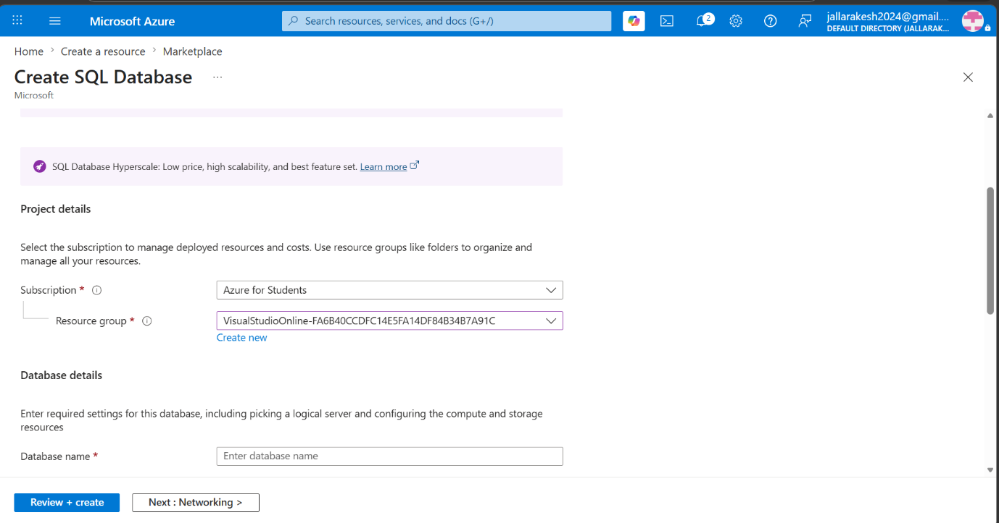
What to do on this screen:
- Go to portal.azure.com → Search "Azure SQL" → Click "Create".
- Select "SQL databases" → Resource type: "Single database" → Click "Create".
- Under Subscription, select "Azure for Students".
- Under Resource Group, select an existing one or click "Create new" and name it.
- Under Database name, type mydb in the text box.
- Click "Next: Networking" or scroll down to configure the server.
Note: The database name must be unique within the selected SQL Server.

Step 2: Enter Database Name and Create New Server
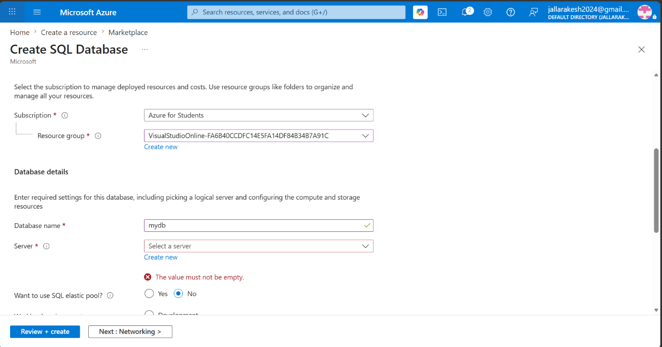
What to do on this screen:
- The Database name field now shows "mydb" filled in correctly.
- Under Server, click "Create new" to open the Create SQL Database Server panel.
- SQL elastic pool: select "No".
- Workload environment: select "Development" for a learning/test setup.
Note: Do not click "Review + create" yet — you must first create the server by clicking "Create new" under the Server field.

Step 3: Configure the SQL Server
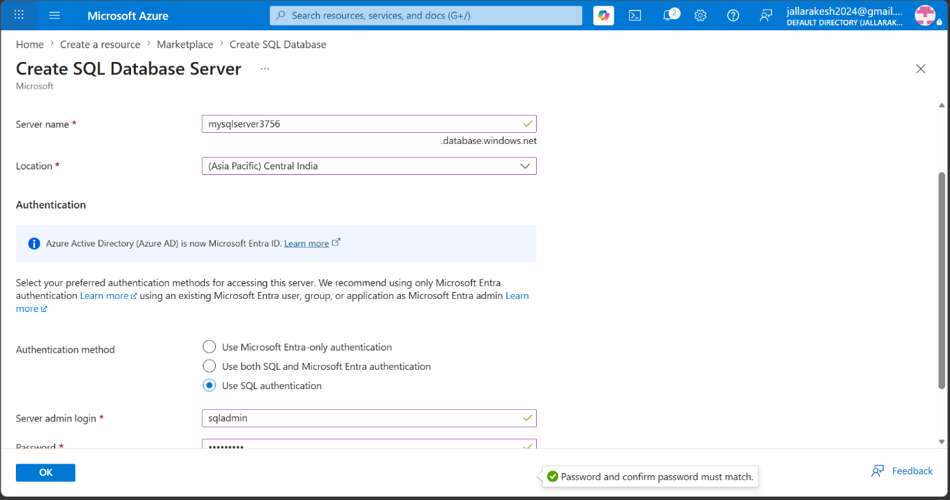
What to do on this screen:
- Server name: type mysqlserver3756 — this becomes your connection URL: mysqlserver3756.database.windows.net.
- Location: select "(Asia Pacific) Central India" or the region closest to you.
- Authentication method: select "Use SQL authentication".
- Server admin login: type sqladmin.
- Password: type a strong password (min 8 chars, uppercase, number, symbol).
- Confirm password: retype the same password.
- Click "OK" to save the server configuration.
Note: Save your admin login and password somewhere safe — you will need them to connect to the database and they will be stored in Key Vault later.

Step 4: SQL Database Created Successfully
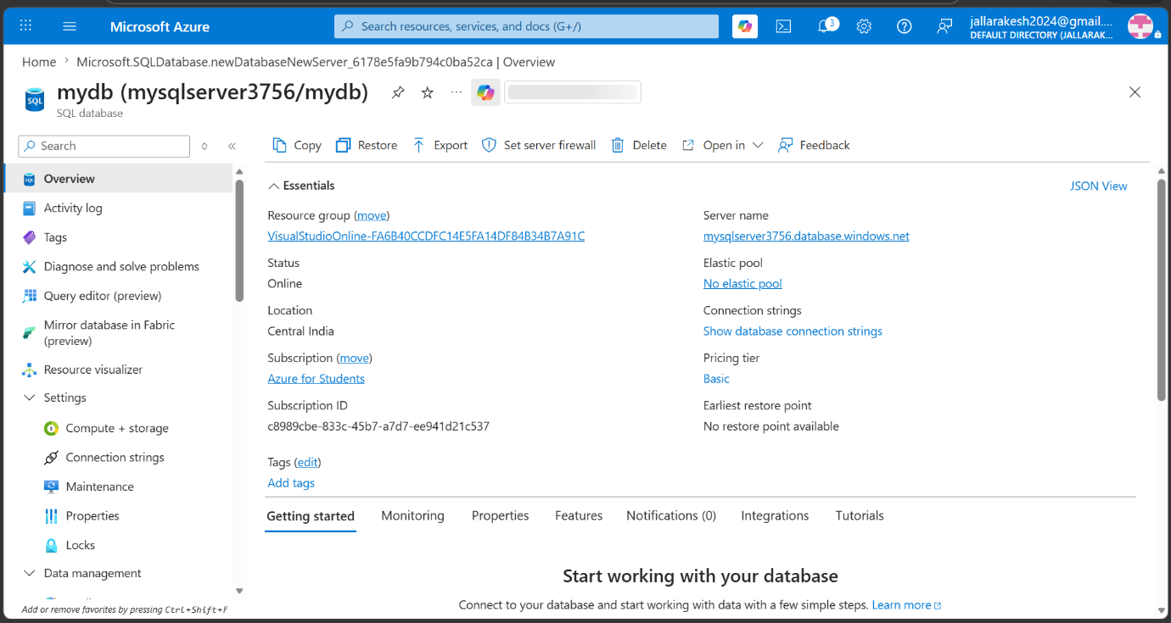
What to do on this screen:
- You are now on the Overview page of your newly created database mydb.
- Verify Status shows "Online" — confirming the database is running.
- Note the Server name: mysqlserver3756.database.windows.net — you will need this in the pipeline configuration.
- Location shows "Central India" and Pricing tier shows "Basic" as configured.
- Click "Query editor (preview)" in the left sidebar to run SQL queries.
Note: If Status shows something other than Online, wait 1-2 minutes and click Refresh.

Step 5: Log in to Query Editor
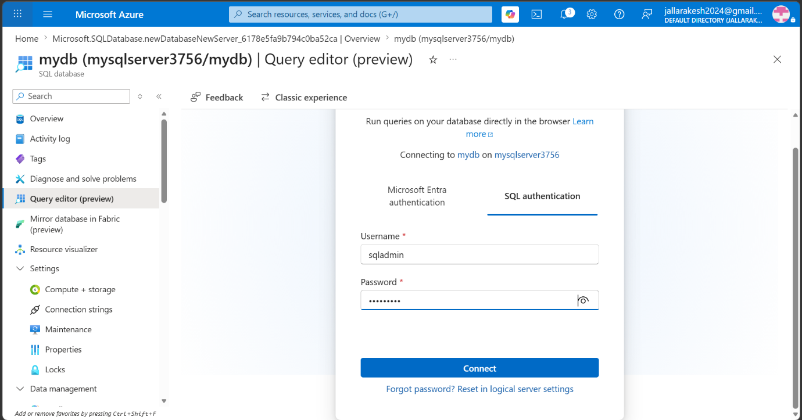
What to do on this screen:
- The Query Editor login screen appears showing "Connecting to mydb on mysqlserver3756".
- Click the "SQL authentication" tab at the top right.
- Username: type sqladmin.
- Password: type your database password.
- Click the "Connect" button.
Note: If you get an IP address error, go back to the SQL Server → Networking → add your current client IP address to the firewall rules, then try again.

Step 6: Query Editor Opened Successfully
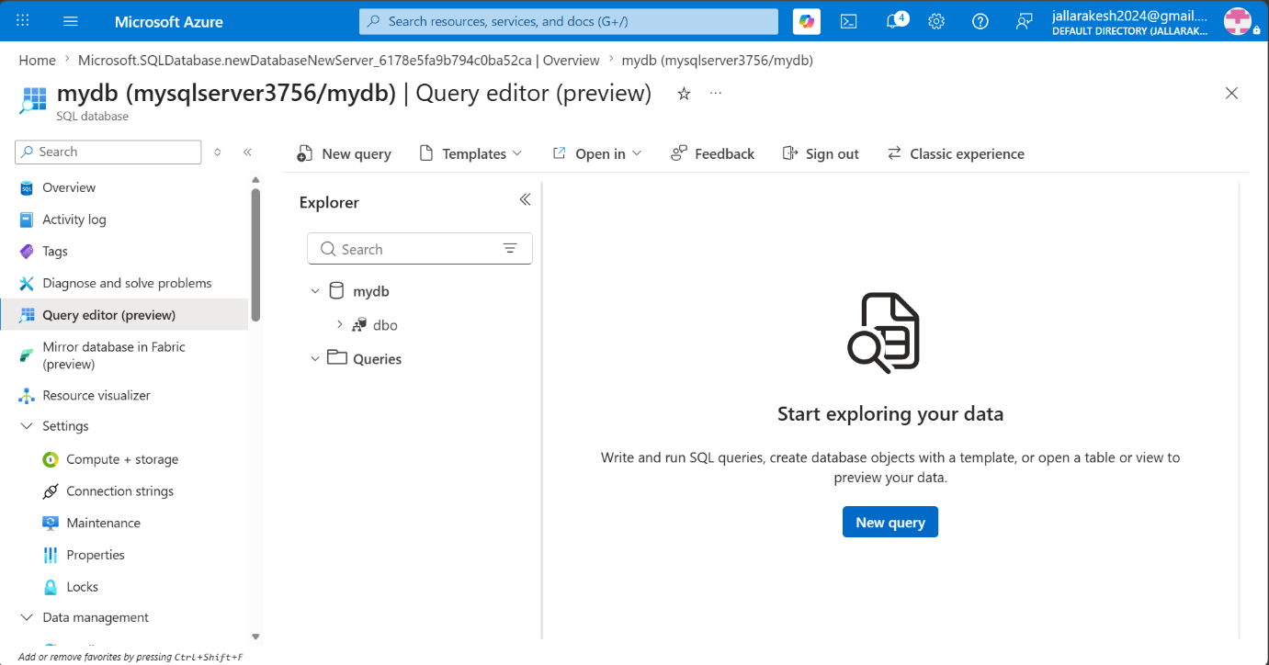
What to do on this screen:
- You are now logged into the Query Editor for mydb.
- The Explorer panel on the left shows the database structure — mydb → dbo → Queries.
- Click "New query" button in the top toolbar to open a blank query window.
- You will now write and run SQL to create tables and insert data.
Note: The Explorer panel will show your tables under dbo → Tables after you create them.

Step 7: Create New Azure DevOps Project
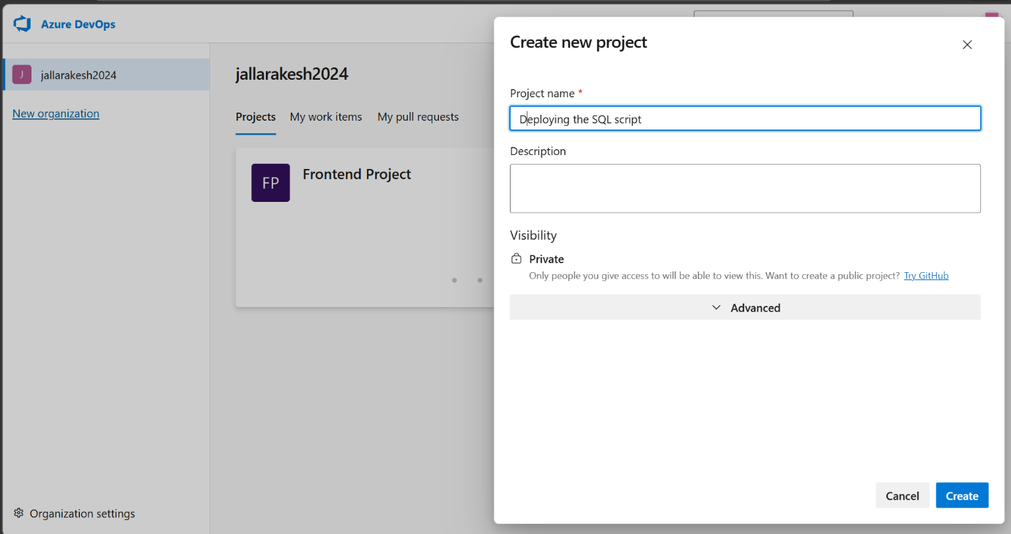
What to do on this screen:
- Go to dev.azure.com and click the "+" icon or "New project" button.
- Project name: type "Deploying the SQL script".
- Visibility: select "Private" so only you can access it.
- Leave Description blank — it is optional.
- Click "Create" to create the project.
Note: This creates a new separate project from your Frontend Project — it will have its own Repos, Pipelines and Library.

Step 8: Create a Repository in the New Project
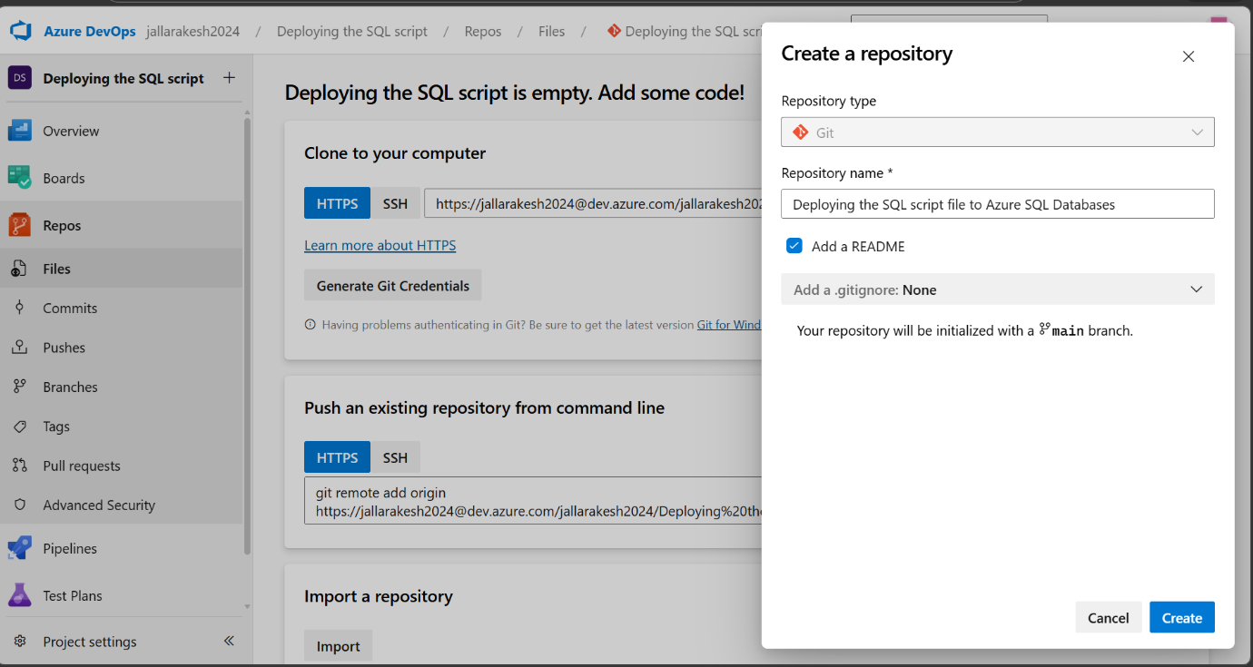
What to do on this screen:
- Your new project is created and the Repos page is empty.
- A "Create a repository" panel appears on the right.
- Repository type: Git (default).
- Repository name: type "Deploying the SQL script file to Azure SQL Databases".
- Check "Add a README" so the repo initializes with a main branch.
- Click "Create" to create the repository.
Note: The repo name becomes part of your clone URL — keep it descriptive but avoid special characters.

Step 9: Clone the Repository to Your Local Machine
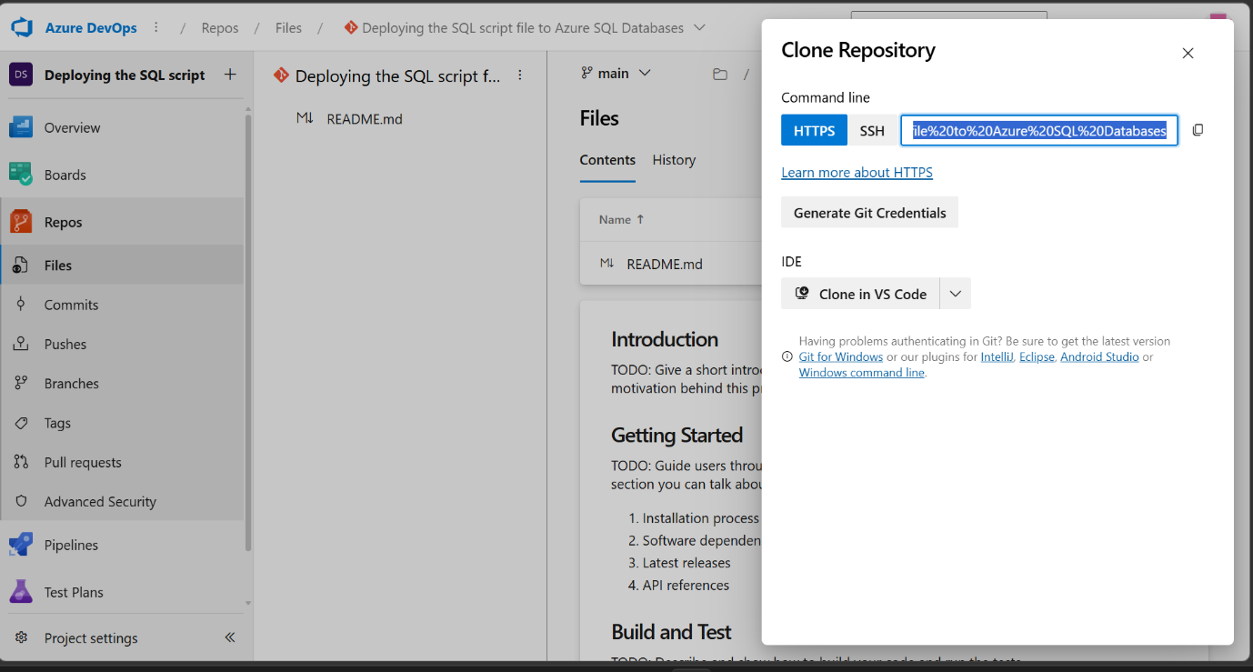
What to do on this screen:
- The repository is created with a README.md file visible in the Files list.
- Click the "Clone" button at the top right to get the clone URL.
- A panel slides open showing the HTTPS clone URL.
- Click the copy icon next to the URL to copy it.
- Open VS Code → Click "Clone Git Repository" → Paste the URL → Choose a folder on your desktop.
- VS Code clones the repo and opens it automatically.
Note: Click "Clone in VS Code" button if you have VS Code installed for a one-click clone experience.

Step 10: Repository Cloned and Opened in VS Code
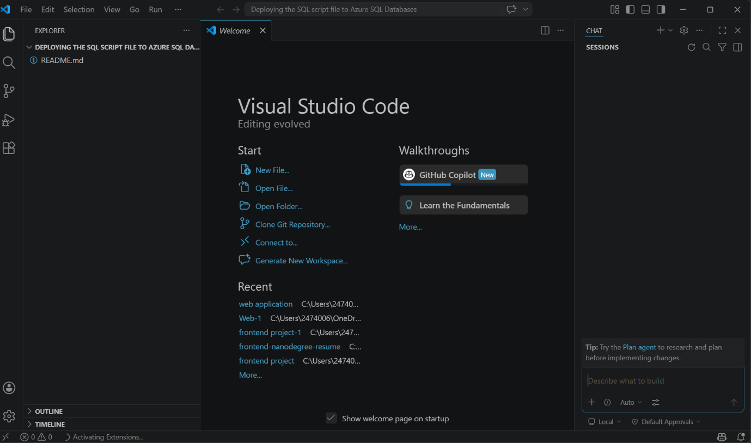
What to do on this screen:
- VS Code has opened with the cloned repository — you can see "DEPLOYING THE SQL SCRIPT FILE TO AZURE SQL DA..." in the Explorer panel.
- README.md is visible in the file explorer on the left.
- Now create a new file: in the Explorer panel, right-click → "New File" → name it schema.sql.
- The schema.sql file will appear in the file list alongside README.md.
- Click on schema.sql to open it in the editor.
Note: Alternatively, open the VS Code terminal (Ctrl+`) and run: New-Item schema.sql to create the file from the command line.

Step 11: Write SQL Script in VS Code
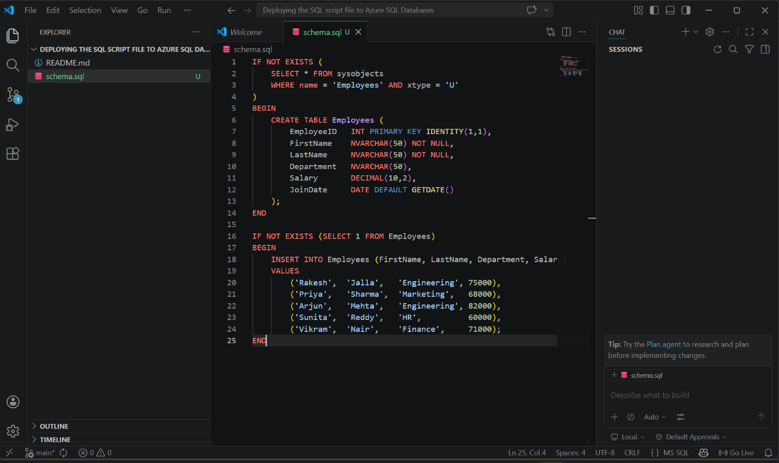
What to do on this screen:
- The schema.sql file is open in VS Code showing the SQL script.
- Paste the following SQL into schema.sql:
IF NOT EXISTS (SELECT * FROM sysobjects WHERE name = 'Employees' AND xtype = 'U')
BEGIN
CREATE TABLE Employees ( EmployeeID INT PRIMARY KEY IDENTITY(1,1), ... )
END
- The IF NOT EXISTS check ensures the table is only created if it does not already exist.
- The INSERT block also has an IF NOT EXISTS check to prevent duplicate rows on re-runs.
- Save the file with Ctrl + S.
Note: The "U" in the bottom right of VS Code shows unsaved changes — make sure it disappears after saving.

Step 12: Push SQL Script to Azure Repos
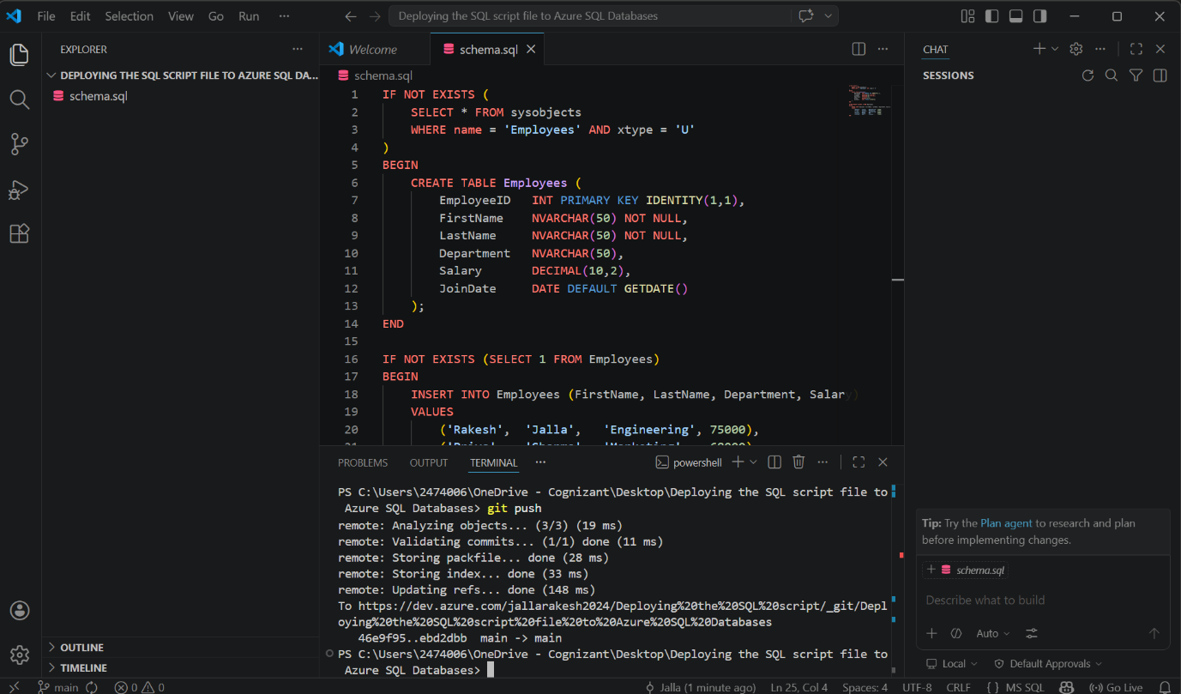
What to do on this screen:
- The VS Code terminal shows a successful git push output.
- Open the terminal (Ctrl+`) and run these commands one by one:
git add .
git commit -m "Add SQL schema and seed data script"
git push
- You should see: "remote: Updating refs... done" and the branch confirmation "main -> main".
- The push is complete when you see the PS prompt return at the bottom.
Note: If git push is rejected with non-fast-forward error, run: git pull origin main --rebase first, then git push again.

Step 13: Verify schema.sql in Azure Repos
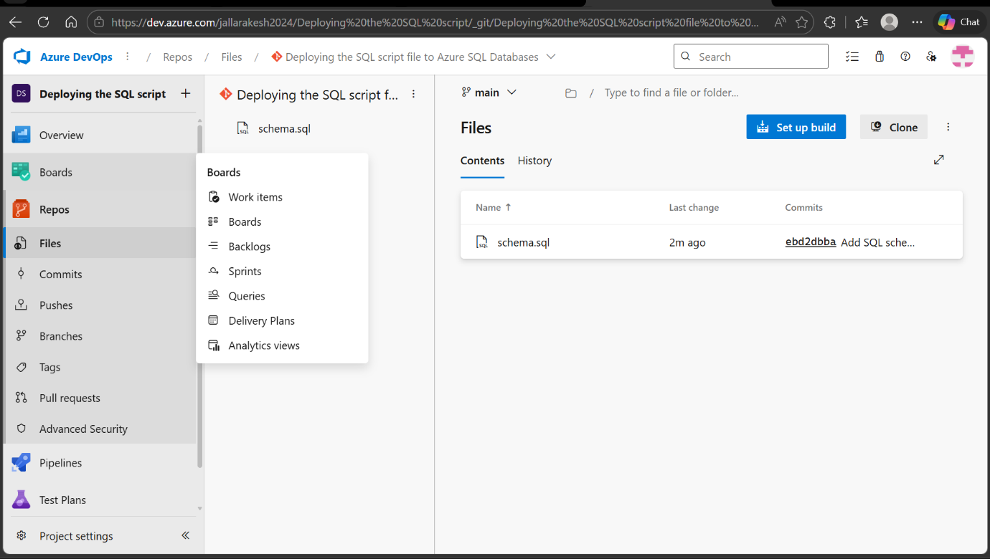
What to do on this screen:
- Go to Azure DevOps → Repos → Files.
- You should see schema.sql listed in the files with "2m ago" in the Last change column.
- The Commits column shows the commit hash and message "Add SQL sche..." confirming your push was successful.
- Click on schema.sql to preview its contents and verify the SQL is correct.
- You can now use this repo as the source for your build pipeline.
Note: If schema.sql does not appear, wait 30 seconds and refresh the page.

Step 14: Create Service Connection — Start
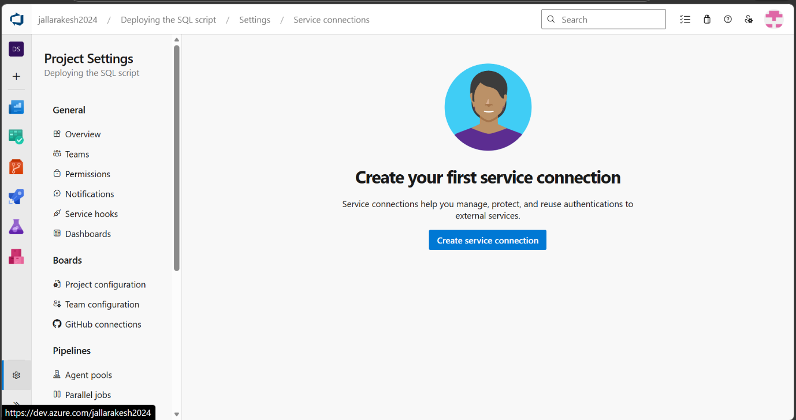
What to do on this screen:
- Go to Project Settings (gear icon at the bottom left of Azure DevOps sidebar).
- Under Pipelines section, click "Service connections".
- You see "Create your first service connection" since none exist yet.
- Click "Create service connection" button.
- Select "Azure Resource Manager" from the list.
- Click "Next".
Note: Service connections allow Azure DevOps pipelines to authenticate and connect to Azure resources like SQL Database and Key Vault.

Step 15: Configure Service Connection as service-2
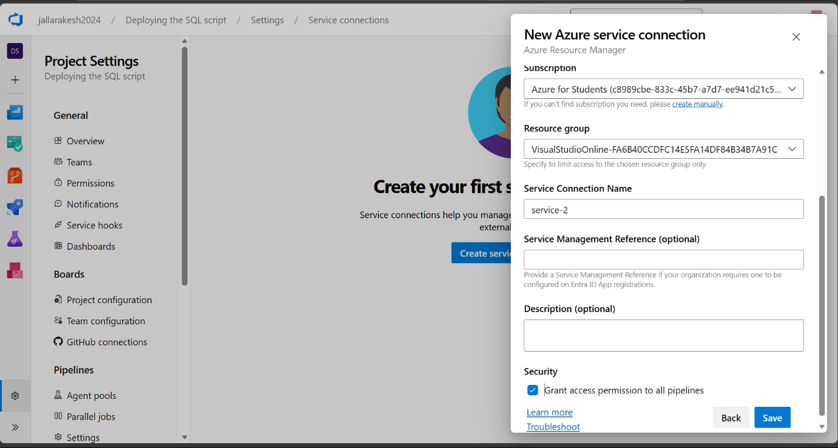
What to do on this screen:
- Subscription: select "Azure for Students" from the dropdown.
- Resource group: select the resource group where your SQL Server is located.
- Service Connection Name: type exactly service-2.
- Check "Grant access permission to all pipelines" checkbox.
- Click "Save" to create the service connection.
Note: The name must be exactly "service-2" as this is referenced in your pipeline YAML and release pipeline task configuration.

Step 16: Create Azure Key Vault
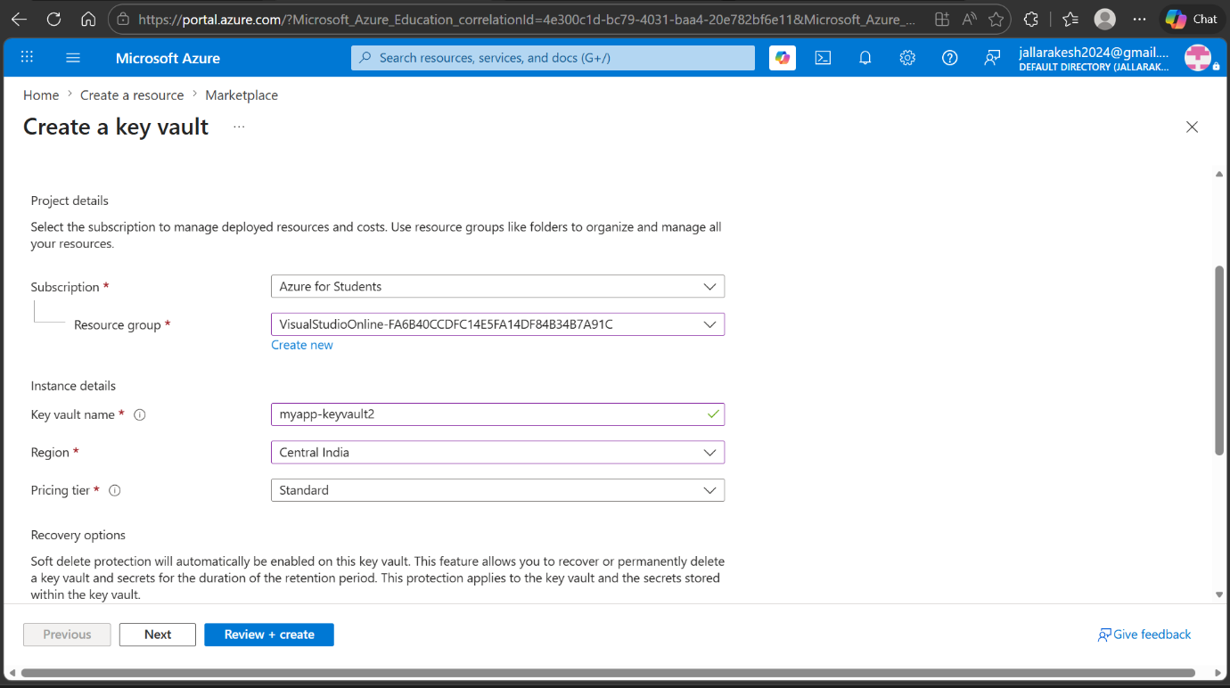
What to do on this screen:
- Go to portal.azure.com → Search "Key vaults" → Click "Create".
- Subscription: Azure for Students.
- Resource Group: select the same resource group as your SQL Server.
- Key vault name: type myapp-keyvault2 (must be globally unique).
- Region: Central India (same region as SQL Server).
- Pricing tier: Standard.
- Leave Recovery options as default (Soft delete is enabled automatically).
- Click "Review + create" → "Create".
Note: When asked about Permission model during creation, select "Vault access policy" for simpler permission management.

Step 17: Key Vault Created — Secrets Page Empty
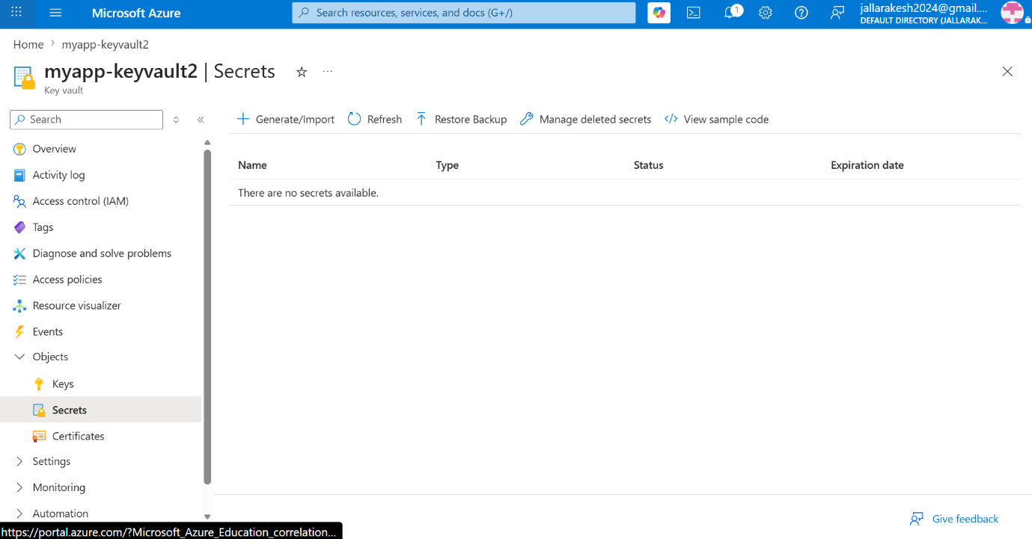
What to do on this screen:
- Your Key Vault myapp-keyvault2 is created and you are on the Secrets page.
- It shows "There are no secrets available" — this is correct since we haven't added any yet.
- Notice "Access policies" is visible in the left sidebar — this means the Vault access policy model is active.
- Click "+ Generate/Import" to start adding your first secret.
Note: You need to add 4 secrets: sqlServer, sqlDatabase, sqlAdmin, sqlPassword — one at a time.

Step 18 : All 4 Secrets Added to Key Vault
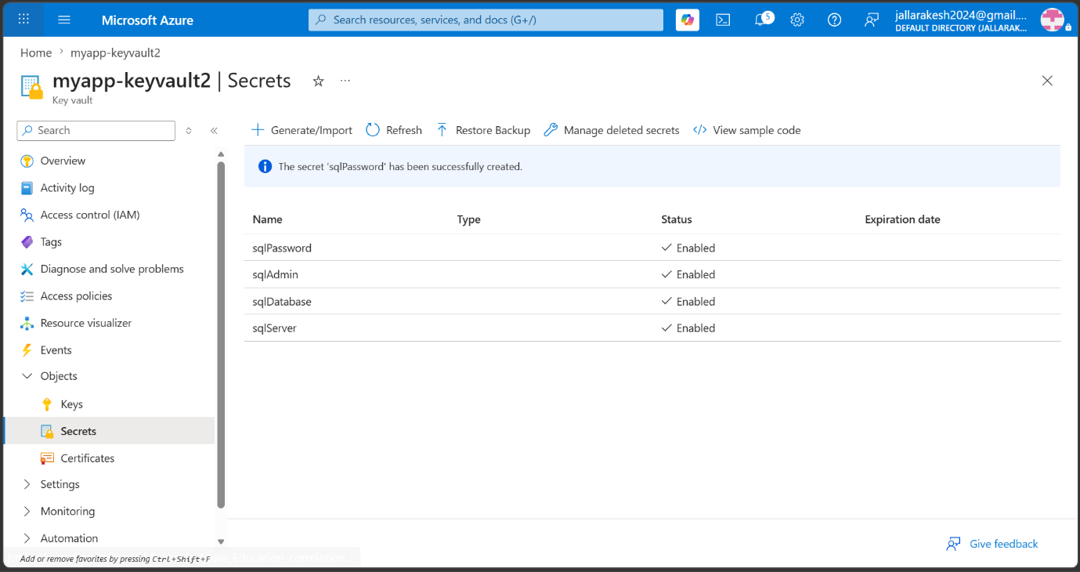
What to do on this screen:
- All 4 secrets are now created and listed with Status "Enabled":
- sqlPassword → your database password
- sqlAdmin → sqladmin
- sqlDatabase → mydb
- sqlServer → mysqlserver3756.database.windows.net
- The blue banner at the top confirms "The secret 'sqlPassword' has been successfully created."
- All secrets show "Enabled" status and no expiration date.
Note: Never share these secret values with anyone. They are now securely stored in Key Vault and will be fetched by the pipeline automatically.

Step 19: Variable Group Linked to Key Vault
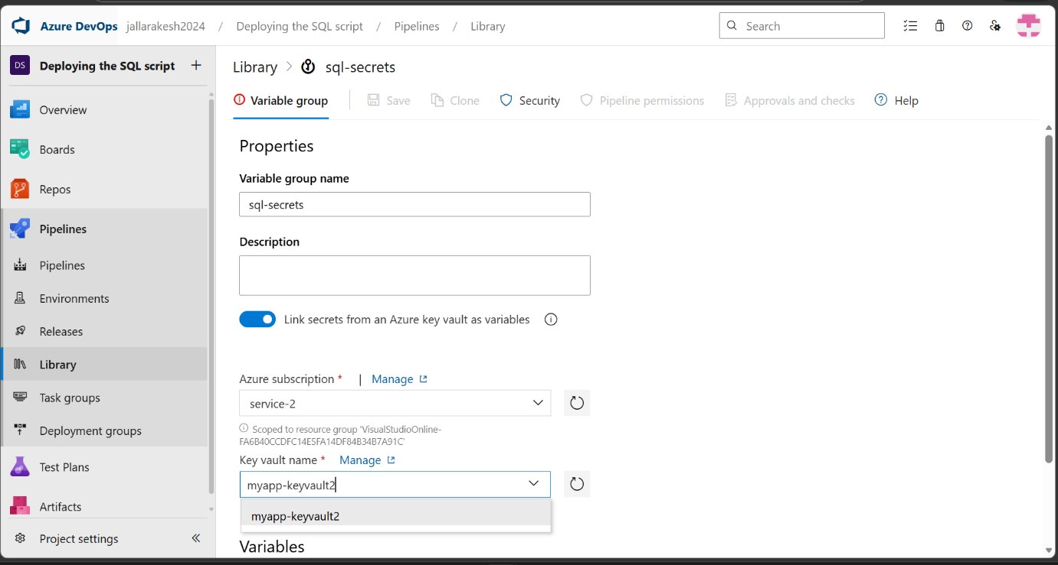
What to do on this screen:
- The variable group is now configured without any error.
- Variable group name: sql-secrets.
- "Link secrets from an Azure key vault as variables" toggle is ON.
- Azure subscription: service-2.
- Key vault name: myapp-keyvault2 is selected from the dropdown.
- Now scroll down and click "+ Add" under Variables to select the secrets.
- Select all 4 secrets: sqlAdmin, sqlDatabase, sqlPassword, sqlServer.
Note: After selecting the secrets, click Save at the top to save the variable group.

Step 20: Variable Group Saved with All 4 Secrets
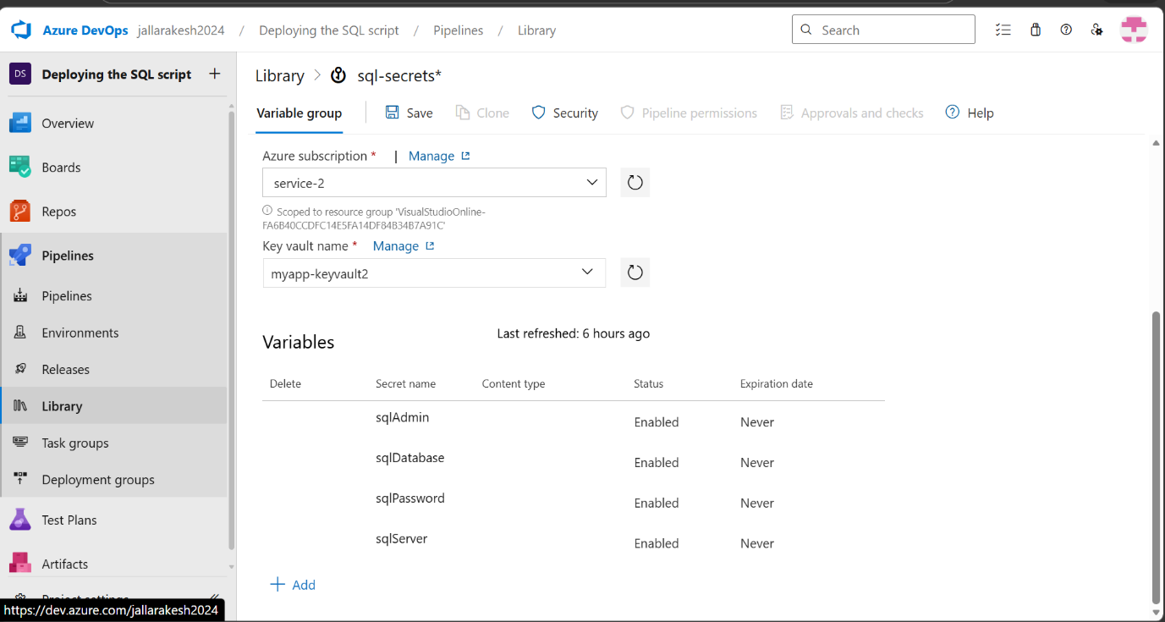
What to do on this screen:
- The variable group sql-secrets is saved and shows all 4 secrets under Variables:
- sqlAdmin — Status: Enabled, Expiration: Never
- sqlDatabase — Status: Enabled, Expiration: Never
- sqlPassword — Status: Enabled, Expiration: Never
- sqlServer — Status: Enabled, Expiration: Never
- "Last refreshed: 6 hours ago" shows when the secrets were last synced from Key Vault.
- Now link this variable group to your release pipeline: Releases → Edit → Variables tab → Variable groups → Link variable group → select sql-secrets.
- Update the Login and Password fields in the SQL task to use $(sqlAdmin) and $(sqlPassword).
Note: Once linked, the pipeline fetches credentials from Key Vault at runtime — passwords are never visible in logs or YAML files.

Step 21: Create CI Build Pipeline — Select Source
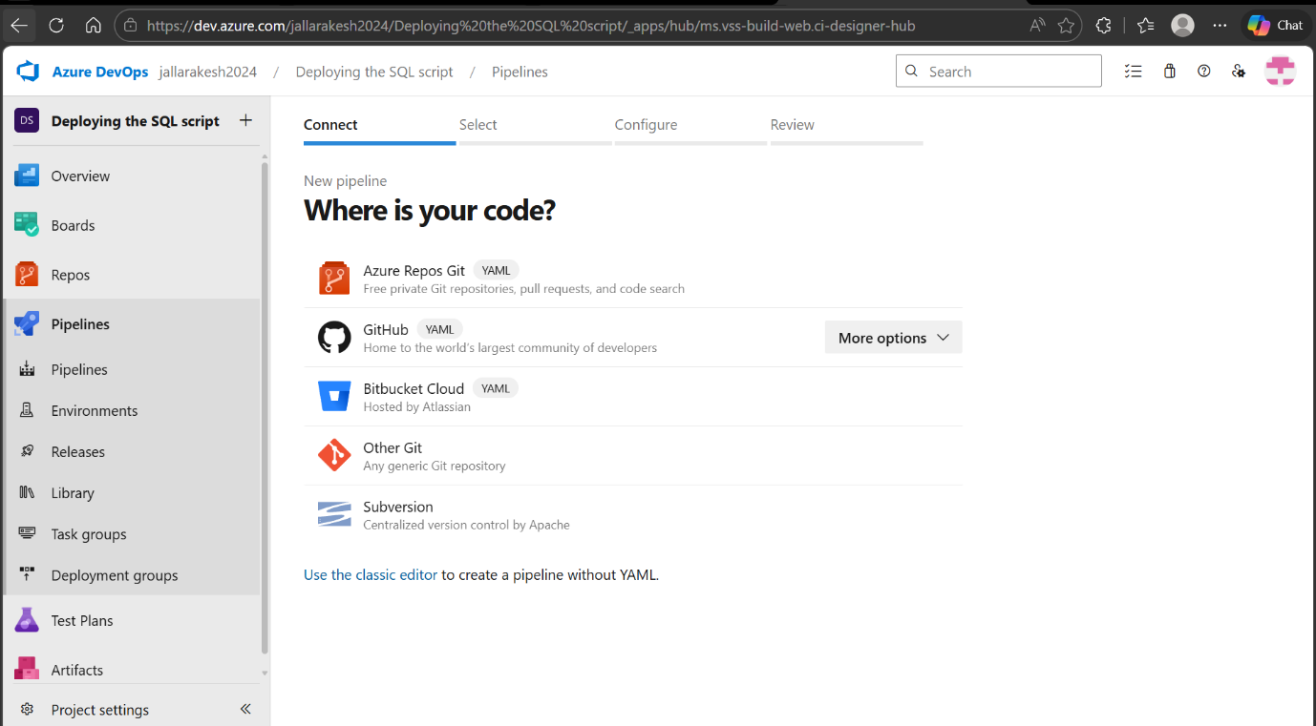
What to do on this screen:
- Go to Pipelines → Pipelines → "New pipeline".
- You are on the "Where is your code?" screen (Connect step).
- Select "Azure Repos Git" — since your SQL script is in Azure Repos.
- On the next screen (Select step), click on your repository "Deploying the SQL script file to Azure SQL Databases".
- On the Configure step, select "Existing Azure Pipelines YAML file" or "Starter pipeline".
Note: If you already pushed azure-pipelines.yml to your repo, select "Existing Azure Pipelines YAML file" and pick /azure-pipelines.yml.

Step 22: Review Pipeline YAML and Save and Run
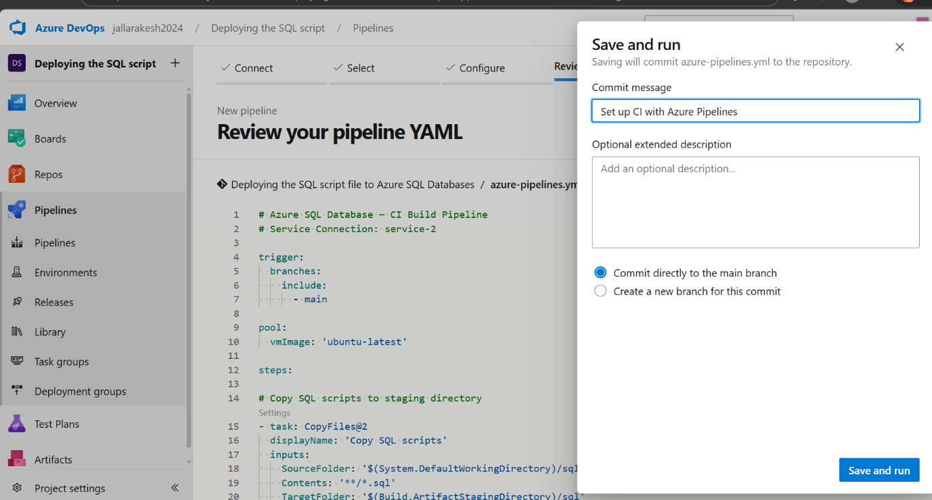
What to do on this screen:
- You are on the "Review your pipeline YAML" screen showing the azure-pipelines.yml content.
- Verify the YAML shows: trigger → main, pool → ubuntu-latest, tasks → CopyFiles and PublishBuildArtifacts.
- The "Save and run" popup appears asking for a commit message.
- Commit message: leave as "Set up CI with Azure Pipelines" or type a custom message.
- Select "Commit directly to the main branch".
- Click "Save and run" to commit the YAML file and trigger the first build.
Note: This saves azure-pipelines.yml to your repo root and immediately triggers a build run.

Step 23: Build and Deploy Successful

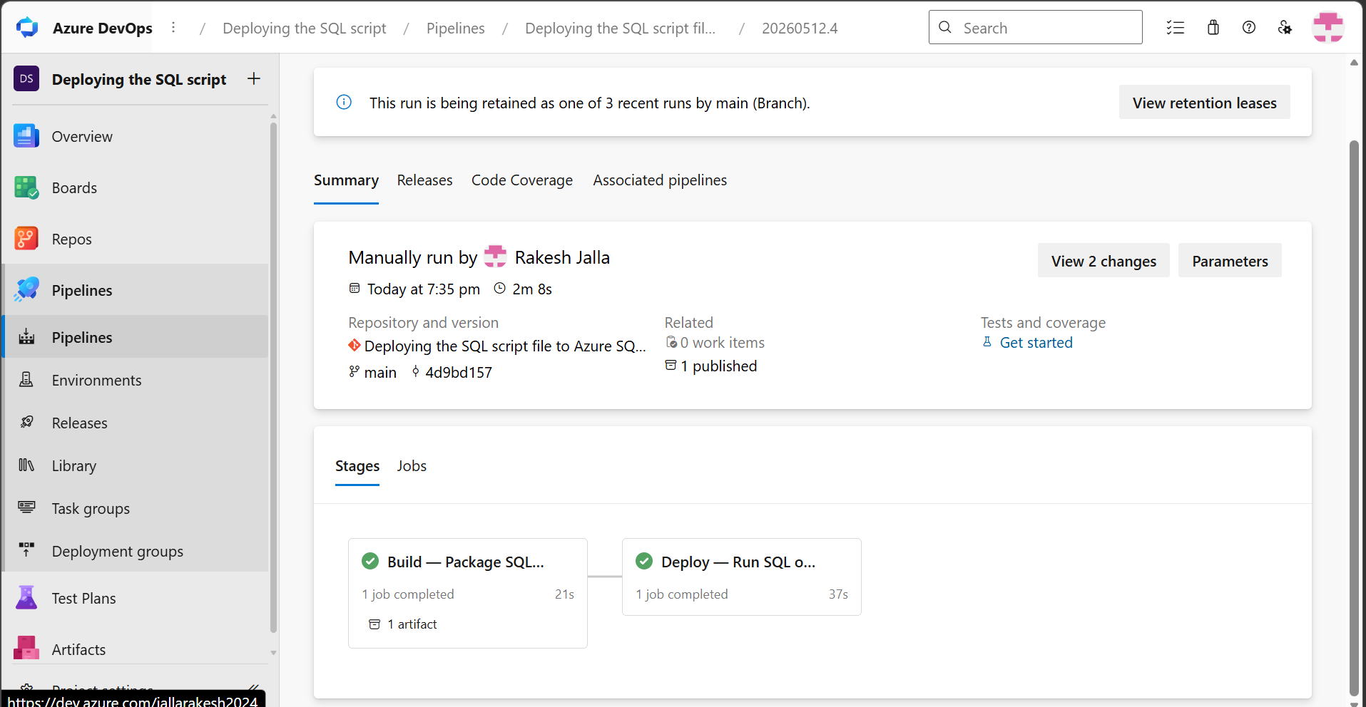

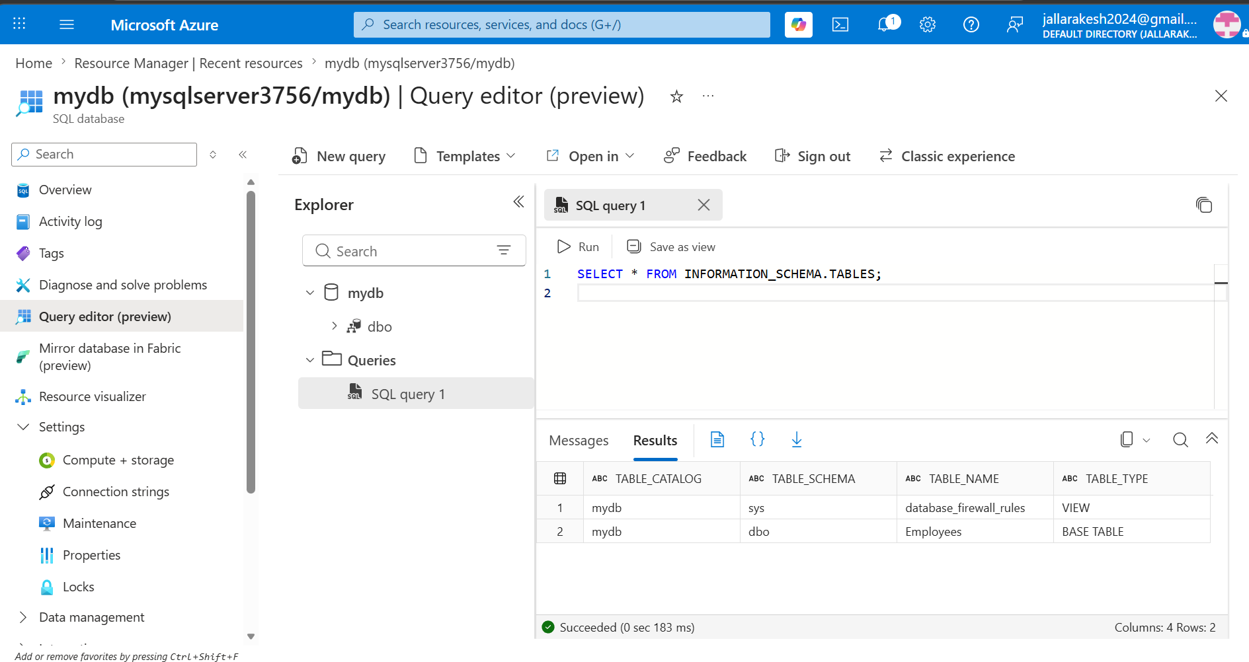

✅ All Steps Complete — Azure SQL Database with CI/CD and Key Vault is Fully Implemented!

