Deployment of .NET Application to
Azure Function App
Using Azure DevOps CI/CD Pipelines
Step-by-Step Implementation Guide
Date: May 5, 2026

Use Case Overview
This document covers the end-to-end deployment of a .NET 8 Azure Functions application to Azure Function App using Azure DevOps CI/CD pipelines. The goal is to automate the build and deployment process so that every code push to the master branch triggers an automatic build and deployment to Azure.
The application used is a basic HTTP-triggered Azure Function that responds with a hello message — keeping the focus on the deployment pipeline rather than application complexity.
Tools and Services Used:
- Microsoft Azure Portal — to create cloud resources
- Azure DevOps — to host code repository and run CI/CD pipelines
- .NET 8 SDK — runtime for the Azure Function
- Azure Function App — serverless hosting for the function
- Azure Storage Account — required by Azure Functions runtime
- Git — for version control and pushing code to Azure Repos

Step 1: Create Azure Resources
Before writing any code or setting up pipelines, all required Azure resources must be created. These are the foundation on which the application will run.

1.1 Create Resource Group
A Resource Group is a logical container that holds all related Azure resources together. Creating one resource group for the entire project makes it easy to manage and clean up resources.
- Go to portal.azure.com
- Search for "Resource Groups" in the top search bar
- Click "+ Create"
- Name: ImageUploadRG
- Region: Austria East
- Click "Review + Create" then "Create"
All three resources (Resource Group, Storage Account, Function App) must be in the same region to avoid latency and extra data transfer costs.

1.2 Create Storage Account
Azure Functions requires a Storage Account to store function state, triggers, and logs. This is a mandatory dependency for any Function App.
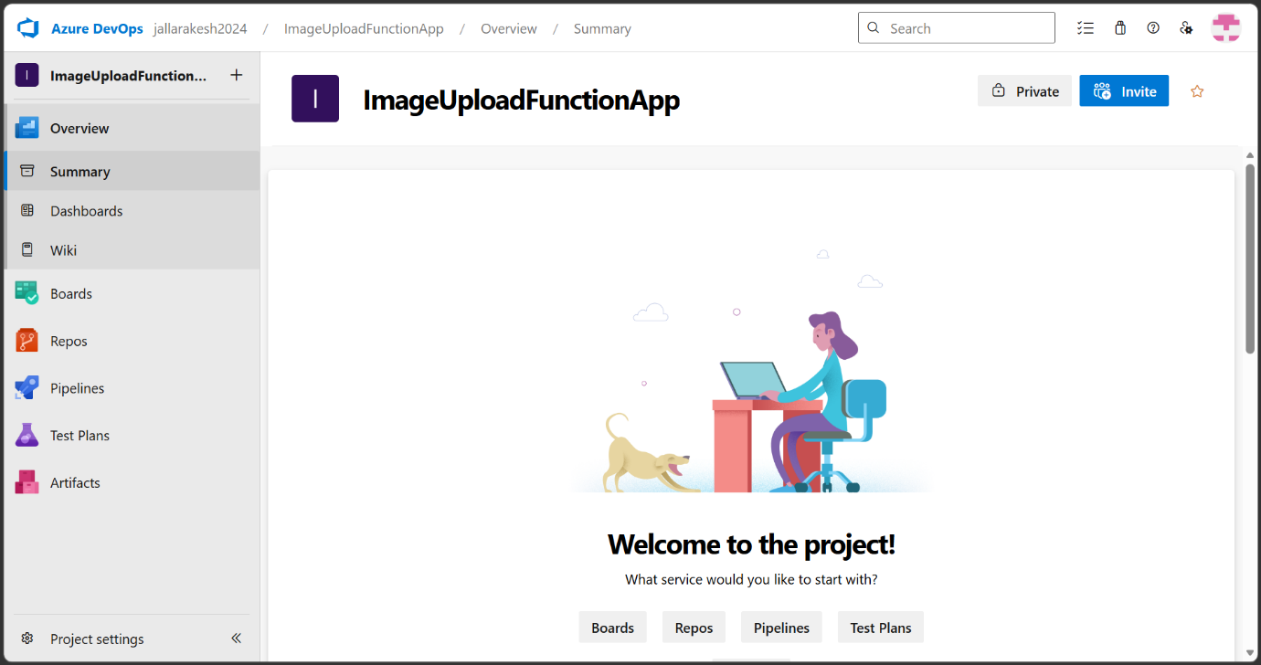
Screenshot 1: Azure Portal — Creating Storage Account
In the screenshot above, the Storage Account creation form is shown. The resource group ImageUploadRG is selected, the storage account is named imageuploadstore001 (all lowercase, globally unique), the region is set to Austria East, performance is Standard, and redundancy is set to LRS (Locally Redundant Storage) which is the most cost-effective option for a student account.
- Go to Azure Portal and search "Storage Accounts"
- Click "+ Create"
- Select resource group: ImageUploadRG
- Storage account name: imageuploadstore001
- Region: Austria East
- Performance: Standard, Redundancy: LRS
- Leave all other tabs as default
- Click "Review + Create" then "Create"

1.3 Create Function App
The Function App is the actual hosting environment for the .NET Azure Function. It runs on top of the Storage Account and uses the Consumption (Serverless) plan which charges only when the function executes.
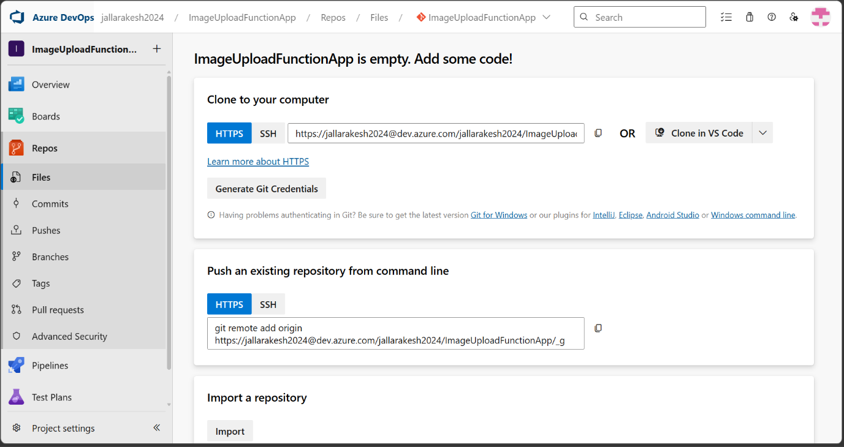
Screenshot 2: Azure Portal — Selecting Hosting Plan for Function App
This screen shows the hosting plan selection for the Function App. The Consumption (Windows) plan is selected — the last option on the right. This is the best choice for our use case because it scales to zero when not in use, meaning no cost when the function is idle. It supports .NET 8 Isolated and is compatible with student Azure accounts.
- Search for "Function App" in the portal
- Click "+ Create"
- Select hosting plan: Consumption (Windows)
- Resource group: ImageUploadRG
- Function App name: ImageUploadFuncApp (globally unique)
- Runtime stack: .NET, Version: 8 (LTS) Isolated
- Region: Austria East, OS: Windows
- Storage account: imageuploadstore001
- Click "Review + Create" then "Create"
The Consumption plan is ideal for student accounts as it only charges per execution. The function sleeps when idle and wakes up instantly on trigger.

Step 2: Write the .NET Azure Function Code
With the Azure infrastructure ready, the next step is to write the application code. A basic HTTP-triggered .NET 8 Azure Function is created. The purpose of this function is not complex logic — it simply demonstrates that the deployment pipeline works end to end.

2.1 Project Structure
The project follows the standard Azure Functions isolated worker model for .NET 8. Four files are needed:
- ImageUploadFunc.cs — the main function class with the HTTP trigger
- Program.cs — the host builder that initializes the function runtime
- ImageUploadApp.csproj — the project file with NuGet package references
- host.json — configuration file for the Azure Functions host

2.2 Key Code Files
The function uses Microsoft.Azure.Functions.Worker and Microsoft.Azure.Functions.Worker.Extensions.Http packages. It is important NOT to use the AspNetCore package as that causes build errors in the pipeline. The function accepts GET and POST requests and returns a plain text response confirming it is running.
During development, the AspNetCore package caused repeated build failures (Error AZFW0014). The fix was to use the standard Extensions.Http package instead, which is compatible with the isolated worker model.

Step 3: Push Code to Azure DevOps Repository
Azure DevOps Repos is used to host the source code. The pipeline will automatically trigger when code is pushed to the master branch.
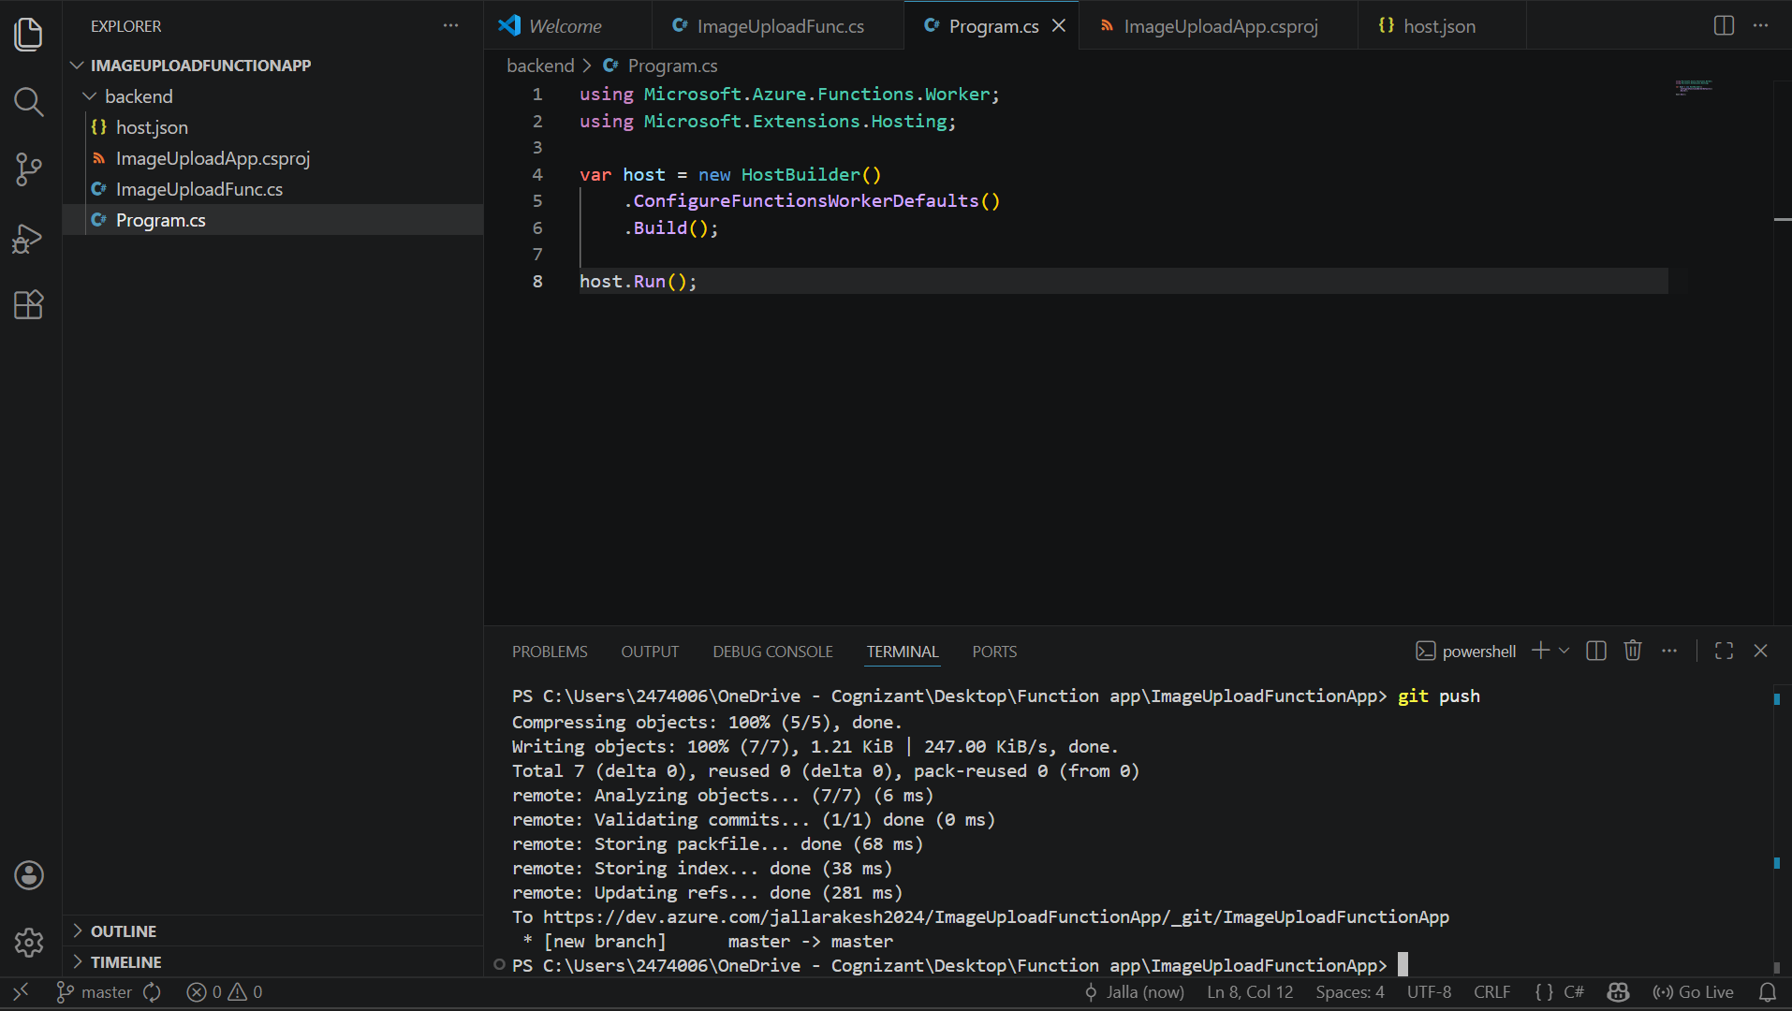
Screenshot 3: VS Code — Project files in the backend folder
This screenshot shows the project files open in VS Code. The backend folder contains all four required files: host.json, ImageUploadApp.csproj, ImageUploadFunc.cs, and Program.cs. The azure-pipelines.yml file is at the root level. The terminal at the bottom confirms the code has been pushed to Azure DevOps with the commit message "Fix all code issues".
- Open Azure DevOps at dev.azure.com
- Create a new project named ImageUploadFunctionApp
- Go to Repos and initialize the repository
- Clone the repo to your local machine
- Create the backend folder and add all 4 code files
- Create azure-pipelines.yml at the root
- Run: git add . → git commit -m "backend code" → git push
The repo branch is named "master" (not "main"). The pipeline YAML trigger must match — use trigger: master.

Step 4: Create Service Connection in Azure DevOps
A Service Connection allows Azure DevOps to authenticate with your Azure subscription and deploy resources on your behalf. Without this, the pipeline cannot communicate with Azure.
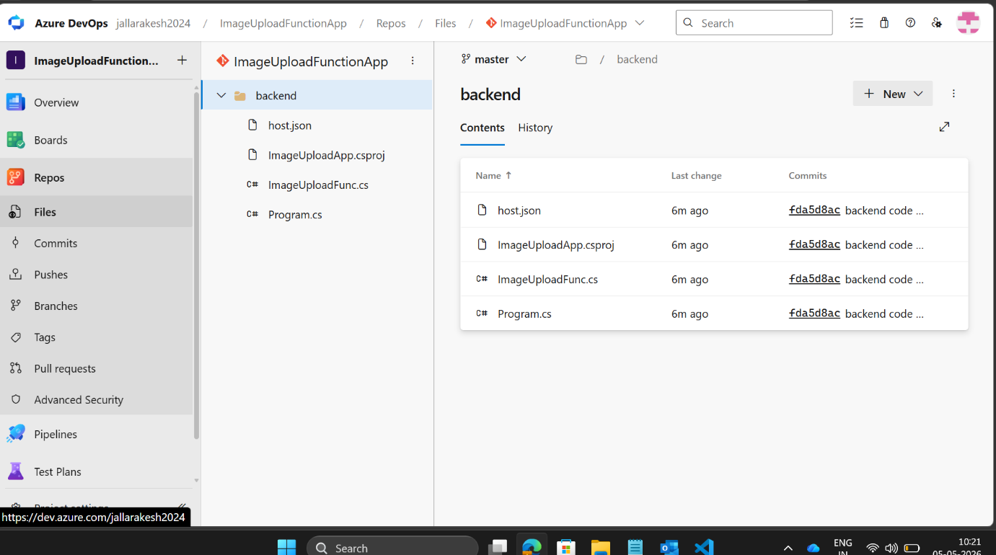
Screenshot 4: Azure DevOps — Service Connection Setup
The Service Connection screen in Azure DevOps Project Settings is shown here. The connection is configured as Azure Resource Manager with Service Principal (Automatic) authentication. The student Azure subscription is selected along with the ImageUploadRG resource group. The connection is named AzureServiceConnection and permission is granted to all pipelines.
- Go to Azure DevOps → Project Settings (bottom left)
- Under Pipelines section, click "Service Connections"
- Click "New Service Connection"
- Select "Azure Resource Manager" → Next
- Select "Service Principal (Automatic)" → Next
- Scope: Subscription, select your student subscription
- Resource Group: ImageUploadRG
- Name: AzureServiceConnection
- Check "Grant access permission to all pipelines"
- Click Save
The Service Connection must be created AFTER the Resource Group exists in Azure. If the resource group does not exist yet, it will not appear in the dropdown.

Step 5: Create Build Pipeline (CI)
The Build Pipeline is the Continuous Integration part of the workflow. It automatically runs whenever code is pushed to the master branch. Its job is to restore packages, build the project, publish it, and store the output as an artifact called "drop".
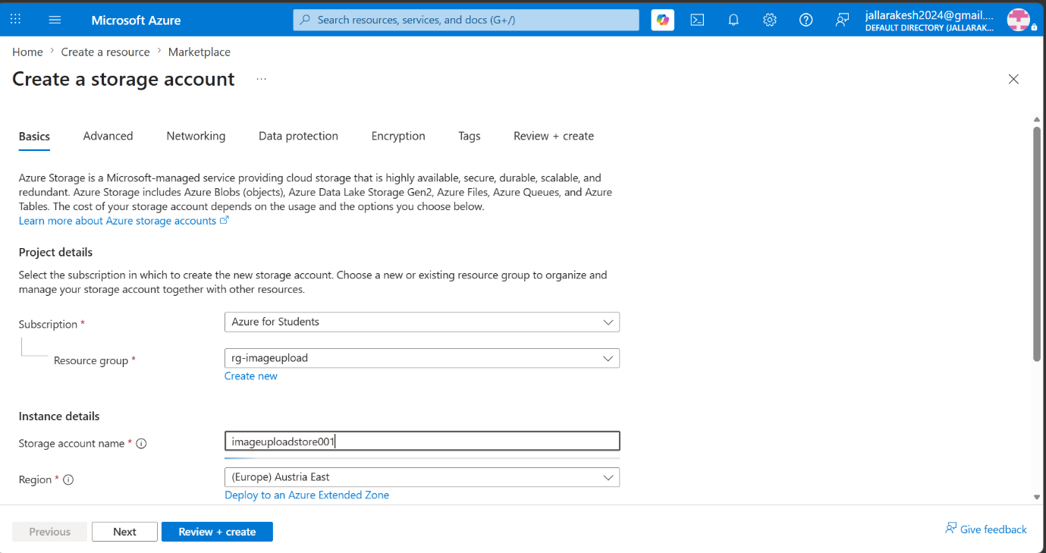
Screenshot 5: Azure DevOps — Build Pipeline YAML Editor
This screenshot shows the YAML pipeline editor in Azure DevOps. The pipeline is configured with five steps: Use .NET 8 SDK, Restore packages, Build, Publish, and Publish Artifact to Drop. The key fix here was setting publishWebProjects: false in the Publish step so that the pipeline correctly identifies the project as a Function App and not a web application.
- Go to Azure DevOps → Pipelines → New Pipeline
- Select "Azure Repos Git"
- Select your repository: ImageUploadFunctionApp
- Choose "Starter Pipeline"
- Delete all default content in the YAML editor
- Paste the build pipeline YAML code
- Click "Save and Run" → "Save and Run" again on popup
Critical fix: Add publishWebProjects: false to the Publish step. Without this, the pipeline throws "No web project was found" error even though the project builds successfully.
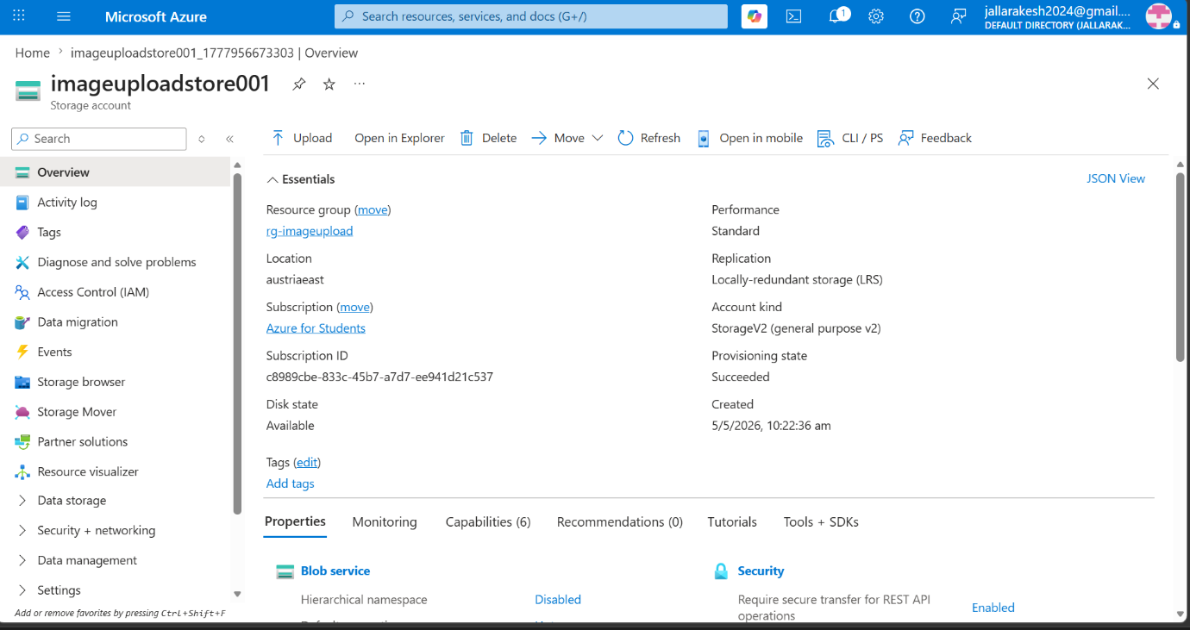
Screenshot 6: Azure DevOps — Build Pipeline Running
The pipeline is now running. Each step is shown with its status and duration. The Use .NET 8, Restore packages, and Build steps have completed successfully (green ticks). The Publish step is currently executing.
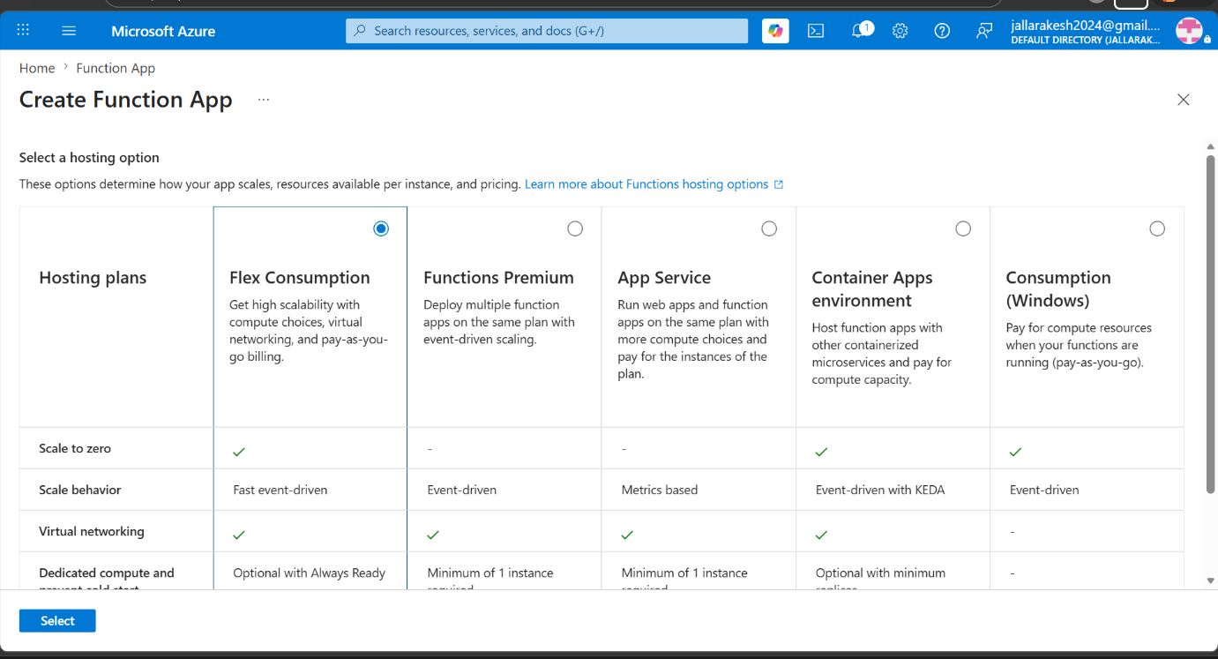
Screenshot 7: Azure DevOps — Build Pipeline Failed (Earlier Attempt)
This screenshot shows an earlier failed run where the build pipeline encountered 3 errors. The main errors were: IFormFileCollection does not contain a definition for FirstOrDefault, string[] does not contain a definition for Contains, and Math does not exist in the current context. These errors occurred because the original code was using AspNetCore HTTP types which are not compatible with the isolated worker model. The fix was to replace the function code entirely with the simpler HttpRequestData approach.

Step 6: Build Pipeline Success
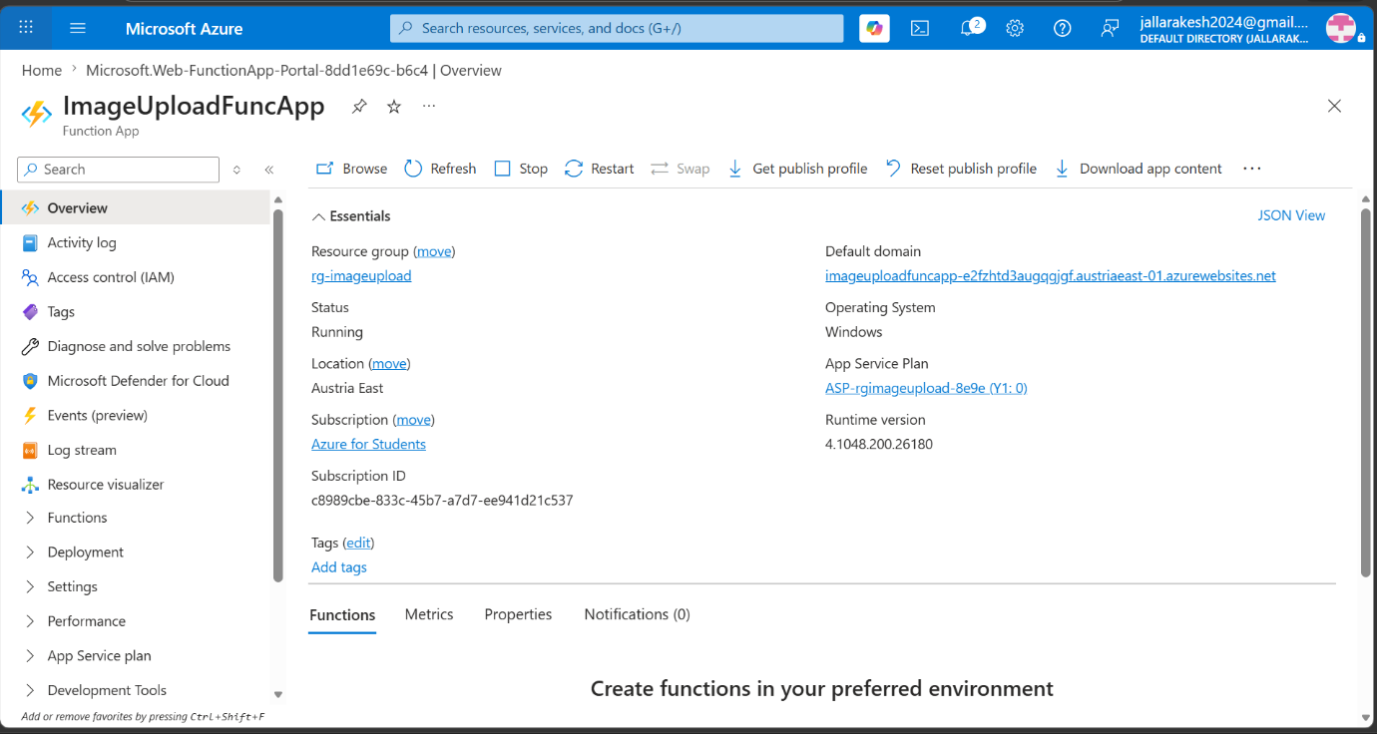
Screenshot 8: Azure DevOps — Build Pipeline Succeeded
After fixing the code and pipeline configuration, the build pipeline run #20260505.10 completed successfully. The summary shows: Stage completed, Job completed in 2 minutes 29 seconds, and 1 artifact published. The artifact named "drop" contains the compiled and zipped .NET function ready for deployment. This artifact will be used by the Release Pipeline in the next step.
- All 5 steps completed with green ticks
- 1 artifact published successfully
- Total duration: 2 minutes 29 seconds
- Branch: master, Commit: f389503d
Once the build pipeline succeeds and produces an artifact, the Release Pipeline can pick it up and deploy it to Azure. The artifact is stored in Azure DevOps and persists for 1 month as shown in the pipeline settings.

Step 7: Create Release Pipeline (CD)
The Release Pipeline is the Continuous Deployment part. It takes the artifact produced by the Build Pipeline and deploys it to the Azure Function App. This is done using the Classic Release Pipeline UI in Azure DevOps.
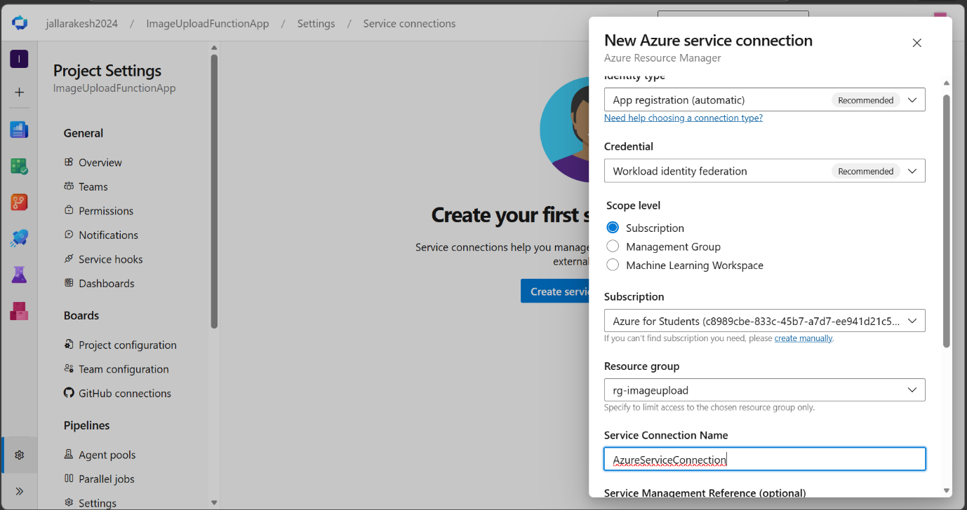
Screenshot 9: Azure DevOps — New Release Pipeline with Artifact
The release pipeline editor is open showing the Pipeline tab. The artifact _ImageUploadFunctionApp is already connected on the left side, and Stage 2 is added on the right with 1 job and 0 tasks. The next step is to add the Azure Functions Deploy task to Stage 2.
- Go to Azure DevOps → Pipelines → Releases
- Click "New release pipeline"
- Add artifact → select the Build Pipeline as source
- A stage (Stage 2) is automatically created
- Click on "1 job, 0 task" to open the task editor
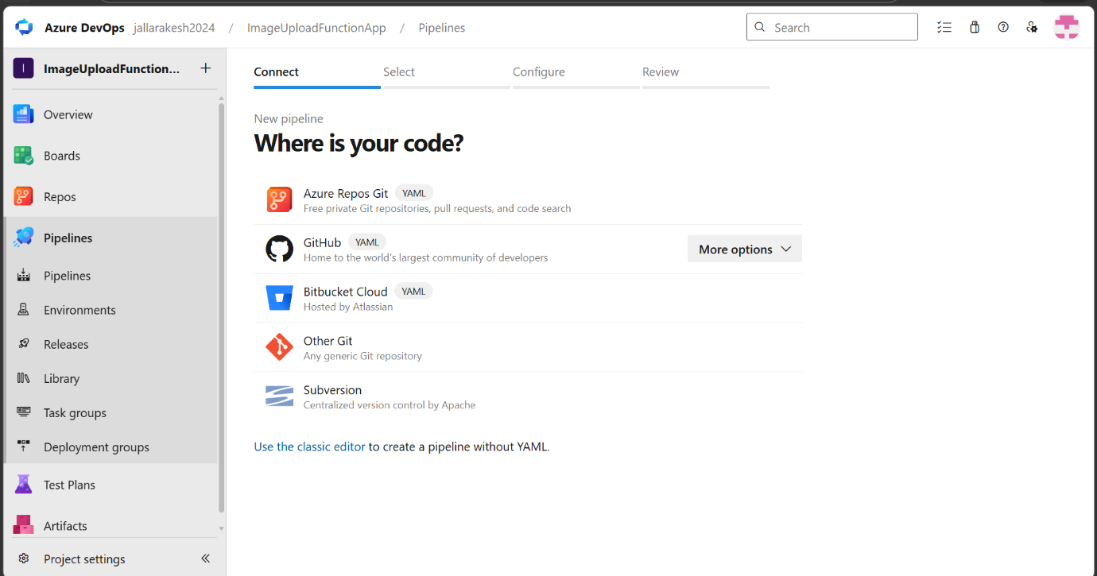
Screenshot 10: Azure DevOps — Adding Azure Functions Deploy Task
The Tasks tab is now open showing the task search panel on the right. "Azure Functions Deploy" is searched and two options appear: Azure Functions Deploy (for .NET, Python, JavaScript, etc.) and Azure Functions for container. The first option "Azure Functions Deploy" is selected and added to the Agent job.
- In the task editor, click the "+" button next to Agent job
- Search for "azure function app" in the search box
- Select "Azure Functions Deploy" (first result)
- Click "Add"
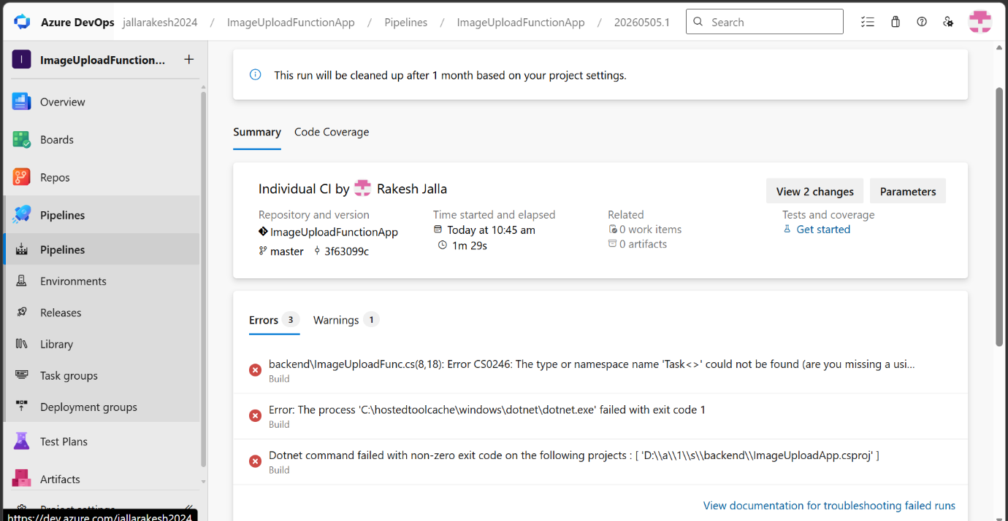
Screenshot 11: Azure DevOps — Configuring Azure Functions Deploy Task
The Azure Functions Deploy task is now added and configured. The form on the right shows all the required fields filled in correctly: Azure Resource Manager connection is set to AzureServiceConnection, App type is Function App on Windows, Azure Functions App name is ImageUploadFuncApp, and the Package or folder path is set to $(System.DefaultWorkingDirectory)/**/*.zip which automatically finds the zip artifact produced by the build pipeline.
- Azure Resource Manager connection: AzureServiceConnection
- App type: Function App on Windows
- Azure Functions App name: ImageUploadFuncApp
- Package or folder: $(System.DefaultWorkingDirectory)/**/*.zip
- Click Save at the top → OK
- Click "Create release" → Create
The package path $(System.DefaultWorkingDirectory)/**/*.zip automatically picks up the zip file from the drop artifact. No manual path specification is needed.

Step 8: Release Pipeline Execution
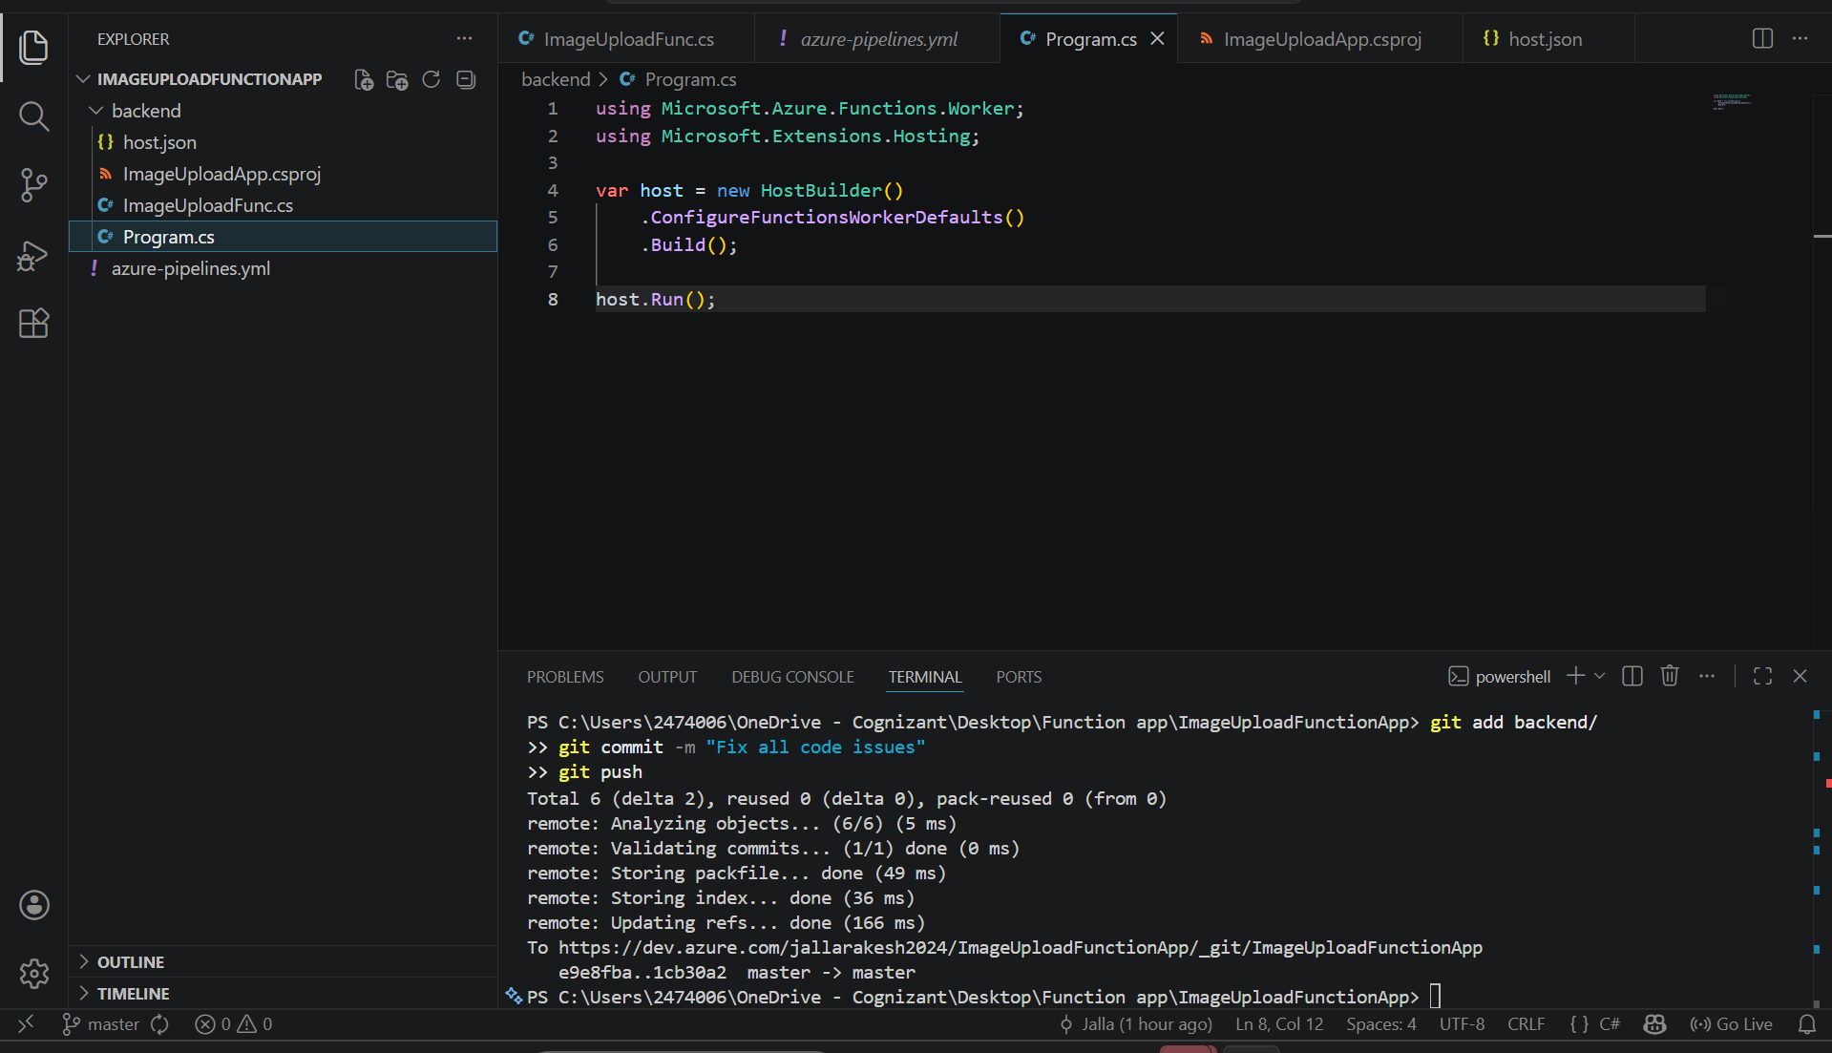
Screenshot 12: Azure DevOps — Release-1 Succeeded
The release pipeline has executed successfully. The screen shows Release-1 under the "New release pipeline". The left panel shows the release was manually triggered by Rakesh Jalla on 5/5/2026 at 12:09 pm. The artifact _ImageUploadFunctionApp version 20260505.10 from master branch is shown. On the right, Stage 2 shows a green "Succeeded" status, completed at 12:12 pm. This means the .NET Function App has been successfully deployed to Azure.
- Release-1 was manually triggered
- Artifact: ImageUploadFunctionApp build 20260505.10
- Stage 2: Succeeded at 12:12 pm
- Total deployment time: approximately 3 minutes
In production environments, the release can be set to trigger automatically whenever the Build Pipeline completes successfully, making the entire process fully automated without any manual steps.

Step 9: Verify Deployment in Azure Portal
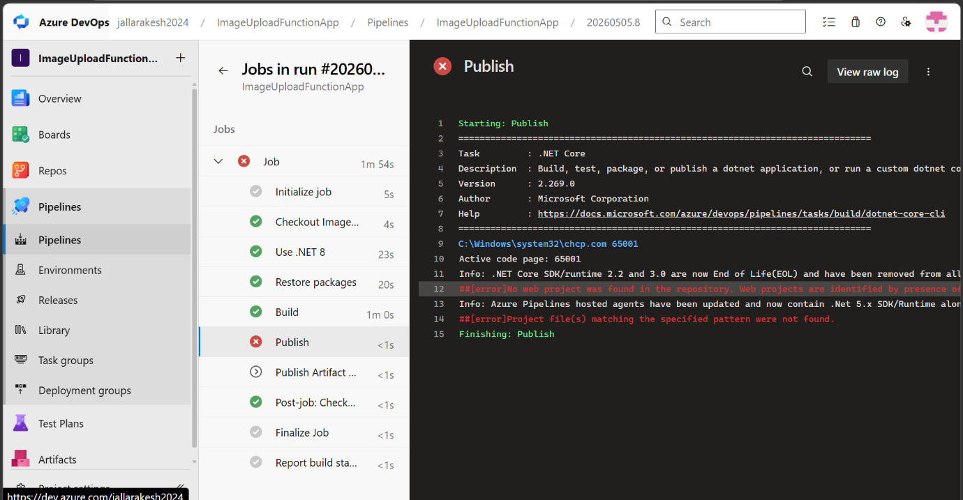
Screenshot 13: Azure Portal — Function App Overview
After the successful deployment, the Azure Portal is opened to verify the Function App is running. The ImageUploadFuncApp dashboard shows the app is active. The App Keys section shows the system keys and host keys that can be used to authenticate requests to the function.
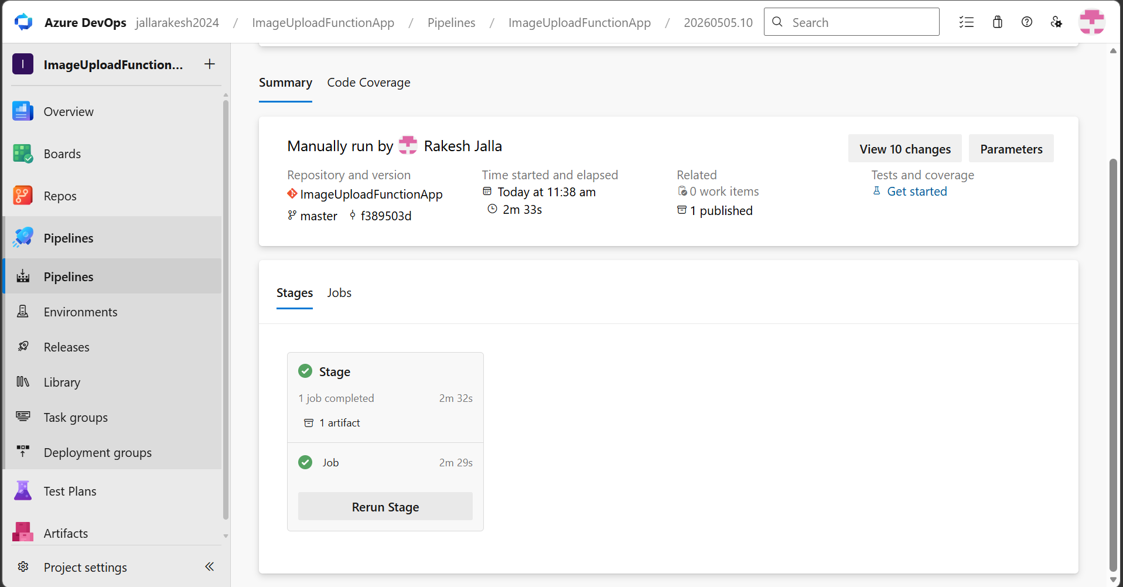
Screenshot 14: Azure Portal — Function App Running Screen
When the Function App URL is opened in a browser, the Azure Functions welcome page is displayed showing "Your Functions 4.0 app is up and running". This confirms the Function App infrastructure is correctly deployed and the runtime is active. This page appears when the base URL is accessed without the /api endpoint path.
- Open portal.azure.com
- Navigate to ImageUploadFuncApp
- The Function App dashboard shows the app is running
- Open the Function App URL in browser
- See the "Your Functions 4.0 app is up and running" confirmation page

Step 10: Test the Azure Function
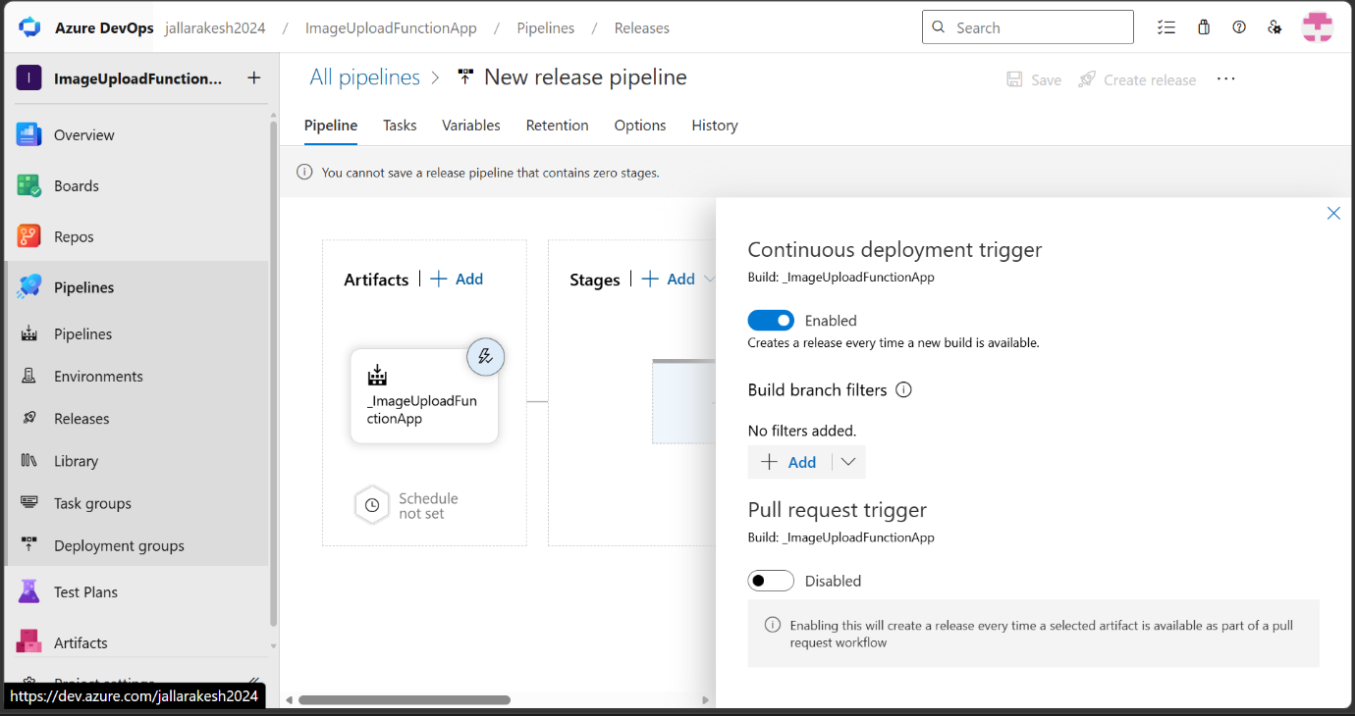
Screenshot 15: Azure Portal — App Keys Page
The App Keys page shows the system keys and host keys for the Function App. These keys can be used to authenticate HTTP requests to the function. For our use case, the function is set to Anonymous authorization level, so no key is required to call it.
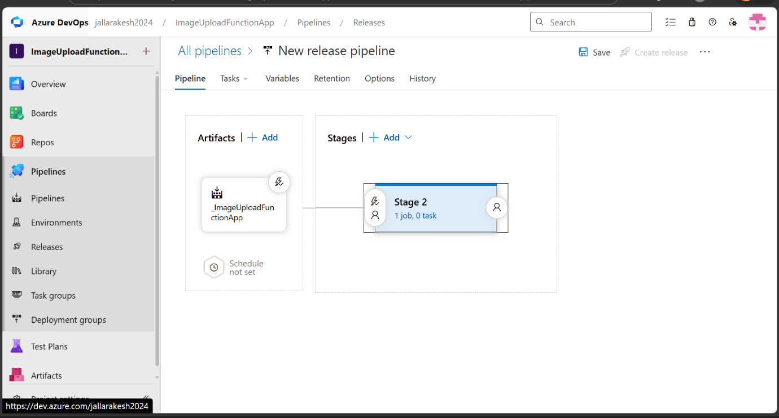
Screenshot 16: Browser — Final Verification
The final verification step shows the Azure Function responding in the browser. The URL https://imageuploadfuncapp-e2fzhtd3augqgjgf.austriaeast-01.azurewebsites.net/api/ImageUploadFunc is accessed and the response "Hello from Image Upload Azure Function!" is displayed. This confirms the entire CI/CD pipeline worked successfully — the code was built, packaged, deployed, and is now live and responding to HTTP requests.
- Copy the Function App base URL from Azure Portal
- Append /api/ImageUploadFunc to the URL
- Open in browser
- Response: "Hello from Image Upload Azure Function!"
- Deployment verified successfully ✅
The function URL format is: https://{functionappname}.azurewebsites.net/api/{functionname}. In this case the region-specific URL format is used: austriaeast-01.azurewebsites.net.

Complete CI/CD Workflow Summary
The following is the end-to-end flow of the entire implementation:
Phase 1 — Infrastructure Setup (Azure Portal)
- Created Resource Group: ImageUploadRG in Austria East
- Created Storage Account: imageuploadstore001 (Standard LRS)
- Created Function App: ImageUploadFuncApp (.NET 8 Isolated, Consumption plan)
Phase 2 — Code and Repository Setup
- Wrote .NET 8 Azure Function with HTTP trigger (isolated worker model)
- Created Program.cs, csproj, and host.json files
- Pushed all code to Azure DevOps master branch
- Created Service Connection: AzureServiceConnection
Phase 3 — CI Pipeline (Build)
- Created YAML-based Build Pipeline in Azure DevOps
- Pipeline restores NuGet packages → builds → publishes → creates drop artifact
- Build pipeline triggers automatically on every push to master
- Artifact stored in Azure DevOps for 1 month
Phase 4 — CD Pipeline (Release)
- Created Classic Release Pipeline in Azure DevOps
- Connected drop artifact from Build Pipeline
- Added Azure Functions Deploy task to Stage 2
- Configured deployment target: ImageUploadFuncApp
- Release-1 executed and succeeded
Phase 5 — Verification
- Azure Portal shows Function App is running
- Browser test confirms function responds: "Hello from Image Upload Azure Function!"
- Use case completed successfully

Issues Encountered and Fixes Applied
During the implementation, several issues were encountered and resolved. These are documented here as learning points.
Issue 1: Missing using statements in function code
Error: CS0246 — Task<> could not be found, CS1061 — FirstOrDefault not found, Math not found.
Fix: Added using System; using System.Linq; using System.Threading.Tasks; to the function file.
Issue 2: AZFW0014 — ConfigureFunctionsWebApplication error
Error: The registration for method ConfigureFunctionsWebApplication is expected for ASP.NET Core.
Fix: The function was using AspNetCore packages. Replaced all code to use the standard isolated worker model with HttpRequestData instead of HttpRequest. Removed Microsoft.Azure.Functions.Worker.Extensions.Http.AspNetCore package and used Microsoft.Azure.Functions.Worker.Extensions.Http instead.
Issue 3: Pipeline trigger branch mismatch
Error: Pipeline was set to trigger on "main" branch but repo uses "master" branch.
Fix: Changed trigger: - main to trigger: - master in the pipeline YAML.
Issue 4: No web project was found in Publish step
Error: No web project was found in the repository. Web projects are identified by presence of a web.config file.
Fix: Added publishWebProjects: false to the DotNetCoreCLI Publish task in the pipeline YAML. This tells the pipeline that the project is a Function App and not a web application.

Final Status
✅ Resource Group — ImageUploadRG — Created
✅ Storage Account — imageuploadstore001 — Created
✅ Function App — ImageUploadFuncApp — Created
✅ Service Connection — AzureServiceConnection — Configured
✅ Code Pushed to Azure DevOps Repo — Done
✅ Build Pipeline — Succeeded
✅ Release Pipeline — Succeeded
✅ Function App Deployed and Live — Verified
✅ Browser Test — "Hello from Image Upload Azure Function!" — Confirmed

Use Case Completed Successfully
Deployment of .NET Application to Azure Function App using Azure DevOps CI/CD Pipelines

