Deployment of Backend Application to Azure App Service
Step-by-Step Guide: Frontend → Backend → Azure Blob Storage

Step 1: Create a New Project in Azure DevOps
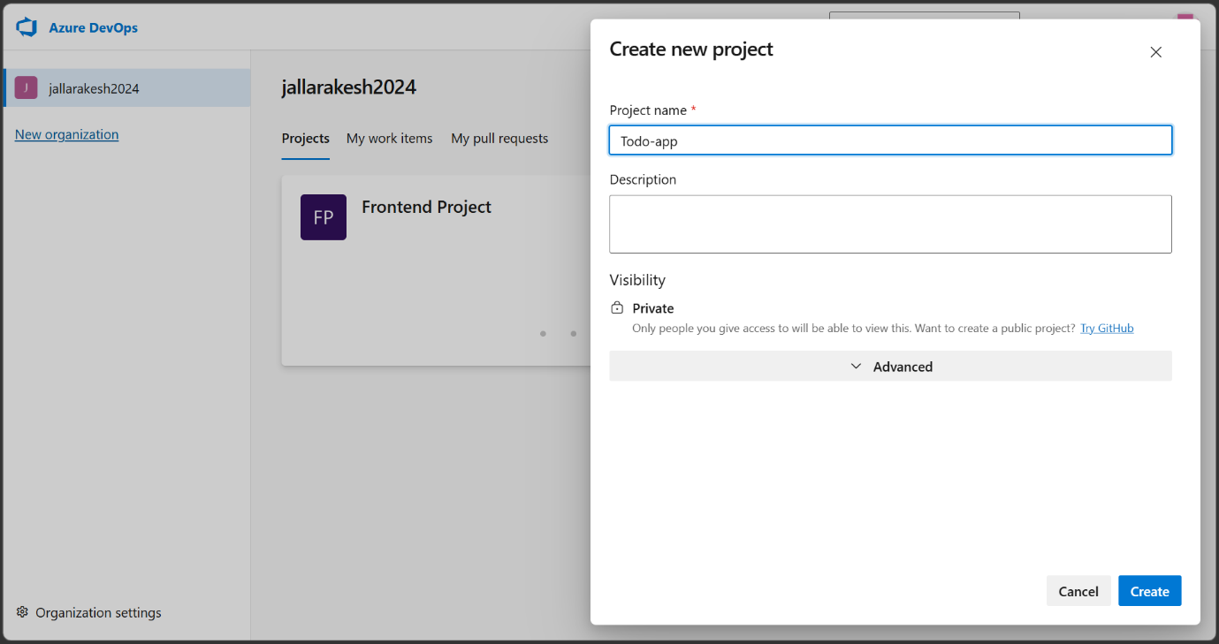
Go to https://dev.azure.com and log in with your student account.
Click on your organization name (e.g., jallarakesh2024).
Click the "+ New Project" button on the top right.
Enter the Project name as "Todo-app", set Visibility to Private.
Click "Create" to create the project.
Note: A project in Azure DevOps is a container that holds your repos, pipelines, boards, and more.

Step 2: Create Project Files in VS Code
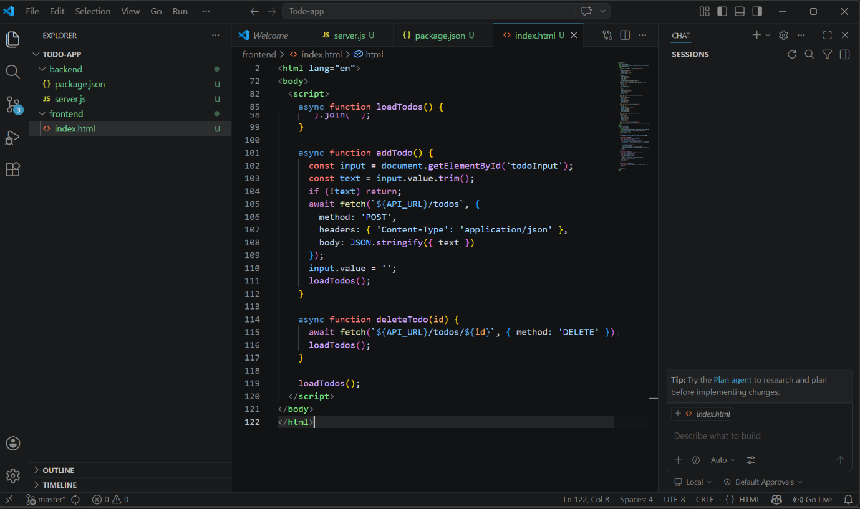
Open VS Code and clone the Azure DevOps repository to your local machine.
Create the folder structure: backend/ and frontend/ folders inside the root.
Inside backend/, create server.js and package.json files.
Inside frontend/, create index.html file.
Add all the required code to each file as provided.
Note: The backend folder contains the Node.js Express API code. The frontend folder contains the HTML UI that users will interact with.

Step 3: Push Code to Azure DevOps Repository
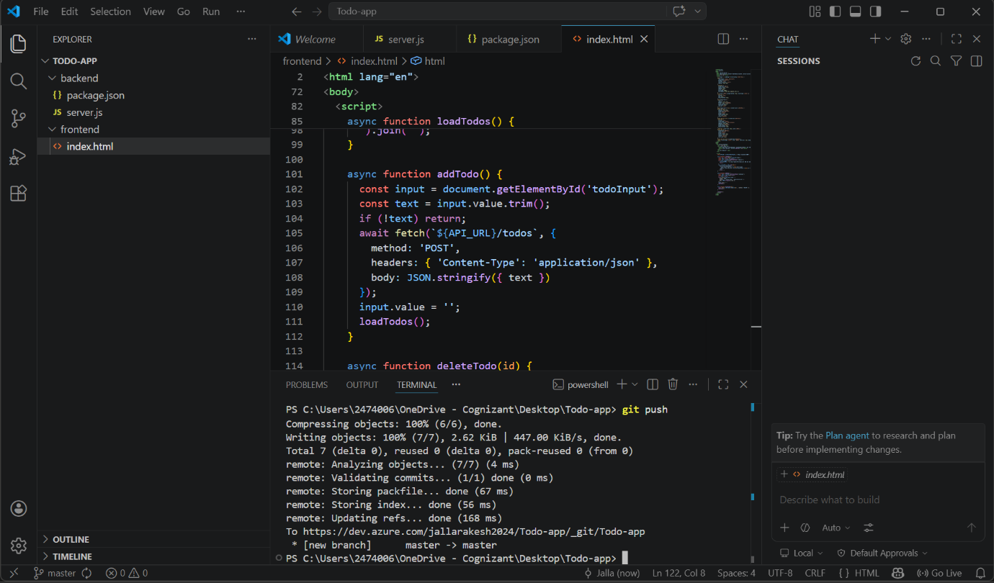
Open the VS Code terminal (Ctrl + `)
Run the following commands to push your code:
git add .
git commit -m "first commit"
git push
Verify the push was successful — you should see "master -> master" in the terminal output.
Note: This pushes all your local files (server.js, package.json, index.html) to the Azure DevOps remote repository.

Step 4: Verify Files in Azure DevOps Repo
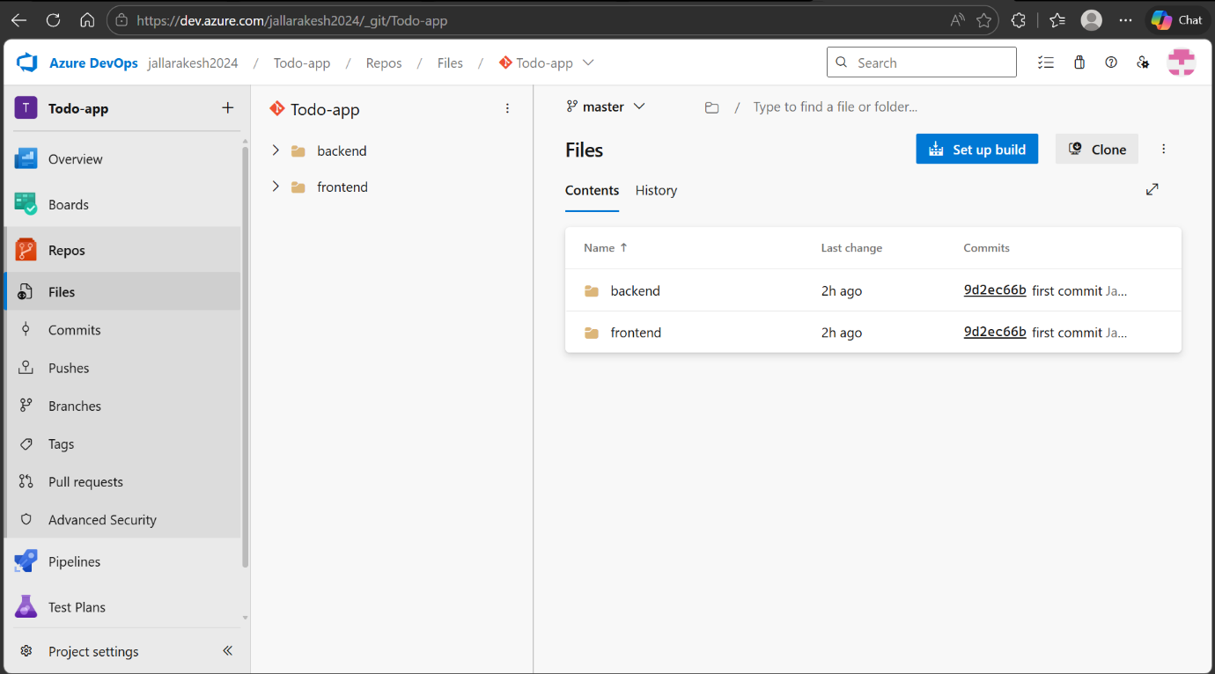
Go to Azure DevOps → Repos → Files.
You should see two folders: backend and frontend in the repository.
Click on each folder to verify the files are present.
Note: This confirms that your code has been successfully pushed to the Azure DevOps repository.

Step 5: Create Azure App Service — Fill in Basics
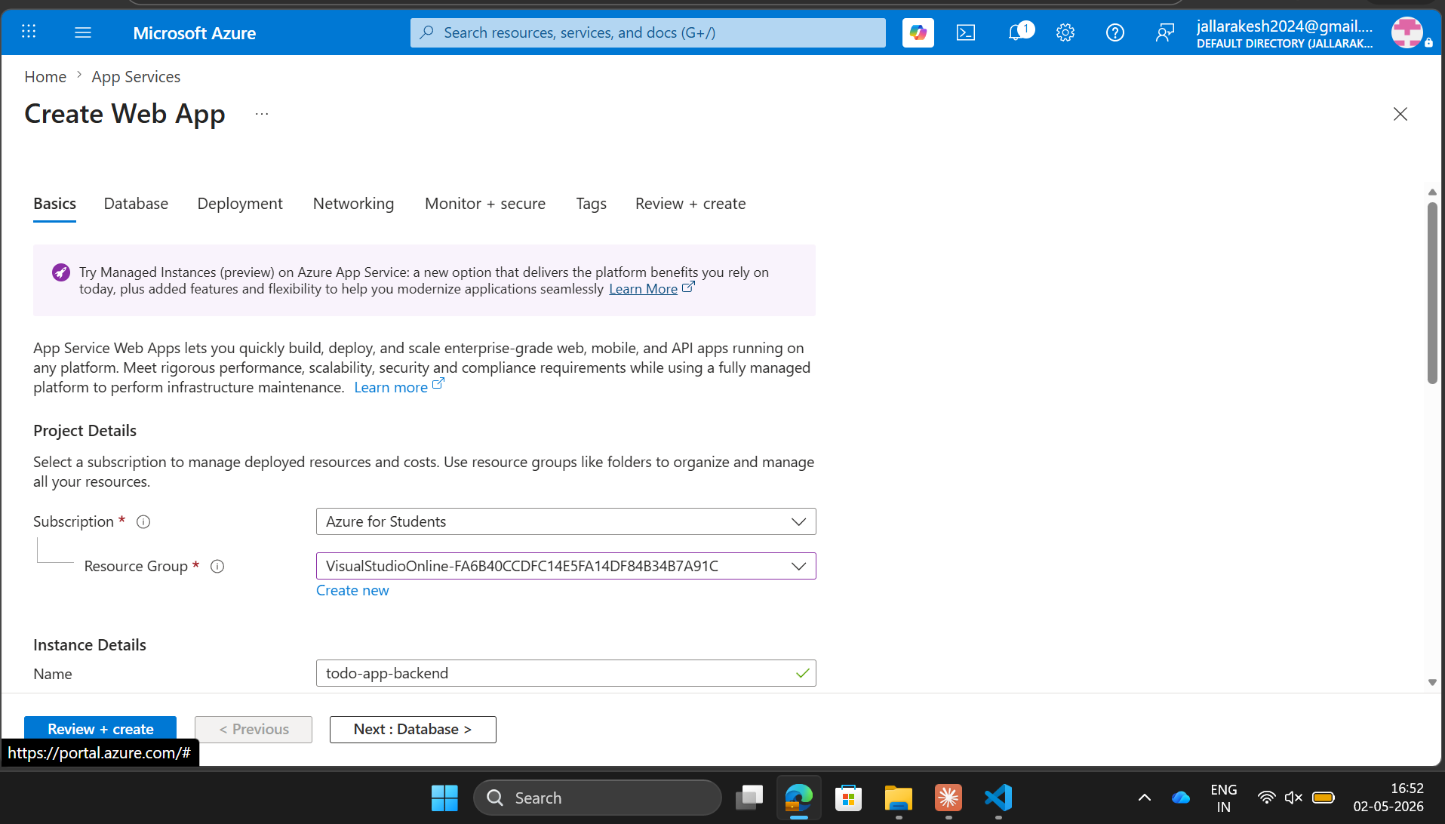
Go to https://portal.azure.com and log in.
Click "+ Create a resource" and search for "Web App".
Click "Create" to open the Web App creation form.
Fill in the details: Subscription = Azure for Students, Name = todo-app-backend.
Set Publish = Code, Runtime stack = Node.js, OS = Linux.
Note: The App Service Plan determines the pricing tier. Use F1 (Free) for student accounts to avoid charges.

Step 6: App Service Deployment Failed — Region Issue
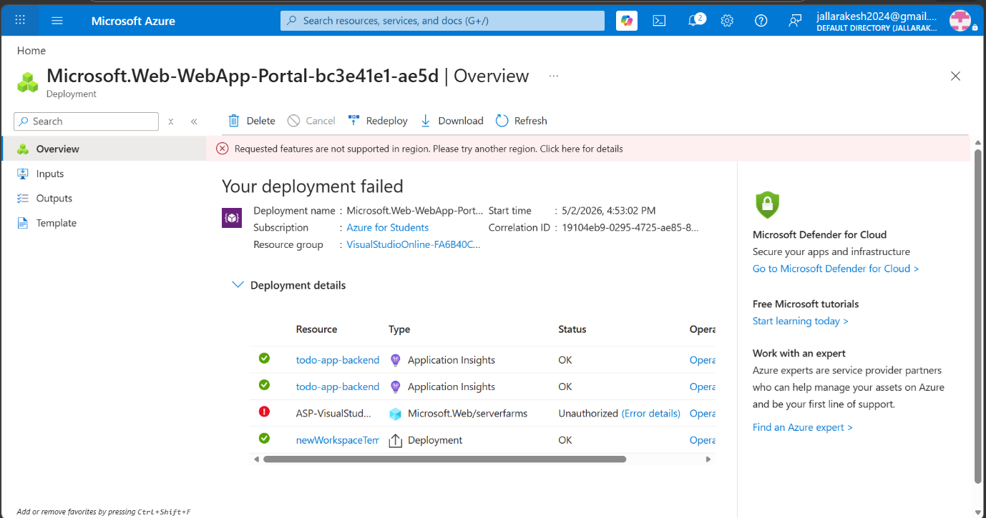
If you see "Requested features are not supported in region", the selected region does not support the F1 free tier.
Click "< Previous" to go back to the Basics tab.
Change the Region to a different one (e.g., Austria East, West Europe).
Try clicking "Review + Create" again.
Note: Azure for Students subscriptions have restricted regions. Try different regions until the deployment succeeds.

Step 7: App Service Created Successfully
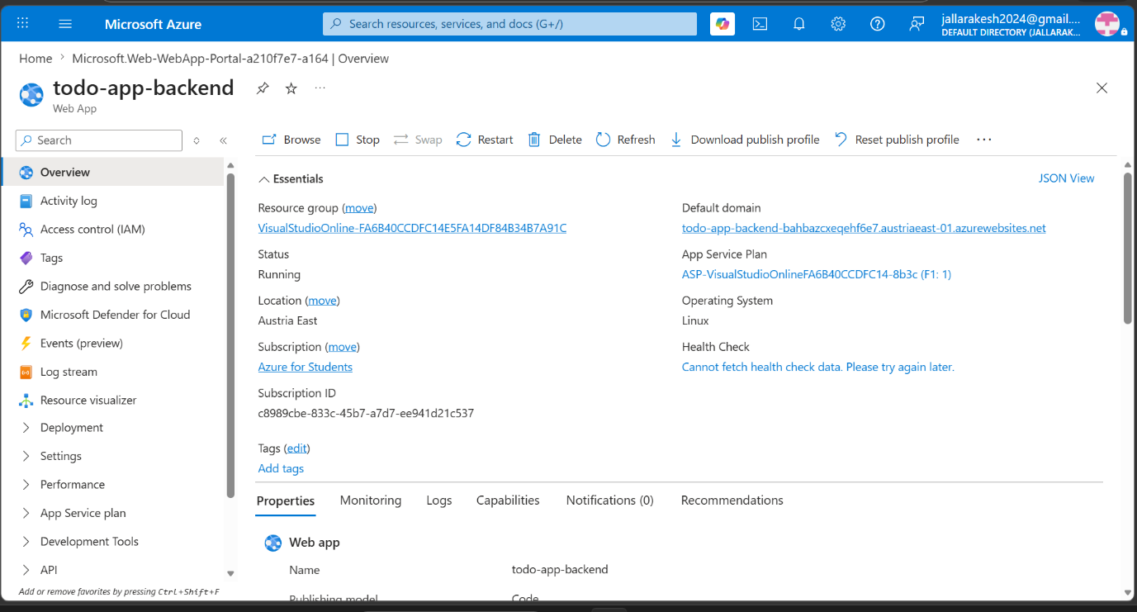
Once the region is corrected, the App Service is created successfully.
You can see the App Service overview with Status = Running.
Note down the Default domain URL (e.g., todo-app-backend-xxx.austriaeast-01.azurewebsites.net).
This URL will be used to access the backend API.
Note: The App Service Plan shown as "F1:1" confirms the free tier is being used.

Step 8: Create Azure Storage Account
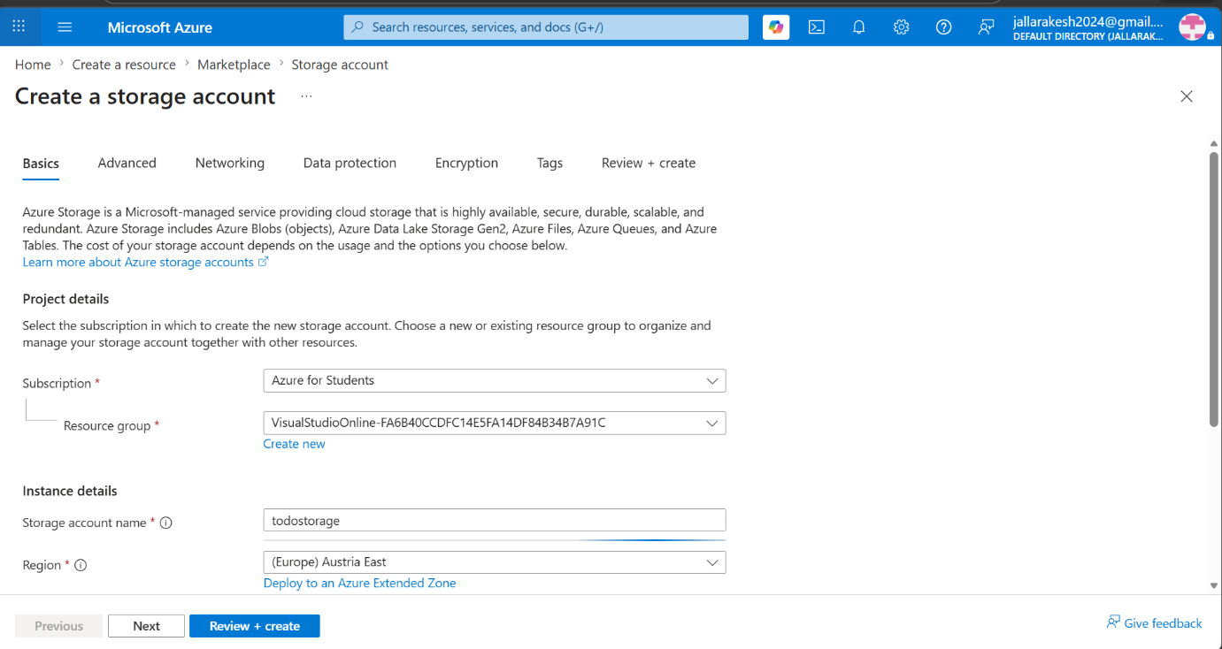
In Azure Portal, click "+ Create a resource" and search for "Storage account".
Click "Create" to open the storage account creation form.
Fill in: Resource Group = todo-app-rg, Storage account name = storagetodoapp.
Set Region = Austria East (same as App Service), Performance = Standard, Redundancy = LRS.
Click "Review + Create" then "Create".
Note: Using the same region as the App Service ensures faster and more reliable communication between the app and storage.

Step 9: Storage Account Created Successfully
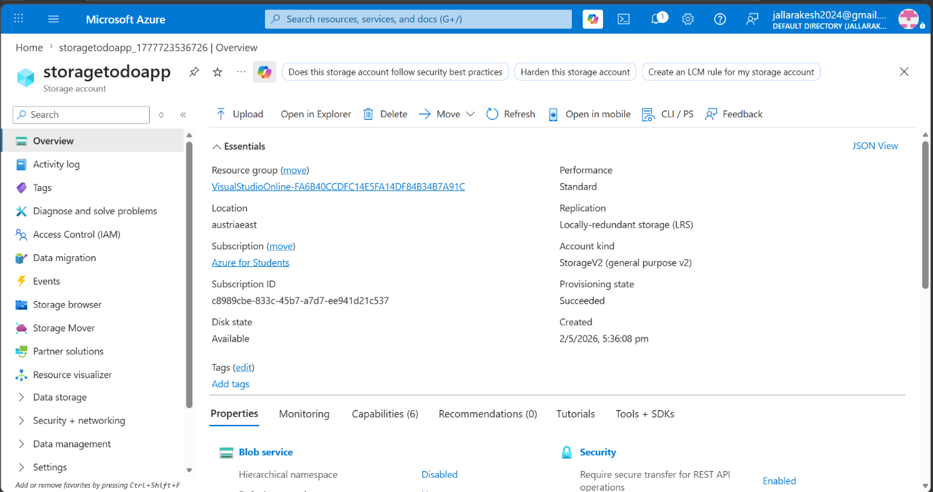
After creation, the Storage Account overview page shows Provisioning state = Succeeded.
Note the storage account name (storagetodoapp) and location (austriaeast).
Click on "Data storage" → "Containers" in the left panel to create a container.
Note: Blob Storage stores unstructured data like files and JSON. We will use it to store our todos.json file.

Step 10: Create a Blob Container
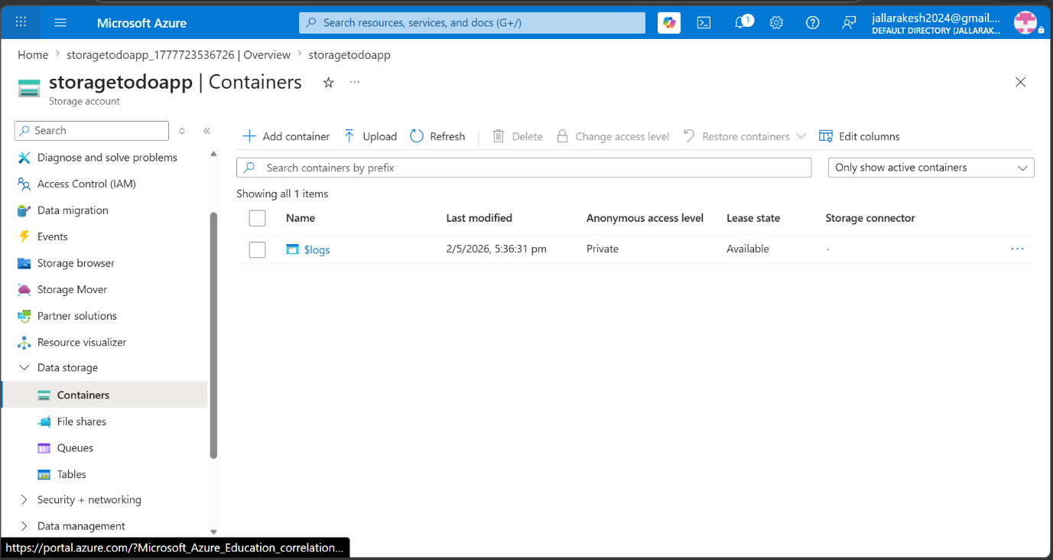
In the Storage Account, go to "Data storage" → "Containers".
Click "+ Container" to open the New Container panel.
Enter the Name as "todos" and set Anonymous access level to Private.
Click "Create".
Note: A container in Blob Storage is like a folder. Our backend will read and write todos.json inside this "todos" container.

Step 11: Get Storage Account Connection String
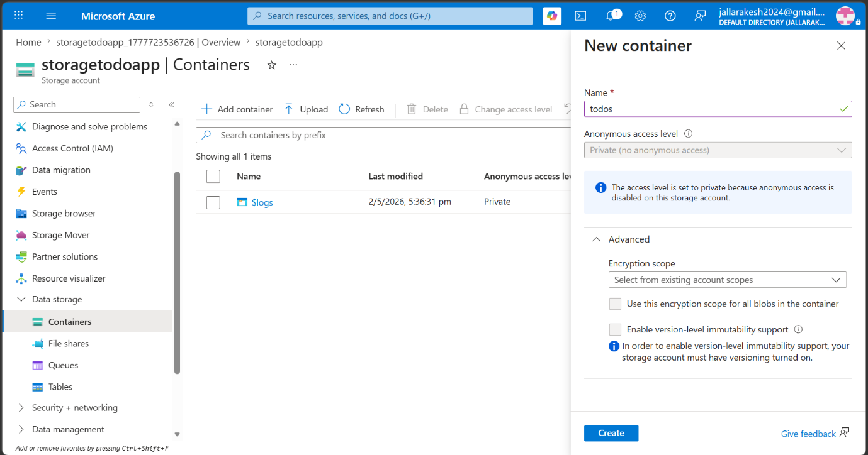
In the Storage Account, go to "Security + networking" → "Access keys".
Click "Show" next to the Connection string under key1.
Click the copy icon to copy the full connection string.
The connection string format is: DefaultEndpointsProtocol=https;AccountName=...;AccountKey=...;EndpointSuffix=core.windows.net
Note: Never share this connection string publicly. It gives full access to your storage account.

Step 12: Add Connection String to App Service Environment Variables
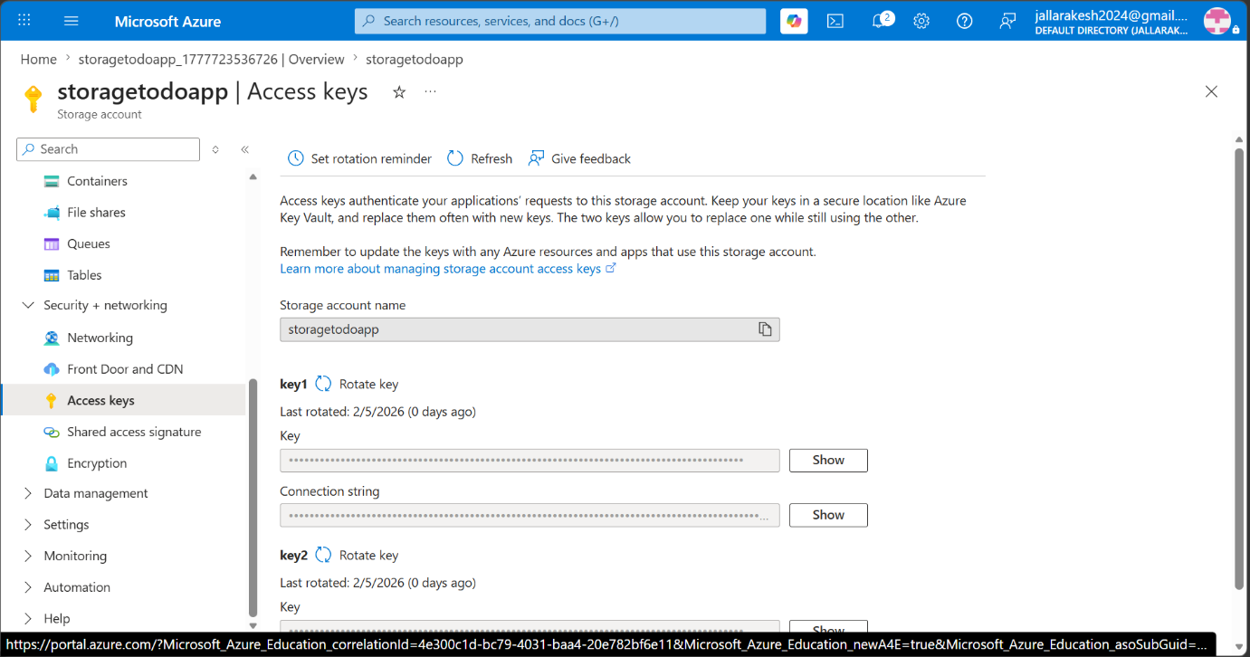
Go to the todo-app-backend App Service.
In the left panel, click "Settings" → "Environment variables".
Click "+ Add" to add a new environment variable.
Set Name = STORAGE_CONNECTION_STRING and paste the connection string as the Value.
Click "Apply" then "Confirm" to save.
Note: Environment variables allow the backend code to securely access the storage connection string without hardcoding it in the code.

Step 13: Adding Connection String in Environmental variables
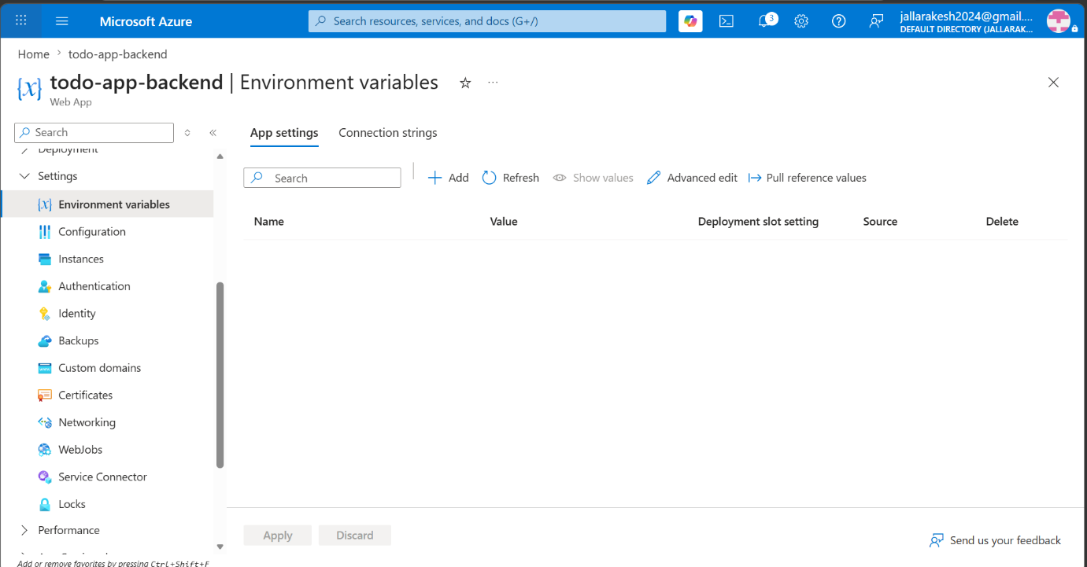
In Azure DevOps, go to your project and click "Pipelines" in the left panel.
Click "Create Pipeline".
Select "Azure Repos Git" as the code source.
Select your "Todo-app" repository.
On the Configure screen, select "Node.js Express Web App to Linux on Azure".
Note: The pipeline automates the build and deployment process. Every time you push code, it automatically deploys to Azure.

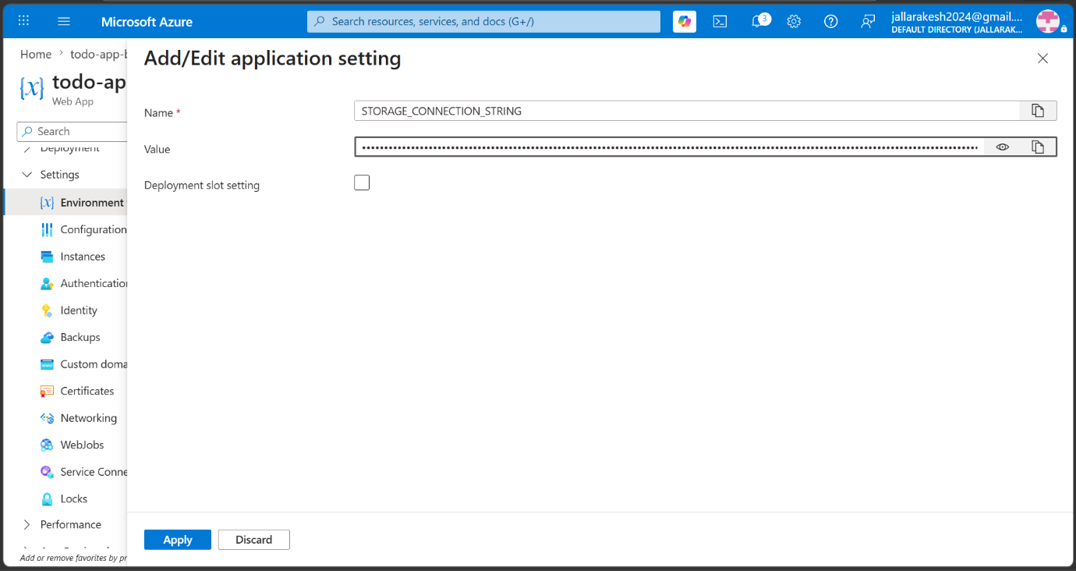
After selecting the Node.js Express template, a popup appears asking for the Web App name.
Select "todo-app-backend" from the dropdown.
Click "Validate and configure".
Note: Azure DevOps automatically creates a Service Connection to your Azure subscription when you validate here.

Step 15: Review and Update Pipeline YAML
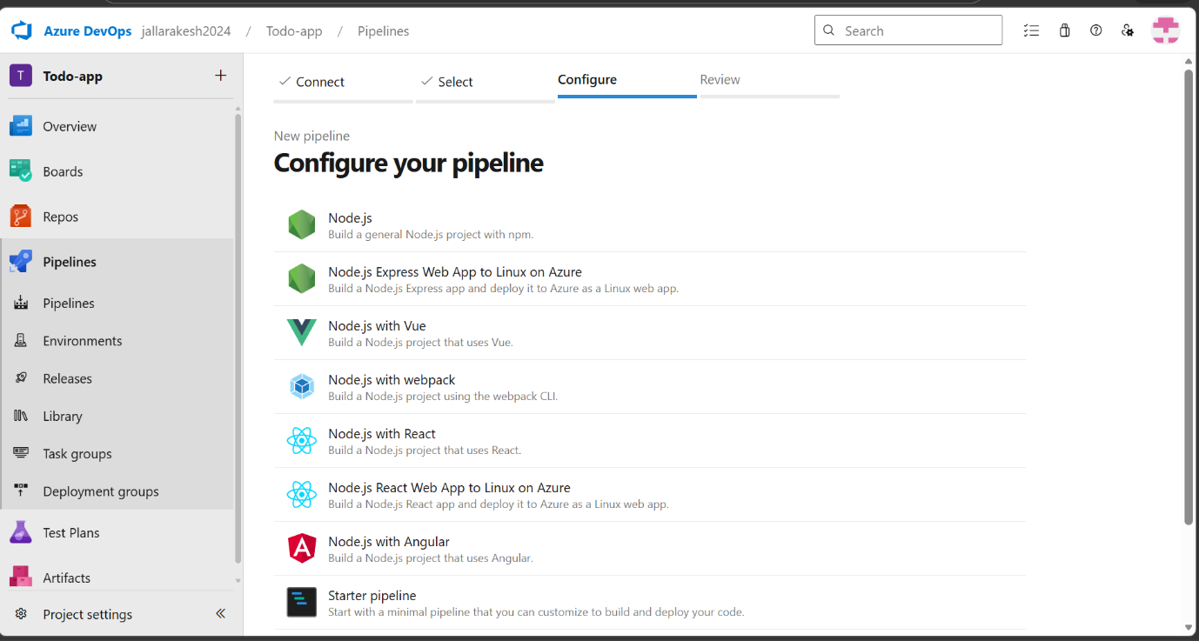
Azure DevOps generates a YAML pipeline file automatically.
Review the generated YAML code.
Update the trigger branch from "master" to "main" if your branch is named "main".
Update the rootFolderOrFile path to point to the "backend" folder.
Add the cd backend command in the npm install step.
Click "Save and run" to save and trigger the pipeline.
Note: The YAML file defines all build and deploy steps. It is stored as azure-pipelines.yml in your repository.

Step 16: Pipeline Running — Build and Deploy Stages
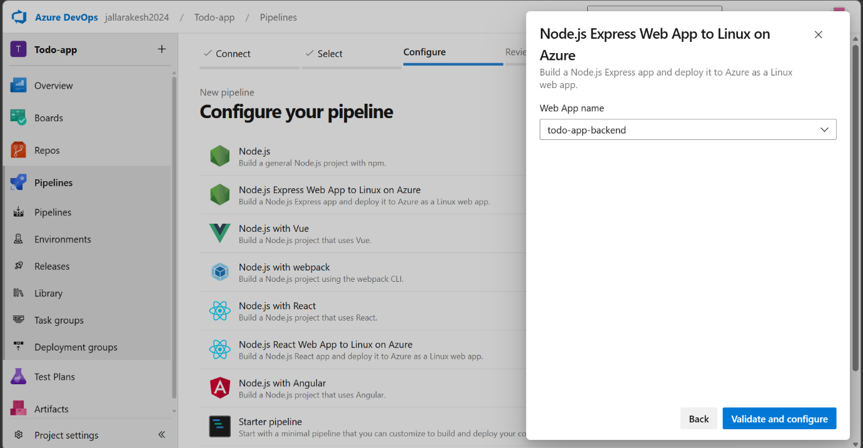
After saving, the pipeline starts running automatically.
You can see two stages: Build stage and Deploy stage.
Wait for both stages to show a green checkmark.
Build stage compiles and packages the code. Deploy stage sends it to Azure App Service.
Note: The first pipeline run may take 3-5 minutes. Subsequent runs are faster.

Step 17: Pipeline Completed Successfully
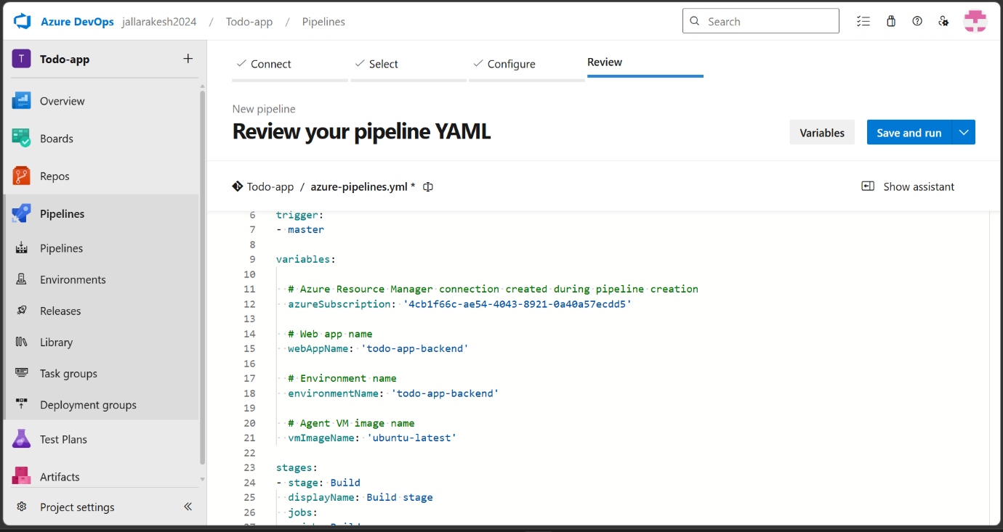
Both Build stage and Deploy stage show green checkmarks.
Build stage completed in ~26 seconds, Deploy stage in ~2 minutes 39 seconds.
The backend is now deployed to Azure App Service.
Note: Any future code pushes to the main branch will automatically trigger a new pipeline run and redeploy.

Step 18: Verify Backend is Running — /todos Endpoint
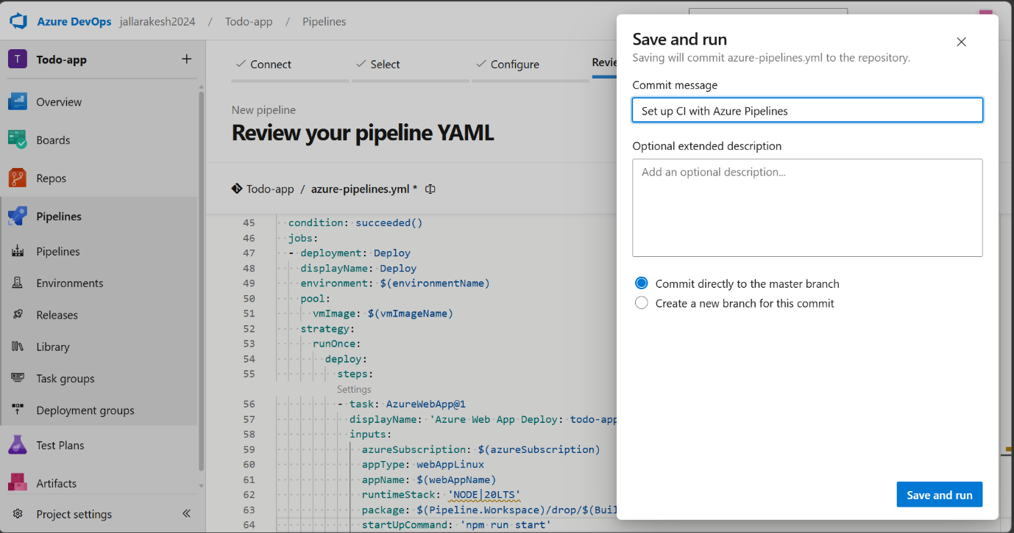
Open the browser and navigate to: https://todo-app-backend-xxx.austriaeast-01.azurewebsites.net/todos
You should see an empty JSON array: []
This confirms the backend is running and connected to Blob Storage successfully.
Note: The empty array means there are no todos yet — this is correct. The backend is ready to accept requests.

Step 19: Mult staging Pipeline Runs Successfully
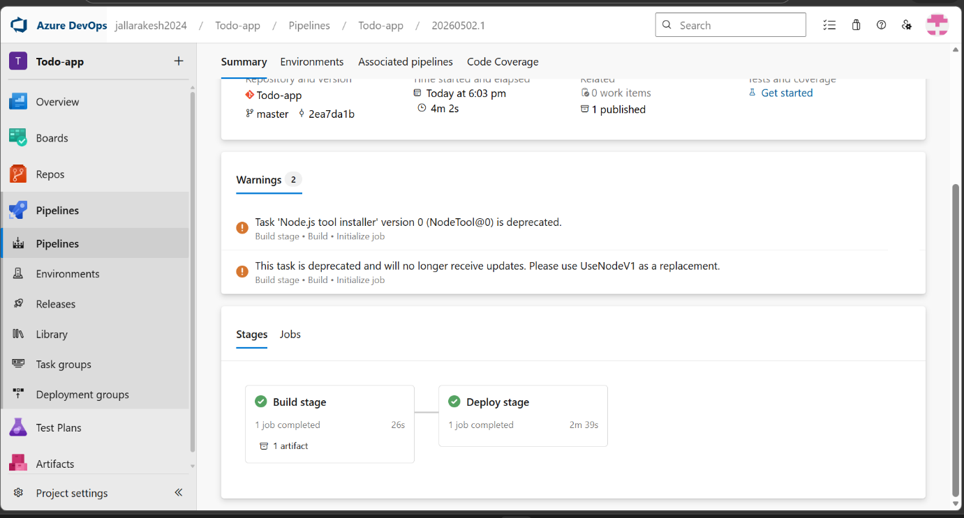
Open the VS Code terminal and run:
git add .
git commit -m "updated frontend API URL"
git push
Verify the push was successful in the terminal output.
Note: Pushing triggers the pipeline automatically, which will redeploy the backend with the updated files.

Step 21: Move Frontend to backend/public Folder
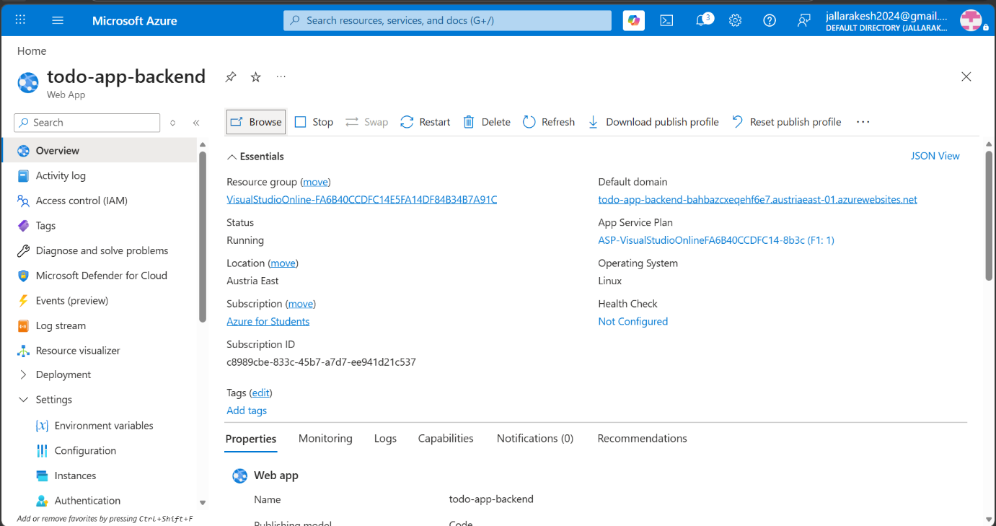
In VS Code, create a new folder called "public" inside the "backend" folder.
Move the index.html file from the "frontend" folder to "backend/public/index.html".
The folder structure should now be: backend/public/index.html
Note: Moving the frontend inside the backend allows the Node.js server to serve the HTML file directly, eliminating the need for a separate hosting service.

Step 20: backend runs successfully
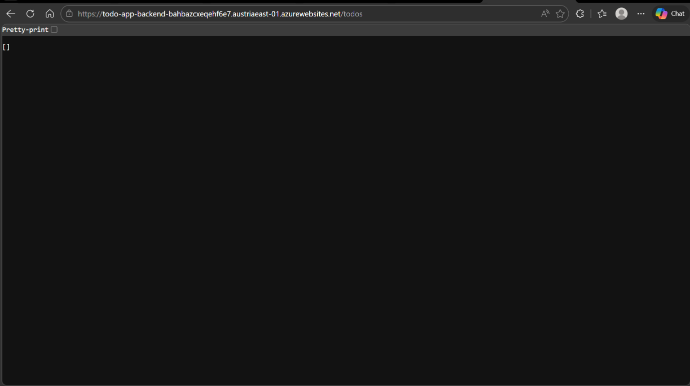
In Azure DevOps Pipelines, you can see all pipeline runs with green status.
Each commit triggers a new pipeline run automatically.
Verify the latest run "moved frontend to backend/public folder" is green.
Note: The pipeline history shows all deployments. This is useful for tracking changes and rolling back if needed.

Step 21: Update Frontend API URL in VS Code

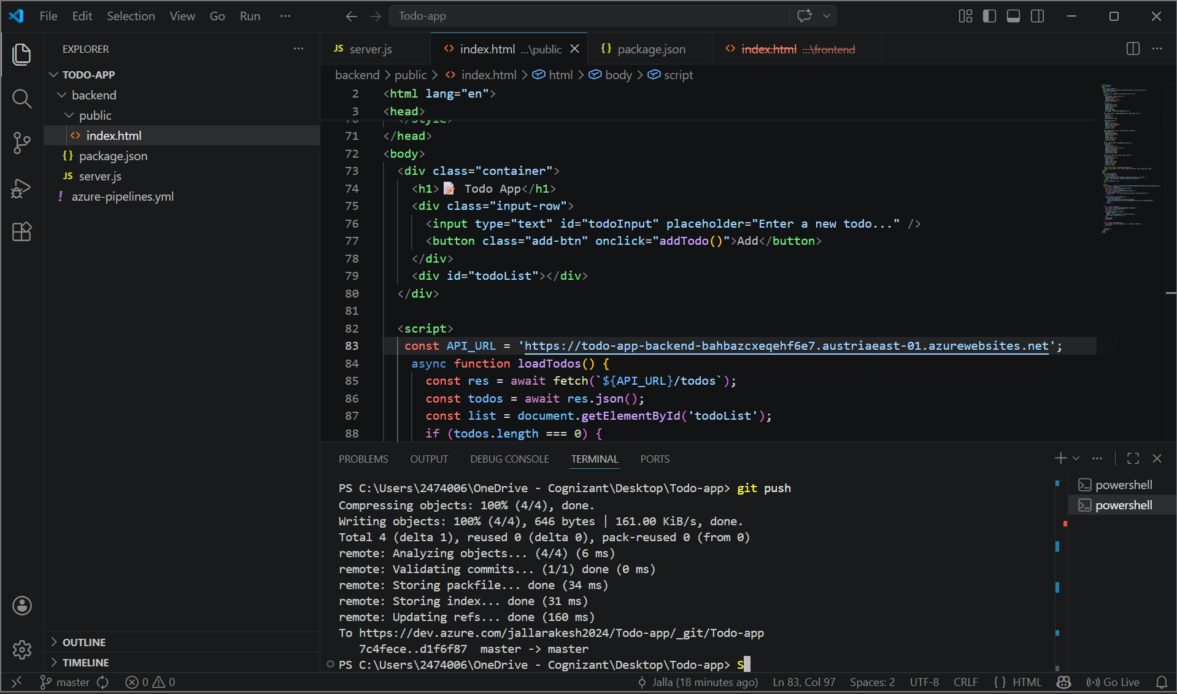

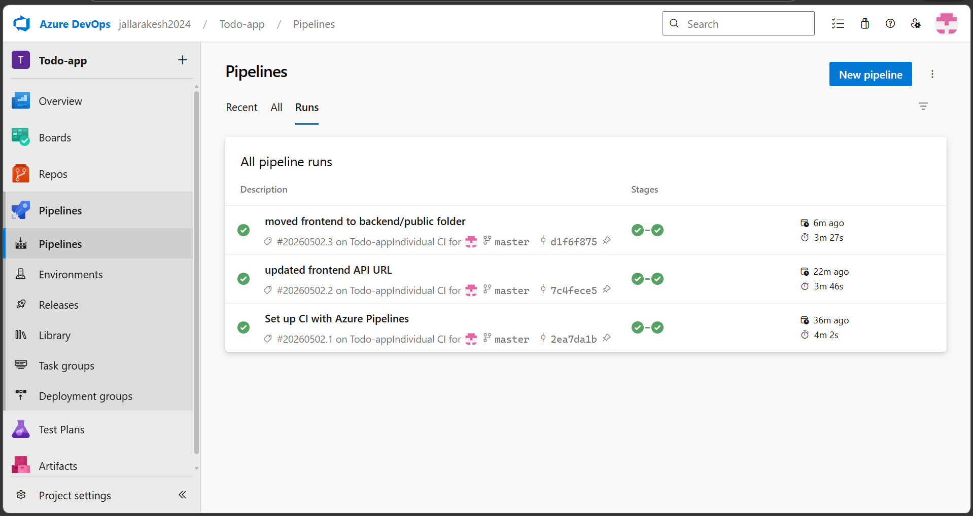

Step 22: App Service Shows Quota Exceeded

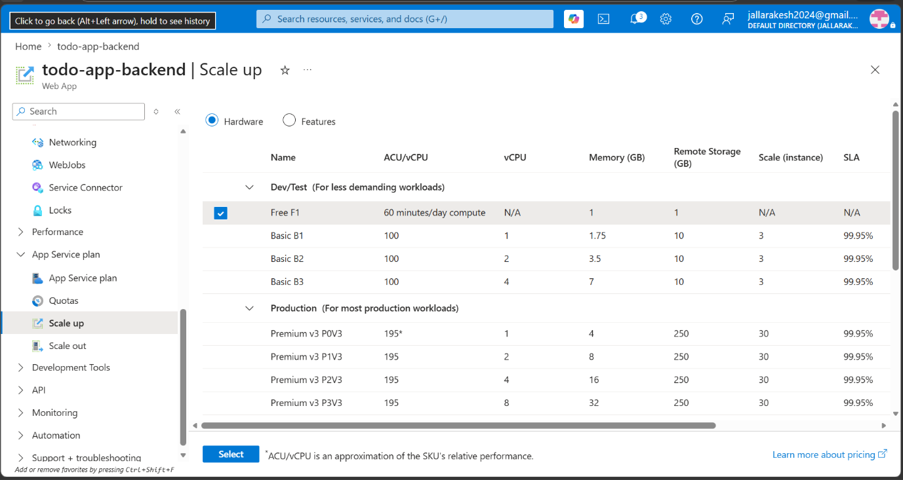
Why we upgraded: The F1 free tier only allows 60 minutes of CPU compute per day. During development and testing, multiple deployments and restarts consumed the daily quota. Once the quota was exhausted, the App Service status changed to "Quota exceeded" and started returning 503 Service Unavailable errors to all users. To resolve this, we upgraded to B1 Basic which provides unlimited compute with 1 vCPU, 1.75 GB memory, and 99.95% SLA uptime guarantee, at an approximate cost of $13 per month from the student Azure credits.

Step 29: Upgrade App Service Plan to B1
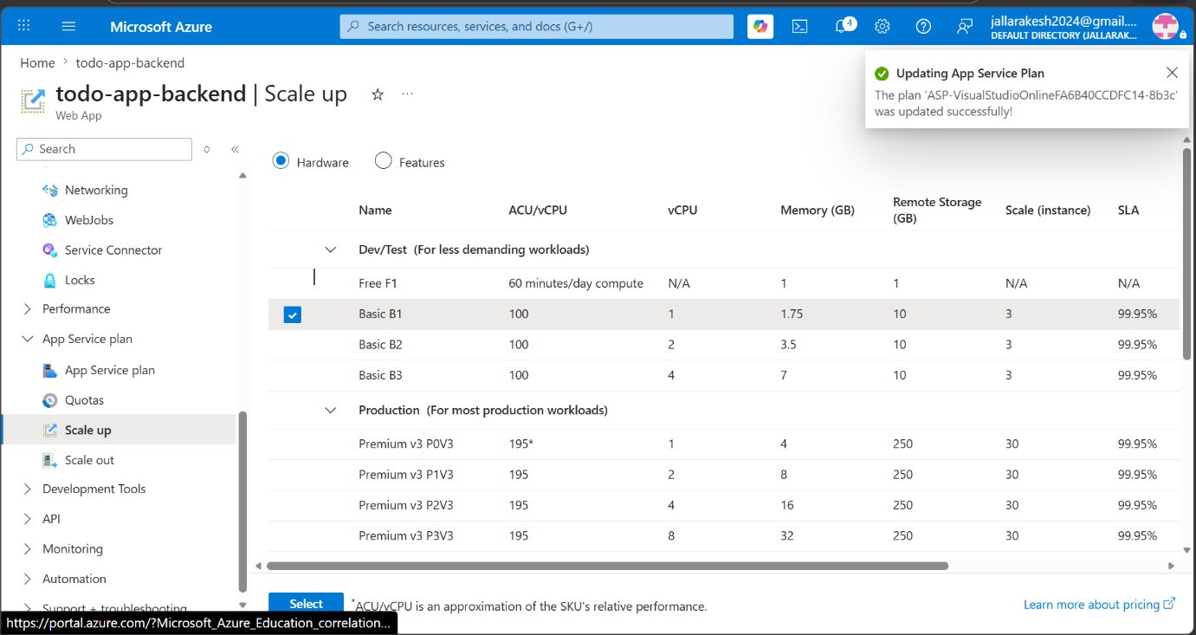

Step 31: Added Storage connection string to pipeline
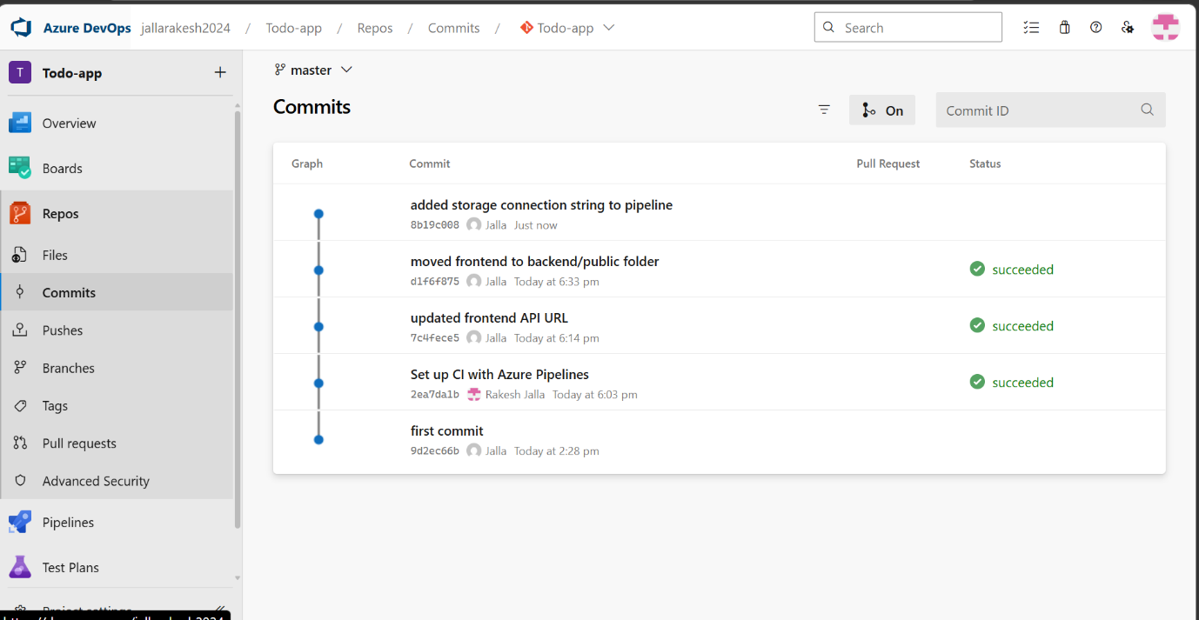

Step 38: Todo App Working — Add and Delete Todos
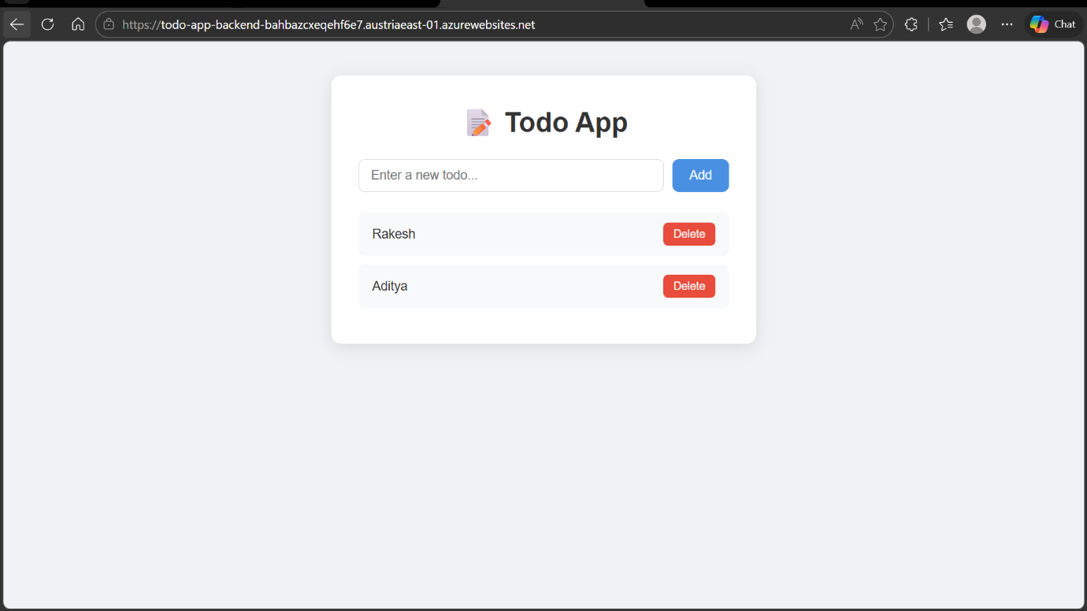
Navigate to: https://todo-app-backend-xxx.austriaeast-01.azurewebsites.net
Type a new todo in the input box and click "Add".
The todo should appear in the list below.
Click "Delete" to remove a todo from the list.
Note: The todos are stored as a JSON file (todos.json) in Azure Blob Storage. They persist even after restarting the App Service.

Step 39: Verify Todos Stored in Azure Blob Storage
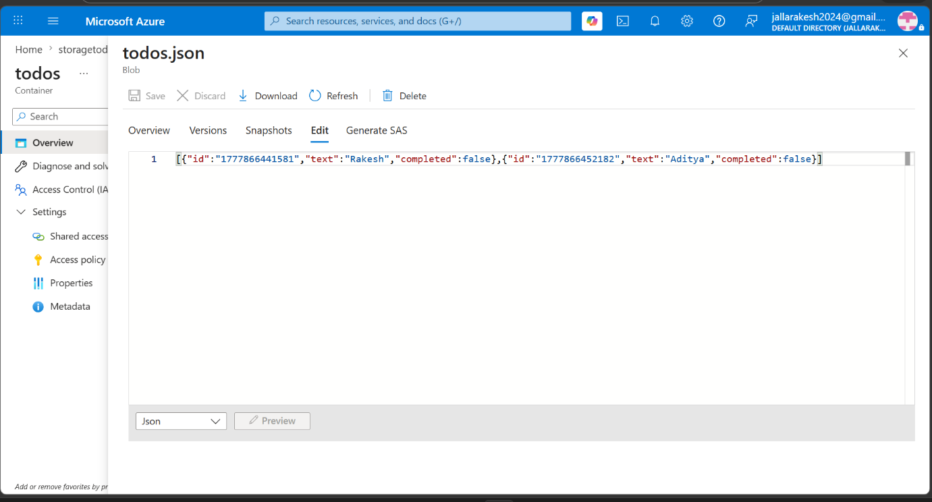
Go to Azure Portal → storagetodoapp Storage Account.
Click "Data storage" → "Containers" → "todos".
You should see todos.json file created inside the container.
Click on todos.json to view its contents and verify the todos are saved correctly.
Note: This confirms the complete flow: Frontend sends requests → Backend processes them → Data is stored in Azure Blob Storage.

Deployment Summary
The complete deployment flow has been established:
User Browser (Frontend) → Azure App Service (Backend) → Azure Blob Storage (Data)

