Deployment of Web Application to Azure VM
Using Azure CI/CD Pipelines
Student Record Manager — Node.js + Express

Step 1: Create the Azure VM
Create an Ubuntu VM in Azure Portal which will be the server where our web application will be deployed and run 24/7.

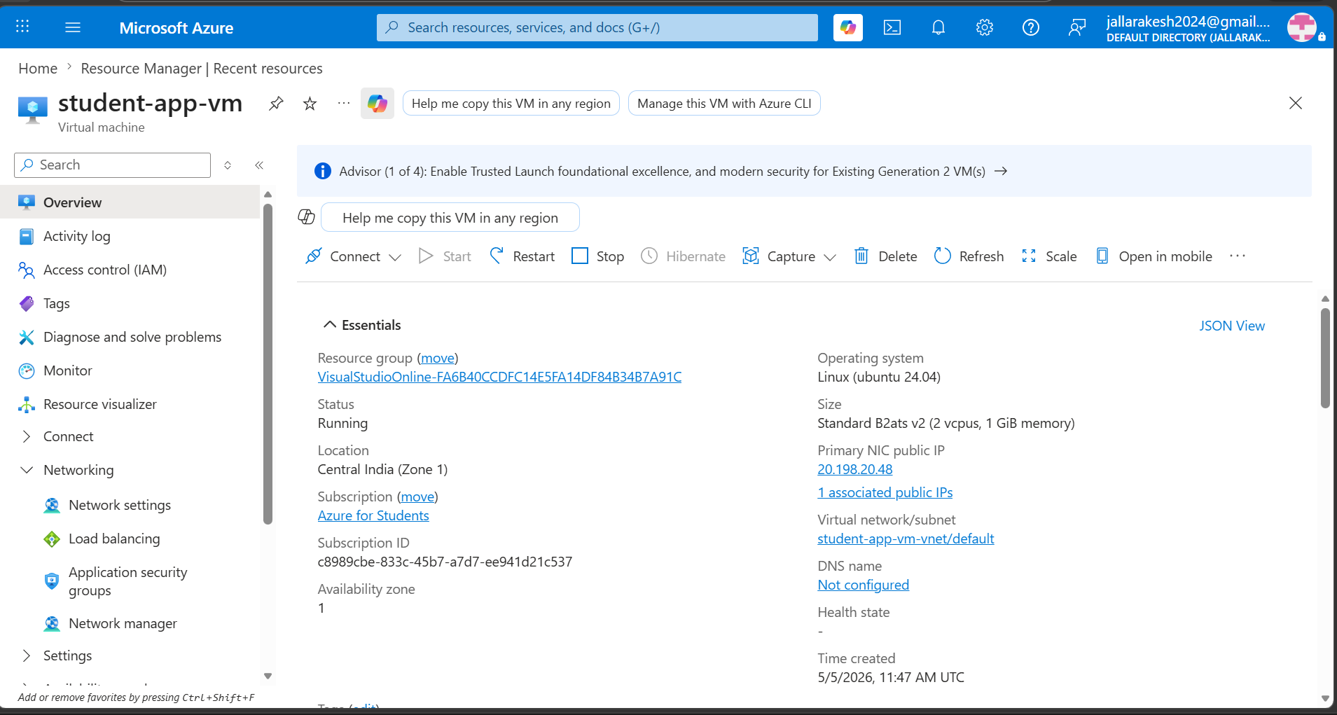

What you can see in the screenshot above:
- VM Name: student-app-vm
- Status: Running
- Location: Central India (Zone 1)
- OS: Linux (Ubuntu 24.04)
- Size: Standard B2ats v2 (2 vCPUs, 1 GiB memory)
- Public IP: 20.198.20.48
- Subscription: Azure for Students

Steps to create the VM:
- Go to portal.azure.com and search for Virtual Machines
- Click Create > Azure Virtual Machine
- Set VM Name to student-app-vm
- Select Region (Central India or East US)
- Choose Ubuntu Server 22.04 LTS as the image
- Select size Standard_B1s or Standard_B2ats
- Set authentication type to SSH public key and username to bucky
- Under Networking, allow inbound ports: 22 (SSH) and 80 (HTTP)
- Click Review + Create then Create
- Download the .pem key file when prompted

Step 2: Create the Node.js Application
Create a simple Node.js + Express web application called Student Record Manager locally using VS Code.

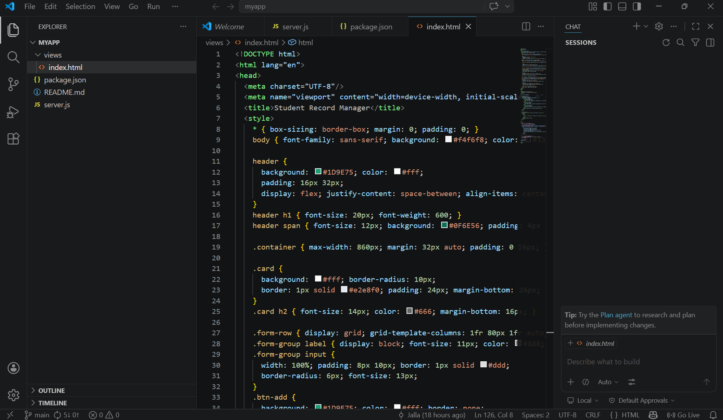

What you can see in the screenshot above:
- VS Code editor is open with the myapp project
- Project files: server.js, package.json, views/index.html
- index.html contains the frontend HTML and CSS for the Student Record Manager UI
- The app uses Express.js framework

File structure of the application:
- server.js — Main Express server with all API routes
- package.json — Node.js project configuration and dependencies
- views/index.html — Frontend HTML page with CSS styling
- .gitignore — Excludes node_modules from Git
- azure-pipelines.yml — CI/CD pipeline configuration

The application has these API endpoints:
- GET / — Serves the main HTML page
- GET /students — Returns list of all students as JSON
- POST /students — Adds a new student
- DELETE /students/:id — Deletes a student by ID
- GET /health — Health check endpoint used by the pipeline

Step 3: Push Code to Azure Repos
Push the application code to Azure Repos (Git repository in Azure DevOps) so the CI/CD pipeline can access it.

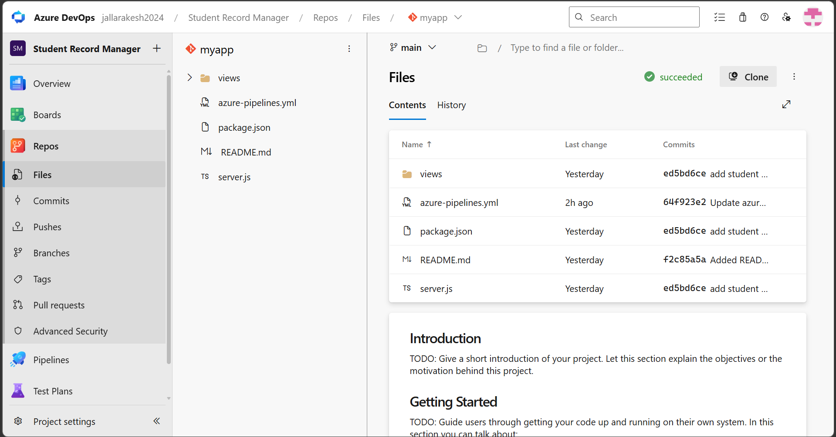

What you can see in the screenshot above:
- Azure Repos showing the myapp repository
- All project files are visible: views/, azure-pipelines.yml, package.json, README.md, server.js
- Branch: main
- Latest commit: 64f923e2 — pipeline successfully ran (shows green tick "succeeded")
- The repository is under the Student Record Manager project in jallarakesh2024 organization

Steps to push code to Azure Repos:
- Go to dev.azure.com and create a new project called Student Record Manager
- Go to Repos and copy the remote URL
- Open terminal in your project folder and run:
- git init
- git add .
- git commit -m "add student record manager app"
- git remote add origin YOUR_REPO_URL
- git push -u origin main
- Verify all files appear in Azure Repos under Repos > Files

Step 4: Build Pipeline — Success
The Build pipeline automatically triggers on every git push to main branch. It installs dependencies, zips the app, and publishes the artifact.

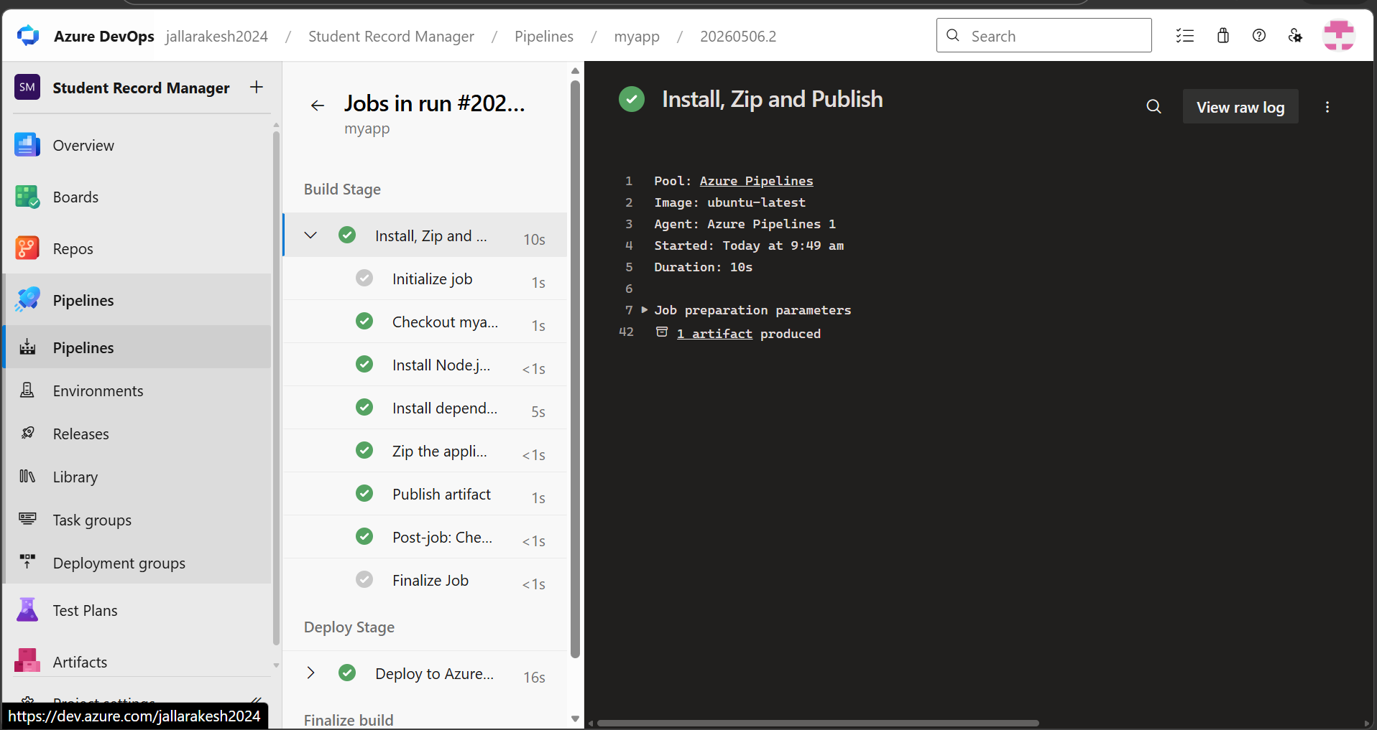

What you can see in the screenshot above:
- Build Stage is running with all steps green (success)
- Steps completed: Initialize job, Checkout, Install Node.js, Install dependencies, Zip the application, Publish artifact
- Pool: Azure Pipelines (Microsoft-hosted agent)
- Image: ubuntu-latest
- Duration: 10 seconds
- 1 artifact produced (myapp.zip)
- Deploy Stage is also visible below and completed in 16 seconds

The azure-pipelines.yml Build Stage configuration:
- trigger: auto runs on push to main branch
- UseNode@1: installs Node.js version 20.x
- npm install: installs all dependencies from package.json
- ArchiveFiles@2: zips entire app into myapp.zip
- PublishBuildArtifacts@1: uploads myapp.zip as myapp-drop artifact

Step 5: Setup VM — Install Node.js, PM2 and Nginx
SSH into the Azure VM and install all required software: Node.js to run the app, PM2 to keep it alive, and Nginx as the reverse proxy on port 80.

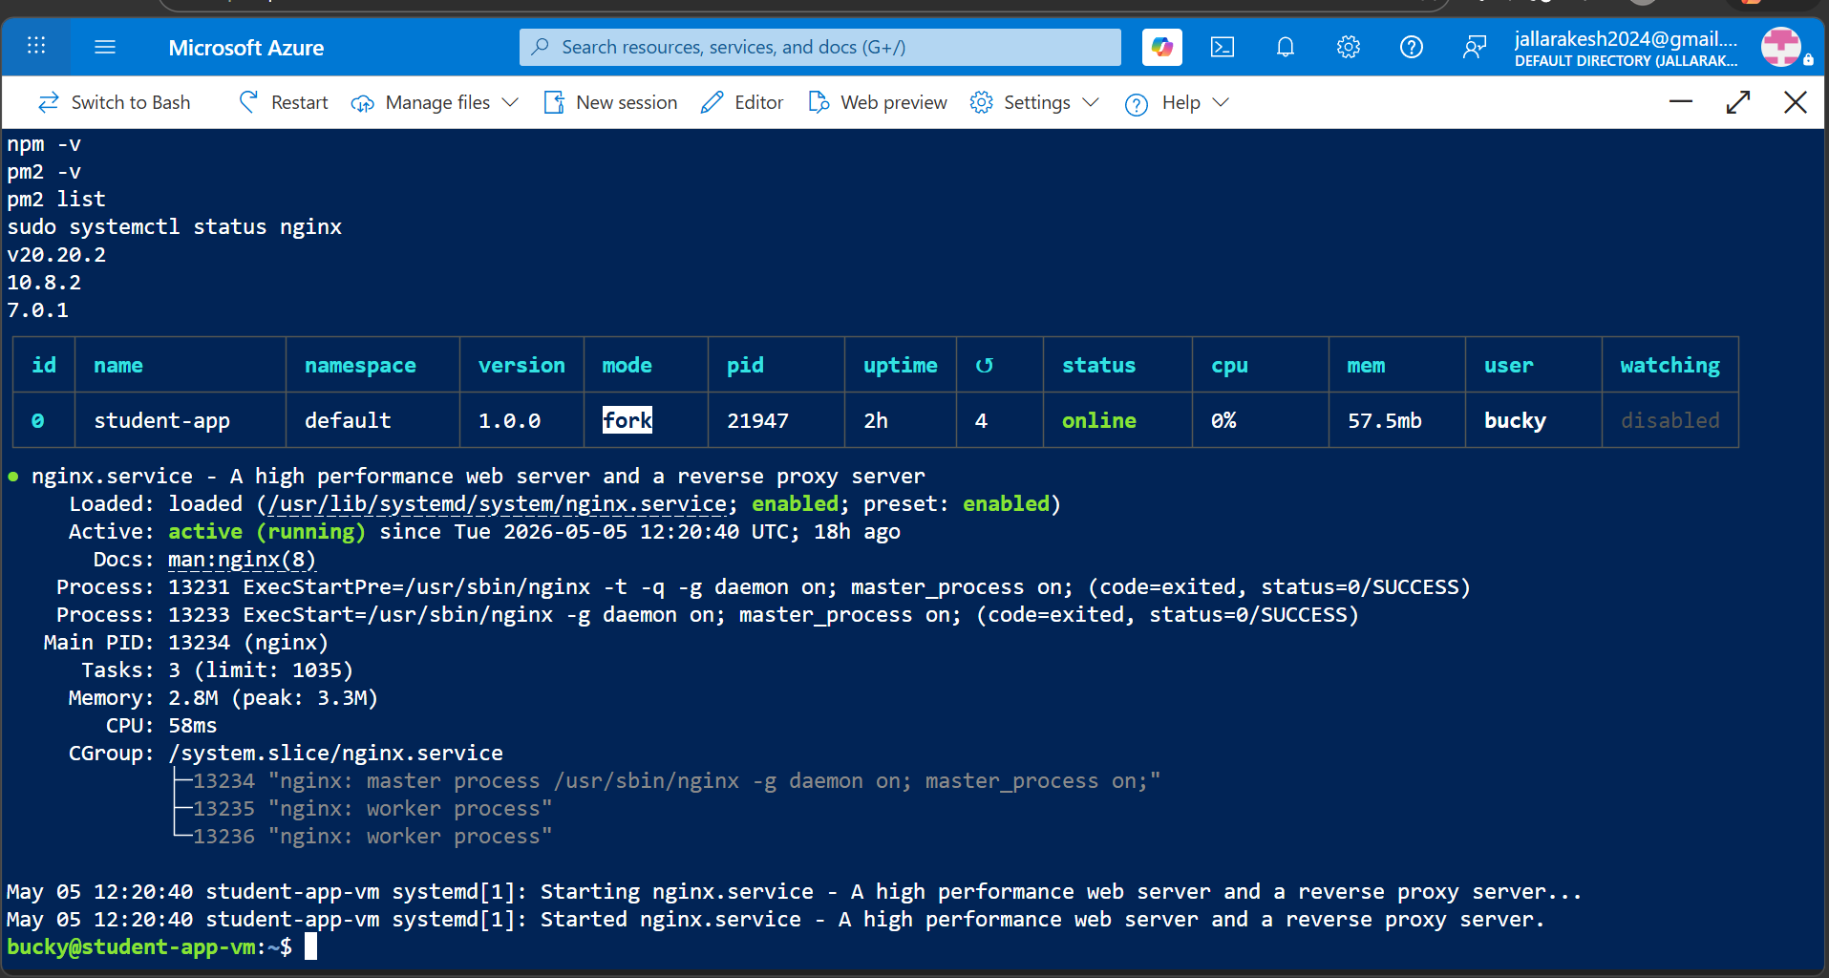

What you can see in the screenshot above:
- npm -v showing version 20.20.2 (Node.js 20 installed successfully)
- npm -v showing version 10.8.2
- pm2 -v showing version 7.0.1
- pm2 list showing student-app is online with status online, running for 2h, using 57.5mb memory
- nginx.service is active (running) — started on Tue 2026-05-05 12:20:40
- Nginx enabled and running as a systemd service

Commands run on the VM to setup the environment:
- sudo apt update && sudo apt upgrade -y
- curl -fsSL https://deb.nodesource.com/setup_20.x | sudo -E bash -
- sudo apt install -y nodejs
- sudo npm install -g pm2
- sudo apt install -y nginx unzip
- sudo systemctl start nginx && sudo systemctl enable nginx
- sudo mkdir -p /var/www/myapp
- sudo chown -R bucky:bucky /var/www/myapp
- sudo chmod -R 755 /var/www/myapp

Nginx reverse proxy configuration (/etc/nginx/sites-available/myapp):
- listen 80 — Nginx listens on port 80 (default HTTP port)
- proxy_pass http://localhost:3000 — forwards all requests to Node.js app on port 3000
- This allows users to access the app via http://20.198.20.48 without typing the port number

Step 6: Create SSH Service Connection
Create an SSH service connection in Azure DevOps so the pipeline can securely connect to the VM and deploy the application without needing an agent installed on the VM.

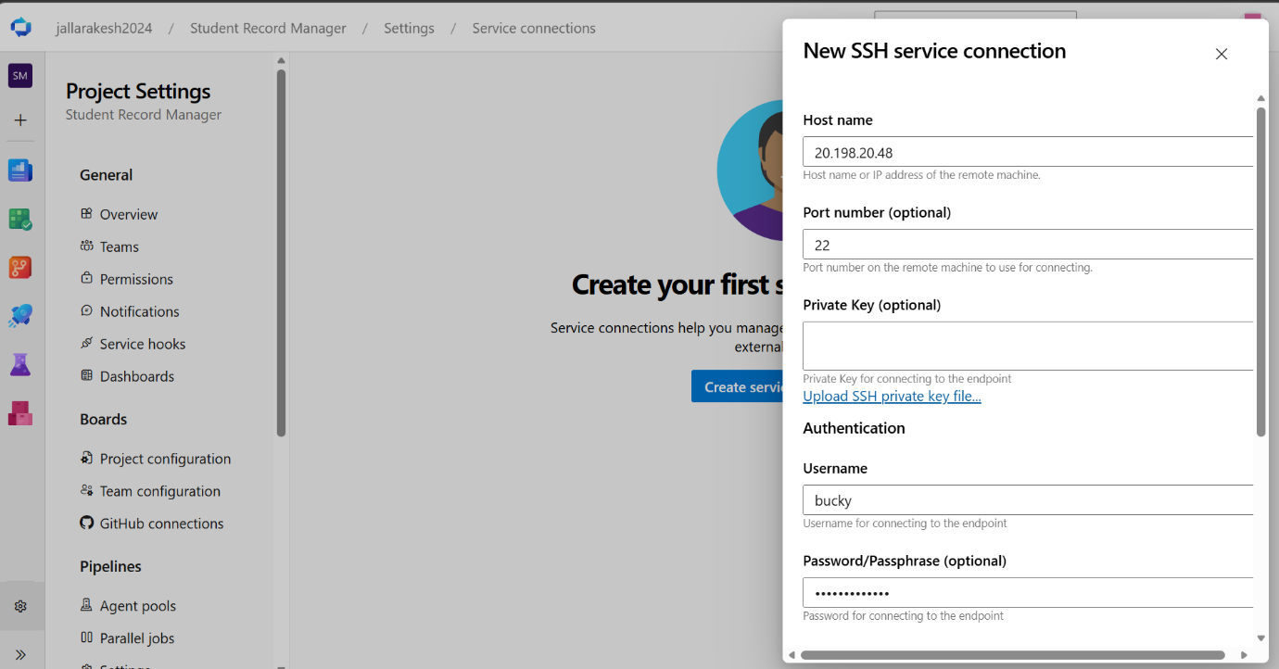

What you can see in the screenshot above:
- New SSH service connection form is open
- Host name: 20.198.20.48 (VM public IP address)
- Port number: 22 (default SSH port)
- Private Key: optional (left empty)
- Username: bucky (VM username)
- Password: filled in (VM password set via Azure Portal Reset password)

Steps to create the SSH service connection:
- Go to Azure DevOps > Project Settings > Service connections
- Click New service connection
- Search for SSH and select it
- Fill in Host name with your VM public IP (20.198.20.48)
- Set Port to 22
- Enter username as bucky
- Enter your VM password
- Scroll down and set Service connection name to vm-ssh
- Tick Grant access permission to all pipelines
- Click Save

Why SSH service connection instead of an agent?
- No need to install anything on the VM
- Pipeline connects to VM using SSH (like logging in from terminal)
- Copies files and runs commands directly on the VM
- Simpler setup — just VM IP, username and password

Step 7: Full Pipeline Success — Both Stages Green
The complete multi-stage CI/CD pipeline runs successfully. The Build stage compiles and packages the app, and the Deploy stage copies it to the Azure VM and restarts it.

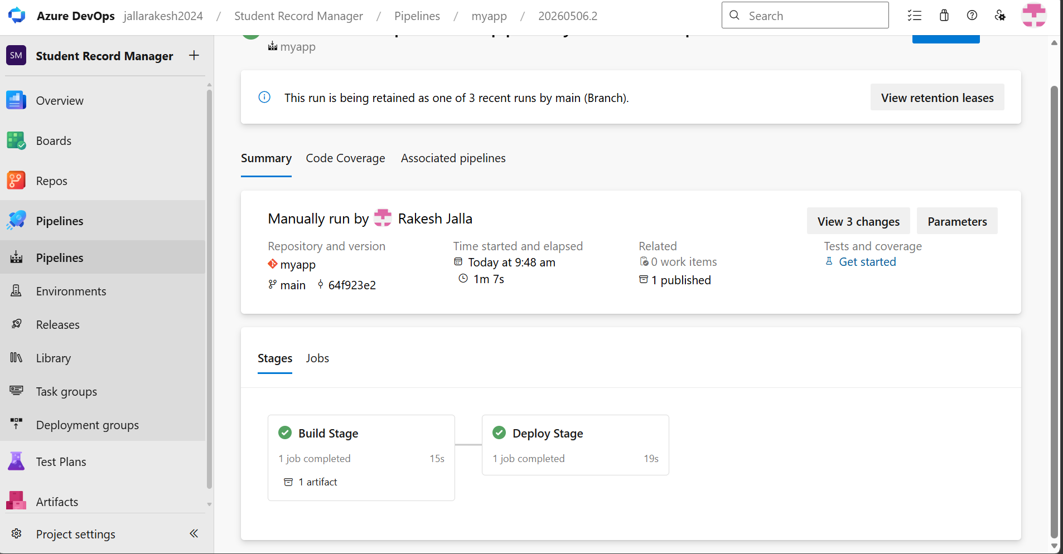

What you can see in the screenshot above:
- Pipeline run #20260506.2 completed successfully
- Run triggered manually by Rakesh Jalla
- Repository: myapp, Branch: main, Commit: 64f923e2
- Total time: 1 minute 7 seconds
- 1 artifact published (myapp.zip)
- Build Stage: 1 job completed in 15 seconds — green tick
- Deploy Stage: 1 job completed in 19 seconds — green tick

What happens in each stage:
- Build Stage: Microsoft-hosted Ubuntu agent runs npm install, zips the app, publishes myapp-drop artifact
- Deploy Stage: Same Microsoft-hosted agent downloads the artifact, connects to VM via SSH, copies zip file, unzips, runs npm install and pm2 restart

Step 8: Deploy Stage — All Steps Green
A detailed view of the Deploy Stage showing every step completing successfully including the final health check confirming the app is live.

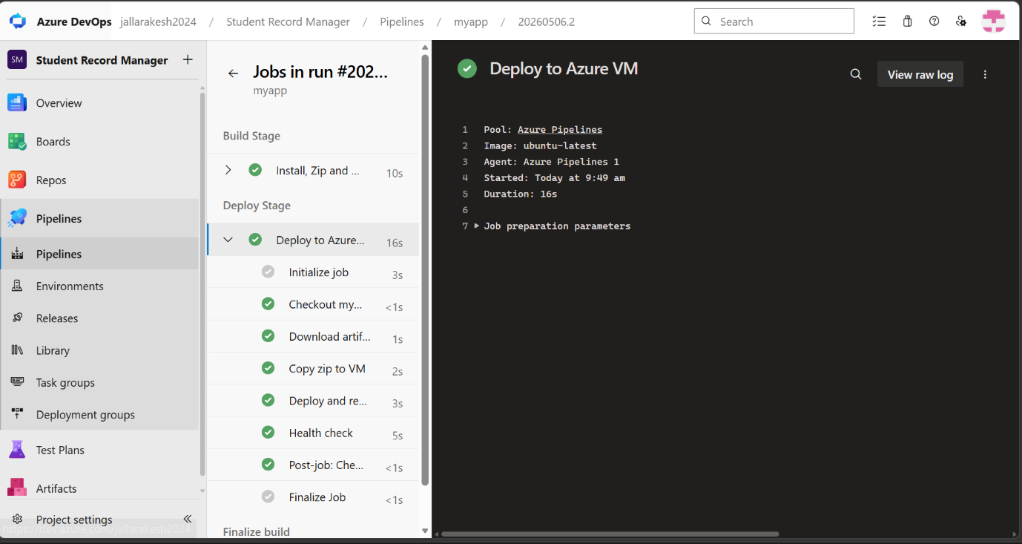

What you can see in the screenshot above:
- Deploy to Azure VM job — all steps green
- Initialize job: 3s — sets up the job environment
- Checkout: <1s — checks out the repo code
- Download artifact: 1s — downloads myapp.zip from Build stage
- Copy zip to VM: 2s — copies myapp.zip to /var/www/myapp on the VM via SSH
- Deploy and restart: 3s — unzips, runs npm install, restarts app with PM2
- Health check: 5s — runs curl http://localhost:3000/health to confirm app is running
- Post-job cleanup: <1s

The Deploy stage YAML tasks used:
- DownloadBuildArtifacts@0: downloads myapp-drop artifact from current build
- CopyFilesOverSSH@0: copies myapp.zip to /var/www/myapp on VM using vm-ssh service connection
- SSH@0 (Deploy): runs unzip, npm install --omit=dev, pm2 restart student-app
- SSH@0 (Health check): runs curl -s http://localhost:3000/health to verify app is up

Step 9: Application Live on Azure VM
The Student Record Manager web application is now live and accessible at http://20.198.20.48 from any browser anywhere in the world.

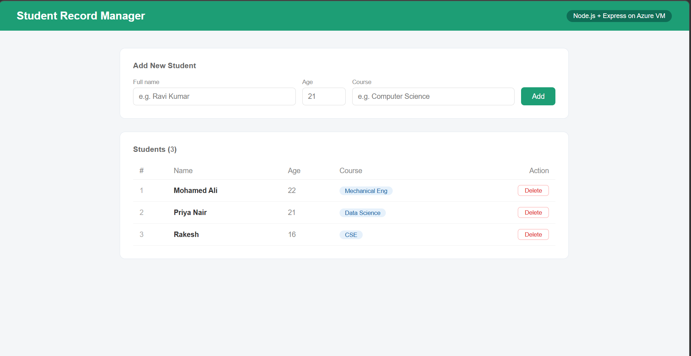

What you can see in the screenshot above:
- Student Record Manager application running in the browser
- URL: http://20.198.20.48 (Azure VM public IP)
- Header shows: Node.js + Express on Azure VM
- Add New Student form with fields: Full name, Age, Course and Add button
- Students table showing 3 records: Mohamed Ali (22, Mechanical Eng), Priya Nair (21, Data Science), Rakesh (16, CSE)
- Each student has a Delete button to remove them

How the request flow works:
- User opens http://20.198.20.48 in browser
- Request hits Azure VM on port 80
- Nginx receives the request and forwards it to localhost:3000
- Node.js Express app running on port 3000 handles the request
- PM2 keeps the Node.js app running 24/7 automatically
- HTML response is sent back to the browser

Summary — Complete CI/CD Flow
Every time you push code to the main branch, the entire pipeline runs automatically:

- Developer pushes code to Azure Repos (git push origin main)
- Azure Pipelines auto-triggers the Build stage
- Build stage: installs dependencies, zips app, publishes artifact (myapp.zip)
- Deploy stage: downloads artifact, copies to VM via SSH, unzips, restarts PM2
- Health check confirms app is running at http://localhost:3000/health
- App is live at http://20.198.20.48 for the entire world to access

Tools and technologies used:
- Azure Repos — source code storage (Git)
- Azure Pipelines — CI/CD automation (YAML-based)
- Microsoft-hosted agent (ubuntu-latest) — build and deploy runner
- Azure Artifacts — stores the myapp.zip artifact
- SSH service connection (vm-ssh) — secure connection from pipeline to VM
- Azure VM (Ubuntu 22.04) — the production server
- Nginx — reverse proxy, forwards port 80 to port 3000
- PM2 — process manager, keeps Node.js app alive 24/7
- Node.js + Express — the web application runtime

Deployment Successful! App live at http://20.198.20.48

