RVI stool workload data analysis

Joy Allen

8 January 2018

## R Markdown

## Including Plots

You can also embed plots, for example:

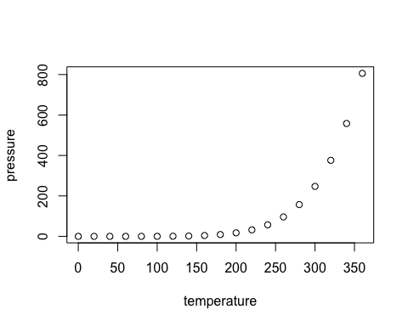

Note that the echo = FALSE parameter was added to the code chunk to prevent printing of the R code that generated the plot.