

jallen’s Casino in Prolog

Manual



December 11, 2018

Contents

Bug Report 3

How to Run 3

Feature Report 3

Non-Implemented 3

Implemented 3

Descriptions of Data Structures 3

Player 3

Card 4

Build 4

Log 5

November 22 5

November 23 5

November 24 5

November 25 5

November 26 5

November 27 5

November 28 5

November 29 6

November 30 6

December 1 6

December 2 6

December 3 6

December 4 7

December 5 7

December 6 7

December 7 7

December 8 7

December 9 7

December 10 7

December 11 8

Screenshots 8

Coin Toss: 8

Ai Help 9

Build 9

Capture Build 10

Ai Capture Identical 10

Scoring 11

# Bug Report

* Computer sometimes to fails to capture all matching symbol even after detecting them. This issue can also cause some cards on the table to be lost
* In games where the computer plays first, the ask for help causes the program to crash do to calling the wrong clause due to it not being updated correctly to match the new definition.
* If both players have a build of the same sum, the build will appear as a multi build, but both players will retain ownership of their individual build.

# How to Run

1. Start the prolog interpreter
   1. This program was built for the SWIPL interpreter
2. Ensure the file Casino.pro is consulted
   1. Do “swipl -s casino.pro)
   2. Start the interpreter, then do consult(casino.pro)
3. Call the main\0 clause which will consult all other files, and go to the main menu, and from there will act as

# Feature Report

## Non-Implemented

* Ai Capturing Multiple Sets of cards
* Ai being able to use Ace high and ace low at the same time.
  + The human is able to do this

## Implemented

* No Extra features besides what is on the rubric

# Descriptions of Data Structures

## Player

A list in the form:

[Id, Hand, Pile, Reserved, and Score]

Id is an int, represents the id of the player. 0 for Human 1 for Computer

Hand is a list of cards

Pile is a list of cards

Reserved is a list of ints, which are the sums of the build that the player have

Score is an int

## Card

A list containing a suit and a symbol

## Build

A list of Card Lists, and anything that has the isBuild function return true for

# Log

## November 22

* Getting and validating the environment (SWIPL) was working correctly (1 hour)
* Implemented ListAll function from class (.1 hour)
* Able to generate the four suits (.25 hours)
* Able to display a card correctly (.5 hour)
* Able to create all cards for a suit (.25 hour)

## November 23

* Able to create a deck of cards (.25 hour)
* Implemented the replace function from class (.1 hour)
* Able to implement a face value cards as a letter (.5 hour)
* Added comments (.25 hours)
* Able to shuffle deck (.1 hour)

## November 24

* Able to deal cards from the deck (1 hour)
* Able to display a list of cards correctly (.5 hour)
* Implemented skeleton of the round loop (.75 hour)
* Able to get and print hands for the board (.25 hour)
* Able to differentiate between Human and Computer (.5 hour)

## November 25

* Added ability to remove an element at the nth location and return the value (1 hour)

## November 26

* Able to get the move type the human wishes to make, and ensure it’s a validate choice (.5 hour)
* Human is able to trail cards (1.5 hours)
* Computer can trail cards (.25 hour)
* Able to deal cards after both hands are empty (1 hour)

## November 27

* Able to get list input [Later removed from game] (.5 hour)
* Spent time trying to debug user input not bouncing back correctly, but failed to fix (2 hour)

## November 28

* Able to remove matching symbols on table for capture, and add those cards to pile – Which implements capturing (2 hour)
* Spent more time trying to debug invalid move input, at this point I decided to scrap the system (1.5 hour)
* Rewrote the system to get each input individually and to end it with -1. (1 hour)

## November 29

* Invalid numeric input can sometimes bounce back to the prompt for move action (1 hour)
* Can validate that at least once card is captured (.25 hour)
* Able to display piles and decks to the table (.25 hour)
* Show action menu before each player makes their move (.25 hour)
* Rewrote program to use prompts instead of writes when user input is desired (.75 hour)
* Polished up the multiple input function to use less clauses (1 hour)
* Fixed string input crashing the program (.25 hour)

## November 30

* Debugged the program on why it would get stuck in an infinite loop after a player did a capture
  + Time to trace the error to an erroneous check of isHuman on the computer’s trail function (.75 hour)
* Human is able to capture sets (1 hour)
* Restructured code so new clauses are in their correct categories (.5 hour)
* Replaced my clause of addIfNotDuplicated with the native sort after getting your approval to use it (.25 hour)
* Wrote skeleton of computer outputting its move (.5 hour)

## December 1

* Fixed all outstanding singleton variables warning (.5 hour)
* Computer is able to make captures (1 hour)
  + Required adding multiple clauses to get the indices of the matching cards. Once that was done, it was able to use the same capture function as the human did.
* Fixed table printing twice in some move combinations (.25 hours)
* Able to create a build which sums to a target value, and mark it as a reserved value (This value is not respected by any other logic yet) (1.5 hour)

## December 2

* Able to display builds and multi builds to the screen with correct formatting (.75 hour)
* Added an isBuild function to determine if a list is a card or a build (.5 hours)
* Able to get value of a build (.25 hours)
* Able to get symbol of a build (2.5 hours)
  + The long time was due to a combination of finding a subtle bug in implementation which caused a logic error in recursion, and having to rewrite some supporting functions which relied on knowing both the symbol and the value before running
* Added an atomize Cardlist function and a rebuild card from atom list functions (1.75 hour)
  + This takes a list of cards and makes a list of their atoms
  + This ended up having no use for the current problem, however it ends up being useful for flattening builds into cards for adding to piles

## December 3

* Fixed bug of builds of odd number cards not displaying correctly (.5 hour)
* Able to load in a file and get into the round state (1.25 hours)
* Converted all test cases to work with internal structure of program (.5 hour)
* Removed singleton variable warnings (.25 hours)

## December 4

* Added helper clauses to add cards to pile, which flatten a build using the previously useless atomize build and rebuild (1 hour)
* Updated player printing to be cleaner (.5 hour)
* Play tested game to get a better feel for how it runs and what bugs there are (1 hour)

## December 5

* Ai is able to capture a set of cards (1.5 hours)
* Fixed issue where AI would delete its hand when unable to find a capture (.5 hours)
* Play tested to update list of issues (.5 hours)

## December 6

* Able to parse the reserved values for builds from save files (1 hour),
* Reordered clauses to match requirements (.25 hours)

## December 7

* Able to create multi Builds (2 hours)
* Able to capture multi builds (1 hour)
* Computer can load in first as first player from save file (.5 hour)
* Able to track who captured last (.75 hour)
* Cards on table go to who captured last (.5 hours)
* Able to fully score a round (2.5 hours)

## December 8

* Able to score tournament between round (1 hour)
* Scores can be returned through coin flip (.5 hours)
* Updated wrapper classes (.25 hours)
* Able to start new round if tournament doesn’t end (1 hour)
* Fixed computer not starting on repeated round where it won (.5 hour)
* Computer is able to make builds and multi builds (2.5 hours)
* Fixed reserved values being duplicated ( .1 hour)
* Computer can capture multi builds (.25 hours)
* Fixed bugs in human capture function (.5 hour)
* Split into multiple files to improve readability (1 hour)

## December 9

* Able to save the game to a file without build owners (1.5 hours)
* Playtesting and debugging which solved no issues (2 hours)

## December 10

* Able to ask the Computer for help (1 hour)
* Added removeVal function, which will be used to remove values in the reserved part of the player list (.5 hour)
* Able to remove values from the list of build values (.5 hours)
* Able to remove values from the other player when capturing (1 hour)
* Able to remove values from other player when extending the build (1 hour)
* Added ai output for capturing identical symbols
* Added bounce backs for player moves which allows for better user input validation (1 hour)
* Added validation to coin toss (.25 hours)
* Make sure file exists before trying to open it (.25 hour)
* Fixes some prompts1 and writelns for output formatting (.5 hour)
* Human is required to capture all matching cards ( .5 hours)
* No longer able to trail while owning a build (.5 hour)
* Round is able to end regardless of who started (.5 hour)
* Changed save file format to allow build values to be saved (1 hour)
* Aces can be treated as Ace High for capturing
* Able to keep track of round number as tournament continues (.75 hour)

## December 11

* Fixed a missed conversion to add round num (.2 hour)
* Validate input on choosing to load or save a file (.1 hour)

# Screenshots

## Coin Toss:

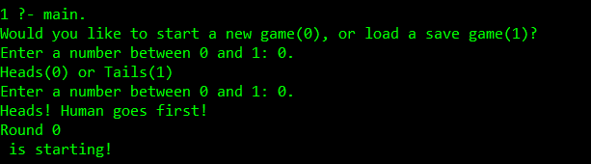

## Ai Help

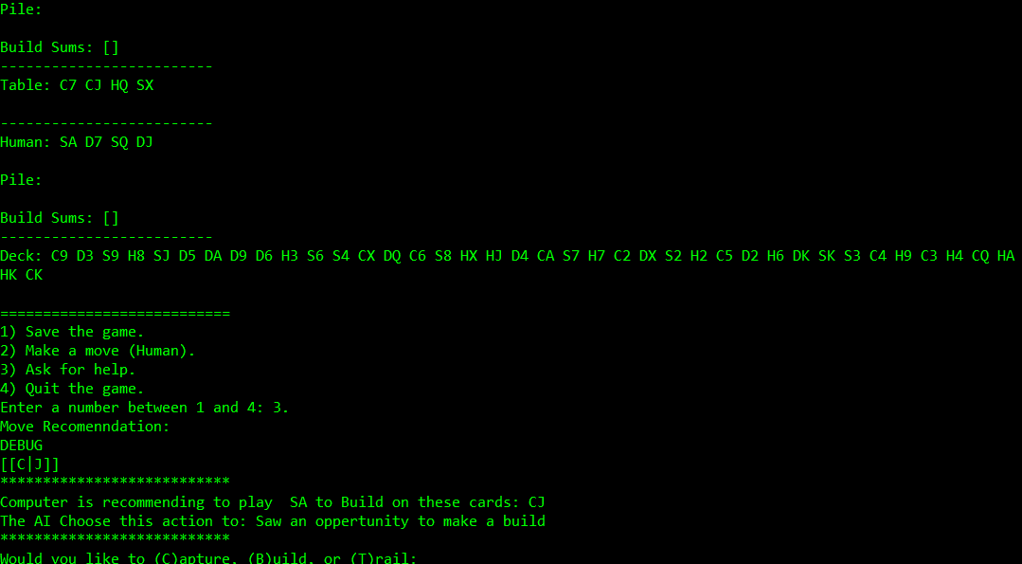

## Build

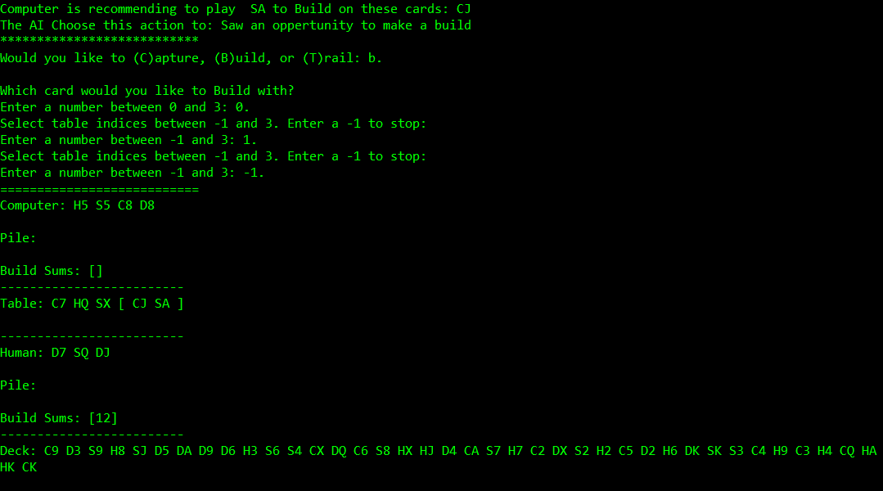

## Capture Build

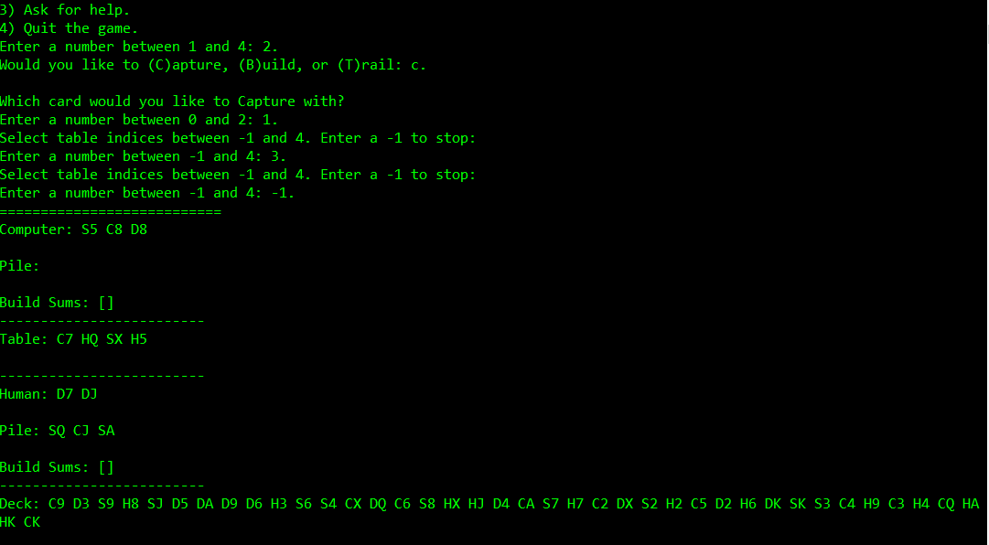

## Ai Capture Identical

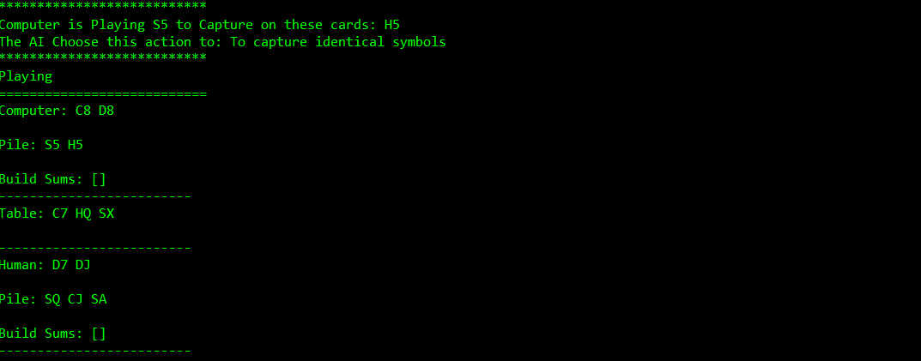

## Scoring

